Objective
To create a spreadsheet for recording of Level Play League Matches from which a SWCF Scoresheet and a Rankings spreadsheet which can be sent to Croquet England for inputting into the Golf Croquet Grading System.
The inputs to these two systems have significant differences.
The SWCF Scoresheet needs to include doubles games. The Home team is on the left and the Away team on the right.
The Rankings spreadsheet only includes singles games and shows the winner of each game on the left and the loser on the right.
The purpose of the spreadsheet is so that information is only input once and included in the Score Sheet or Ranking sheet as required reducing/eliminating errors.
The Spreadsheet can be completed as the match is played or afterwards using information from a manually completed copy of the scoresheet. This can be a print of the Scoresheet tab preferably after the match details have been completed.

Structure
The spreadsheet has three tabs in it.
- Match Details
- Score Sheet
- Ranking
All three tabs are ‘protected’ so that input can only be keyed into the required fields.

Match Details
Start with this tab and enter the details of the League and the Match played.
There are four sections to be completed.
1 – Match Details
League Name is limited to four values which can be selected from the drop down list, these being:
- GC Level Play Premier
- GC Level Play
- GC Level Play 5+
- GC Level Play 10+
Drop down list appears as:
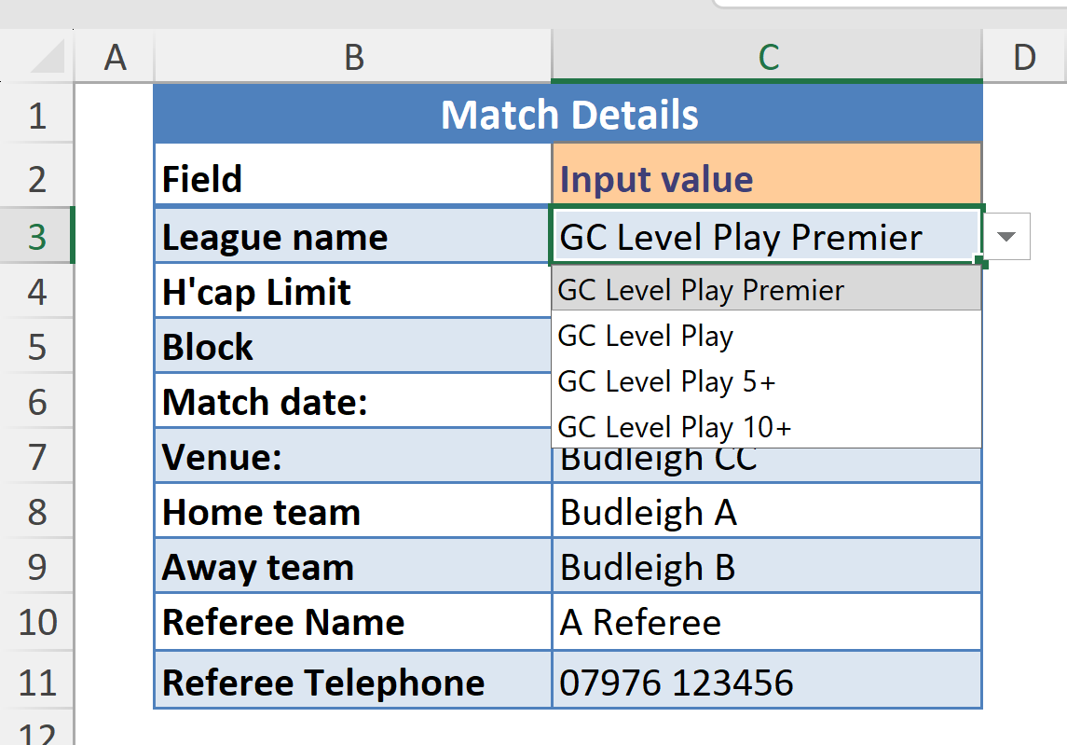

H’cap Limit is set according to the League name selected and will set to one of the following values:
- No Handicap Restriction
- Handicaps 5 or over
- Handicaps 10 or over
Match Date is restricted to a date 01/04/2026 onwards to the year 2099. It is completed by entering a date in the numeric date format dd/mm/yy or just dd/mm for the current year.
Block probably refers to the region such as North or South, it is free format.
All other fields in this table are free format.

Home and Away Teams
2 – Home Team
The only input fields in this table are Forename, Surname and Handicap. Player Name and Played are derived and cannot be changed. Player Name is derived by concatenating Forename and Surname after removing rogue spaces. Played is a count of games played from the Scoresheet.
Important: Forename and Surname must be entered exactly as that player’s name appears in the Golf Croquet Ranking System.
You will find cases where the Ranking name is slightly different to the CqE name for example:
- CqE name is Patrick Jones, but their Ranking name is Pat Jones. You must use Pat Jones otherwise they will not be found in the Ranking system.
- Two players have the same forename and surname, for example two players called: Richard Nixon. In the Ranking system one player will be known as Richard Nixon and the second player known as RichardH Nixon, using the initial of the player’s middle name. (note, there is no space between Richard and H)
- Only used the Initial field where it has been used in the Ranking system.
- If a player does not have record in the GC Grading system then make sure that you do not construct a name for a player that does already exist in the system.
  - Use a preferred forename, for instance Liz for Elizabeth
  - Append the initial of a players first middle name to their forename to create an unique name.
  - This name can then be used by the Results manager to create the player’s preferred GC Ranking Name.
Only names entered in the team tables can be entered on the Scoresheet.

3 – Away Team
Equivalent table for the Away team:

4 – New Players
For new players that do not have a D Grade in the Ranking system the follow additional information must be provided in the covering email.
- Full Name as in:
  - Title
  - Initials for first and middle names
  - Surname
  - Forename
  - Honours
- , if the person is under 25 years of age
- Country
The details above will be used to identify the person in the CqE system, also required is their name as it will appear in the Ranking system.
- Name to be used in the Ranking System. This should be the same as used in the teams above and as on the score sheet, but may be a variation on their Full Name. For instance,
  - Pat Smith for Patricia Smith
  - JohnD Smith, for when John Smith already exists in the Ranking system.

5 - SWCF Scoresheet Recipient
This is the name and email address of the SWCF contact responsible for recording the match result.
The score sheet must be sent to the appropriate SWCF recipient for the match result to be recorded. Select the appropriate recipient name from the drop-down list in the Name cell and their email address will be picked up from the table below.
Use the drop-down list in Name to select the SWCF contact the completed sheet is to be sent to, their appropriate email address will be picked up from the table below.

Score Sheet
This is the South West Croquet Federation Score sheet:
The match details are all automatically brought forward from the Match Details tab.
The only fields that can be entered on the Score Sheet are the Player(s) and the Hoop score.
The spreadsheet will keep a tally of the games won and lost and the Match Result.
The Player Names appear as a drop-down list copied from the Match Details tab. Player Handicaps are brought forward automatically.
The players names appear as a drop down list, for example:
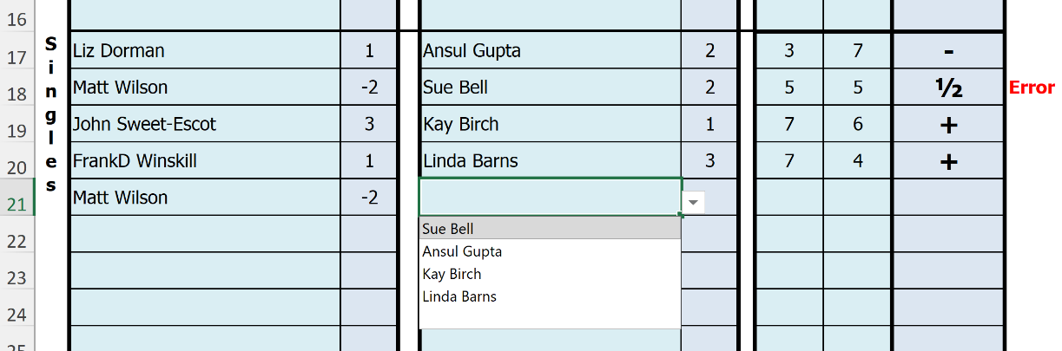
Partial names can be entered and the list will show matching names, for instance:
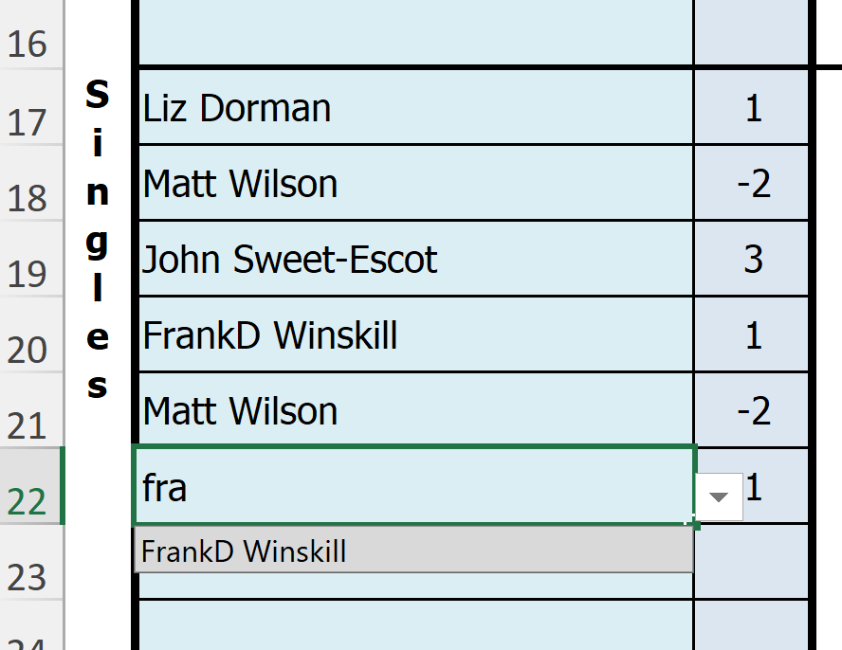
Press the tab key to enter Frank into the scoresheet.
Hoop Scores must be a value between 0 and 7.
Important: A doubles game can be drawn and singles games cannot result in a draw.
If you enter a singles game as draw this will be flagged as an Error, as per the example game between Matt and Sue
When the match is complete save the spread sheet with an appropriate name, for instance:
SWCF LP BudleighB vs BudleighA 19 Apr 2026.xlsx

Ranking
The format of this sheet is prescribed by Croquet England and is in the format required to update the Golf Croquet Grading System.
Most players will already have a DGrade and have a record in the GC Grading System. However some players new to competitive play in league matches may not have a record in the GC Grading System. For these players additional information is required. This information comprises of:
- Actual forename as it appears in the CqE system
- Initials
- Gender
- Under 25 flag
- Over 50 flag
- Country of Residence, to be completed when not England
- Representing County also to be completed when not England
This information is entered into a table next to the players handicap table.

Once the recording of the match is complete this Ranking tab need to be copied to a new Excel document.
The formulas used need to be resolved to the resulting values by breaking links.
The new spreadsheet can then be emailed to: results@croquetengland.org.uk

Process
The process to create the document to be sent to Croquet England is as follows:
First, copy the Rankings Sheet to a new spreadsheet by right clicking on the Ranking tab, this will bring up a menu list of which the fourth item from the top is ‘Move or Copy…’ select this option.
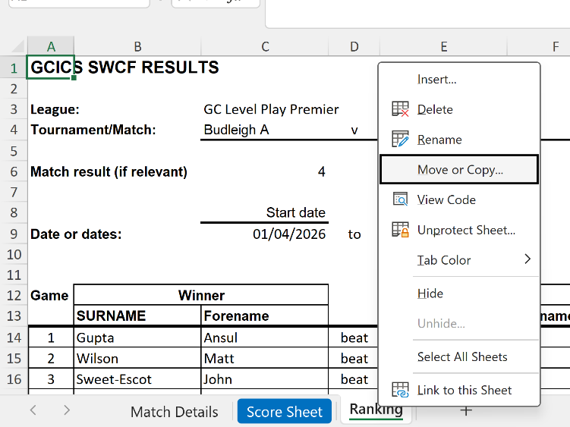
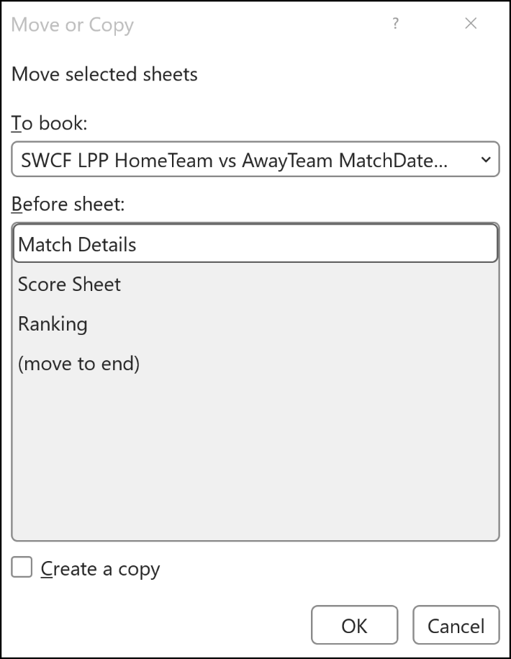
This brings up a window:
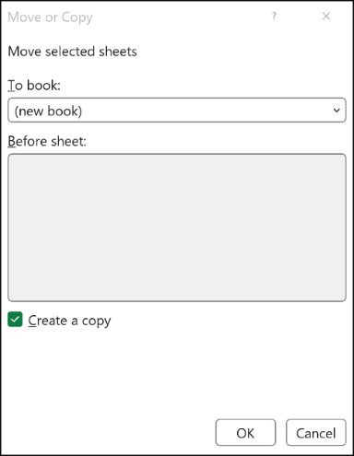
Using the drop down list change the To book: to ‘New Book’
Important:
Check the ‘Create a copy’ so the window looks like:

Click OK.
This creates a new Excel document with a copy of the ranking tab in it. In this new document all the formulas reference the relevant cells in the original document.
The next step in the process is to break these links and retain the values.

Breaking the Data Links
First the ‘protection’ needs to be removed. To do this right click the tab name again and same menu list appears. Click on the sixth item ‘Unprotect Sheet…’

Breaking Links – Method 1
Using the data tab at the top of the screen there is an item ‘Workbook Links’
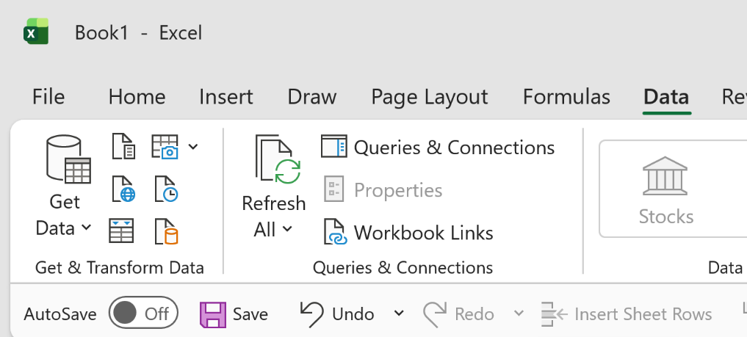

See second group in.
Click on Workbook Links this bring up a side menu Workbook Links:
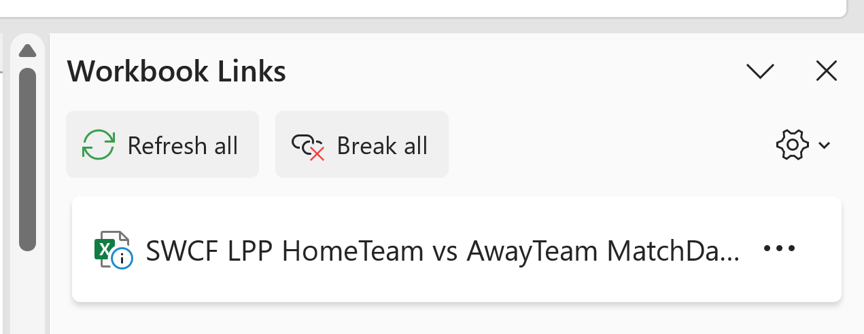
Click on the button ‘Break All’. This will convert all the formulas into text

Save the new Workbook. Suggested name is of the format:
SWCF LP <hometeamname> vs <awayteam> <date> Ranking.xlsx
For Example: SWCF BudleighB vs BudleighA 19 Apr 2026.xslx

Alternative method to breaking links
The alternative way to break links uses copy and paste.
Start by highlighting the WHOLE sheet, to do this click on the arrow (or triangle) at the top left corner of the spreadsheet, the spreadsheet will go grey to show it has been selected:
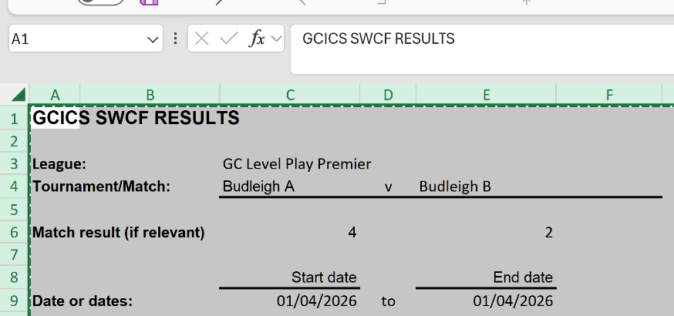
Click COPY or use Ctrl C to copy the whole spreadsheet.
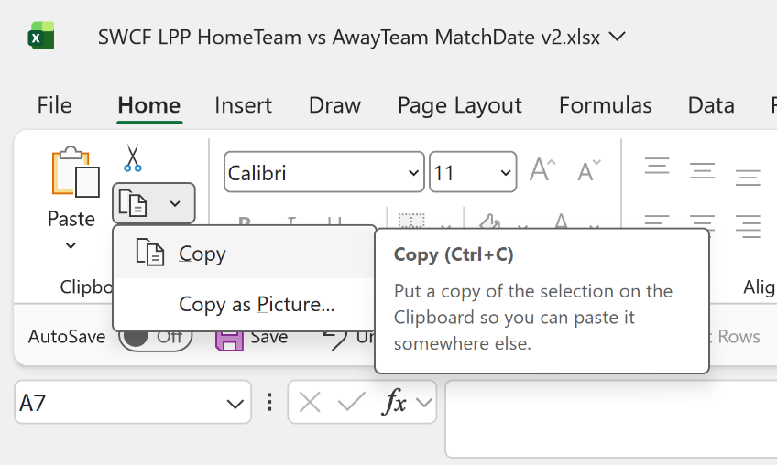

Then click Paste Values. There are various ways to achieve this:
- Use the Paste function from the menu bar.
- Right click on the triangle, this bring up a menu on which Paste Values can be found.
- Use Shift F10, this brings up a submenu on which Paste Values can be found
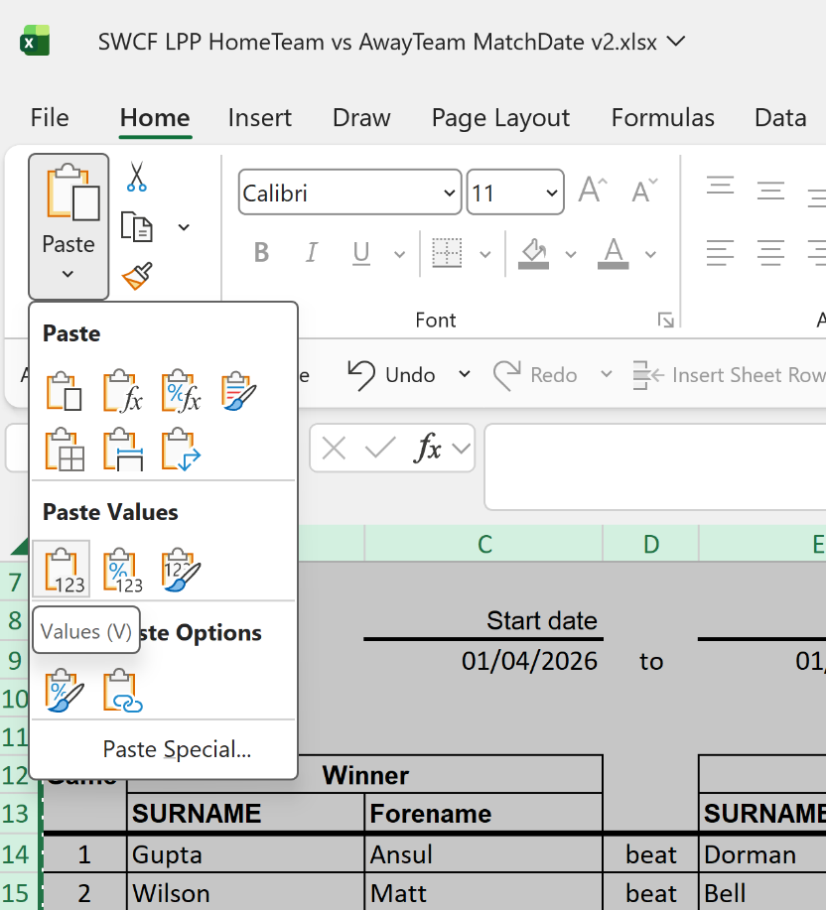

Another method to paste back the values by right clicking on the triangle:
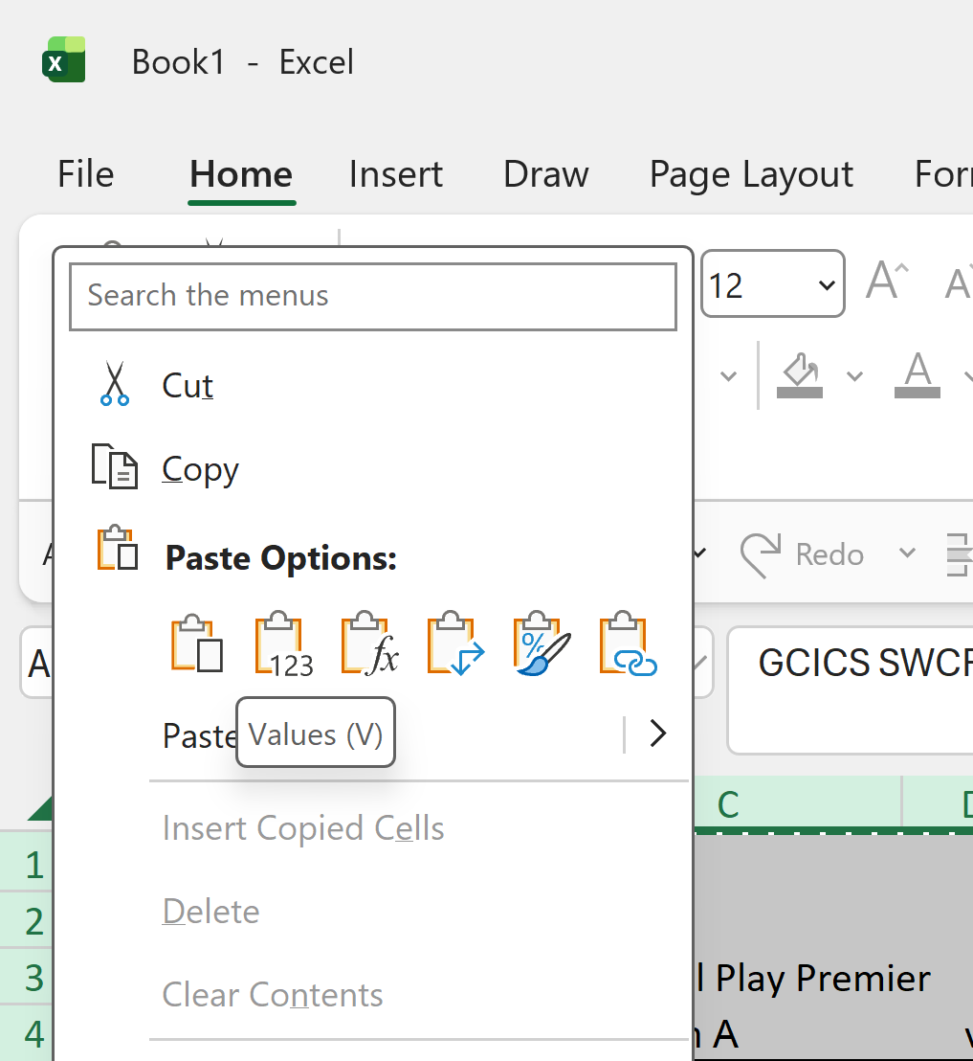

Save the new Workbook. Suggested name is of the format:
SWCF LP <hometeamname> vs <awayteam> <date> Ranking.xlsx
For Example: SWCF BudleighB vs BudleighA 19 Apr 2026.xslx

Submitting the Scores and Rankings:
Send the full scoring spreadsheet to the appropriate contact from the Recipient table as on the Match Details tab.
Send the Ranking spreadsheet to results@croquetengland.org.uk
<end>

