Here’s hoping by the time you read this, our lawns will be open and we’ll be swinging those cobwebs off our mallets. The rain has done us no favours and has kept our grounds team on their toes (and in their wellies) so let’s hope it’s a decent summer and all their hard work pays off.
Contents
Welcome to our new handicapper p1
Richard Jelly is Remembered p2
Welcome to our GC Refs p3
Coaching Corner p6
AGC Update p6
GC Coaching Pods (advert) p7
Success for Aston – and more p7
Cheltenham High Bisquers (advert) p9
Safeguarding Update p9
Local fixtures p10
Dress Code Debate p10
Award for Glamorgan p11
David Fuller is Hooked p11
PHC Mallets (advert) p13
Reading Corner p14
Advertising Rates p14

Read on for a general catch up and please keep sending in those snippets of news and photos throughout the season – it’s great receiving them all.

Welcome Mike

We’re delighted to welcome Mike Rice (East Dorset) to the Committee as our Handicapping Officer. It’s great to have the post filled after quite a gap, so do get in touch with him if you’d like to check out your systems. Here he introduces himself for those of you who haven’t met him yet.

“I started playing over four years ago and you soon realise how important accurate handicapping is. It is therefore a topic I have taken a keen interest in.

My wife and I are both very keen AC players and I see a lot of croquet, a pre-requisite for a handicapper. We are regulars in the SW AC Intermediate Leagues, play in three club tournaments each year and enter Handicap and Level play CA Tournaments.

Last year I became East Dorset’s AC Club Handicapper and the winter has been busy checking handicap cards and adjusting handicaps for those players who do not play enough games for the Automatic Handicapping System to be effective.

Joining the SWF Committee as the Handicapping Officer gives me the opportunity to get more involved in this aspect of our sport.

Some points for the new season:

- Check that your handicaps are correct on the CA website, if you have access to that site
- For any competitive match turn up with your handicap card and offer it to your opponent
- If you are the captain of any team in SWF Leagues or a CA team event present all the handicap cards of your players to the opposing captain soon after your arrival
If you have any handicapping issue, have concerns about a player’s handicap or have issues about another club’s handicaps then feel free to contact me: mikerice7981@icloud.com“

That still leaves plenty of room on the Committee for other help so do get in touch if you’re at all interested – we’re a friendly and supportive bunch as most of you probably know.

Obituary: Remembering Richard Jelly of Bath CC

Club members were deeply saddened to hear that Richard had passed away on February 22nd, after a very short illness. Lynne Passfield remembers him.

Richard wore his love of croquet ‘on his sleeve’ and his enthusiasm was spread by a kind, warm and generous approach to all. His gentle demeanour and good sense of humour meant that everyone welcomed his presence. Members of the younger generation in particular, very much benefitted from and thoroughly enjoyed his company, his wisdom and his thoughtfulness, when on the lawns.

His good friend Philip wrote,

“It was Richard who got me playing croquet; he knew, from his own experience, it would fill the empty days after retirement and he persuaded me to join BCC just as soon as I had hung up my stethoscope. And it was him who pointed out that I'd never be a very effective player until I abandoned my 'garden-croquet stance' and stopped 'shovelling the ball forward with my bottom hand'! Great advice. We were soon playing each other regularly and continued to do so for nearly eight years. Our last game together was 12 days before he died. When I dropped him home afterwards, he turned to me and said, "I loved that, Philip - thank you".”
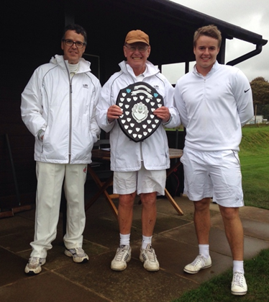
Richard joined Bath CC in 2002. His first handicap card was signed by Audrey Whittaker on 20th July of that year. He started out as an AC 20, and won his way down to an AC 18 that summer, with 9/14 wins, so the handicappers made him an AC 16 for the 2003 season.

During his time at Bath Richard was a very considerate and supportive team captain, represented Bath at SWF league matches, was the Club representative at the National One Ball Finals and travelled to play in numerous National CA tournaments.

Richard and his team, David and Dan, having won the 2017 Federation Shield.

He was a familiar face at the end of season presentation dinner and collected much silverware for his endeavours in our internal competitions. Listed below is a sample of his many AC achievements

- 2005 and 2014 Garrard Trophy (Most improved Player of the Year)
- 2005 Founders Trophy (Handicap Doubles paired with Michael Beard)
- 2005 Secretary’s Cup Handicap Singles (14+)
- 2008 Apps Heley Cup – Handicap Singles (4-12)
- 2014 Alderwick Cup – Handicap Singles (Open)
- 2021 Stopforth Cup – Advanced Level Singles (4-12)
- 2013, 15, 18, 19 and 21 Jubliee Cup (Open)
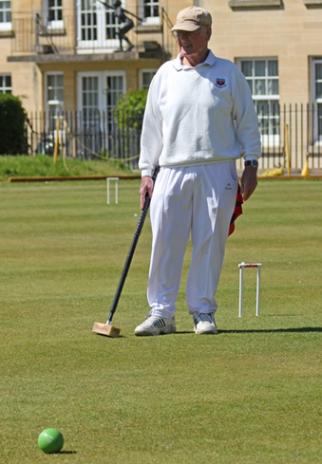
As well as being an enthusiastic competitor Richard played a significant part behind the scenes and served on the Committee for many years. He worked tirelessly offering invaluable support in his role as Secretary. In 2016 on standing down from Committee his role was split between two people.

Richard was keen to share his love of opera and classical music and one could always keep up with his various concert outings and muse on his colourful descriptions of various artists, whilst sitting alongside him on the lawn.

No tribute to Richard would be complete without mentioning his WONDERFUL horizontally stripped socks, displaying the colours of the croquet balls. He worn them at many croquet events and of which he jokingly reported that his wife forbade him from wearing on any other occasion.

A true gentleman, whose presence on the lawns will be greatly missed.

Greta

Following our tributes to Greta Stringer in the previous issue of Cygnet, we heard from Eugene Chang (we featured a photo of the two of them together). He wrote:

The tributes in your newsletter speak volumes about Greta alongside her immense contribution to Nailsea and the SWF. She was so warm and generous to me in my early years playing the game, and made croquet that much more welcoming. We shared some great moments on and off the lawn and I will miss her infectious smile and twinkle in her eye.

Welcome to our new GC Referees
As we stated at the AGM, we are using monies from the Judith Moore Bursary Fund to provide qualifications coaching in the South West and as a result we can proudly welcome five new GC referees into the region. The following reports give you a flavour of how successful the GC Referees’ course and subsequent ‘refresher’ day, were. To kick us off, Brian Wilson reports on the two-day qualification course:

From all corners of our region, 8 people came to Bath C.C. on Monday 13th Feb, to take part in the GC referees’ course organised by the SW Fed and led by Ian Shore of the Chiltern Academy - ably assisted by Ron Carter and our own Paul Francis.

Having received some pre-course reading from Ian, which had raised some queries (all to be answered on the course), we congregated in Bath’s new enhanced club house and, as there was a lot to get through, got down to matters straight away. Ian is an excellent teacher - not only clearly putting the facts across but also giving a series of handout cards that covered the key facts about each topic - we will certainly be using them in the future.

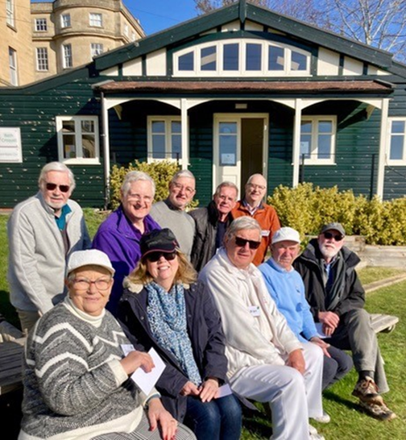
The two-day course was a blend of classroom and on-lawn work - we never got bored and time seemed to pass by so quickly. Ian’s detailed preparation was clear when he answered the myriad of questions from the group - so we were soon clarifying how to respond to a wrong ball, or balls close together, or … well, we covered so many areas.

Then came Valentine’s Day (Tuesday), where we completed our classroom work before we spilt into two groups to demonstrate what we had learnt as a referee on lawn (assessing not only your answer to a question, but how to maintain authority so that the players accept your decision whilst agreeing that they got a fair hearing and answer). Meanwhile the others would be taking the written test.

You may have heard horror stories of the written test, as you do not have access to the Rule Book or Ian’s excellent handouts. OK, it is a searching test of your knowledge (and yes, we all had revised overnight!!) and it poses some interesting questions (many of which you may not come across in ordinary play). For some questions you’ll know the answers, whilst for others you have to use the information covered in the course and your own pre course reading.

Ian’s support was evident for after the course as he personally phoned up each participant with their results (and this is the sign of a good teacher) areas where each of us did not do so well and hence points to revise and go over again. For those on whom the exam gods had not been kind, Ian would discuss how to move forward including retaking the test - no-one was left out.
Before we had the results, we agreed that, even if we did not pass this time, the course was well worth the two days (and pre course) work as we all learnt so much to take back to our clubs

So, if your club does not have a GC referee, or if you wish personally to improve your knowledge, we strongly recommend that you take part in any future course. Do not be put off by thinking ‘what if I fail?’ You'll gain a wealth of knowledge that’s worth the investment of time.

To sum up - an excellent course. Thanks to Bath for hosting and Ron and Paul for their support, thanks to the SW Fed for organising. A heartfelt thanks to Ian and all at the Chiltern Academy for such a stimulating course.

Many congratulations to the following for qualifying:

Steve Durston | Nailsea
Tony Green | Swanage
Bob Hart | Bath
Felicity Owen | Cornwall
Brian Wilson | Camerton & Peasedown

Brian would like you all to know that he is very happy to Referee at other clubs for matches and tournaments, so do get in touch with him to see if he can help.
brian@europaassociates.co.uk
07970 922867

Now Tony Mayer tells us about the refresher day:

What is the collective noun for a group of GC referees? An Assembly of Arbiters? A Meeting of Mediators? A Reunion of Referees? or a Gathering of GC Refs? Stephen Custance-Baker comments: “I’m sure the correct collective noun is a ‘Marker’ of referees.” Any more suggestions?

Whatever it is, eight of us met at Bath’s elegant clubhouse for a GC Referees’ Refresher seminar under the leadership of Ian Shore, assisted by Ron Carter, from the Chiltern Academy. This half-day meeting was added after the SWF GC referees qualification course which had taken place on the previous two days.
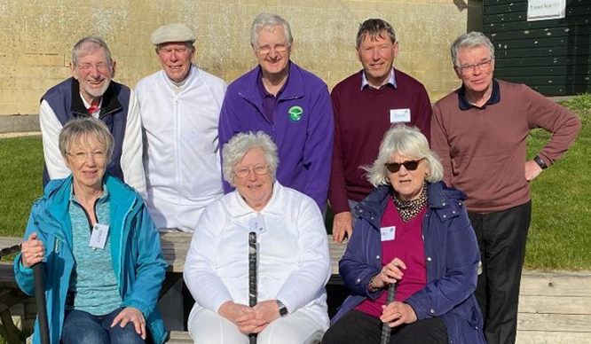

Back row (L to R): Tony Mayer (Swindon), Robert Honey (Moreton in Marsh), Ian Shore (Seminar leader, Chiltern Academy), David Palser (Llandaff), Darryl Whitehead (Cheltenham)
Front row (L to R): Linda Hicks (Budleigh), Ros Key-Pugh (Camerton & Peasedown), Mo Boys (Camerton & Peasedown)

Ian provided a stimulating, very knowledgeable and well-prepared leadership of the seminar. We started off with a ‘round robin’ of our concerns as referees and this set the agenda for our discussions. This included short-range clearances plus hammer strokes and jump shots in hampered situations, wrong balls, faults, interferences and the possible use of new technologies as well as attitudes of players to referees and vice versa – an etiquette for referees.

We had a series of stimulating discussions and Ian distributed a set of Q cards (‘crib’ cards) including a ‘croquet protractor’ which we shall all be carrying in the future as part of our referees’ equipment! We also had two sessions on Bath’s courts setting up various situations including using our mobile phones to video shots and replay in slow motion. Interestingly, shots that we declared ‘clean’ by careful observation were faults when viewed in slow motion!

In discussion, we all felt that the delay in videoing shots and reviewing the playback took a significant amount of time. Our conclusion was that the use of this technology should be reserved for major championships, internationals and finals and not used in most tournaments and league matches. We certainly don’t want the delays seen with VAR in football or the TMO in rugby!

In summary, this was a really valuable experience as we all had faced similar challenges and it was good to know that one was not alone in such experiences and Ian had provided with new tools and guidance. For the future, I hope that sessions like this for both AC and GC referees can be a regular feature of the SWF programme.

The next course will be in October at Bath but is heavily oversubscribed already. The next opportunity will be in Spring 2023, dates to be agreed, we will contact clubs as soon as we have firmed up on the dates and venue.

Coaching

We are pleased to announce that the SWF’s Club Level Coaching courses will be returning in 2023. These courses will consist of a series of short Zoom sessions followed by a one day practical at various clubs across our federation. In addition, Grade 1 courses will be offered subject to demand.

If you are interested in joining one of these courses, further information will be shared at the SWF’s Zoom on 11th April. If you are unable to attend this, please register your interest by emailing: paulwfrancis@icloud.com

AGC – What do we know so far?

Following our Zoom AGC discussion on 24th January we sent round a survey in order to gather some more factual information.14 clubs responded to the survey – about 1/3 of our members so we may be a bit premature but here are the results:

- 9 had never played AGC on club days  - 3 had played once  - 1 had played three times | Range of handicaps  - 3 – 7: 3  - 8 – 12: 1
Did the results favour the higher or lower handicaps?  - Higher handicaps: 2  - Lower handicaps: 0  - Neither: 1  - Don’t know: 4 | Members’ reactions to AGC  - Better than Extra Strokes: 3  - Similar to Extra Strokes: 2  - Don’t know: 2
There was inconclusive information about how long the games took  - One game was timed and 4 untimed | Will internal competitions be AGC in 2023?  - Yes: 8  - No: 5

We’re hoping more clubs will give it a go during the year and we plan to repeat the survey in the Autumn to see if a clearer picture emerges of experiences and impressions.

If you are playing AGC in club competitions or club afternoons, Stephen would be really interested in the results. The information that is helpful to him is:

- Handicaps and results
- Whether games were timed or untimed
- Length of time games took whether or not they were timed

And if you play in any AGC tournaments, please let us have your impressions and thoughts on how these go.

Contact Stephen: results@swfcroquet.org.uk

There are various article about AGC on the CA website www.croquet.org.uk/?p=games/golf/advantage

Golf Croquet coaching pods at Taunton Deane in April and May 2023
Each pod is limited to a maximum of 12 players, but some places are still available. Each pod will last about 3 hours, with assembly starting at 10:15 am. The cost is £10 per pod, which will cover tea/coffee and biscuits, and each player will receive a booklet at the end with all of the text and exercises.
Each coaching pod addresses a specific aspect of Golf Croquet. The first is open to all handicaps but the other two are targeted at more experienced players.

April 11th | Using extra strokes (all handicaps)  When and how they can be used, Calculating the number, Signalling their use, Deciding when to play one, Optimising their use and avoiding waste, Playing against them.
May 2nd | Five-shot thinking (handicaps 2 – 7)  Go for the hoop or delay, Setting up, How to run the hoop, Optimising the use of partner.
May 16th | Making the most of a hoop (handicaps 2 -9)  Available options when the ball is in the jaws, Partner ball or opponent ball?, Odd-numbered hoop or even-numbered hoop?
If you would like to come to one or more of the pods, please write to Stephen Custance-Baker, webmaster@TauntonCroquet.org. Entries will be treated on a first-come-first-served basis for those in the handicap range. If any places are unfilled then applications from outside the specified handicap ranges will be accepted.

Aston brings more international success to the SW

Following on from Erica’s success in the Women’s Worlds, another local player has made a name for himself on the international scene. Our congratulations to Aston Wade who tells us about his success in the Under 21s World GC Championship.

“Having been postponed during the pandemic, the U21 Golf Croquet World Championship finally went ahead in February. Players from England, Egypt, Spain, Australia, New Zealand and the USA were all there to compete for the title.

After a total flight time of 28 hours, I landed in Christchurch and immediately went along to United for an afternoon’s practice. Chris Clarke introduced me to one of the local members there – “This is Aston Wade from England, he’s the favourite for the upcoming U21 world championship”. That certainly put the pressure on!

I then had a fantastic week exploring New Zealand before heading up to Tauranga for the start of the tournament. Bungee jumping and white-water rafting in Queenstown may have been unusual preparations for a world championship but they were well worth it!
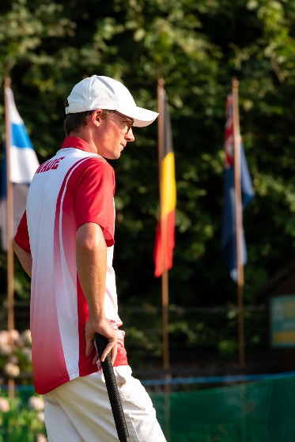

Day 1 of the tournament got off to a good start with wins in my first two block matches, but having played very little over the winter I was rusty and lost to a decent performance from Nathan Bullen in my final match of the day. Days 2 & 3 went better with wins in my remaining four block matches.

Day 4 marked the start of the knockout and although there was definitely still some rust to knock off, I made it past Myles Duggan in the last 16 and then Levi Franks (who was hot off his recent victory in the NZ Open). Courtesy of the impending cyclone, the manager decided to squeeze in the semi-finals that evening as well. I had a brilliant match against Te Kiri King of New Zealand who despite being an underdog certainly gave me my money’s worth in a match which was as close as they come - 6-7, 7-6, 7-6.

Day 5 rolled around and unusually for a GC event each of the top two seeds had made it to the final. I was up against Fawzy Helmy of Egypt, who at that stage had won 20 of his 21 games in the tournament. The manager gave us the option of a best-of-3 or best-of-5, I decided a best-of-5 would be more fun so we went with that.

Game 1 was extremely high quality from us both. It was probably one of the best games I’ve ever played, it had to be to beat Fawzy. The weather then deteriorated rapidly and the quality of play declined slightly with it, but after another well fought 11 hoops, I took game 2. At this point I decided I really should have agreed to a best-of-3! Fawzy then produced another strong performance to win game 3. Game 4 went to the 13th with a brilliant battle at the final hoop.

Eventually Fawzy missed a difficult clearance and gave me a shot to take the U21 World Championship. I came off the lawn absolutely soaked through and shivering, I could have jumped into the Pacific Ocean and not become any wetter. That wasn’t enough to wipe the Cheshire cat grin from my face though and playing a world championship final in a cyclone will undoubtedly go down as one of my favourite croquet moments of all time.

We finished the day with a lovely tournament dinner for the players and tournament officials. Overall, it was an amazing experience and it was a delight to meet and compete with so many talented young players from around the world. It’s a real honour to be the first English player to win the event and I’d like to thank everyone who has supported me on my croquet journey.

And more to come …

Steve Leonard (East Dorset) and Stephen Custance-Baker (Taunton Deane) have been awarded ranking places in the GC Over-50s World Championship in Western Australia in October.
Many congratulations to them – we look forward to hearing all about it.

Cheltenham: High Bisquers (AC) Tournament

Handicap: 14 – 24 (Min: 14 Max: 24
Manager: Adam Moliver
Mon / Tue 14 – 15 August 2023 (2 working days)

“A great way to start Tournament play”

- Entries via CA website (TES) preferred: https://www.croquet.org.uk/?p=tournament/caCalendar
- Otherwise by post using CA entry form or by email to the Club Tournament Secretary
If so, payment should be made by bank transfer (BACS) to
a/c 21367544 sort code 40-17-53, reference 'Surname/CA Fees'.
£27.50; Club member: £25.50
Teas provided, bring own lunch

Day One: 3 x 18-point games each day
Day Two: 2 games
Full-Bisque off base tba.

Coaching / supervised games on day two for those struggling on day one.
admoliver@btinternet.com for any queries.

Safeguarding
Our Safeguarding Officer, Andru Blewett, reminds us of a few basics:

As we approach the new season, I thought I would take this opportunity to send a gentle reminder to those involved in organising and running all the tournaments and matches associated with the SWF this season. Attached you will find the Safeguarding Advice for Clubs issued by the CA. I particularly wanted to draw your attention to the 4th guidance point under the Practical Guidance to Clubs, Federations, and Academies section. Namely to "Ensure that your Club officials running Club competitions, league and friendly matches, and Open events are aware of and receptive to safeguarding considerations and procedures relating to both the under 18s and adults at risk of harm." For league matches this is simply a matter of the team captains when speaking to each other prior to the match, just to check if there are any safeguarding issues the other should be aware of.

Recent correspondence from the CA's Beatrice McGlen, Executive Chair and Ron Carter, National Safeguarding Officer has been circulated to all club secretaries and provides an excellent summary of the role of Club Safeguarding Officer. There is also a request for those clubs that have not registered their Safeguarding Officer with the CA to do so promptly, and if as yet you have not filled this role in your club you are asked to make a real effort to do so by the end of May.
Club Safeguarding Officers should expect to receive information on a two-stage training programme soon. This will start with a child safeguarding course and will be followed later by an adult safeguarding workshop.
Ffi: https://www.croquet.org.uk/?p=ca/schemes/safeguarding
Other Fixtures in the South West
If you’re looking to play a little further afield within the region, you can check out the Federation page on the CA website https://www.croquet.org.uk/?p=games/federations&FederationID=3072

If you scroll down the page and past the location map, you’ll come across the list of clubs in the region that are hosting fixtures events.

Local regional information may be found on each of the Federation pages so it’s easy to see if there’s any croquet happening while you’re on your travels.

Is it time for croquet to relax its all-white dress code?

This was the question asked by Lisa Bailey at Bristol CC’s AGM and they passed it on to us for our views. We are very sympathetic to the argument and will be raising it at a Federations’ Focus Group meeting but we’d like your views as well. This is what she says:

I saw a TV news article recently talking about solving the issues sportswomen have with training and competing due to their menstrual cycle. This reminded me of my younger days playing in croquet matches when menstruating. Added to the physical issues of periods were mental ones: the fear of embarrassment of a bright stain appearing on white trousers and anxiety affecting concentration. A web search on “do female sports women wear white?” returned many articles on the issue and the changes being made in various sports. This kind of anxiety isn’t limited to girls and women: similar issues can also be experienced by those with bladder or bowel problems.

I recently raised the issue at our club’s AGM and there was some sympathy and empathy with this point of view. I believe the federation wish to elicit members’ views on the issue; we should also consider that some people may be put off croquet entirely.

The ‘whites’ dress code is part of the CA Tournament Regulations and ultimately, they would need to be lobbied to consider changing it but it could well be that clubs and the SWF can set their own guidance on this for the events run at those levels.

The recent move by the English Roses football team to change their white shorts for dark blue, adds weight to the debate.

What do you think? And if a change of code is overdue, what should an alternative be? Just email us with your thoughts.

Glamorgan LTCC – Townsend Award winners

Great news for Glamorgan – Paul Pristavec gives us the low-down:

As a club, we have managed to survive several events in the past few years. Removed from our previous home and finding a new home; serious flooding of poor lawns, resulting in stones deposited on the lawns; Covid.
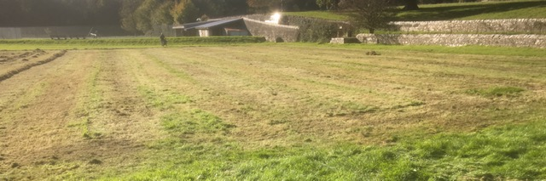
We resurfaced after the first lockdown to re-lay two lawns professionally, with thanks to generous donations from club members. They have proved to be of excellent quality and are able allow some decent croquet played on them. We have installed a generator system into the clubhouse giving us electricity so that we can offer a decent ‘cuppa’ to visiting teams!

We applied to the CA for the Townsend award in September 2022 and with some good guidance from SW Fed Development officer, Paul Francis, we managed to meet the deadline.

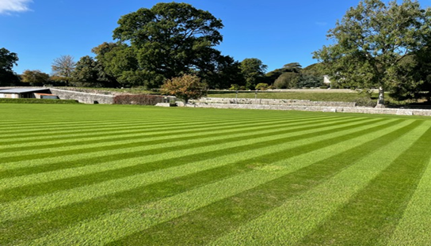
January was a tense month as we had been told that the relevant committee would meet on January 19th – coinciding with date of our annual presentation dinner! A few days later, we were informed that we had won the award. For a club that almost went under with no real home or decent lawns to winning this award is incredible. It’s all due to the hard work of members who lent a hand when needed. (I won’t list them as I’m sure to miss someone out – I don’t want to cause offence!)

To give you some idea of the progress, the pictures are a before (above) and after (below) of the lawns. The first when we arrived in October 2018 after initial mowing and removal of long grass and the second now.

Me and Croquet - Part 2 - Completely Hooked David Fuller continues his tale:

Following on from Part 1 of my ramblings as a croquet novice, I still feel a bit awkward talking about myself, but I hope that you will agree that most of the time I am talking about the people who have helped me, the interesting events that occur, and creating sentences that are far too long.

So, my novice diary had got as far as the East Dorset June Tournament in, well, June. Chris Weedon offered his help as a mentor and soon enough we were regularly talking all things croquet and playing training games. Chris and I seem to be similar characters, both of us being a little obsessed with AC particularly (we will get to GC later!). We got on like a house on fire. I think that it is fair to say that we learnt a lot from each other, and continue to do so, through our many games and discussions.

My handicap was dropped from 14 to 12 for June Week but I was lucky enough to win the Handicap Knockout, beating Tim O'Donnell in the final, who had more excellent advice for me ('practice three-ball breaks only; then the four-ball breaks will seem like a luxury!'). That's the thing about croquet: miserable/bad losers are fairly rare in my experience, and I have been lucky to receive a great deal of input from many high standard opponents. I was also able to win the C-Class Singles event. Two trophies. That's another thing about croquet... OK, I think that I need a 'things’ list now:
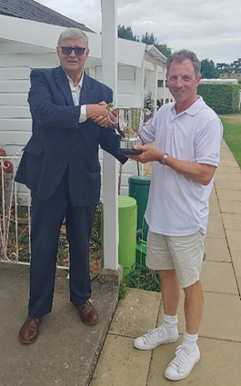
Things About Croquet:
#01 - Miserable/bad losers are fairly rare and opponents are happy to help improvers.
#02 – Trophies are really good in the croquet world; lovely silverware etc. that have been around for almost a century (far better than in chess, which I also play; stick with croquet is my advice).

So, after the East Dorset June Tournament, TM, Andrew 'Slasher' Gregory, hacked my handicap down to 8 just because I won a couple of the trophies! But honestly, it was great to be cut. I felt that I was playing better than 12 at that time, and nobody likes a bandit, especially those running off with the trophies!

The July schedule offered a series of inter-club events and East Dorset club matches so I just played lots of croquet and read whatever books I could find... Bang for your Bisque... Taming the Triple... Croquet Secrets... and the 'classic' Expert Croquet Tactics (top players just call it 'Wylie', which is handy to know if you want to appear clever). Chris and I had many 'exciting' conversations about the content!

David Harrison-Wood has been a member of East Dorset and part of the fabric of Croquet England for many years and it is fair to say that he has some stories to tell! David asked me if I would like to play some croquet and work through some training routines. Well, of course! I was flattered! He talked through some of his croquet shot theories, particularly regarding peeling shots, to help develop my game. He is very technical. Right up my street. Then that spectre appeared... the Triple Peel. I was nowhere close of course, but it was there, taunting me with two fingers.

Around this time, I played a handicap match at Hamptworth and was paired against Tim O'Donnell again. Tim seemed a little miffed that I was playing too slowly; he was completely right. I realised how seriously I was taking each game, overthinking how to use bisques, and that I had to lighten up. That was an important lesson. Chill out and enjoy the game! That is now two beers that I owe Tim.

August came and went with lots of handicap matches, but apparently, if you want to get better, you need Advanced Level Play matches. A quick bit of swatting up on Diagonal Spreads and I felt I was ready. Well, let’s see how that will turn out…

So in early September I entered the Challenge and Gilbey at Cheltenham: two days of Handicap and two days Advanced Level Play. I wrote a detailed report for Sarah Hayes at the time and re-reading it reminds me what a great event it was. This is how I wanted to play croquet, but it is easy to be impressed by eleven pristine lawns stretching out into the distance.

Three specific events are very clear in my mind. Firstly, I had my first -26 game against David Warhurst where I didn't take croquet! Secondly my game against Dave Kibble which finished on the sixth turn: T4 - Dave hit in and round to penult; T5 - I hit in and did the same; T6 - Dave again hit in across the lawn and double peeled home - that was great to watch. And finally, during the match with Dave, I had a hampered shot after H5, called for a referee and out strolls James Death. I was somewhat nervous but got a 'good shot' from James. I should add #03 to the Things About Croquet list:

Things About Croquet:
#03 - You meet all the top players around these tournaments. I know that croquet is a minority sport, but it is still pretty cool, especially if they referee a good shot!

I was pleased to win the Challenge B-Class Level Advanced play winning against a scratch and 1.5 opponent. As usual, there were a number of constructive comments from the likes of Sarah Hayes ('stand up straight man'), David Warhurst, Dave Kibble and others. I bought Keith Davis's 'ABC of Croquet' book and some proper croquet kit from Croquet HQ next door. All in all, a great week.

I do need to come clean about the circumstances of my win over David McGee in a level play block game. David didn’t seem to be playing his best, but with his last turn after time being called, he was approaching H6 to win by that dreaded/wonderful '+1 on time'. Inexplicably, he stuck in the jaws of the hoop from two feet. My only chance was a shot from the south boundary to a ball behind H6, for a simple win. At this point, just as inexplicably, I asked for help beyond the grave (those of you who read Part 1 might recall that I lost my dear wife Christine two years ago). 'Come on Christine, just give me this one', I asked as I glanced skywards (I am not religious at all, it just seemed a nice thing to do!), and blimey if I didn't hit the roquet full on and pinch the match! So, I have to confess to some outside assistance one that one. I hope the result still stands.

Beautifully crafted mallets from South Africa,
made with South African Aluminium or
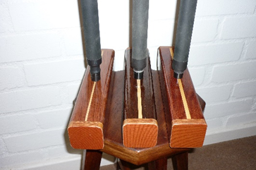
carbon shaft
- end weighted,
- ex stock or bespoke.
You choose.

From £155 inc postage.

A delight to play with.

Contact: Marie Stuchfield
Tel: 01392 757672
or
Mob: 07929940893
E mail: mlstuchfield@gmail.com
Reading Corner

Quite fortuitously I came across a murder mystery by AA Milne (yes, that one) when yet again our fascinating game played a key role. And this time it was a box of croquet kit, kept in the shed by the bowls lawn (yes, they were ahead of us on that one).So, do you know, or can you guess, what role this box played in solving the murder?

The shed was two or three yards to his left … From where he lay he could see almost entirely inside it. Everything seemed to be as they left it. The bowls-box, the lawn-mower, the roller, the open croquet-box, ---

"By Jove!" said Anthony to himself, "that's neat." The lid of the other croquet-box was open, too.

No more clues, find the book or take a stab in the dark – the decision is yours.

And two for the price of one this time - it’s always good to get into conversation with Brigit Clayton at Nailsea who’s sent in this teaser:

The second teaser was sent in by Brigit Clayton at Nailsea who wants to know if anyone recognises where this came from:

The croquet lawn was well used and Compton Mackenzie, who began to visit President Benes regularly in 1944, noted with amusement that the croquet hoops had all been widened at the base.

Answers to both questions in the next, exciting, episode of Cygnet …

Advertising in Cygnet

All adverts must be sent fully formatted in such a way as they can be easily inserted (copy and pasted) into Cygnet. We are not in a position to undertake any artwork or correct for errors or omissions.
Charges include a 2/3-line entry in the Diary Dates column in up to three subsequent issues.

Charges
Full Page: £12 Half Page: £6 Quarter Page: £3

