**SWF Committee Meeting 26th January 2023 7.00pm: Agenda**

**Present:** Tony Mayer, Peter Kirby. Paul Francis, Stephen Custance-Baker, Andru Blewett, Brian Wilson, Linda Shaw

1. **Minutes of last meeting** 
   1. Previously circulated and agreed as correct
2. **Update and Matters Arising** not covered elsewhere
   1. Issues to be raised at Feds Forum
      1. Paying expenses to teams representing the region at national level – this doesn’t happen elsewhere so no further action from us
   2. The idea raised at AGM of playing to a base in Intermediate will be presented as a topic for February Zoom **Action: Paul**
3. **Treasurer’s Report**
   1. Previously circulated – see below
      1. Updated information on Judith Moore Bursary agreed and to be placed on website **Action: Linda**
   2. Progress on opening interest-bearing account
      1. Nat West account not opened yet as Peter doesn’t have full control – not transferred over by Neil when he resigned
      2. **Action: Peter** to continue trying
   3. An invitation and a reminder to renew have been sent out to member clubs– that is considered to be enough but all will be contacted annually in case their circumstances have changed
      1. Non-renewing clubs will be removed from the circulation list at the end of January each year **Action: Linda**
   4. Membership queries outstanding – need to think if these need to be followed up:
      1. Beckford: **Action: Paul** to ask Klim to make contact
      2. Cary Valley: wait to hear back from them
4. **League Secretary**
   1. The paperwork is now complete for all the leagues and I sent out the match details and contact information to all of the match secretaries yesterday. After a couple of corrections, I am now hopeful that this is all finished until the results start coming in, (the first matches are on April 17th) - 299 matches across the Leagues and website is up to date.
   2. SC tournament entries less than anticipated but still greater than last year
   3. Finals venues

|  |  |  |
| --- | --- | --- |
| Venue | Date | League |
| Sidmouth | Saturday Sep 16 | AC Intermediate |
| Nailsea | Saturday Sep 16 | GC Level Play 5+ |
| Cheltenham | Sunday Sep 17 | B League |
| Swindon | Sunday Sep 17 | GC Handicap |
| Budleigh | Saturday Sep 23 | AC Federation |
| Camerton | Saturday Sep 23 | Short Croquet (Restricted) |
| Bath | Sunday Sep 24 | Short Croquet (Open) |
| Bristol | Sunday Sep 24 | GC High Handicap |

1. **Development Officer**
   1. See report below
   2. Brian and Klim have both introduced themselves to their nominated clubs
      1. Kington Langley looking for funding for new club house
         1. They will also be playing some home matches away because of work on an adjacent lawn
2. **Coaching**
   1. See report below
      1. Note Peter’s concern that people should have paid on entry for our courses
      2. Also concerns at tracking who’s paid
      3. Prefer to use TES in future **Action: Paul & Peter**
      4. Be ok to go over the £1,000 subsidy level subject to prior committee approval
      5. Re travel costs: we should adhere to our stated policy – Peter and Paul will deal with this but our existing policy will be checked **Action: Linda**
   2. Coaching page on our website needs updating including link to **Action: Paul**
   3. CADB info on coaches is out of date – Paul has raised this with the Coaching Committee and will keep an eye on progress **Action: Paul**
   4. BS has asked if it’s possible to have a link to their coaching page – this was agreed
      1. Confirmed they will be given a free advertorial in the next Cygnet and will be charged at normal rates thereafter.
      2. David Warhurst will be invited to the next Zoom **Action: Paul**
      3. As many of our clubs are closer to the Chiltern Academy it was agreed to offer them a link from our website **Action: Linda**
   5. Paul will be qualifying as an examining coach so should be able to run club level and grade 1 coaching this summer hopefully
3. **Handicapping**
   1. We really need to find someone to fill this role – Paul will approach one potential candidate
      1. Subsequently we were informed this person is not in a position to do this – an alternative person will be contacted **Action: Paul**
      2. GC / AC handicap conversion will be raised at the forthcoming Handicap Committee meeting
         1. *Paul subsequently reported that Brian Fisk will be working on this*
4. **Safeguarding**
   1. Andru reported some clubs have given info re LSO **Action: Andru** will check CA website
   2. No more news on the national situation
5. **Feds’ Focus Group**
   1. Minutes circulated
   2. Frequency of meetings discussed
   3. They will be seeking more input from CA officers in the future to strengthen their role and influence
6. **Update from Rep to CA Council**
   1. Council meeting on Sat - no updates til after then
7. **Committee membership**
   1. Key posts that still need filling: handicapping and website managing
   2. Another call to be put in Cygnet including a reminder of the co-option process **Action: Linda**
8. **Reflections on AGC Zoom**
   1. A plethora of views were expressed on the many dimensions to this topic, not least of which is how differently the SWF runs it’s GC handicap leagues
   2. No consensus was identifiable and our knowledge of what clubs have been doing and what they have learnt, is patchy
      1. Agreed to send out Survey Monkey to clubs to establish more factual information **Action: Stephen / Paul**
   3. Stephen’s discussion paper and comments on this may be found below
9. **AOB**
10. **Dates of next meetings**
    * 1. 23rd March
      2. 25th May – note new date
      3. 13th July – note new date
      4. 21st September
      5. Oct tba – Stephen will be away a lot – requires careful planning nearer the time
      6. AGM tba
      7. Follow up to AGM tba

**Treasurer’s Report**

|  |  |
| --- | --- |
| |  | | --- | | **South West Federation of Croquet Clubs** | |
| **Treasurers Report 18th January 2023** |

**Summary of Expected Income & Expenditure for 2023**

I refer to the table on page 3, this shows the budget for 2023, the actual income & expenditure for the period up to January 18th, the expected income & expenditure for the full year and in the last column the difference between the expected position and the budget.

Income is forecast to be £68 lower than expected in the budget principally due to a slightly lower than anticipated entry in the Nailsea & Budleigh Short Croquet Tournaments (55 entries vs expected 60).

Expenses are currently expected to be in line with the forecast, although it is early in the financial year to be confident of the final outcome.

In summary the net impact is that there is a projected deficit for the year of around £540 vs the expected deficit of £470. This slightly higher deficit can be adequately covered by reserves.

**Creditors / Debtors**

Debtors – c. £1,000 payment from the Bears Residual Fund

**Balance Sheet**

At January 18th there was £6,203 cash at Bank including cheques received but not yet banked but excluding Judith Moore Bursary (see below),

**Judith Moore Bursary**

There have been no payments made from the Judith Moore Bursary Fund, and the cash balance remains at £5,000.

It is anticipated that payments from the Fund of c. £1,000 will be made in the current year to support coaching projects as outlined at the AGM. It is too early to give a more detailed picture.





**SWF Development Report Jan 2023**

**CA Club Awards 2022**

* Both Glamorgan and Moreton in Marsh submitted strong applications for the Townsend Award.
* Outcome will be announced in February.

**CA Webinar on Crowdfunding**

* Christine McCormick from Moreton in Marsh presented at the January webinar.
* Apart from Moreton in Marsh and Bradford on Avon, SWF clubs in attendance included Bristol, Taunton Deane, Plymouth, Swindon and Swanage
* February webinar is addressing ‘legal structures for croquet clubs”

**Next Generation Pilot Clubs**

* SWF clubs participating in the pilot programme include: Bath, Bradford on Avon, Camerton and Peasedown, Nailsea and Worcester Norton.

**Developments at Swanage**

* Still exploring options for their new home. They have identified five locations. They will be playing all Home league matches, Away.

**SWF Coaching**

**Referees Courses**

* A strong level of demand and so we have scheduled a second course in the Autumn.
* All courses are limited to eight people.
* Dates are: February 13/14 at Bath Croquet Club and October 7/8 venue TBA.
* Clubs represented are:
  + February: Bath, Camerton, Cornwall, Exeter, Mumbles, Nailsea, Plymouth and Swanage
  + October: Bath, Bude, Bristol, Broadwas, Camerton, Nailsea, Swindon and Worcester Norton.
* There are six more people on the waiting list for October and so we anticipate sufficient demand for a third course in February 2024.
* Half day refresher course for GC Referees on February 15 at Bath Croquet Club is full.

**Breakdown of finances**

* Referees Course
  + Priced at £80 per head.
  + Funded through SWF Subsidy £30/ CA Subsidy £25/ Participants Contribution £25
  + Costs: Travel and accommodation £350 and hire cost £74
  + This gives a surplus of £216
  + However, there are participants’ travel expenses estimated at £443
  + So the net cost to the SWF is £227 plus the subsidy of £240 = £467
* The refresher course helps to reduce this by £53 but also spreads Ian Shore’s travel expenses over two courses rather than one.
* Net cost to SWF is just over £400
* The financial position for October is similar but the travel expenses for participants is likely to be lower due to proximity to a central venue.

**Budleigh Salterton**

A programme for 2023 is in the planning stage.

**AC**

* Openings
* Better break play
* Shot technique
* 3 ball endings
* Getting into Advanced Play (parts 1 and 2).
* Getting from B to A
* Advanced peeling workshop
* AC Improver
* An introduction to AC for GC players

**GC**

* Practical competitive play
* GC Improver
* Two-in-one strokes
* GC mistakes

**SC**

* 1 day course: An introduction to Short Croquet

**Coaching Courses**

Subject to the outcome of the March course in Sussex followed by coaching committee’s decision on Examining Coach status in April.

**AGC discussions**

These could helpfully be read in conjunction with the notes of the Zoom meeting on 24th June which demonstrated lots of opinions but no consensus– circulated separately.

Stephen’s reflections:

Two thoughts to start with:

1 What is Handicap GC for?

* Level Play (GC or AC) is a competition to find the better player.
* Handicap (GC or AC) is aimed at giving both sides an equal chance of winning, whatever their ability.
* Therefore, the idea of a Handicap ‘competition’ is fundamentally flawed because if both sides in each game have a genuine 50:50 chance then the result simply depends on who happens to have a good (or lucky) day. If a player (or a club) tends to be winning much more than 50% of their games, we query whether their handicapping is correct.

2 What is Advantage GC for?

* Until we started to hear about AGC, no-one was seriously querying Extra Strokes. There was often grumbling from low handicappers about having to play against large numbers of ES, but they generally did slightly better.
* High handicappers, both beginners and others, have a problem with knowing when to use their ES but this is resolved by a combination of experience and coaching. With guidance, a high handicapper can reduce their handicap (and therefore their ES) until they find themselves on the other side of the fence.
* AGC seems to be designed to offer the simplicity of the Level Play game without its purpose of identifying the better player. In simplifying the game, it reduces the tactical interest of GC for both sides.

As I pointed out at the meeting, the SWF is much larger than the Southern Federation and plays far more GC Handicap league matches. (These figures do not include their doubles league, but our matches include doubles as well as singles.)

South West: 38 clubs (one non-CA member)

Longest separation 228 miles

GC Handicap (handicaps up to 10) inter-club matches in 2022

N 21, C 21, SE 20, SW 21: Total 83

GC High Handicap (handicaps 8 or more) inter-club matches in 2022

N 10, C 14, SE 10, SW 12: Total 46

Total of GC Handicap matches: 129

Southern: 24 clubs

Longest separation 130 miles

GC Handicap (handicaps up to 12) inter-club matches in 2022

N 15, C 15, S 15: Total 45

This is not intended as a boast, but to emphasise that we should not be involved in this debate as the lesser partner. We have more matches, with a wider range of players involved, and should therefore be considering our own interests, even if that puts us at odds with the CA.

I believe that Linda has made a very good point in contrasting AC bisques with GC extra strokes. Obviously, they are different, but AC high handicappers are unable to use their bisques well and low handicappers are daunted by a forest of sticks at the side of the lawn. No-one has suggested that we should have a version of Handicap AC in which there are no bisques, but the higher handicap starts with their clips on hoop 5.

Tony has put forward a Survey Monkey list of options for the leagues, but I don’t think that we (or our clubs) are ready for this yet. I also doubt that we would get any sort of consensus, though it might help us to eliminate one or two options.

I agree with the idea of an opinion survey, but I see it more as a fact-collecting exercise.

1. Has your club played any competitive AGC yet?
   1. How many players were involved and what was the handicap range?
   2. Were the games timed or untimed?
      1. If they were untimed, did you keep a record of their durations?
      2. If they were timed, how many were uncompleted?
   3. Did your members like AGC?
   4. Did they prefer it to Extra Strokes?
   5. Were you aware of any bias in the results?
2. Do you plan to have any internal competitions in 2023 using AGC?

A number of people have been questioning the use of minus values for the starting positions. Both players starting on 0 with different target scores has a couple of advantages:

Fewer clips are required as none need to be put on the centre or Advantage posts.

Calculating a running score is easier, as is necessary in a timed game. Each player has a “time-score”, which is (current score) x (total number of hoops the opposition needs to run).

But it also has one disadvantage; there is no visual clue to the players, or the audience, of the required final score, which could cause some confusion.

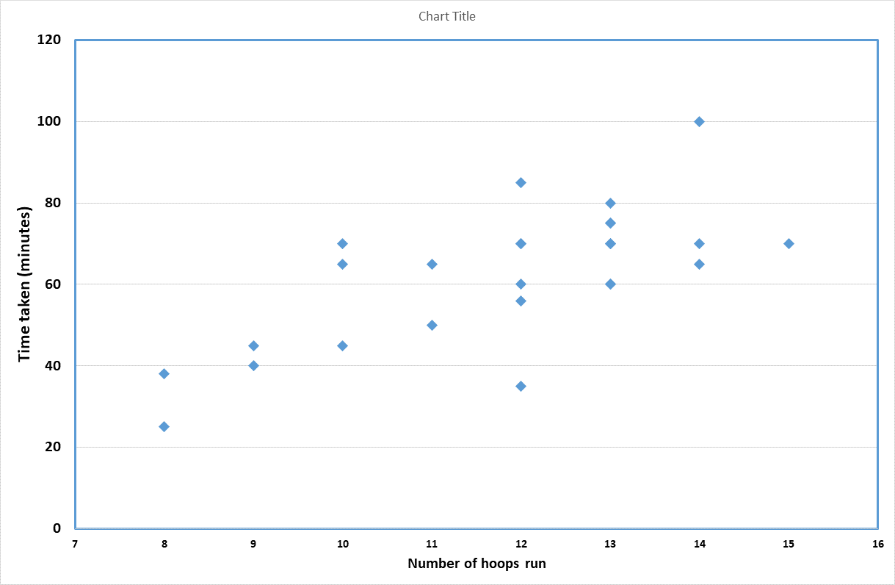Peter has pointed out that the average time for an AGC game may be similar to that for an ES game, but the standard deviation may be greater.

I have no data on this except for the 26 St Agnes results sent to me by Andru. 73% of the games went over 50 minutes, 58% over an hour and 12% over 75 minutes. Some of this may be due to delays caused by the unfamiliarity with the system, but it certainly implies that there were some long games.

This shows how the time correlated with the hoops.

Roy Tillcock’s email to Tony warns us that, “*If it is decided to try AGC either in parallel with or instead of ES it is important not to bias results by using too wide a handicap difference in either game/league*”. We don’t “use” wide handicap differences, they are simply a consequence of our league structure.

Although his look-up table seems well designed, I don’t like the idea of having to refer to a card to find out how the game’s going.

He also points out that “*It is not intended as a replacement for ES which is an entirely different game*.” It is being used as a replacement for ES by the CA but this doesn’t mean that we have to follow suit.