Welcome to this end-of-season issue of Cygnet – by the time you read this many of the club competitions will be over, the winners admiring their silverware and others reflecting on how to do better next year.
Contents

AGM p1
Short Croquet Handicaps p1
Ray Bartlett Remembered p2
GC Inter-Counties p2
WCF World Championship p4
GC Federations Shield p5
PHC Mallets (advert) p5
Writing Corner p6
Reading Corner p6
CA Club Awards p7
Coach of the Year Award p7
Lifetime Coaching Award p7
Moreton in Marsh p8
Mallets Please p9
Want a Mower? P9
Website p9
Advertising p10
Diary Dates p10
Appendix 1: p11
- AGM Nominations and Proposals

Those of us lucky enough to enjoy playing through the winter will be looking forward to winter competitions and friendly games.

Maybe you have some of your own ideas on how these can be run – do share, we’d love to hear them.

Next time we’ll be reporting on all the League finals but in the meantime catch up on what’s been happening in the last couple of months – and don’t forget our forthcoming AGM.

AGM reminder
All clubs will have received initial information about our AGM which will be held on 20th Nov 10.00 by Zoom.

Any nominations for SWF Committee or for Proposals for discussion must be submitted by your club committee by 9th October. See Appendix 1 for further information.

Short Croquet Handicaps

A timely reminder for us all from John Grimshaw:

It has recently been brought to my attention that some players maintain that SC handicap cards are irrelevant, and are using the AC-SC conversion every time to arrive at their handicap. THIS IS NOT CORRECT.

It is true that if a player has not previously played competitive SC, then the initial handicap is derived from the AC conversion. However, thereafter the index on a SC card should be adjusted by +1 or -1 according to the result of an SC game. The SC handicap is adjusted, up or down, when a trigger point is reached in the same way as AC or GC handicaps.

There is one exception in SC however. If a player's AC handicap reduces, and the conversion from the new AC handicap is below the existing SC handicap, then the SC handicap must be adjusted also. There is no adjustment made if an AC handicap increases.

These are the correct procedures as determined by the Croquet Association and should be adhered to.

John Grimshaw
Ray Bartlett 1939-2022

Many members will remember Ray and this fitting tribute will remind us all of the spirit that pervades our wonderful game.

Ray sadly passed away in July after a long battle with cancer. He was a member of the Dowlish Wake Croquet Club for many years which is a small village club near Ilminster in Somerset. It is well known to many league players from the South West Federation for its suburb location and excellent pavilion even though the lawns have a little bit of a slope!
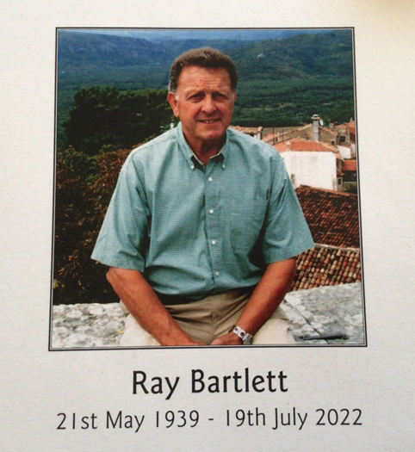
Ray was mostly around 5 or 6 handicap and a regular winner of in-house competitions and an important member of one of the club league teams. Ray came from a farming background and later became an agricultural sales representative visiting farms all over the south west. When traveling to league matches he could be relied upon to give a near continuous commentary about the farming families for many of the farms we passed on the way much to the amusement of his traveling companions!

Ray was also a committee member for many years and a real stalwart when it came to doing things. He could be relied upon to clean, overhaul and paint our equipment during the winter months as well constantly seek to improve our lawns often doing a lot of the work himself as well as organising our small white lining squad.

We submit this tribute to Ray to mark the huge contribution he made to our croquet club but also as a celebration of the many people all over the country who, like him, are the backbone of our wonderful croquet clubs.

Tony Carter

Devon and Somerset County teams promoted to Division 1 in the GC Inter-Counties

Thanks to Louise Smith for this report:

The Devon County team, newly formed in 2020, have gained promotion to the GC Inter-Counties Division 1 in 2023. The 2022 fixture was held at Sussex Croquet Club in Southwick, 20/21st August, with Division 1 teams playing at Cheltenham Croquet Club. The two Divisions currently rotate every second year to the alternative venue.

Devon’s team consisted of four Players meaning all competed in every match, which consists of round 1: one doubles and two singles games, followed by four singles games in round two, which are played against each players’ opposite or nearest grade, depending on the pairings in round one. A match therefore consists of the best of 7 games.

Devon’s top two strongest players have healthy pedigrees - Stuart M. Smith (Captain) is an England International, member of the GC Elite Squad, and winner of the Shield in the recent GC Word Championship, and James Goodbun is a former England U21 player and winner of the GC National Singles Championship (Ascot Cup). Philip Harris and Louise Smith both from Sidmouth Croquet Club completed the line-up, both seasoned GC competitors in Open and Championship level tournaments.

Somerset with a contingent of six rotating players proved a strong side and were previous champions in Division 1 in 2019. In the 2022 Division 2 tournament, good tactical Player choices and confident play saw Somerset to victory with an impressive full house of wins. Devon narrowly missed the top spot losing to Somerset 3/4, giving Devon 2nd place with 5 wins from the 6 qualifying matches.

The top two teams are promoted to Division 1, with the two bottom teams from Division 1 joining Division 2 the following year – Division 2 will gain Glamorgan & Oxfordshire in 2023.
So, many congratulations to our neighbouring county Somerset on their success, and to the Players of the Devon County team on gaining promotion – onwards and upwards!

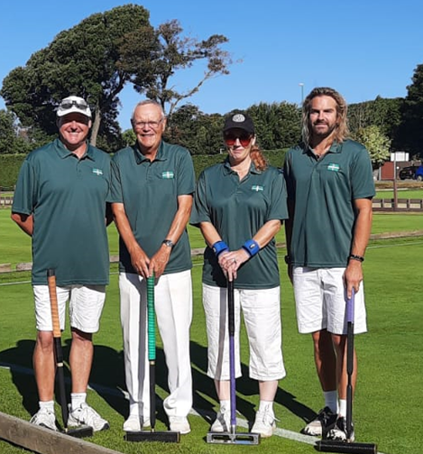
Winners, whichever way you look at it!
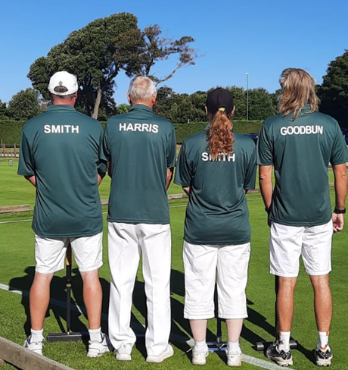

Note from the Devon County Manager

We are interested in developing the county squad, the eligibility criteria are:
- Born in County or parents born in County
- Permanent resident in County or previous residence in County
- Main club is located in County
- Played for county in previous three years

If you fulfil any of the above and are preferably a scratch player or below, please contact me for further details. We would also be interested in hearing from developing players with future potential.
Louise Smith: mrsljsmith@outlook.com

WCF Golf Croquet World Championship, 2022
Louise writes again:

The WCF Golf Croquet World Championship was held at Sussex County Croquet Club, 30th July to 7th August with 64 of the top selected players from 22 countries invited to take part. Originally scheduled to be held in New Zealand, the implications of the covid pandemic resulted in England once again hosting the event, as in 2019.

The contingent representing England consisted of 20 players in total, with 4 being from the SWF region, Steve Leonard (Winterbourne Valley), Tim Jolliff (Budleigh), Jonathan Powe (Winterbourne Valley) and Stuart M. Smith (Budleigh).

Three of the four SWF regional players went forward, Tim Jolliff faced the recent GC British Open Champion Robert Fulford, and the draw co-incidentally pitched Jonathan Powe against Stuart M. Smith. Steve Leonard went on to win 3 games from 5 in the Plate Block, but lost to Chris Roberts (Wales) in the last 16 Plate knock-out.

Despite a close 2nd game, Robert Fulford beat Tim Jolliff 7/2, 7/6 and Stuart M. Smith beat Jonathan Powe, 7/3, 4/7, 7/5 and subsequently progressed to the main tournament last 16 knock-out.

At this point Stuart M. Smith drew the formidable opponent of Mohamed Naser positioned at 3rd in the world rankings. The match went to a third game, and Nasser went through to the quarter final.

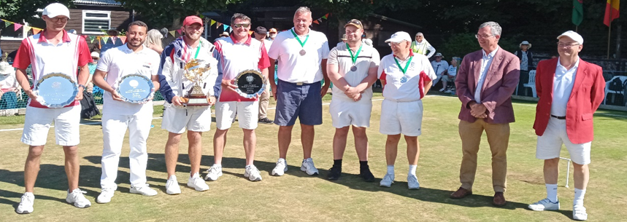

Photo Left to Right:

Aston Wade (England): Plate Winner
Karim Ghamry (Egypt): Bowl Winner
Matthew Essick (USA): World Champion
Stuart M. Smith (England): Shield Winner
Reg Bamford (South Africa): Losing Semi Finalist
Robert Fletcher (Australia): Losing Semi Finalist
Robert Fulford (England): Runner -Up. (Losing finalist)
Ian Burridge: WCF Chairman
Mike Town: Tournament Manager

Stuart M. Smith went on to play in the Shield play-offs which he won.

This was a terrific achievement from a player ranked 43rd out of the 64 players at the onset of the tournament and winning the Shield to finish in 9th place overall in his first World Championship was a proud moment in Stuart’s short playing career.

GC Federations’ Shield

Thanks to Keith Bryant for this report.
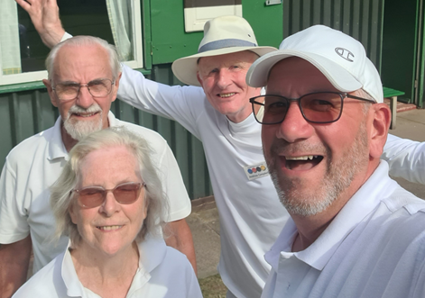
Teams from Dowlish Wake and Southport met half way geographically at a neutral club to contest the semi-final of the GC Federations Shield. Edgbaston CC were wonderfully hospitable, making both sides very welcome.
A slight change to the DW team saw Barbara Dean replace Mark Gooch who was unavailable for selection. She was joined by Keith Bryant (C), Andrew Campbell, and Richard Gardiner.
Dowlish won the only doubles but Southport took both singles rubbers in the morning session, albeit they were pushed all the way by Richard & Andrew. Four singles rubbers were played in the afternoon so all was not lost. Both Andrew & Richard won their best of three rubbers in quick time, each winning two games without reply.
The final two rubbers were contested on the same lawn, with Keith on Primaries and Barbara following on with secondary colours. It was a tough watch for those who could do no more. The pressure was finally released when Keith won his second tight game giving Dowlish a well-earned 4 - 3 win.
The final against Enfield is at Swindon CC on Friday 30th September – note this has been re-arranged because of The Funeral.

Writing Corner

And on the subject of match reports …

We welcome articles about all sorts of events and personal successes in the South West and despite a number of tournaments held in the region each year, we hear virtually nothing of them in Cygnet or indeed in the Croquet Gazette.

Surely this is a missed opportunity to share the trials, tribulations, fun and personalities and encourage players to take part in croquet life and in more competitive play.

For example, Roger Mills (Sidmouth CC and Coach extraordinaire) came across an excellent article in an ancient Gazette which is an amazing read: http://www.bristolcroquet.org/croquet/bristol/images/historic/Gazette214.png

And Louise Smith’s (Sidmouth CC) GC report on p 23 of the June CG was an entertaining and informative read. It’s only available online to CA members at the moment but will be open access if a few weeks. https://www.croquet.org.uk/?p=members/gazette&Action=Issues

Reading Corner

There is a lovely little book in Bristol CC’s club library recently. “A Rush on the Ultimate” – a very easy-read murder mystery. Set in the early 60’s, the story revolves around the annual family croquet tournament. The weapon is a croquet mallet but who dealt the fatal blow leaving no fingerprints or clues?

Do overcome the feeling this is all a bit stereotypical – the characters, not the perception of croquet – as the writing is lovely and a bit quirky.

The author is H R F Keating, who I’d never come across but was in fact a well-respected and prolific crime writer in his day.

The final 5-line paragraph furnishes a beautifully satisfying peg-out.

Apart from the coaching books, have you come across any good reads? Do let us have your recommendations.

Just how well-read are you?

Do you recognise the author of this quote or the book in which it appeared? Answer in the next issue of Cygnet.

The Lord Chancellor of England was a small, fat, ugly man with steel-rimmed spectacles which gave him the schoolboy look which led to his nickname 'The Owl of the Remove'. He was given to fits of teasing when he would laugh aloud at his own jokes and unpredictable bouts of biting sarcasm during which he would stare at his victims with cold hostility. He had been, for many years, the captain of the House of Lords croquet team, a game in which his ruthless cunning found full scope.

CA Club Awards 2022

CA Club Awards are made at the CA AGM and beside a trophy and a certificate, a prize of £250 is given to each winning club. The CA makes awards biennially in three categories to clubs that have made exceptional progress in club development over the previous two years:

- The Townsend Award is given every two years to a club with one or two lawns that has, in the opinion of the Sport Development Committee, made exceptional progress in club development in any of two of the previous three years.
- The Apps Heley Award is given every two years to the club with three or four lawns that has made most progress at a national or local level in any of two of the previous three years.
- The Millennium Club Award is given every two years to the club with five or more courts that has made most progress at national or local level in any of two of the previous three years.
To apply for any of the Awards contact your Federation Development Officer for further information and an application form. The CA Sport Development Committee will consider nominations at its October meeting and will use the following criteria.

- The nominated Club must demonstrate evidence of significant and exceptional improvement in player numbers, playing environment, or infrastructure development.
- Evidence of self-help will significantly enhance the nomination.
- Evidence that the club has progressed with the CA priorities e.g. increasing the number of AC players as well as GC playing competitive croquet; and increasing the number of qualified coaches and referees within the club will enhance the nomination.
- Pictorial evidence will enhance the nomination.
- Not a recent winner

The closing date for submission to your Federation Development Officer is Friday September 30th.

The results will be announced in the Croquet Gazette and on the Website. The Awards are presented at the following AGM.

Nominations invited: Coach of the Year 2022 and Lifetime Coaching Award

The Coach of the Year and the Lifetime Coaching Award are prestigious awards that are made to CA Graded Coaches who have shown a significant and above normal contribution to coaching. Guidance criteria include:

- Has shown dedication, innovation and enthusiasm in expanding knowledge and skills of the game.
- Carries an endorsement from Federation Officials, National/International players, or club committees.
- Has a significant length of service as a coach.
- Has made a particular contribution within the relevant playing season.
- Is recognised as helping individual players, a group of players or a team achieve significant success.
- Has led a successful reorganisation or development of coaching that has reached a number of players.
- Has dedicated significant time and expertise to producing a widely-used CA coaching asset, such as a manual or technique.

The Lifetime Coaching Award is awarded only once to anyone, whereas Coach of the Year may be awarded again after at least five years have passed.

The Lifetime Coaching Award encompasses additionally:

- A sustained contribution over a number of years.
- The candidate is widely recognised as having made a significant contribution to coaching in the domain throughout that time.

These criteria are for guidance and the candidate would not necessarily have to fulfil all of them.
The Coaching Committee will be considering all nominations at their next meeting so if you know of a coach you consider worthy of either of these awards, please send their name, together with a suitable citation to Paul Francis by 31st October 2022: paulwfrancis@icloud.com

Moreton in Marsh

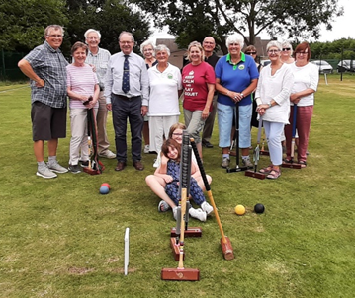
The club enjoyed a visit from their local M.P. Geoffrey Clifton-Brown who entered into the spirt of the game of Croquet at Moreton in Marsh, and also praised our Fund raising for a Croquet Club house, and will do his best to help with our
fund raising.
Gordon Gill.

And you’ll be delighted to learn that Moreton in Marsh achieved their target – we’re all looking forward to watching the progress of this ambitious project.
Thanks to everyone who supported them in this.

Mowers

Clive Sawers, Budleigh Salterton CC, has some mowers he’d like to see being put to good use. Contact him direct if you’re interested: clivesawers@aol.com

“The main one is a 61cm Ransomes 10 blade machine with a new engine which I bought and paid for including the engine.

I also have two 12” push mowers. One is a Ransomes Ajax and the other a Web 8 blade machine. I used to use them for mowing before lining the boundaries and as emergency backup.

I am more interested in seeing the mowers go to a good home than trying to recover the money spent although the large petrol machine ought to be worth something. Each mower has a grass box.”

Worcester Norton CC would love your surplus mallets

Chris Dunn would love to hear from you if you can help:

In the past year we have been able to organise several corporate events but because of the popularity that we have encountered and the small reserve we have, participants have had to share the mallets which is not ideal in promoting the sport fully.

We are also looking to set up a junior section within the Club next season to attract a younger member base. But to do this we need the added equipment. We obviously have everything else to furnish the lawns and balls to play with but lack the essential quantity of mallets to give everyone attending a fair crack of the whip.

We are calling on all our friends in the South-West Federation to see if anyone has any surplus reasonable quality square faced mallets that we could buy. It would be great if we could get 10 mallets, but any would be appreciated. (If, by any chance, anyone wishes to donate to our cause then that would be fantastic!).

If you can help, please contact me direct on chrisdunn49@live.co.uk or by mobile on 07854266693. Collection could be arranged if distance reasonable.
relating to croquet? Do share.

Website revamp

We have asked Alison Maugham to make some changes to how our website is set out and it should now be easier to navigate. Thank you Alison.

In particular we’ve reorganised information about our grants and policies so under the ‘Info for Clubs’ tab you will find

- Zoom meetings
- Press Liaison and Coverage
- Handicaps
- Coaching
- Cygnet
- Funding
  - Development Grant
  - Qualifications Grant
  - Judith Moore Bursary
- Policies
  - Constitution
  - Committee Roles
  - Expenses
  - Privacy
- Committee Minutes Archive

If you have any suggestions for improving the website, please let us know – particularly if you have some IT skills we could put to good use.
Advertising in Cygnet

All adverts must be sent fully formatted in such a way as they can be easily inserted (copy and pasted) into Cygnet. We are not in a position to undertake any artwork or correct for errors or omissions.
Charges include a 2/3-line entry in the Diary Dates column in up to three subsequent issues.

Charges
Full Page: £12 Half Page: £6 Quarter Page: £3
Diary dates column

4th / 5th October: Open Short Croquet Tournament at Budleigh Salterton CC
Contact: toursec@budleighcroquet.org with Open Short Croquet as subject heading

Appendix 1

SWF AGM 20th November 2022

Call for Proposals for consideration by the AGM and Nominations to Committee

The deadline for receiving proposals and nominations is 9th October 2022

Amongst the purposes of the AGM are:

- To consider proposals presented by member clubs or the SWF Committee
- To elect the committee for 2022 - 2023

Please see our Constitution for full details: https://www.swfcroquet.org.uk/constitution/

The official notice of the AGM will be circulated by the by 23rd October and will include the agenda, all proposals, all nominations and further details about the event which will be held by Zoom.

The application form to enter SWF League AC and GC events will also be circulated then.

Proposals for consideration by the AGM

- A proposal for inclusion in the Agenda of the Annual General Meeting may be presented either by the Committee or by a member-club (duly signed by its Secretary or delegate)
- Proposals to the AGM will not be tabled if they were considered in the previous AGM.
- Please include the following information:

- Name of Club
- Proposal
- Rationale
- Name and contact details of club secretary

Nominations for Committee

We are looking for enthusiastic, skilled and reliable people to join the committee in a number of roles and would particularly love to hear from people in clubs not currently involved in the Committee.

Our constitution states:

- The Committee shall consist of up to 12 persons to be elected annually comprising Chair, Secretary, Treasurer, League Secretary, Development Officer (candidates to be directly elected to these positions) and up to 7 other people.

When completing the application form, please state which role you are standing for. If you are standing as a General Member, please state your particular area of interest or expertise e.g. coaching, handicapping, lawns management, IT.

To be eligible to stand you must be a member of a fully paid-up Full Member Club. If you are not sure – ask your club committee, check out our website www.swfcroquet.org or email lindawithani@hotmail.com

Please use the form below or ensure that all the requested information is provided in an email or letter.

SWF of Croquet Clubs: Nomination for Committee
Name of nominee
Please state the role/s they wish to be nominated for
Proposed by | Name
 | Email
 | I am an officer of – please insert name of club and position held
Seconded by | Name
 | Email
 | I am an officer of – please insert name of club and position held
Consent to nomination | Name
 | Email
 | I am a member of – please insert name of club

Please send any queries, completed proposals and nominations to:

SWF Secretary
Linda Shaw
lindawithani@hotmail.com
21, Grove Avenue, Bristol, BS9 2RP

They must be received by 9th October 2022

