Contents

League Play p1
Judith Moore Bursary p2
Development Matters p3
The Bears p3
Swindon Spree p4
Coaching p4
Safeguarding p5
Camerton & Peasedown 64 - advert p5
CA News p6
Bisques Calculator p6
PHC Mallets – advert p7
Advertising Rates p7
Appendix 1: The Bears Inventory p8
Appendix 2: Dress Code p8
Well, we’re nearly there – days are longer, sap is rising and we’re all gearing up for another season. Lawns are being prepared, club houses Spring Cleaned, club competitions organised, for open days and beginners’ courses scheduled - League match dates have been arranged (https://www.swfcroquet.org.uk/ and click on the Leagues tab) and the CA Fixtures list has been published. All evidence of a very busy winter.

So, you owe yourself a few minutes relaxation to digest this edition of Cygnet over a cup of coffee and a custard cream.

The minutes of the SWF Committee meeting are now on the website (follow the link on the Home Page). The Committee next meets on 24th March so do let us know of any issues you’d like to see raised.
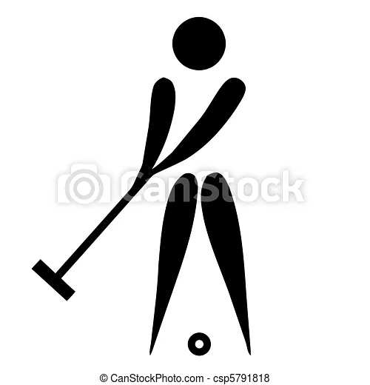
League Play

Matches

Yes, everyone is geared up for action and League Match dates have been arranged - https://www.swfcroquet.org.uk/ and click on the Fixtures tab. This represents an amazing amount of work and co-ordination, so well done everyone.

Rules

And before you start playing, Team Captains should be aware of the updated League Rules and have access to a copy during a match as it’s not unusual for doubt to occur. They may be found on https://www.swfcroquet.org.uk/ - click on the Leagues tab.

Please note that these are different from those posted following the AGM as a phrase was omitted at that stage relating to AC Appendix 5. It concerns Short Croquet and states:
“This does not alter the requirement, in the Restricted Short Croquet League, that at least half of the games played by each team must be played by players with Short Croquet handicaps of 6 or above.”

Advantage GC

We enjoyed a really informative session on this at our January Zoom. Chris Roberts answered loads of questions and we sent several more on to him. His commitments mean he has been unable to get back to us on these and we have therefore refrained from sending out notes of the meeting.

Rest assured we will not let this drop and will complete the write up when we receive his answers.

We are not adopting Advantage GC for 2022 for SWF League Play but will continue to monitor developments, clubs are free to make their own decision in respect of club competitions. So, all GC Handicap League matches will be played using extra turns as usual.

Dress Code

We were asked whether players were able to wear club colours when playing in Matches. This is covered in the CA Tournament Regs – see relevant section in Appendix 2 - and we have nothing further to add!

Short Croquet Tournament

The Spring Tournament takes place at Nailsea from 8th – 10th April this year. There are 25 entries so far but John Grimshaw is happy to take additional entries so it’s not too late to take part in this extravaganza of a start to the season. You should note that teams enrolling now would be playing on Friday 8th April.

Please contact John direct if your club would like to take part - johnandjulieg@talktalk.net

Judith Moore Bursary - financial support for competitive play

As the season begins and we’re planning our competition entries, it’s a good time to be reminded of this excellent source of support. Generously established by Peter Moore in his wife Judy’s memory, it provides financial support to players entering the world of tournament play:
It was a particular desire of Judy’s that new players should not just relax into social play at their clubs - they should engage as soon as possible in serious tournament play, the heart of croquet. She believed that croquet players should support the CA and should play outside of their familiar settings to strengthen not only their own play but to develop their appreciation of the wider world of croquet – new chums, new tactics, different ways of running things – and indeed of the wider world.

Full details and the application form may be found here https://www.swfcroquet.org.uk/swf-bursaries/ but basically anyone entering their CA Fixtures listed first, second or third tournament may apply for reimbursement of the Tournament entry fee as long as they are a member of a club which is itself a member of the SWF.

Development Matters

Onward and upward

Our February Zoom looked at several issues including quality standards and linking these to club improvement and funding.

If you haven’t received it already, the notes of this meeting will be circulated shortly – but if any club would like to discuss this further or would like some third party support, you should contact Paul in the first instance.

Crowd Funding

You may have already seen this from Lionel Tibble at Northampton, but Bristol’s Chris Frew brought it to our attention:

You may be aware that Northampton Croquet Club intends to relocate to new grounds in 2022 at Roade village, building 2 new lawns in the short term and expanding to 4 within a few more years. Take a look at the video and information on the link and you will find out more about our development plans. https://crowdfunder.co.uk/take-off-to-roade

This could well be an avenue other clubs would wish to explore so check it out. And of course if you’d like to support Northampton, you can do so: https://northamptoncroquet.org.uk/supporters/

Lawns

Dennis Mowers are offering local roadshows on lawn care and their equipment. If there is sufficient interest, we can organise one for our area – please let Paul know.

Zooming in

The next two Zoom meetings will be held on Tuesday 8th March and Tuesday 12th April at 7.00pm. We plan to include discussion on new GC Rules, our Coaching Programme and Handicapping. Do let us know of any issues you’d like discussed.

The Bears

Sadly, The Bears Croquet Club will be dissolving – they find themselves in an unsustainable situation but it sounds like nearby clubs will be enjoying an influx of ursine players, so the skills and talents are not being lost to the region.

They also have a wide range of croquet equipment they would like to offer to other clubs. The list may be found in Appendix 1. Please contact the club direct if you’re interested in any of these.

Seasonal Swindon Spree

There was an impressive turnout for the inaugural Tinsel and Sausage Sizzle Tournament at Swindon Croquet Club in December. Members, resplendent in festive hats and outfits, enjoyed several games of Golf Croquet in calm, mild conditions.

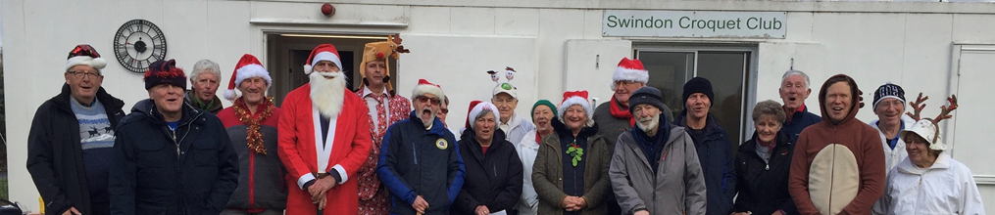

The doubles games were keenly contested but the emphasis was definitely on everyone having a fun day’s play. In between games, competitors were treated to (non-alcoholic) mulled wine, chocolates, mince pies and sausage hot dogs with onion relish and various sauces.
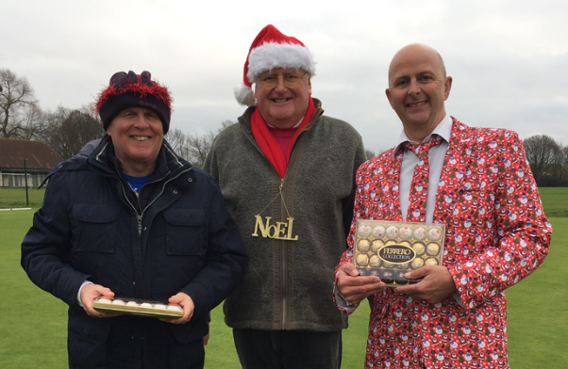
Colin Bailey, David Acheson, Sandra Jerram and Martin Briggs progressed to the final with the pairing of Colin and David securing victory. They were presented with their prizes by Chairman Clive Smith.

As always, Chairman Clive Smith organised the event with a very high level of efficiency and his wife Sharon did a superb job, preparing and serving all the refreshments. All competitors expressed gratitude regarding their efforts and assisted with setting up the event, serving food and drinks and clearing up. The tournament was a roaring success so it is likely to become a regular, annual event.

The Club is always keen to recruit new members, limited play continues through the winter months so, if you are interested in giving the game a try, please email swindon.croquet@outlook.com as free trial sessions are available in the new year.

Coaching

New Regional Coaching Officer

Having worked closely with Roger Mills last year over our highly successful Club Coaches programme, Paul now represents the SW on the CA Coaching Committee. Roger will remain an active contributor to the development and delivery of this year’s programme, so we are really fortunate to benefit from their talents.

They are working hard on this year’s programme and we’ll let you know what’s happening with this as soon as we can.

Paul remains our Regional Development Officer and will be supported in this role by other members of the Committee.

New CA Coaching Manual

A more extensive version of the 2006 version has been produced focussing on beginners. It includes thoughts on working with players from different backgrounds and has lots of ideas for spicing up the sessions to make them more fun.

It may be downloaded from: https://www.croquet.org.uk/?p=/games/coaching/resources under AC Coaching Resources.

Safeguarding

Andru Blewett has taken on the role of Federation Safeguarding Officer which Paul had been doing on an interim basis.

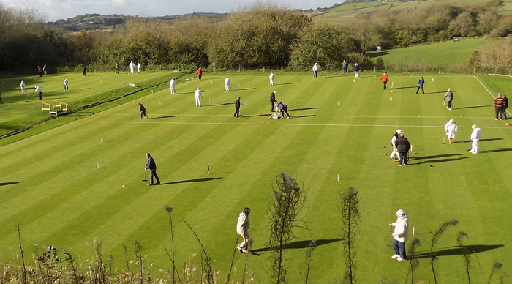

Camerton & Peasedown Croquet Club
invite you to their
64 Challenge
Sunday 8th May 2022 10:00- 4:00
To enter, contact Trish Naish by 3rd May
07885 912723
Patricia.naish@hotmail.com
£15 per player to include lunch
(£10 for CPCC members)
GC progressive doubles format
Please advise Trish of any specific dietary requirements

What’s the CA up to?

Legal structure

Brian Wilson – one of the region’s reps to CA Council tells us that we should be expecting further information on the CA’s work on the organisations’ new legal structure.

As a result of this, several clubs are questioning their own legal status and thinking what is the best structure for them. As a result, East Anglia Fed are holding a seminar on the topic. If there is sufficient interest, we could certainly run one here – do let us know if this is on your radar and we can get it sorted.

New GC Rules

According to our sources, the 6th edition of the rules should be on the WCF and CA websites in early March with the booklet appearing later in the month, printers permitting. The GC Rules Committee will be developing some training material.

Stephen plans to go through his six Zoom talks and identify where the changes are so that he can give a revised version, probably in a single talk. Unfortunately, we won’t know what all the changes are until they appear on the website as two were left as ‘consultation’ items and others may have changed since the draft version.

So, keep your eyes peeled for further news.

Astounding Bisques Calculator

Brian Wainman is a Plymouth Croquet Club member and has worked out a way of stopping us scratching our heads over what can be complex calculations or conversion tables when trying to work out who gets what in terms of bisques and extra strokes. He writes:

I’ve devised a simple to use website which calculates the number of bisques / extra strokes / change in index for all GC / AC / Short /1-Ball games and their variations.
It allows the user to select for

- all the different game lengths
  - GC: 7pt, 13pt & 19pt.
  - AC: 14pt, 18pt, 22pt & 26pt
- single or doubles - yes, it even calculates the extra strokes for GC Doubles
- handicap or level play
  - yes, it calculates the change in index for level games
- different lawn sizes and other variations like GC Advantage and AC York Variable Base
The idea is that any player can use the website (on their smartphone) just before they start their game to get the right bisques / extra strokes without the need for all the tables / rules in the law books.

It doesn’t need any instructions to use, but just select the type of Croquet first (AC/GC etc) as this resets the handicap ranges, select the players’ handicaps, and then press calculate to get your answer.

The website address is https://chc.eu.pythonanywhere.com - there is also a link from the WCF web pages.

I’d be really interested to receive feedback from players and I am happy to add other popular variations if required. Do contact me: wanderingwainmans@blueyonder.co.uk

Advertising in Cygnet

All adverts must be sent fully formatted in such a way as they can be easily inserted (copy and pasted) into Cygnet. We are not in a position to undertake any artwork or correct for errors or omissions.
Charges include a 2/3-line entry in the Diary Dates column in up to three subsequent issues.

Charges
Full Page: £12 Half Page: £6 Quarter Page: £3

Appendix 1: The Bears Croquet Club – Inventory of Assets

Please contact Richard Way if you’re interested in any of these items: richard.way@btinternet.com

Set of Davidson hoops (SWF)
Set of “Our Time Ltd” bolted hoops (SWF)
Miscellaneous old hoops (SWF)
Set of Dawson 2000 balls (primary colours) (SWF)
Set of Dawson 2000 balls (stripy primary colours) (SWF)
2 centre pegs (SWF)
6 plastic chairs
Scotts Easygreen rotary spreader
Brace and bit (for drilling hoop holes)
Car jack
6 copies of “Plus One on Time”
First Aid kit
Pair of hoop gauges
Broom
Plastic rake
Shovel
Set of hoop-related ground fittings
String
Folding table

Appendix 2: Dress Code

https://www.croquet.org.uk/?p=tournament/regulations
- ATTIRE.
  - In all events, flat-soled footwear, without significant ridges or sharp edges, must be worn on the courts and, unless otherwise permitted, predominantly white clothing should be worn. Recognised international croquet team clothing, of a country that the player is eligible (under WCF Regulations) to represent, is permitted.
  - In team events, such as the Inter-County Championships and Inter-Club events, teams may, subject to any dress code of the host club, elect to wear other colours of clothing, provided all team members (other than those wearing white) are wearing the same design.
  - Variations to this policy are to be agreed by both the Organising Body and the Host Club.

