Welcome, from the Chair
Enquire within:

Welcome from the Chair p1
Feedback from the AGM p2
Finances
Catering
Remembering Chris O’Gorman p3
Coaching p4
Leagues 2022 p5
National competitions
Planning ahead p6
Zoom p6
Stormy weather p7

Welcome to the last issue of Cygnet for 2021. Let’s start with a message from our new Chair, Tony Mayer.

“At the Federation AGM in November, I was honoured to be elected as the new Chair of the Federation Committee. I am following Brian Wilson whose term came to an end at the AGM.

However, Brian is staying on as a valued member of the Committee, combining this with his new role as one of the three South West area representatives to the CA Council. The other representatives are Dave Kibble and Peter Nelson who is the Vice-Chair of the Council.
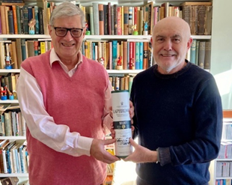
Brian has led the Federation for the past three years, two of which have been unprecedented in their difficulty as we have all had to grapple with COVID. I want to thank Brian most sincerely for his leadership during this difficult time.

In the photo, Brian (L) receives a well-deserved tipple from Paul – he’ll deserve it even more as a rep to CA Council!

The other members of the Committee who were re-elected are Linda Shaw, our super-efficient Secretary, Paul Francis who now chairs the CA Development Committee and is the technical expert behind all our monthly Zoom meetings that we run for our Clubs, Stephen Custance-Baker, who does a great and complex job in planning and managing our Leagues, including the introduction of the new Short Croquet Leagues, Peter Kirby, the Treasurer whose financial expertise is a key to our operations and Andru Blewitt, our second member at large and who provides valuable insights from his Cornish perspective.

Actually, we still have some committee vacancies and a number of key tasks which need to be covered including upgrading and maintaining the web-site and helping with social media and other Federation communications.
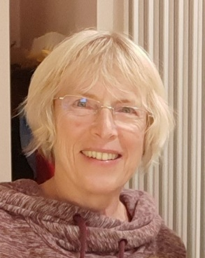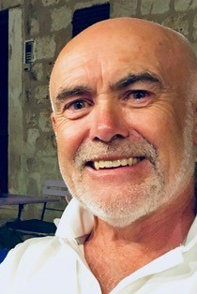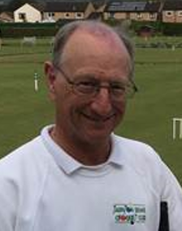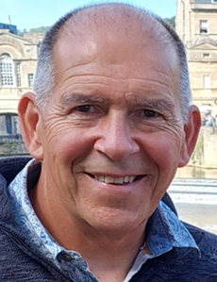

Linda Paul Stephen Peter Andru

I am especially keen to ensure that we have a good representation from across our region which stretches from the Gower to Poole and from Land’s End to Moreton in Marsh. Given that croquet is one of the very few sports where men and women compete on an equal basis, we really do need more women on the committee so I hope that we can achieve gender equality on your Committee. So, everyone, please help us in running the Federation for the benefit of everyone in our region.

I look forward to seeing you at our monthly Zoom meetings and especially on meeting as many people as possible on the croquet courts.

I wish everyone a Merry Xmas and a Happy (and especially) Healthy New Year”
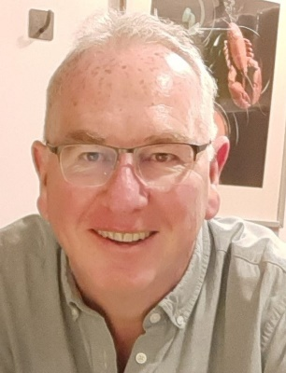

And just to remind you,
the other SW Reps to CA Council are Peter Nelson (Vice-Chair of Council), on the left
and Dave Kibble, on the right.

The AGM

Twenty-two clubs and the SW’s three reps to CA Council enjoyed our Zoom AGM in November. The technology worked well though there was a bit of confusion about the voting at one stage, but a bit of patience and co-operation meant we were able to resolve that – and a useful lesson learned for next year.

The minutes of the meeting are now on our website along with the updated Constitution and League Rules. Plenty of time for League Team Captains to become familiar with them for next season.

Finances You may recall at the 2020 AGM we said we wanted to reduce our reserves which are quite high in relation to our turnover and that we’d be doing this by reducing fees for a few years which we are doing. We were asked at the 2021 AGM to consider this again and look at possible alternatives.

We did this at our recent Committee meeting and have decided not to introduce any new measures at the moment. This is in part due to the fact that any new scheme would need managing and we just do not have the capacity to do this.

Also, we are planning to continue to offer local coaching / training, and the cost of this can be offset at least in part by our reserves.

However, if anyone has any good ideas, and has the capacity to manage these, we’d love to hear from you.

Catering arrangements at League Matches has been a concern for several clubs. These have evolved over the years and have always been in the hands of the clubs involved. I remember when the norm was for teams to bring their own packed lunch then host clubs provided tea, sandwiches and cake at the end of the day. This seemed to fall out of favour as it made a long day and increasingly lunches were provided by home clubs with a cup of tea and maybe a slice of cake to see the Away team comfortably on its way.
Clubs who are well-endowed with facilities and caterers enjoy laying on a bit of a spread, but clubs with neither of these, expressed concern that they cannot reciprocate and many clubs feel pressurised into coming up with the goodies – sometimes it’s hard enough to come up with a team!

And then there are special diets, allergies and food hygiene issues to think about – it’s amazing the caterers don’t bury their heads in the soup!

The SWF has never made a ruling on this and still feel it is not our place to do so. What we would say is that the point of the day is to play croquet and to be sociable. It is perfectly possible to achieve this when people take their own lunch.

We therefore ask all clubs to be sensitive to all the issues and agree the arrangements with their opponents. We know of one club whose committee has made a policy decision neither to offer lunches to visiting teams or to accept lunches as an away team.

We remember Chris O’Gorman

Chris O’Gorman died peacefully following a major Stroke on the 17th November 2021. Chris, wife of John O’Gorman, was a keen GC player and was greatly involved in the life of the Budleigh Salterton Croquet Club. Frequently serving behind the bar, and watering the hanging baskets which were her pride and joy.

As you will see from the poem, written by Tim our son-in-law, she had a love of crosswords, doted on our granddaughters, gardening and cooking. Pay her a compliment and the reply would often be ‘one endeavours’.

One Endeavours

That was the reclining chair she sat in,
Spotting migrating birds in Latin,
Asking how many players in Lacrosse
To complete that dastardly eight across,
And despite a Yorkshire dialect so strong
Another Earl Grey was brought along.

The crossword is so nearly done,
I suppose I could let John do one,
Although the garden looks pristine
There must be a weed I haven’t seen,
And if there isn’t I’ll be off to lawn seven
To ensure the borders are the pride of Devon.

Then pots and powders in a room of scents
Conducting the girls experiments.
Why does this one float but that one sink?
Why does the liquid turn bright pink?
What a lot we’ve learnt, it deserves a clap
And a cuddle and stories on Grandma’s lap.
To mark rich memories in their making
The kitchen a whir with feats of baking.

Then with a consummate lack of fuss
The cork is popped and “here’s to us”,
For tonight we can order battered chips
And reminisce on all our O’Gorman trips,
Recollections too vivid to ever weather
For whatever happens “one endeavours”.

Coaching

Inspired by our successful Club Level Coaches’ training this year, we’re thinking about next year’s programme and in particular we’re asking

- Are there any clubs out there without a Club Level Coach
- How many Club Coaches would like to achieve a Graded Coach qualification
- Who would be interested in becoming a Referee or Assistant Referee
- Would you like an update on GC Rules
- Would you like an update on AC Laws
Please let Paul Francis know if any of these applies to you - paulwfrancis@icloud.com

And while we’re talking about Laws and Rules

- the World Croquet Federation is consulting on changes to GC rules and this may be accessed at https://worldcroquet.org/gc-rules-6th-edition-consultation-draft-published/
- Staying with GC, Stephen’s excellent series Know the Rules is also available on line https://www.youtube.com/playlist?list=PLn9vkerUOhypup4mEw6kO9or1tW4Uof88
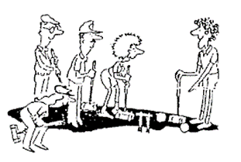
- You might also like to visit the GC Coaching section of Taunton Deane CC’s website www.tauntoncroquet.org/golfcroquet At the foot of the page you will find a series of slo-mo videos from Stephen showing exactly what happens in a range of strokes – Stephen would welcome feedback on these
And with regard to refereeing – we often struggle for refs at League matches but do we realise that CA tournament regulations only require qualified refs at Championships. At other events, the manager can appoint anyone with suitable knowledge and experience to undertake this role.

As so many games are self-refereed, it behoves us all to be familiar with the most common situations – Stephen’s course is an excellent start for GC and there is a useful section on refereeing on the CA website including a video by Tim King. https://www.croquet.org.uk/?p=games/association/refereeing

CA-run courses are advertised in their Fixtures List but if you’d like to see something organised locally, please let us know.

And finally, we will be running our handicapping seminar again in late February / early March – many of you will remember attending these a couple of years ago.

Leagues 2022
The Leagues are looking really healthy for next year with entries from 28 clubs and we’re particularly pleased to see Moreton in Marsh there for the first time.

The total number of teams entered is 131, compared with 111 last year. This breaks down into 51 AC (46), 18 SC (10) and 62 GC (55).

Stephen has formed the entries into 29 blocks, varying in size from 3 to 7. In all blocks with 3 or 4 teams, they will play each other home and away, giving 4 or 6 matches. Blocks with 5, 6 or 7 teams will play each other once, giving 4, 5 or 6 matches.

And the time required for the play-offs and finals has been reduced by

- Having no more than 4 blocks in any league, so that no quarter-finals are needed.
- Having just 1 week between the last date for semi-finals and the finals. It is unnecessary to have 2 weeks for this as the date and venue of the final is fixed, so no arrangements are needed.
Clubs have been notified of the following dates, but for general information: the finals are scheduled for the following dates at venues to be arranged

Saturday September 17th 2022 | Short Croquet (Open) | B League
Sunday September 18th 2022 | AC Intermediate | GC Level Play
Saturday September 24th 2022 | AC Federation | GC High Handicap
Sunday September 25th 2022 | Short Croquet (Restricted) | GC Handicap

The final date for the semi-finals, where required, will be one week before the final and the last date for block matches will be 2 weeks before the semi-final. Block matches must therefore be completed by:

Sunday August 28th | AC Intermediate | GC Level Play
Sunday September 4th | B League | Short Croquet (Open), which have no semi-final
Sunday September 4th | AC Federation | Short Croquet (Restricted),
 | GC Handicap | GC High Handicap
Sunday September 11th | AC Advanced League Divisions, which have no finals

And on the Short Croquet front, Nailsea tournament has received 24 entries and 29 for Budleigh. So it’s all looking good and plenty for John Grimshaw to get sorted.

National Competitions
Just so you can keep an eye on things and root for our local teams, we look forward to hearing good news from Dowlish Wake CC in the National GC Handicap and from Winterborne Valley in the Secretary’s Shield (AC) – good luck to you both.

Planning ahead

Winter is the time for curling up in the warm and planning for the year ahead – if you’d like to develop your club but are not sure where to start, then do contact Paul to sound him out. He’s very keen to support you and has a really good framework to base this on: Club Matters – so do get in touch.

Vroom, vroom Zoom
Our November Zoom included a really interesting discussion about encouraging competitive play outside of internal club competitions.

Clubs of all sizes are experiencing difficulty in entering teams for SWF Leagues for example. While the personal health and social benefits of playing croquet are really important, and make clubs fun places to be, clubs also want to encourage better and competitive play.

There were lots of suggestions on how to achieve this: gymkhanas, fun days with prizes, crazy croquet (whatever that is!), croquet on the beach (also attracts non-players).

Maybe a step on from this is to invite neighbouring clubs to join in the fun, or to build it into your recruitment process. We develop skills and exercise our competitive spirit and have fun at the same time. What else could we ask for!

But it might still seem a huge leap from this to a B-League or Short Croquet match. While travel and other responsibilities are doubtless some of the reasons people aren’t entering the Leagues, what else could it be and how can it be overcome?

What ideas do you have for developing peoples’ skills and enthusiasm and is there anything the SWF can do to help this happen?

And what a coincidence: Croquet Gazette 393 repeats on p2, words from the CA Chair 10 years ago: “… the CA aims to target its recruitment strategy at the more competitive type of player in the future.” It recognises the input of less competitive players to the life of clubs but argues this is not good for the future of croquet. I wonder how this article would be written today – any ideas?

And staying with Zoom – thanks to Alison Maugham who manages our website for adding notes of some of our key Zoom meetings – you can find them on the drop-down menu on the Information for Clubs tabs.

And Lynne Passfield at Bath CC has been doing her bit to promote croquet – listen to her interview:

Marquee and other goodies

Camerton & Peasedown CC are holding this marquee which belongs to the SWF but are very keen to pass it on to a club that might be able to use it. It would remain a SWF asset but if anyone can offer it a useful home, then please contact Brian. brian@europaassociates.co.uk

And as we’re sharing the goodies around, several new clubs are desperately short of mallets, so if you have any that are surplus to requirements, please let Paul know and he’ll find them a good home.

Stormy weather …

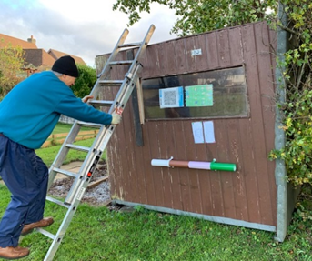
Excitement on Bristol’s Lawn 2 – enthusiastic members Susan King and Mike Chan were playing in the wild weather when the shed that was supposed to be sheltering them blew over!
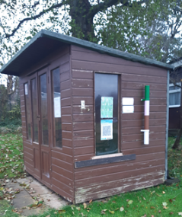
No one was inside and no one was hurt but it took a bit of creativity to rescue their bags.

Mike lives nearby so popped home to pick up a ladder – actually he had to walk as his car keys were in the shed, so not so much a question of ‘popping’ as going home and struggling back with the ladder.

A work party was subsequently organised and the hut is now returned to its former glory – phew!

Advertising in Cygnet

All adverts must be sent fully formatted in such a way as they can be easily inserted (copy and pasted) into Cygnet. We are not in a position to undertake any artwork or correct for errors or omissions.
Charges include a 2/3-line entry in the Diary Dates column in up to three subsequent issues.

Charges
Full Page: £12 Half Page: £6 Quarter Page: £3

