SWF Zoom Meeting 11.08.20

Clubs represented: SWF committee, Bristol, Moreton in Marsh, Plymouth, Swanage, Swindon, Taunton, Rep to CA Council: Dave Kibble

Apologies: Brian Wilson, Peter Dyke: Nailsea, Reps to CA Council: Peter Nelson, Klim Seabright

Clubmark – Club Matters, Croquet Matters

Paul set the context: Clubmark is a quality accreditation based on Sport England’s Club Matters self-assessment framework. Until recently, this process was supported by Sport England and is currently in the process of being modified.

Tony Mayer then described the process that Swindon CC undertook to achieve this accreditation. His presentation overheads are a separate attachment to this document.
At the end of this document may be found an article reproduced from Issue 20 of Cygnet February 2020 which provides further details.

The Clubmark accreditation has been discontinued and Swindon CC was probably the last club to receive this. However, users can use the Sport England Club Improvement tool to develop planning, marketing, finance and management.

Swindon found this a really helpful process although they initially found it difficult to know how to get started. They have always had a strong community focus ethos, e.g. working with local charities: Healthy Lives, Swindon Town Football Club Community Foundation - Extra Time, Parkinson’s Disease Support Group and fundraising for the Wiltshire Air Ambulance. One of its members designed a mallet for use by players who are wheelchair users.

The overall community ethos has given Swindon CC much credibility and this has been invaluable in terms of their funding and subsequent development although the community role has been developed for altruistic reasons.

They commend such an approach to others although this will be dependent on local circumstances. Clubmark is a useful framework for strategic planning and has given the club valuable publicity, especially as the certificate was presented by the local MP and Leader of the Borough Council. Swindon will be part of a new multi-sports facility at its location and hopes to expand to six lawns – councillors appreciate the community focus.

Q: Do you have large wheeled wheel chairs and are they suitable for the lawns?
A: Initially it didn’t matter but it is ideal for an all-weather surface and wouldn’t be suitable for lawns in good condition, which is now the case in Swindon.

Q: Swanage shares with a cricket club who had to undergo this accreditation – it was a difficult process and had to go through a re-accreditation process every three years
But accreditation is really helpful in relation to funding applications.
A: The support of other users (e.g. Parkinson’s group) was really helpful
Noted that people with Parkinson’s tend to shake less when they are focussing on a stroke. Confirmed by other clubs similarly involved

Q: Was there any conflict with club players – competitions, leagues etc
A: No real conflict if properly planned – more awkward if there is a last-minute request.
The normal schedule has all the community groups planned in at the start of the season

Q: Bristol probably can’t become a focus for the community as it has many pressures from members. Is there any benefit for such a club to undertake this process?
A: Having a strong community ethos is dependent on local conditions and members’ inclinations and it is not for everyone. In our case, it was helpful in making the case for funding as the club underwent improvements – lawns re-laid, security fencing etc.

Q: How did you go about the self-assessment process?
A: It is onerous – 63 questions – a lot of paperwork – revealed areas where they didn’t meet requirements e.g. policies, having emergency contact details for all members – which they had to create.

Q: Is it too early for a newly establishing club to approach Sport England?
A: Use the club improvement tool on Sports Matters website to help with this. It is a good planning tool and should help in funding applications.

Congratulations to Swindon for using this tool so effectively and so quickly.

- Please contact Tony if you have any further questions: aesmayer@yahoo.co.uk
- Paul noted that he has funding to visit clubs to support them in this and general development process, and may be contacted: paulfrancis@icloud.com
- Further information: https://www.sportenglandclubmatters.com

CA update

- Covid restrictions – latest advice on CA website
- Development funding for clubs will be available next year - £30k in the kitty
  - Development group will be meeting more frequently so bids should be dealt with more quickly
  - New CA Treasurer has been appointed who will be very hot on the finance aspect
  - Contact Paul for further information / support

Trial vote

The Zoom voting process was trialled as a prelude to the Zoom AGM.
The technology worked
- Motions need to be clearly worded
- Voting options are: for, against, abstain
- Percentage results can be displayed for all – only some devices are able to see the numbers

The following issues were noted:
- It is only possible for one person using a device to vote – so club delegates need to use separate devices to register both their votes
- This means that SWF committee members will not be able to act as their club delegate
- With an attendance limit of 100, it would seem reasonable to restrict attendance to voting delegates only – unless a reasonable method of preventing un-authorised voting is found
- It is possible to record the meeting (including voting)

Topics for future meetings

Choice and use of machinery, lawns care and other ‘basic’ topics

AOB

Recording AGM / Zoom meetings
- It was felt this would deter actual attendance and participation which is actually the point, so will not be undertaken at this stage
- Noted that if this were to happen in the future all participants would need to give their permission for their image / contribution to be shared

Day to day information share e.g. surplus equipment
- Possibility of using website for this was mooted
  - Not practical unless someone will manage this
  - Whatsapp is more effective
  - Also Nottingham List: www.nottingham-lists.org.uk/mailman/listinfo/croquet

Appendix 1
Article from Cygnet issue 0020 February 2020

Prestigious Award for Swindon CC

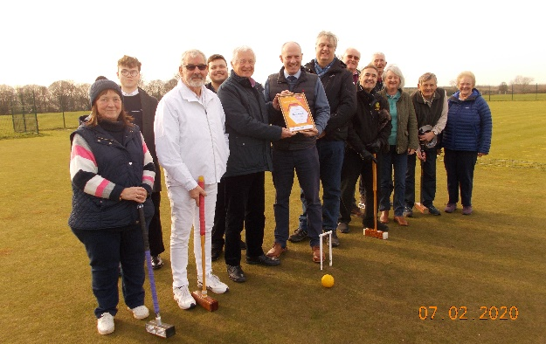
Swindon CC have achieved the Sport England Club Mark – no mean feat. John Airey, Secretary of Swindon CC tells us how they did it:

John Hawkins volunteered to fill the position of Accreditation Manager and take on the challenge of the renewal. With many set-backs he persevered along with Wendy White who volunteered to fill the Welfare Officer’s position, Steve Smith and Tony Tomlin renewing their First Responders certificates.

The photo: Swindon North MP Justin Tomlinson presents Sport England Clubmark Certificate to Swindon’s Accreditation manager John Hawkins. To the left of John is the Club Chairman John Small in whites. To the right of Justin (tallest) is David Reward Leader of Swindon Borough Council
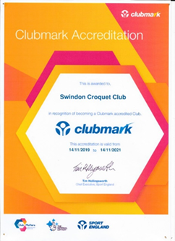
John Hawkins was the Accreditation Manager throughout this process and writes:

“Clubmark is the universally acknowledged cross sport accreditation scheme awarded by Sport England and stands for higher standards of welfare, equity, coaching and management in community sports clubs making sure the infrastructure is safer, stronger and more successful.

An accredited Club is recognised as a safe, rewarding and fulfilling place for participants of all ages providing the right environment which ensures the welfare of members and encourages everyone to enjoy sport and stay involved throughout their lives.

This is based on four key areas of development, each of which has to be supported by specific evidence collected by the Club, covering the Playing Programme, Duty of Care and Welfare, Knowing our Club and Community and Club Management.

Our assessor was Helen Weeks who is a Club Development Officer with Swim England and as Helen Slatter she represented Britain in three Olympic Games in 1988, 1992 and 1996.

After providing satisfactory answers to 63 online questions, with either a written text answer or a copy of an appropriate Club document, she made a site visit to Swindon in November last year and the Club was awarded the status of Clubmark by Sport England.

The certificate is displayed on the noticeboard in the Club Room and may I thank all those who provided me with assistance during this process.”

But the club hasn’t just been looking inwards – they were awarded a certificate of thanks from the Wiltshire Air Ambulance for the donations that Swindon Croquet Club have raised during their annual Charity Tournaments over four years.

