Welcome
Contents

P1 Zoom meetings resume
P2 Coaching
- 24 new club coaches in the SW
- Roger’s new book
- Richard’s on-line Breaks without Bisques sessions
P4 League news
- Stephen the radio star
P4 Lawn improvement ideas please
P5 Rough Guide to Handicap Changes
P6 PHC mallets (advert)
Appendix 1
P7 Federation Final
P8 Intermediate Final
P9 GC Level Final
P10 GC Handicap Final
P11 GC High Handicap Final
P12 SC Final
P13 SC Autumn Tournament
Appendix 2
P15 SWF response to CA consultation

We’re all settling down to a quieter winter season in some ways – the excitement of the competitive season may be over for a few months, but there’s still masses to be done to take care of the lawns, do those odd maintenance jobs and maybe even a bit of winter play.

Read on to catch up with the highlights of the season here in the SW and lots of other news too.

CA consultation on legal status

This continues until 23rd October. Clubs and individual CA members are encouraged to have their say.

The SWF has sent in its own response which may be seen in Appendix 2 p15.

Zoom meetings

These resumed for the winter on 12th October– we were a bit ambitious hoping to re-start in September as it turns out, but the programme will continue through til March 2022.

We used a different format this time, breaking into small chat room groups to share our news which was summarised and fed back to the whole group – a really good way of giving a voice to more people.

There was consistently positive news about the level of recruitment and coaching across the region so everyone will be working hard to ensure these new players will come back next year.

Winter play and lawns maintenance was another hot topic – it’s not always easy to balance the desire of members to play on those warmer winter days, and the needs of the lawns for a bit of R&R.

Finding volunteers to take part in these essential maintenance and development activities was mentioned a lot – the value of making this a friendly, sociable experience was recognised as a key way of getting people to put their hands up.

And a couple of catch-up points

- We’ve talked about finding a timer app that is visible to all players throughout the game – there are a lot of apps around already but we haven’t found one that’s ideal yet – how about you?
- Grounds Maintenance Association – things are progressing well on this front nationally – keep an eye open for ways it can help you, probably in the new year

Our next topic on 10th November will be Using Social Media and Andrew Willis from Bath CC will be exploring how to use Instagram.

If you have useful experience or expertise in Facebook or other social media, do contact Paul to see how we can incorporate this into the session.

Coaching

Roger’s Coaches’ Training courses were really well received and many of you are already benefitting from the enthusiasm and newly-acquired skills that the participants have brought back to your clubs.

At the time of going to press with this issue, the following people have received their Club Level Coach award.

At the time of going to press with this issue, the following 24 people have received their Club-Level Coach award.

Coach | Club | Coach | Club
Peter Allan | Blewbery | Martin Isles | East Dorset
Pamela Branley | Abbey | Michael Kay | Budleigh
Kate Brice | Winterbourne Valley | Martin Kerly | Nailsea
Gill Clark | Bath | Tim Lacy-Hulbert | Kington Langley
Simon Clay | Worcester Norton | Gordon MacRae | Moreton in Marsh
Ed Dolphin | Sidmouth | David Milford | Camerton & P’down
Sue Drew | Winterbourne Valley | Anthony Myers | Taunton Deane
David Enticknap | Bristol | Lynne Passfield | Bath
Chris Greensted | Plymouth | Jacky Raby | Cheltenham
Andrew Higgins | Budleigh | Geoff Scutt | Bude
Gill Hindshaw | Moreton in Marsh | Naomi Whitehead | Cheltenham
Lyndon Hughes | Bath | Ian Wills | Kington Langley

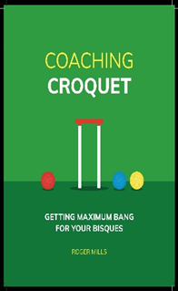
Hopefully many of you will already have come across Roger’s excellent book, ‘Playing Croquet: Getting Maximum Bang For Your Bisques.’ You’ve got your head around the 4-ball break? Your AC handicap is 10+? Then, this book has loads to teach you.

Dave Kibble (International Coach and one of the SW Reps to CA Council) writes:

“Highly readable … it will help the novice and experienced player alike to win many more games. It’s packed with examples to get you thinking, all accompanied with coaching notes so you’re never left alone scratching your head. The nearly 150 diagrams are all impressively clear, and it feels like a personal coaching course.”
James Hawkins, who some of you will have seen playing here in the SW, author of ‘Complete Croquet’ says:

“There’s some fresh thinking here, and Roger Mills has a reassuring way of flipping the reader’s mindset away from the frustrations of the underdog towards a confident winning strategy. It’s a valuable resource for the club coach, the ambitious novice, and experienced players wanting a competitive edge.”

Dave also wrote a review of the book in the Croquet Gazette https://www.croquet.org.uk/?p=ca/gazette&Action=Issues

Not only is Roger offering a half-day coaching session at Sidmouth or Budleigh Salterton to 10 players who ‘have been mad enough to buy the book’, (his words, not mine), but all royalties from the book are being donated to the CA.

The book is available to buy at the CA’s on-line shop https://www.croquetassociationshop.org.uk/
Contact Roger at rcm.mills@gmail.com if you want to be one of the ‘mad’ 10!

Breaks without Bisques: are you an AC player with a handicap 10-14?
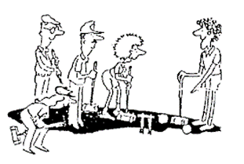
Interesting news from Richard Jackson, our erstwhile Coaching Officer who writes:

“During the pandemic, Richard Jackson of Bristol Croquet Club has adapted his AC course on Break Building without Bisques to be a zoom course of four forty-minute sessions - suitable for AC handicaps of about 10 to 14.

He would like to experiment with two single zoom sessions, one on getting the innings, and the other on keeping the innings when you have made all the hoops you would like or are likely to make. These two sessions would be tailored to the handicaps of the participants, from beginners to about handicaps of about 10.

Anyone interested should contact Richard directly at richard.jackson@yahoo.co.uk and he will arrange a programme if there is a demand.”
Leagues

It’s been a very busy and successful season despite the restrictions, and we owe a huge thank you to Stephen Custance-Baker who ensured that all this competitive croquet was made possible.

There were 184 block matches in 7 regional leagues, plus 18 play-offs and finals matches. Seven different clubs shared the nine league titles, many of the finals settled by the smallest of margins.

Reports of the finals matches may be found below but here’s a summary of the results

Association Croquet
League | Winners
Advanced Division 1 | Bristol
Advanced Division 2 | Bath
Advanced Division 3 | Budleigh Salterton
Federation | Winterbourne Valley
Intermediate | Kington Langley
Short Croquet | Bath
Golf Croquet
Level | Winterbourne Valley
Handicap | Plymouth
High Handicap | Budleigh Salterton

Reports on these matches may be found in Appendix 1

Radio Star

Stephen found time in his busy schedule to promote croquet on the airwaves thanks to BBC Radio Somerset. To listen to an excellent example of how this can be done, go to http://www.tauntoncroquet.org/Coaching.html and click on ‘radio talk’.
Lawn improvement. Any recommendations?

Sidmouth CC is looking into relaying at least one of their courts. If anyone has any recommendations or warnings about contractors and the whole process, Ed Dolphin would like to hear from you please. eddolphinscc@yahoo.com;

A Rough Guide to Handicap Changes

Stephen Custance-Baker has written this guide for the confused!

This is not a full description of the handicapping system, but it is intended to answer some of the questions I have received in the last few months. It applies equally to AC, GC or Short Croquet handicaps.

The handicap system is designed to equalise play between players of different levels so that each player has an equal chance of winning. In AC and GC handicap games, the index changes by +/-10 and in Short Croquet by +/-1. This is different in AC and GC level play and the CA has produced tables to show the points exchanged in Level Play games.

When a handicap changes, either because of the Automatic Handicap System (AHS) or because a handicapper has changed it, it will not change again unless the player has a series of wins or losses.

For example, a player with an AC handicap of 3 loses a game and their index drops to 1650. This is the trigger point for 3½, and their handicap therefore changes to 3½. The next day they win a game, and their index increases to 1660 but their handicap remains at 3½. It will not change again until their index rises to 1700 (the trigger point for 3) or drops to 1600 (the trigger point for 4).

Remember that the trigger point for your current handicap is irrelevant. You can cross it in both directions for years without any effect on your handicap. The trigger points that matter are the ones for the next handicaps up and down.

The AHS causes a handicap to change when it reaches a trigger point,
not when it passes it.

For example, a GC player with a handicap of 4 has an index of 1501 and loses a Level Play game against a minus 2-handicapper. This costs them 1 point; their index becomes 1500 and their handicap becomes 5. Another GC 4-handicapper with an index of 1699 wins a Level Play game against a 14-handicapper and gains 1 point. Their index is now 1700 and their handicap becomes 3.

Generally, the handicap changes at the end of the day for club play and inter-club matches, and at the end of the tournament for multi-day tournaments. (There are a few very long tournaments in which different rules apply.)

If a player has such a good tournament that their index passes not only one but two trigger points then, under the AHS, they can skip past a specific handicap.

For example, an AC player with a handicap of 8 and an index of 1345, plays 5 games in a 2-day Advanced tournament, beating a 3, a 4 and two 6’s, then losing to a 1. Their index changes by 17+16+12+12-1 and therefore increases to 1401. Their handicap will then change to 6, by-passing 7.

The same could be true in a handicap tournament if a player who was near a trigger point won 6 games without a loss.
Club Handicappers, Federation Handicappers and CA Handicappers can make changes to a player’s handicap if it becomes clear that their game is:

- improving too rapidly for the AHS to cope.
- deteriorating too rapidly for the AHS to cope.
- significantly affected by a medical condition when they return to play after a lay-off.

The amount of the change that can be made is subject to limits set by the CA. It is best if any such change is discussed with the player and agreed before the change is made.

Advertising in Cygnet

All adverts must be sent fully formatted in such a way as they can be easily inserted (copy and pasted) into Cygnet. We are not in a position to undertake any artwork or correct for errors or omissions.
Charges include a 2-3 line entry in the Diary Dates column in up to three subsequent issues.

Charges
Full Page: £12 Half Page: £6 Quarter Page: £3

Appendix 1 Finals Reports

The Federation final between Worcester Norton and Winterbourne Valley was played at Nailsea CC on 19th Sept with Mike Tracy dusting off his Referee skills. Linda Shaw was there enjoying the company of two really friendly teams and watching the games. She writes:

Home team Worcester Norton: Ken Potts, Simon Clay, Luke Wurmli, Chris Wurmli, Chris Southworth and Don Clay were supported by Sarah Clay while the Away team, Winterborne Valley, enjoyed the skills of Jonathan Powe, Kath Burt, Tim Dennis and Teddy Wilmot-Sitwell.
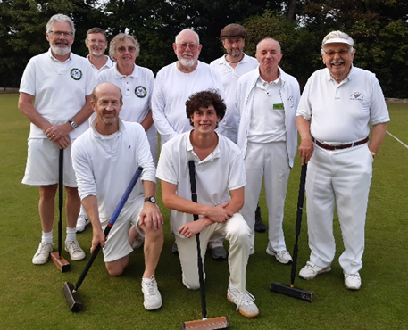
With a 70-year difference between the youngest and oldest players – Don 90 playing since 1974 and Teddy 20 playing seriously for just one year – this must be some sort of record for League play in the SWF – unless you know different?

The morning doubles game was slow to get going - after 1hr 45mins only three hoops had been scored. And despite what threatened to be a great come-back by Jonathan, Worcester Norton prevailed. But Winterborne Valley won both their singles games so after a sociable outdoor lunch, there was all to play for.

Happy teams at the end of the day

Three wins in the afternoon meant Winterborne Valley went home proud winners of the splendid trophy under their new guise, to add to their impressive record this season in their new incarnation, and to add to previous victories as Kingston Maurward.

Two wins for Teddy led to a handicap reduction for him – his considered use of two standing bisques for the final peg-out is a luxury he may not be able to enjoy again!

A good day in other ways for Nailsea as well: two visitors arrived to enquire about playing, were given a commentary on one of the games and enjoyed talking to Teddy who played two impressive games resulting in a handicap reduction at the end of the day. Our two visitors have signed up for the beginners’ course next year!

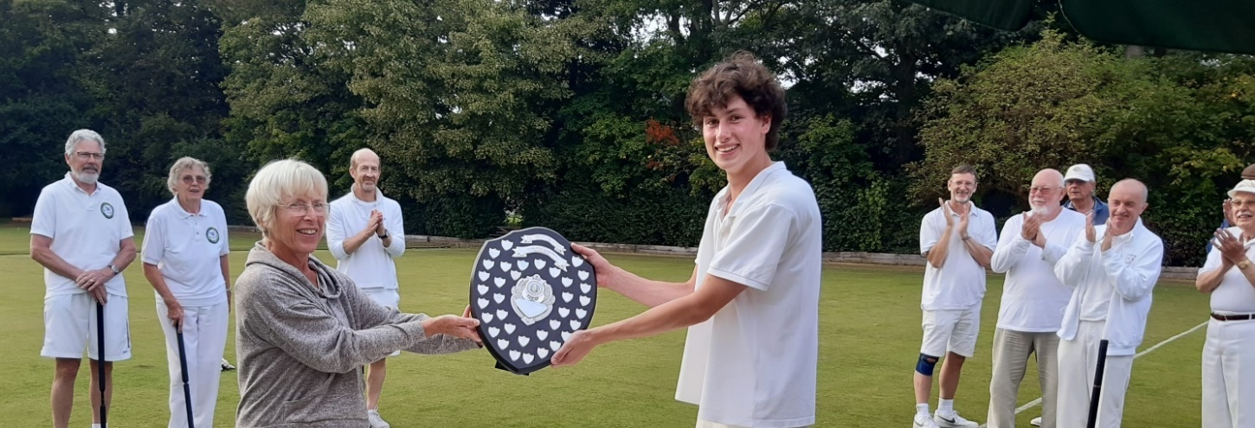
Linda presents the trophy to Teddy

The AC Intermediate Final was held on 26th September between East Dorset and Kington Langley at East Dorset CC with Stephen Custance-Baker as Referee. He gives us this report and the photos.

After a rather murky start to the day, the match got going on time, with 4 home players (Mike and Christine Rice, Martin Isles and Neil Cleverley) taking on 3 visitors (Ian Wills, Tim Lacy-Hulbert and Margaret Murray).
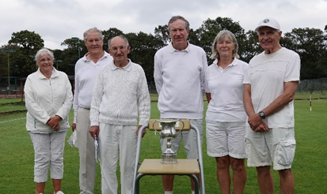
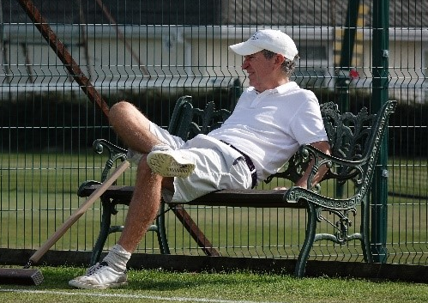
The morning singles and doubles were both very close games, but the visitors came out ahead in both, winning +2 and +3 to give them a 2-0 lead at lunch.

The teams line up at the end of the day – Kington Langley are on the left of the photo on the left while on the right, Mike Rice limbers up for victory.
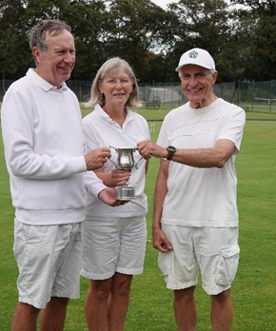
By this time the day had brightened, and we had plenty of sun and a cool wind.
The afternoon’s singles started well for East Dorset, who were leading in two and behind in one after the first hour.
However, by halfway through the games they had a clear advantage in all three and eventually triumphed +16, +10 and +4 to give them an overall 3-2 victory, their first win of this trophy.

The referee’s job was straightforward, except for a case of roqueting Blue with Black and then picking up Blue.

The Champions share the honours.

The GC Level Play Final at Cheltenham was thoroughly enjoyed by the SWF’s Tony Mayer who writes:

This brought together two teams from Bristol and Winterborne Valley including two top GC players, several who have played at World Championship, International and National competition level and the play was representative of the best in Golf Croquet at that level.
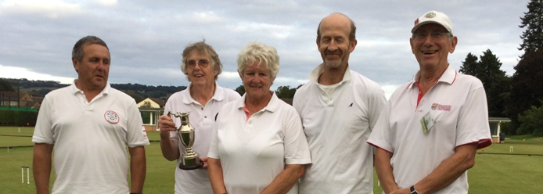

Worthy winners: Steve Leonard, Tess Burt, Michelle Leonard, Jonathan Powe, with Tony Mayer (SWF) on the right. Thanks to Tess for the photo.

Each game was extremely hard fought and evenly balanced. We saw some fantastic long-distance clearances, super jump shots and great hoop running (including winning shots from the boundary and with shots scoring hoops 9 and 10 together!

For a moderate handicap player such as myself (Handicap 5) it was a joy to see the play from both teams and giving inspiration to try to emulate them. At least they showed that they were human with the very occasional missed close clearance or hoop and even the very occasional wrong ball!

Games were taking close to one and a half hours and after four rounds of doubles and singles the score was 6 - 6. This had us all scrambling for the rules in the event of a tied match which might have resulted in the final tie break doubles lasting until dusk.

In the event the afternoon rounds of singles saw Winterborne Valley ease ahead eventually running out 12 - 8 winners.

This completed a great double for the Club which had won two trophies in 7 days (AC Federation and GC Level Play).

Dom Aarvold (B), Steve Leonard, Richard Smith (B), Tess Burt, Michelle Leonard, Martin Murray (B), Eric Soakell (B), Jonathan Powe, David Goacher (B) – all friends at the end of the day

So, Winterborne Valley proved to be excellent winners and Bristol very worthy opponents. Congratulations to both teams for such great croquet.

GC Handicap Final between Plymouth and Dowlish Wake was played on September 19th at Sidmouth CC with Stephen once more the Referee and once more providing this report. The photos were taken by Sue Custance-Baker and Ed Dolphin.

This was a very even match played in good spirits on a bright and warm day, though it did turn chilly before the match was over.

After two rounds of doubles the score was 2-2 and after four rounds of singles it was 8-8. It continued to be neck-and-neck through the final round with one to Dowlish, one to Plymouth, another to Dowlish and finally a tight 7-5 clinched by Plymouth.

This meant that the score was 10-10 and the match was resolved with a tie-break game of doubles between the selected champions for each side. Chris Spiller and Steve Roe from Plymouth, each receiving one extra stroke, took on Mark Gooch and Anthea Carter from Dowlish Wake.

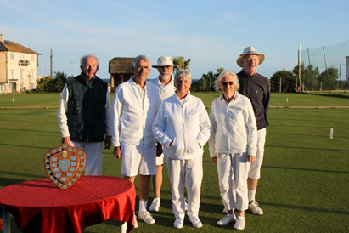
Dowlish Wake’s 3-1 lead was pegged back to 3-3 and the hoops then alternated to 5-5, after a clearance attempt put Chris through hoop 10. A long debate at hoop 11 was resolved in Plymouth’s favour when the first extra stroke was used to good effect. The second extra stroke enabled them to set up in front of 12 which, after a bit of pushing and shoving, they ran for a 7-5 win and the match
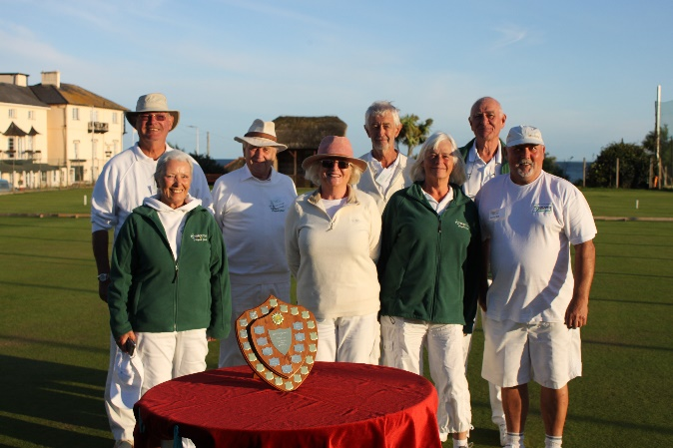

Plymouth: (left) the victorious

Chris Spiller, Linda Lang, Bob Savage, Gill Spiller, Peter Richards, Sue Marples, George Lang, Steve Roe

Dowlish Wake: (right) the courageous

Brian Butt, Mark Gooch, Keith Bryant, Anthea Carter, Barbara Dean, Andrew Campbell

.

The High Handicap GC Final between Llandaff and Budleigh Salterton was played at Camerton & Peasedown CC on 26th and witnessed by Brian Wilson.

It was a long journey for the two finalists - Llandaff and Budleigh - but the weather was kind to us all. Llandaff was the ‘home team’ and play started dead on-time

In the morning we watched 1 round of doubles and 3 sets of singles and all was even after the first round, with many matches having a very close result including 7 - 6 and drawn games. By lunch time Budleigh had just edged ahead, but it was all to play for

In the afternoon Budleigh seemed to be edging forward - so that at the start of the last round they were 3 games ahead. But Llandaff were not finished and they won the next 3 games - the result was on a knife edge.

It all rested on the last game in which all players took a very close interest!! It was ’nip and tuck’ all the way, but eventually Budleigh won by 10.5 to 9.5

Anybody watching this match would have seen croquet at its best - competitive sport and excellence with everyone enjoying their sport Both Captains congratulated both their own teams and opponents, thanking CPCC for their hospitality and excellent lawns

Brian Wilson (Chair SW Federation) presented the award to Budleigh, noting the many close matches, fantastic clearance and hoop scoring, not forgetting that some players improved their handicap. In the end Brian congratulated everyone, thanking players for such an entertaining day and wishing everyone a safe journey home.

Short Croquet Final

Paul Francis writes: Bristol and Bath shared a close fought final on September 25th at Bath Croquet.

By the end of the first round of games, Bristol had established a 3 -1 lead with only Alex Hudson of Bath gaining a win against John Phillips. In round two, the teams tied with two wins each, with Alex Hudson once again, recording a victory.

5 - 3 to Bristol at lunch became 7 - 5 by the end of the third round and the margin of two games only maintained by the in-form Alex. Crucially for Bath, Ninette Flowerdew secured a one hoop win versus John Phillips.
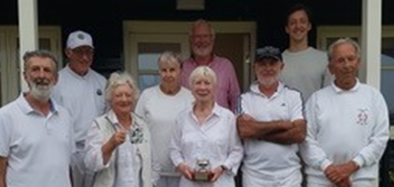
So, Bath’s prospects of a victory seemed marginal as the fourth round commenced.

However, Alex Hudson’s fourth win against David Enticknap (unbeaten until this round) narrowed Bristol’s advantage to one win. The match became tied at 7 - 7 when Martin Alabaster defeated John Phillips.

All smiles at the end of the day

Focus turned to the remaining two games where the lead in both kept changing hands.
Indeed, the Frances Ransome (Bristol) v Paul Francis (Bath) contest was eventually decided in Bath’s favour on the golden hoop. So, for the first time Bath led the match at 8 -7. The likelihood of a tied match had people scurrying off to check the overall hoop scores for the two sides.

However, we were saved this calculation with Ninette Flowerdew winning against Ann Fraser by a two hoops margin and so securing a 9 -7 victory for Bath. At last Bath’s non-playing captain, Philip de Glanville, relaxed for the first time all day!

Even bigger smiles from the winners!

There is no doubt the very experienced Bristol team was unfortunate to come up against two talented beginners, Alex Hudson and Martin Alabaster.

The great spirit of friendly competition throughout the day made the final an enjoyable and memorable occasion.

Autumn Short Croquet Tournament

A hectic time for John Grimshaw preparing and managing this tournament – as usual it went really well, was thoroughly enjoyed by everyone, and he even recovered sufficiently to provide us with this report.

Budleigh Salterton were excellent hosts and the courts were absolutely superb. I should also say that, after the horrendous conditions of 2019 when every day was plagued by waterlogged courts, the weather was dry and on Saturday and Sunday, sunshine all day.

Special mention should be made of the nine players who achieved four wins in their four games.

Jon Knowler  Nailsea Trendlewood | Mike Salisbury  Bristol Allsorts
Richard Smith  Kington Langley Braves | Roger Hayes  Bath A
Lorne Loxterkamp  Taunton Tiggers | Scott Berry  Taunton Tiggers
Elizabeth Scholfield  Fowey Friends | Roger Mills  Budleigh Salterton Mallets
Anthony Myers  Taunton Terriers | David White  Budleigh Salterton Mallets

Moreover, Scott had his handicap reduced by three steps during the day – but that was not enough to deter him!

As an overview, Divisions 2-5 had five teams each, but Division 1 had only four teams due to late withdrawals. Wellington filled one of the vacancies in Division 5 but I could not find a replacement for Division 1.

Division 5

The pattern of the day was really established in Round 2, when the two teams who had three wins from the first round clashed, and Budleigh Salterton took the victory over Lym Valley 3-1. Budleigh's dominance continued and they won both their last two matches with a clean sweep, achieving 14 wins out of 16.

Budleigh Salterton Mallets | 14 | Camerton Peacams | 5
Bath B | 11 | Wellington | 3
Lym Valley | 7

Division 4

Taunton Tiggers took an early lead, and when they beat Bristol Boys+1 in the third round they were clear winners.

Taunton Tiggers | 12 | Parkstone | 6
Bristol Boys +1 | 9 | Sidmouth Connaught | 6
Budleigh Salterton Rushes | 7

Division 3

This one went down to the wire. Bristol Allsorts and Kington Langley Apaches both achieved 4-0 wins in the first round and progressed steadily from there.
KL's downfall came in Round 4 when they lost 3-1 to Sidmouth3 who were bottom of the standings at that stage, leaving the Allsorts needing 2 wins against the Apaches in the final round and this they achieved.

Bristol Allsorts | 10 | Exeter | 7
Kington Langley Apaches | 9 | Bath A | 7
Sidmouth | 3

Division 2

Sidmouth Fortfield and Taunton Terriers were favourites for this division and so it eventually proved, but both had setbacks in Round 4 against Cornwall and Fowey respectively, so they went into the last round level on wins and playing each other. Taunton prevailed 3-1 to avoid the dreaded shoot-out.
Taunton Terriers 10, Sidmouth Fortfield 8, Fowey Friends 8, Camerton Campeas 8, Cornwall 6

Taunton Terriers | 10 | Camerton Campeas | 8
Sidmouth Fortfield | 8 | Cornwall | 6
Fowey Friends | 8

Division 1

Unfortunately, this division had only four teams. We had an all-play-all in three rounds and the scores after three rounds determined who would play whom in the last round with 1s playing 2s., and 3s playing 4s.

The surprise packet was Budleigh Salterton Roquets, who had by far the highest handicaps in the division and were hampered even further when one of their players failed to turn up. Chairman John O'Gorman, who is a GC player, bravely stood in and performed admirably for one who has no AC experience at all. He actually won two games.

After three rounds, The Roquets and Kington Langley Braves were both on 7 wins, so had to play each other, effectively in the final. It was possible for one of the other two teams to force a shoot-out if either won 4-0, and the Roquets/Braves game finished 2-2. This seemed unlikely and was soon confirmed as the pattern in their game was established.

So, it was down to the two leaders, and at one stage it looked almost certain that the score would be 2-2, and a shoot-out at the peg would be required, but as time approached, the two Braves players who were some distance behind, rallied and both won to give the Braves a clean sweep and the title.

Kington Langley Braves | 11 | Budleigh Salterton Roquets | 7
Glamorgan | 8 | Nailsea Trendlewood | 6

Kington Langley Braves are now the current holders of both the Spring and Autumn tournaments.
Appendix 2

South West Federation of Croquet Clubs Committee response to CA consultation on change of status.

The South West Federation (SWF) welcomes the opportunity to respond to the consultation launched by the CA regarding the CA’s future legal status.

In response, taking into account the introductory paper from the CA, the SWF’s view is that:
The CA current unincorporated structure has been untenable for many years and must be changed. As a national Sports Governing Body, and to protect individuals acting on its behalf, it is essential that the CA is structured so as to be incorporated and have a legal personality.

We regret that the CA has not provided adequate information about all the alternatives available and the legal adviser’s assessment of these alternatives. Thus, apart from a move to become a charity, it is difficult to judge if such a move is the best way forward. Ideally, the CA should have provided the more detailed arguments which resulted in the charity route being taken and, assuming this to be the appropriate route, the pros and cons of the CIO and the CCLG options. It would also have been helpful to have had information about the structures of other comparable Sports Governing Bodies.

However, on the assumption that a charity is the way forward, then we strongly recommend that the voting structure to elect Trustees (the role of the Trustees and the responsibilities of such persons need to be fully documented for CA members) should be based on voting members nominated by Clubs. As is discussed in the CA consultation, most players’ primary allegiance is to their club. It is accepted that some unattached players may be disenfranchised but this should encourage such persons to join a club.

If a Club-based voting membership is adopted (with individual members then becoming ‘Associate Members’) then there should be a formal constitutional commitment to consult and take into account the views of Associate Members.

Although large membership clubs are in a minority and should not be in a position so as to unduly influence the election of the trustees, the CA should propose options to better reflect the membership sizes of clubs.

We would like to see membership of the relevant Federation an automatic benefit of CA membership. This may well have financial repercussions for at least some Federations (certainly for the SWF) but we are of the view this would serve to strengthen the basic structure, communication and responsibility within the CA and its members.

For details of the consultation, go to: https://www.croquet.org.uk/?p=press/news&NewsID=7464&pup=y

