Hello everyone.

**Contents**

p1 SWF AGM

p1 News from the clubs

Kington Langley – Mumbles Plymouth – Bristol - Budleigh Camerton & Peasedown - East Dorset

p4 Zoom

p4 Spreading the word

*p5 Bristol CC – Handicap events*

p5 Amongst ourselves

*p6 Budleigh SC Competition*

p7 Safeguarding

p7 Inclusivity & Diversity

p7 Active Partnerships

*p8 C & P GC event*

p9 SW Rep to CA Council

*p9 PHC mallets*

**Appendices**

P10 AGM papers

p12 Zoom – accessibility

p15 Zoom – CA Executive

p17 Zoom – round-up

It’s been quite a while since the last Cygnet so there’s a fair bit to catch up on – so sort yourself out in a comfortable chair with a suitable refreshment to hand, and get catching up.

**SWF AGM**

We will be holding this by Zoom again this year on Sunday 21st November.

We will be issuing the call for Nominations for the Committee, and Proposals for the AGM via an email to all Club Secretaries, but the information may also be found in Appendix 1.

The key date for now is 10th October – all nominations and proposals must be submitted by then.

**News from the clubs**

Kington Langley: Match report

Thanks to Margaret Murray, Secretary at Kington Langley, for sending us this early season Short Croquet report written by John Grimshaw.



At this time of the year, KLCC would usually be sending two teams to the SWF Nailsea SC competition, but current restrictions led to this being cancelled again. So, those two teams met at KL on Saturday 17th April in a socially-distanced battle for the honours within the club.

The Braves were clear favourites, being the current holders of the Nailsea Championship, which was last held in 2019, and this was borne out by the final result of Braves 11: Apaches 5.

The pattern of the day was established in Round 1, when the Braves won three of the four games to take an early lead, Two of the Apaches’ defeats were by 1 point on time, and an Apaches player even had the courtesy to peg out his opponent in a golden-hoop ending to give his opponent victory!

The trend continued in Rounds 2 and 3, each going 3-1 to the Braves, so the result of the match was confirmed before Round 4 got underway, with a 9-3 score-line. The Apaches salvaged some honour in the last round by drawing it 2-2.

A special mention should be made of Brave Margaret Murray who won all four of her games and earned a handicap reduction as a result, though she was the beneficiary of the Apaches generosity in Round 1.

It was a most enjoyable day, and confirms that Short Croquet is growing in popularity, especially in our club. The weather was glorious all day.

Apaches team: John Grimshaw, Ian Wills, Jane Hull and Roderick Corrie

Braves team: Richard Smith, Tim Lacy Hulbert, Margaret Murray and Ian Morrison

Mumbles: Lawns

Andrew Wright wrote earlier in the season: the Mumbles Croquet Club we have had to move because the lawn has been closed down by the local authority because of the state of the 'grass' - very good for Egyptians playing on sand!

So, we have moved to another venue, to Brynmill Park, an abandoned bowls green which has not been used for at least three years. It is in desperate need of a lot of TLC. We meet with the Council to discuss a way forward. Watch this space.



As our session at Brynmill was finishing we had an incident that was reported to the police. Today we had a scheduled meeting at Brynmill with various council officials and because of unease by some players, we were offered King George Sports site on Mumbles Road, Blackpil on the outfield of the cricket pitch (cricket is Thursday and Saturday with Sunday being a popular day).

We were taken down to view the 'lawn' and find out what facilities there might be. We were pleasantly surprised and have accepted their offer starting Monday 17th May. The groundsman seemed enthusiastic that he could get us a good playing surface.

Again, watch this space!

Treasure in Plymouth

George Lang sent us this link about a recent discovery under the reservoir!

<https://www.plymouthherald.co.uk/news/history/lost-treasure-plymouths-history-discovered-5639091>

Bristol Website

The good folk at Bristol Croquet Club had become concerned at the number of ‘unwritten rules’ that were flying around, absorbed by new members through a process of osmosis. Biting the bullet firmly, they determined to get them all down in writing. Thus was born the Club Guide.  
  
As it matured it became the Club Handbook to include useful information and has now metamorphized by replacing the club website. It was at times a painful process, but ultimately very worthwhile.  
  
The first task was to agree on what these unwritten rules were – can you book a lawn for practice - how long for, etc.  
  
Then, what else should be included? How does a new member find out about the club and the game? The club doesn’t exist in a vacuum – how does it relate to the wider world of croquet?  
  
It aims to provide a route map for the croquet-curious through to the beginners’ course, joining the club, entering competitions and taking part in the running and social life of the club. Routes to regional, national and international play are signposted.  
  
It’s friendly and clear and the task now is to ensure it stays abreast of the times and the gaps filled in as they are spotted.  
  
Do have a look at the site and feel free to copy or adapt the ideas to suit your own club. It’s certainly food for thought for the SWF committee who are really keen to improve our website.  
  
The result is available for all to see at <http://www.bristolcroquet.org/> and please provide feedback on things missing or poorly explained.  
  
Bristol club owes a huge debt of gratitude to the committee, to those members who provided feedback to the work-in-progress, to Linda Shaw for pulling it all together, and to Dave Kibble for the hours spent translating our efforts into a suitable format for easy reference.

The Budleigh Bear

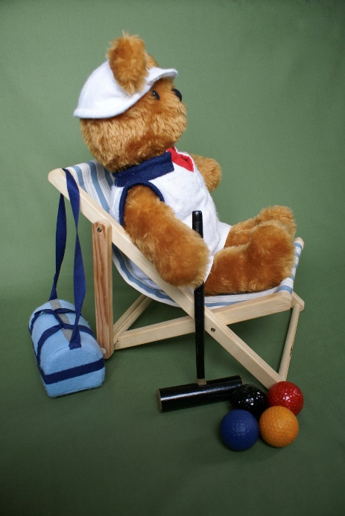

Our favourite bear relaxes – Robert Moss papped him in this private moment.

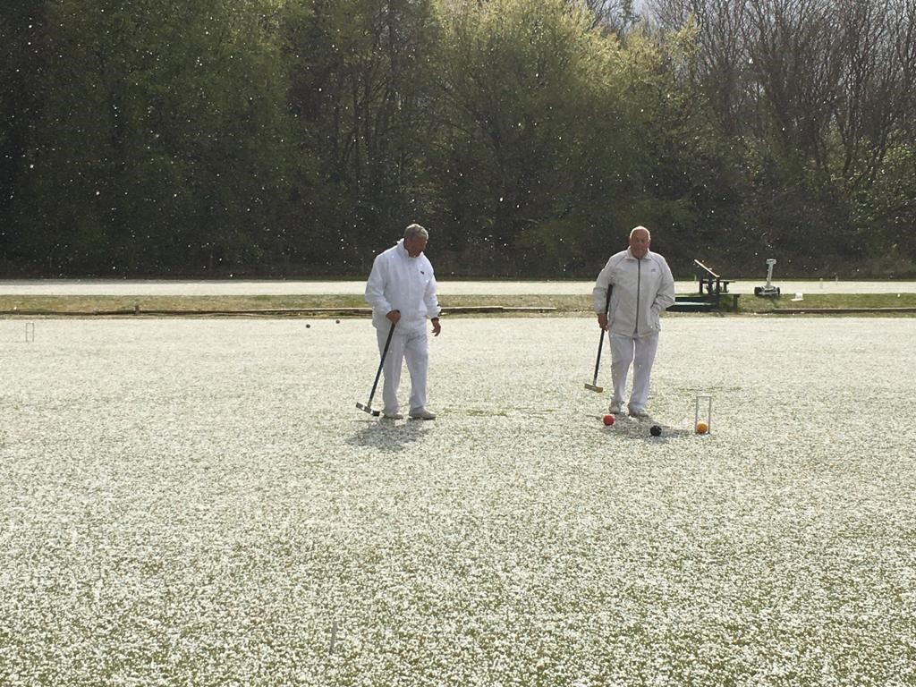

Meanwhile at Camerton & Peasedown, Patrick Knight got caught in a massive hailstorm – anyone know who supplies hard hats in white?

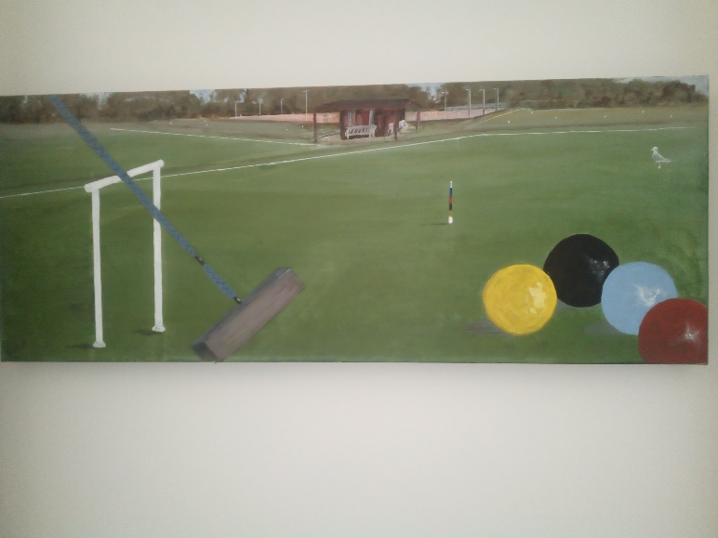

East Dorset has been getting creative: Susie Clarke has been putting her artistic skills to good use raising funds for the club.

What talents could you use to such good effect?

**Zoom**

We’re giving ourselves a break over the summer and will be resuming our monthly Zoom meetings on Tuesday 14th September. In the meantime we’ll be devising a programme of topics and welcome your suggestions.

Contact Paul with your ideas [paulwfrancis@icloud.com](mailto:paulwfrancis@icloud.com)

Catch up on the last three topics: Accessibility, Role of CA Executive Council and a general round up, in Appendices 2 – 4.

**Spreading the word**

Have you noticed there’s been a fair amount of croquet publicity over recent months out in what some people like to refer to as the ‘real’ world?

Some of it has been local – Worcester Norton CC hosted a live broadcast with BBC Radio Hereford and Worcester which worked really well. A scheduled repeat didn’t happen due to the death of the Duke of Edinburgh but they were promised a further airing on the subsequent Bank Holiday.

<https://www.dropbox.com/s/mv3fakviw2yseh2/MM%20CROQUET%20PART%201.mp3?dl=0>

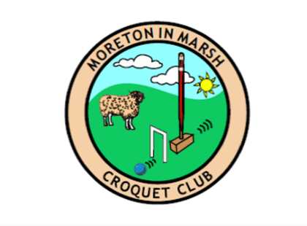

And don’t you just love the new Moreton in Marsh CC logo?

They are now open for business and we hope they’ll be playing in the Leagues before too long.

Continuing the royal theme, the Daily Mail revealed just how much Pippa Middleton knows about croquet!

<https://www.dailymail.co.uk/news/article-9531501/Croquet-OK-Sport-proves-hit-teenagers-students-Covid-pandemic.html>

Then you surely didn’t miss the River Nene dispute, did you? That’s what you call conflict resolution:

<https://www.dailymail.co.uk/news/article-9584571/Croquet-match-settle-centuries-old-dispute-pronounce-River-Nene.html>

Several clubs in the region have created a lively Facebook presence (probably on other socially media as well) which really captures the fun, collaboration and competition of club life.

*Does your club post regularly on social media? Let us have the link and we’ll circulate a list.*

**BRISTOL CROQUET CLUB**

Invite you to a two-day **HIGH HANDICAP** event

**AC** day - Handicaps 16 to 24 on **Thursday 2 September** - Fee £10

**GC** day - Handicaps 8 to 16 on **Friday 3 September** - Fee £10

Fee for both events £16

On Thursday, four 14-point 90-minute games are guaranteed

On Friday, five ‘best of 13’ 50-minute games are guaranteed

Enjoy a friendly atmosphere and three wonderful lawns

Bring your own lunch, afternoon tea will be available.

Maximum numbers for each day is **12**

Entries **by Monday 23 August** to Bob Whiffen

07967125361 or [bob.whiffen@virgin.net](mailto:bob.whiffen@virgin.net)

Please give your name, telephone number(s) and email address,

and state whether for Thursday, Friday or both days.

Payment will be requested soon after Monday 23 August

**And amongst ourselves**

Earlier this year Paul ran a short Survey Monkey poll amongst our members to find out about the level of interest in the game from new players. He received 24 responses.

66% reported a higher, or much higher level of interest this year over last year and well over 40% were expecting more than 10 people signing up for beginners’ courses.

A range of methods were used to generate interest and their effectiveness was gauged

|  |  |  |  |
| --- | --- | --- | --- |
| Method | % Used | Method | % Used |
| Club’s website | 70 | Public posters | 22 |
| Family & friends | 91 | Local papers etc | 48 |
| Social media | 35 | Local radio / TV | 26 |

In terms of what clubs were trying out, there were lots of comments:

* Developed coaching skills with Roger Mills
* Enrolling temporary members
* Continually improving beginners’ coaching sessions – developing course notes
* Active Facebook
* Selling beginners’ course gift vouchers
* Hosting social sessions e.g. local scouts
* Free taster sessions – ad hoc taster sessions for those who contact the club
* Buddying with other members – gradual introduction to the game and the club
* Website update

|  |
| --- |
| **BUDLEIGH OPEN - Individual Short Croquet**  **5th & 6th October 2021**  **To be held at Budleigh Salterton Croquet Club**  **Westfield Close, Budleigh Salterton, Devon, EX9 6ST**  **Tel: 01395 442548**  **Manager:** Chris Donovan **Maximum entry:** 32  **First Come First Served** – allocation will be confirmed on receipt of your email entry.  **Closing date for entry:** 20th September 2021. A waiting list will be kept.  **Entry Fee:** £25 including welcome tea and coffee. Bring your own lunch. Bar available.  **If you have to withdraw, please inform the manager at once.**  To enter, please send an email to **treasurer@budleighcroquet.org** with ‘**Individual Short Croquet**’ as the subject. The entry fee can be paid by card on the day or by sending it directly to the club’s bank account. In your email, please state which method of payment you will be making. If you choose to pay directly to the bank, the account details are as follows:  **Account Name:** BUDLEIGH SALTERTON CROQUET CLUB LTD  **Account Number:** 73493830  **Sort Code:** 20-30-47  **Reference:**  Please enter **BOS** then the first 4/5 letters of your surname followed by a space and the first letter of your forename (e.g. **BOSOGOR J** for John O’Gorman) |

**Child Safeguarding – it’s everyone’s responsibility**



Paul Francis is now the SWF Local Safeguarding Officer so please contact him with any queries about this. [paulwfrancis@icloud.com](mailto:paulwfrancis@icloud.com)

And do check out our League Rules which now contain information on how the new policy applies in League Matches. <https://www.swfcroquet.org.uk/>

Paul is in touch with Ron Carter, the CA Safeguarding Officer and we’re hoping for a greater dialogue about how we’re all managing this, as time goes on.

Missing seminar

And on the topic of Safeguarding, we circulated details of a webinar run by the Ann Craft Trust and NSPCC but we’d been given the wrong date. An email to the organisers promised a reason and link to any recording, but nothing was forthcoming – sorry to those of us who were disappointed in this.

**Inclusivity and Diversity**

The CA is establishing an Inclusivity and Diversity Working Group and so far there is no one from the SW to contribute to this.

It would be a real shame to miss out on this so if you have even the slightest flicker of interest, do get in touch will Paul. He is really approachable and would love to hear from you. Contact him: [p_h_brown@icloud.com](mailto:p_h_brown@icloud.com)

**Active Partnerships**

SportEngland has delegated the responsibility for encouraging more active lives to 43 Active Partnership. These partnerships tend to be managed by counties or metropolitan areas.

The Active Partnerships collate information on sports available in their areas. Their main features include an 'A - Z of Sports' and an ‘Activity Finder’.

<https://www.wesport.org.uk/sport/croquet/>

One of the Active Partnerships’ priorities is ‘Living Longer Better’. This initiative is aimed at the 55 plus age group. In addition, these partnerships are very keen to introduce activities which encourage well-being and reduce social isolation. As a result, the CA see the Active Partnerships as an opportunity to promote our sport to the wider population and health professionals.

To date, Paul has worked with Active Cornwall and Wesports (covering BANES, Bristol, North Somerset and South Glos) and Croquet is now represented on their sites. He is currently working with Devon, Dorset and Wiltshire to achieve the same level of coverage. Active Gloucestershire and SASP might be ‘harder nuts to crack’.

Eventually, there will be a link to each club’s website via the relevant Active Partnership. The CA Development Committee has trialled the project with Active Cumbria, it’s worth visiting this site to see what can be achieved. Here’s the link:

<https://www.activecumbria.org/activities/croquet/>

Active Partnerships in the SWF: Active Cornwall - Active Devon - Active Dorset - Active Gloucestershire - Active Wiltshire - Somerset Activity and Sports Partnership (SASP)



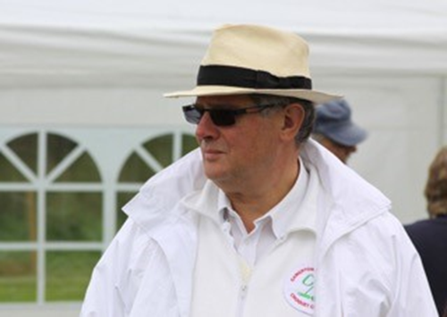**SW Reps to CA Council**

There was one nomination for the vacancy in the South West – Brian Wilson – who has therefore declared duly elected without the need for a ballot and will assume the role from the date of the CA AGM.

Thanks to Klim for his work in the role and good luck to Brian as he joins the Council – we know of his keen interest and enthusiasm for the sport in the SW and look forward to his active participation at national level.



|  |
| --- |
| **Advertising in Cygnet**  All adverts must be sent fully formatted in such a way as they can be easily inserted (copy and pasted) into Cygnet. We are not in a position to undertake any artwork or correct for errors or omissions.  Charges include a 2-3 line entry in the Diary Dates column in the three subsequent issues.  **Charges**  Full Page: £12 Half Page: £6 Quarter Page: £3 |

**Appendix 1**

**South West Federation of Croquet Clubs. AGM 2021**

**Call for Proposals and Nominations**

Our AGM will be held on Sunday 21st November 2021 at 10.00am.

It will be held as a Zoom meeting.

Amongst the purposes of the AGM are:

* To consider proposals presented by member clubs or the SWF Committee
* To elect the committee for 2021/2022

**Proposals for consideration**

* A Resolution for inclusion in the Agenda of the Annual General Meeting may be proposed either by the Committee or by a Member club (duly signed by its Secretary or delegate)
* Proposals to the AGM will not be tabled if they were considered in the previous AGM.
* The SWF Committee is currently considering a number of improvements to the Constitution and League rules which will be presented at the AGM.
* If you have any suggestions for these or other matters, please submit them to arrive no later than 10th October 2021.
* Please include the following information:
* Name of Club
* Proposal
* Rationale
* Name and contact details of club secretary

**Nominations for Committee**

These must be received no later than 10th October 2021 using the format described below.

This year the post of Chair falls vacant, Brian having served his three-year term, so please bear this in mind.

**Notice of AGM**

This will be circulated by 24th October and will include the agenda, all proposals, all nominations and further details about the venue and event, and application form to enter League AC and GC events.

If you have any queries in the meantime, please send them to:

[lindawithani@hotmail.com](mailto:lindawithani@hotmail.com) or

Linda Shaw, 21 Grove Avenue, Coombe Dingle, Bristol, BS9 2RP

**Nominations for Committee**

We are looking for enthusiastic, skilled and reliable people to join the committee in one of the following roles and would particularly love to hear from people in clubs not currently involved.

|  |  |  |
| --- | --- | --- |
| *Chair* | *League Secretary* | *Publicity Officer* |
| *Treasurer* | *Development Officer* | *GC Adviser* |
| *Secretary* | *Youth Officer* | *Regional Coaching Officer* |

To be eligible to stand you must be a member of a fully paid-up Full Member Club. If you are not sure – ask your club committee, check out our website [www.swfcroquet.org](http://www.swfcroquet.org) or email [lindawithani@hotmail.com](mailto:lindawithani@hotmail.com)

If you’d like to stand for election, your nomination should reach the address below no later than 10th October 2021.

Please use this form or ensure that all the requested information is provided in an email or letter.

|  |  |
| --- | --- |
| **SWF of Croquet Clubs: Nomination for Committee** | |
| Name of nominee |  |
| Please state the role/s you wish to be nominated for |  |
| Proposed by | Name |
| Email |
| I am a member of – please insert name of club |
| Seconded by | Name |
| Email |
| I am a member of – please insert name of club |
| Consent to nomination | Name |
| Email |
| I am a member of – please insert name of club |

Please send this form to [lindawithani@hotmail.com](mailto:lindawithani@hotmail.com) or

Linda Shaw, Secretary SWF

21 Grove Avenue, Coombe Dingle, Bristol, BS9 2RP to arrive no later than 3rd October.

**Appendix 2**

**Accessibility: notes of the Zoom meeting 13.4.21**

12 clubs were represented at this enlightening and thought-provoking presentation from Jonathan Toye, East Anglian Federation’s Development Officer. We received excellent feedback:

*Really useful, worthwhile and interesting meeting. Thank you for putting it together.*

The recording of this meeting may be found here:

|  |
| --- |
| Meeting Recording:  <https://us02web.zoom.us/rec/share/ovq8-tOeh0nHAs6AFIAYmR8B50zo2TK2MjwsSeBWOCsW9wiglho3hETudYXjEh2U.JMMrRFqPCd5IGVii>  Access Passcode: e83Yz1@4 |

**Context**

The CA is developing a more pro-active approach to inclusivity which encompasses disability and impairments. This has an impact not only on our recruitment and attracting new players, but also on our ability to sustain the involvement of our existing players.

He asked us to reflect on our perceptions of disability, noting that despite it being the stereotypical image, only 5% of disabled people use a wheelchair. The term disability covers a myriad of conditions: physical, mental or learning disability. A number of disabilities may not be at all obvious at first or even at all. For example, impaired sight or hearing: or even balance or mobility difficulties. And of course, especially as we get older, we all become more likely to experience these.

**What we can do**

Jonathan reflected on a disabled person’s experience as they came to the club

* Parking facilities – are spaces reserved for people with disabilities or mobility needs
* Access to buildings – ramps, rails
* Accessible toilets – consider having one accessible toilet that can be used by all, rather than more but poky men’s, women’s and ‘disabled’. And don’t fill it with junk!
* Look for hazards around the lawns – leave 2-meter gaps in boundary boards so people with mobility needs can get away from the lawn more easily
* Leave a double-buggy wide route around the lawns and facilities where possible

This makes it easier for everyone, not just for people with disabilities. People will use the slope in preference to the steps!

There is a lot that each club can do with a little forethought

* Consult with members themselves to find out what they would find helpful
* Make provision for people who need to, to play on lawns nearest the facilities
* The provision of half-size lawns improves accessibility considerably
* Remember, this will make it safer and easier for everyone

People with balance or mobility needs on the lawns have devised various aids to assist them. And there’s a lot of suggestions to. For example

* Weight-spreading devices on mallets or walking sticks that can be used for balance and rest
* Space for buggies to enable people to sit there when they are off the law
* Short mallets for use by wheelchair users
* A two-handled mallet is being developed in Oz!
* Adapted wheelchairs – be careful about mixing electricity and water!
* A trolley to carry an oxygen supply around the grounds
* Scooping devices to pick up balls

And these needn’t cost you – see possible sources of funding below

**Further help**

Jonathan, is able to undertake access audits for clubs. Adopting a ‘keep it simple and realistic’ approach he will come along to your club (for the price of his petrol) and look at the experience for people with a range of disabilities or impairments as they come to the club grounds, club house and its facilities, and around the lawns.

He has agreed to trial a virtual access audit in conjunction with Bath CC – so an interesting experiment. We’ll keep you abreast of developments.

More locally, there is a network of Disability Information and Advice Line services who may be able to offer an access audit. Find out more: <https://www.dialuk.info/>

**Ball colour and CVD / Visual Impairment**

One member submitted a question prior to the meeting about this. While provision may be made for people with CVD, there is no mention by the CA of other visual impairments and one member asked for clarification about the choice of colour. This is a matter under consideration by the CA.

First of all, clubs should remember that for club competitions, they can set any conditions they want to. They are not bound by the CA Tournament Regs. Similarly, federations can set conditions for their Leagues and events.

Jonathan points out: Regardless of any CA regulations, if someone has a visual impairment/colour blindness, they must be given the colours they can clearly see. Opponents should be prepared to clarify which of their balls is which and which clip is on which hoop, if there is a problem distinguishing them.

The consensus of this discussion was

* Someone with a visual impairment should be able to choose the set of balls they wish to play with
  + This would also apply in double banked games
* They should be able to choose the pair they wish to play with
  + In AC this should mean the opponent automatically has the choice to go in first or second
  + In GC, a toss should be made and the winner starts with whichever colour they are playing
* At least two types of tertiary sets are available which may be better

**Behaviour in play**

One member raised concerns about the impact of someone with mobility difficulties playing in high level tournaments and events when balls may be moving hard and fast (this was with specific reference to GC).

The responses are

* In all games, every player has a responsibility to look out for everyone else on the lawn
* If such a shot is to be played, all players should be warned
  + People may be hearing-impaired or looking in another direction anyway
  + There is an argument that the risk is greater in club tournaments and events where there may be less awareness of what else is going on
* There is a desire (and responsibility) to make the game and all games inclusive, that means taking everyone’s needs into account

**Funding and information**

Funding

<https://www.tnlcommunityfund.org.uk/funding/programmes/national-lottery-awards-for-all-england>

<https://www.tnlcommunityfund.org.uk/funding/programmes/national-lottery-awards-for-all-wales>

<https://www.sportengland.org/how-we-can-help/our-funds>

<https://www.tnlcommunityfund.org.uk/funding/programmes/national-lottery-awards-for-all-england#section-2>

Do be aware that funds’ criteria do change from time to time, so check it out carefully.

Information

Bradshaw Buggies: <http://bbbugs.co.uk/>

Bowls Royce chairs: <https://www.bushhillbowls.co.uk/>

|  |
| --- |
| The CA has made a commitment to increasing diversity in the game and Beatrice Glen is heading up a working group on this.  The topic has been discussed at two Zoom meetings ably hosted by Eugene Chang – the Federations’ Focus Group and the open CA monthly meeting. <https://www.youtube.com/watch?v=aymHAaTWD0A&feature=youtu.be>  These indicate a widespread commitment to increasing diversity but a less widespread practical approach to making this happen. |

**Appendix 3**

**SWF Zoom Meeting 11.5.21: Role of CA Executive Committee**

21 participants representing around 19 clubs.

**Paul Brown**

Paul is a member of the CA executive and gave a comprehensive overview of their work within the CA structure. His presentation may be found in a separate document.

By way of introduction, he told us of his croquet background and relative newness to the game. He emphasised the sport whether played for fun or competitively, would not exist without the CA and that the CA would not exist if it were not for the myriad of volunteers who contribute so much at every level of the game.

While CA Council focusses on the long-term future of the game and its governance, the Executive Committee is responsible for ensuring the day-to-day activities are undertaken in accordance with this.

The presentation was well received and gave rise to the following discussions:

* It would be helpful to know who does what
  + Dave Kibble noted that this information is available on the CA website. Go here for starters: <https://www.croquet.org.uk/?p=ca>
* Noted the value of local contact between the CA and its grassroots members
* What is the relationship between the CA and people who play more socially than competitively
  + Paul replied it is important to support the social aspects and the CA has a role in motivating and supporting this
* Can individual members contact e.g. Exec and other committee members direct or do they have to go through their clubs
  + Paul would be very disappointed if people felt they could not contact any committee member direct
* Is the CA considering charity status?
  + This is under active consideration and proposals will be put to the membership at the AGM in the autumn

**General discussion**

Paul left the meeting at this point and the following discussions ensued:

* Linda reminded everyone that contributions for Cygnet were always welcome – the next issue is scheduled for the end of May
* Child Safeguarding – all clubs should now have this policy in place and identified their Local Safeguarding Officer to Ron Carter who is the CA Safeguarding Officer
  + This policy reflects the complexity of developing and implementing such a scheme and the importance of such policies to individual clubs, members and the CA
* Recruiting new players
  + Attention was drawn to the CA webinar being held this Thursday.
  + Prior enrolment is necessary but the webinar should be available on line shortly afterwards
* All clubs will have received a reminder from the CA about the impending deadline for nominations for a CA Diploma
  + Dave Kibble asked for views on the value of this scheme as opinion at Bristol CC was divided
  + Cubs valued the scheme and felt its overall impact was positive for not only the club but also for the award winner
* Paul F noted plans to be able to provide good lawns-care advice to clubs were progressing well
  + Noted clubs often receive conflicting advice
  + Noted that lawns are used for different purposes and advisers with expertise in e.g. bowls lawns will be better for croquet than those with expertise in e.g. football
* The coaching programme is going really well thanks to a phenomenal input from Roger
  + The first cohort of CTC participants has completed the background work and are delivering their coaching sessions prior to being awarded their badge
  + Coaches L1 training is just beginning
* The Survey Monkey of recruitment across the region showed very positive results and the findings will be reported more fully in Cygnet.

**Handicapping -** Tony reported there is little regional activity on this at the moment but as play resumes, this is likely to change

**Appendix 4**

**SWF Zoom Meeting 8.6.21: Catch up**

10 clubs were represented at this meeting

**Grounds Maintenance Association**

Paul explained the developing relationship between the CA and this organisation who are keen to encompass support to croquet clubs.

GMA identify a link between the quality of lawns and player retention and are developing a lawns grading framework. This will help clubs identify their position which will be useful in terms of

* Applying for grants
* Planning lawns improvement and maintenance

The higher the quality of the lawns, the greater are the skills and knowledge needed and the GMA is developing training modules to support progression. Regional specialists can provide support at more local levels.

Paul is hopeful this will be piloted in the SW and is confident that Sport England funding can be secured to support this.

In the longer term it is hoped the CA will meet costs of basic membership of the GMA – but all that remains to be seen. There will be a cost to training and advice services.

Contact Paul if your club wants to find out more. [paulwfrancis@icloud.com](mailto:paulwfrancis@icloud.com)

**League Play**

Stephen reported that 2 league matches had been played so far - one of these was Short Croquet which demonstrated that the format works.

Stephen noted that someone had entered results for one match on Croquet Scores but had not filled it in correctly. This causes real problems for those who use the results to analyse play, so if you know who it was – **please ask them to stop!**

Noted that East Dorset are unable to create a team for away matches due to the travel distances involved and the difficulty in finding overnight accommodation. These are clearly Covid-related problems and no penalties for play next year will be applied.

**Survey Monkey**

Paul presented the results of the survey on player recruitment which showed 67% of clubs reported higher than usual levels which is excellent news and could well reflect increased media interest over the past year.

Bristol records show that around 50% of new players fail to renew after their second year. This might suggest a failure to provide sufficient coaching to inspire them, or failure to feel part of the club, or a realisation it’s just not the game for them.

The importance of quality beginner coaching was noted, alongside opportunities for coached and competitive play with club members and a welcoming social environment.

Clubs are encouraged to share their good and bad experiences of coaching via Cygnet.

**Social media**

Recruitment for this year suggests an interesting shift to finding out about clubs via social media and websites. Previously word-of-mouth has been the key to this.

The value of Facebook and websites was noted, and the use that some clubs have put WhatsApp to – though this runs the risk of excluding some members who do not engage in this way.

Noted that the CA model website is really good for clubs who do not yet have their own. The SWF will give consideration to using this as well.

It was agreed that further support and advice would be helpful for clubs and in the absence so far of anyone in the region being in a position to help with this (hint, hint) the committee will research alternatives.

**Round up**

* One club has a man with autism who comes along with his carer and asked for suggestions on welcoming and supporting him
  + Ken at Lym Valley offered to discuss in the light of his experience
  + The man and his carer would also have useful insights