Welcome to the second issue of Cygnet within a month!
Contents

p1 Child Safeguarding
p3 Golf Croquet Mistakes … advert
p4 League Fixtures
p4 Coaching
p4 Photo Gallery
p5 Development News
p5 Club Matters
p5 Judith Moore Bursary
p6 AC Laws Update
p6 PHC mallets advert
p7 A Lighter Touch
p7 Diary dates
p7 Advertising Fees
p8 Appx 1: Safeguarding
p9 Appx 2: Judith Moore Bursary
p10 Appx 3: Club Matters
p

It seems it’s not only Spring that’s in the air, many croquet players couldn’t wait to get back onto the courts and from what we hear the lawns booking sheets are filling up nicely.

Do let us know your experiences and suggestions for making this season as safe as possible – perhaps your club has seized the opportunity to make some longer-term improvements to facilities or practice. Then do share them with us.

Or maybe you’re running into difficulties of some sort – do share these with us too, maybe someone out there can help.

There’s important information in this issue – so read on.

Child Safeguarding
Every club will have received a letter from Ron Carter, the CA’s Safeguarding Officer, informing them of the new Child Safeguarding Policy which is to be implemented with effect from 1st May.

By then every club and Federation must have a named Local Safeguarding Officer and notified Ron of who this is.

Ron addressed one of our recent Zoom meetings and answered lots of questions about the topic which does raise anxieties but which the policy and its processes and procedures should address.

If you have any questions about this, do contact Ron for clarification, and it would be really helpful if you could let us know as well.

Could you be the Federation’s Local Safeguarding Officer?

The Federation is looking for someone who is able to take on the role of Federation Local Safeguarding Officer. You do not have to be experienced in child welfare, although clearly an appreciation of and concern for safeguarding is important.
What is equally important is an ability to follow a process and support clubs to follow the process. We understand that Ron is considering ways of developing a support network of LSOs, and in the south west you would be fully supported by the SWF Committee.

It is not necessarily a Committee post, but we do have vacancies for co-opted committee members, so if you’re looking for an opportunity to support the development of croquet in the south west – then this is a great opportunity.

What’s all the fuss about?

And if your club is thinking ‘What’s all the fuss about? We don’t have any under 18 members.’, then think again.

- It is a requirement that all members of the CA – individuals, clubs and Federations, adopt and implement the policy – your CA insurance may be invalidated if you do not
- There are actions to take if your club is host to a tournament or event at which under 18s may be present – this includes open days
- It is increasingly a requirement of all sorts of funders that a Child Safeguarding Policy is in place
Further support

- Suggested format to evidence your club has adopted the policy may be found in Appendix 1
- Sport England Club Matters: https://www.sportenglandclubmatters.com/?s=safeguarding
- NSPCC: https://www.nspcc.org.uk/
- Ron Carter: CA Safeguarding Officer: dr.roncarter@gmail.com
Implications for League Matches

The CA Child Safeguarding Policy requires the organisers of events to be responsible for ensuring Safeguarding measures are in place. The SWF takes the position that while the programme is managed by the SWF, the matches are organised by the participating teams.

We are therefore amending the Appendices to the League Rules as follows:

- Appendix 1: ‘Step-by-step guide for arranging a League Match’ will include a new paragraph 4 (with renumbering of subsequent points):
Inform the opposing captain if your team includes any player for whom Safeguarding might be an issue e.g. players under 18

- Appendix 6 (AC) and Appendix 2 (GC) ‘Regulations’ will include a new second paragraph:

Safeguarding
Safeguarding of vulnerable players, including minors, is the responsibility of their team captain. The Local Safeguarding Officer of the host club should be made aware when a vulnerable player is included in either team.”

This guidance will take effect immediately and there will be an opportunity to discuss further at the AGM if necessary.
League Fixtures

These will be out shortly, so Team Captains do keep an eye open for details of this which Stephen will be sending to you shortly.

In the meantime you can keep an eye on progress by following the Fixtures tab on the home page of our website: https://www.swfcroquet.org.uk/

Coaching
Our Coaching SW programme is progressing really well under Roger’s stewardship.

An introductory session for potential Club Coaches was well attended and proved really positive as a tool for helping people make a decision as to whether or not to undertake the training.

- Very helpful 76%
- Fairly helpful 23% in making a decision
- Impact on making decision very positive 35% fairly positive 38%
- Sign up: definitely 51% likely 22%

So far, 30 people have signed up for the Coach Training Course for club coaches, and Roger is looking into the possibility of running a Coach Qualification Course for graded coaches.

If the qualifications jargon is confusing check out https://www.croquet.org.uk/?p=games/coaching

As Roger says: If these courses can be arranged and run successfully (still to be proved!), then it will offer a new model for the CA Coaching Committee to consider for training and qualifying coaches.

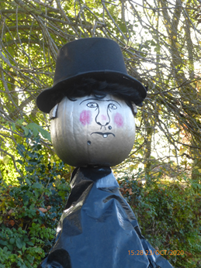
Photo gallery

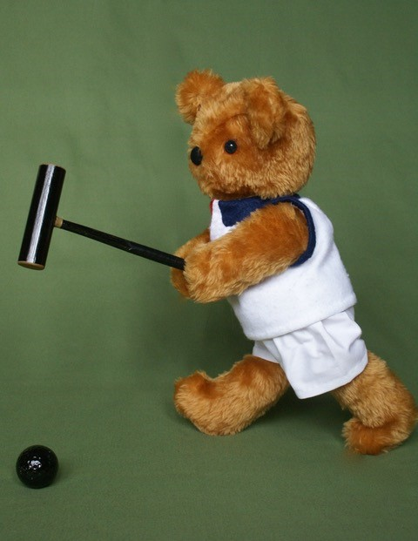
On the left, Robert Moss’ Budleigh Bear is ready – are you?

Meanwhile, on the right over in Nailsea, a very special person makes an appearance.

(It’s Nanny McPhee in case you didn’t recognise her!)

Development

Our monthly Zoom meetings continue to be well supported and we are really pleased that key people from outside of our region respond so positively to requests to speak to us. As part of the coaching survey, we asked how you felt the SWF had performed overall during lockdown. It seems our efforts to engage with our members is working well. You have rated us:
excellent 35% very good 35% good 15% satisfactory 2%
If you have suggestions about how we can improve this, then please let us know.
And do check out information about a new Clubs in Crisis funding stream which opens for applications on 12th April. This should come to you as a separate attachment with Cygnet. A grant of £2,021 is available to clubs who can demonstrate

- They have been adversely affected by Covid 19
- They need funding to resume or adapt their activity

Read the attachment for full details.

And news on the live streaming front. Something to aspire to– albeit from the other side of the world via the Notts List:

“Croquet Victoria recently announced a new partnership with Australia’s leading sports streaming service, Kayo Sports, to stream major events in 2021 live and free.”

Club Matters

This really is an excellent source of information and inspiration about all things sport. We promote it fairly regularly in Cygnet and again we encourage you to sign up for their email bulletins. You won’t be grabbed every time, but it’s really helpful to think about croquet in the wider sports context.

In Appendix 3 we reproduce a recent sample, so if you haven’t done so already, get yourself signed up. https://www.sportenglandclubmatters.com/

Judith Moore Bursary

As you sign up for tournaments in the CA Fixtures List, don’t forget our own Judith Moore Bursary fund, made possible by the generosity of Peter Moore.

Full details may be found on our website https://www.swfcroquet.org.uk/swf-bursaries/ and in Appendix 2
There are two types of application.

- First CA Fixture
- Second and Third CA Fixture

A CA Fixture is one that is promoted in the CA Fixtures Calendar which is published annually and may be found on the CA website: https://www.croquet.org.uk/?p=tournament/CACalendar

AC Laws Update
Over 100 people using 100 devices tuned in to Dave Kibble’s session on the new AC Laws. The presentation was recorded and is available:

https://www.youtube.com/watch?v=2dVi1-d2xFw

https://www.swfcroquet.org.uk/wp-content/uploads/2021/03/SWF-AC-Laws-Changes-March-2021.pdf

Dave has circulated this to all the Federations and comments:

The presentation does not go into the more esoteric aspects, nor those that a Referee on Request or in Charge needs to know and a player could be excused for not being on top of. The caveat of course is that this is not authorised by any Laws committee.

A lighter touch
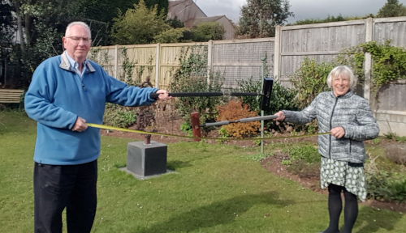
2 metres is still 2 metres

It’s easy to become a little too relaxed a little too quickly so Dave and Linda remind us what 2 metres looks like.

If you can hit someone with your mallet, they’re far too close, so go ahead and give them a gentle reminder.

This is brilliant

If you haven’t seen this on Facebook or elsewhere, do have a look at this excellent promo for croquet – even if you don’t ‘do’ social media, how about making your own film for your website?

https://www.bbc.co.uk/news/av/uk-england-sussex-56593488

Not the April Fool

April Fools’ Day may have passed but there’s still time to be a bit silly – you may prefer the term ‘creative’ – so here’s a couple of starters:

- Players should come on to the lawns to the strain of their most inspiring music choice as they do in snooker – what’s your anthem?
- We should have official cheer-leading teams with pom-poms matching the colours of the player they are supporting
  - An idea for those wet afternoons in the club house (when we’re allowed back in there): create your chants and step routines

Diary dates column
21st June: Deadline for entries to East Dorset CC High Bisquers’ 1-day tournaments AC & GC to be held 30th June and 1st July respectively. Contact Gary Brennan 01202 690 230

Advertising in Cygnet

All adverts must be sent fully formatted in such a way as they can be easily inserted (copy and pasted) into Cygnet. We are not in a position to undertake any artwork or correct for errors or omissions.
Charges include a 2-3 line entry in the Diary Dates column in the three subsequent issues.

Charges
Full Page: £12 Half Page: £6 Quarter Page: £3

Appendix 1: Child Safeguarding Policy: suggested adoption proforma
Club logo

Child Safeguarding Policy
Name of Croquet Club
Date

As a member of the Croquet Association, name of club Croquet Club accepts that the club Committee has lead responsibility in this area and has established checks and procedures to ensure the following are implemented:
- CA Child Safeguarding Policy: https://www.croquet.org.uk/?p=ca/schemes/safeguarding
- Safeguarding Codes of Conduct: https://www.croquet.org.uk/?p=ca/schemes/safeguarding/conduct
- Child Safeguarding Processes: https://www.croquet.org.uk/?p=ca/schemes/safeguarding/processes
- Child Safeguarding Guidelines: https://www.croquet.org.uk/?p=ca/schemes/safeguarding/guidance

The name of club Committee will ensure:
- A Local Safeguarding Officer (LSO) is appointed and their details registered with the CA
- All members of name of club are informed on joining, and annually thereafter, of their responsibilities:
  - Be aware of the need to safeguard children (i.e. those under 18 years)
  - Be good role models both in play and other croquet activities
  - Be aware of, and comply with, the CA Codes of Safeguarding Conduct
  - Know how to contact their Local Safeguarding Officer (LSO)
  - Report any safeguarding concerns they have to the LSO at the earliest opportunity
- Those whose responsibilities will, or may, include Safeguarding responsibilities liaise with the LSO to ensure they are undertaken properly. These include:
  - Membership Secretary
  - Those with access to personal data
  - Coaches
  - Team Captains
  - Tournament and event organizers
- Our adoption and implementation of this policy, and LSO contact details are available:
  - On our website
  - Clearly displayed posters on our premises
- Implementation of this policy is monitored at each committee meeting and an annual report is presented to AGM.
- This policy is reviewed at least every three years

This policy was adopted by the Club Committee on date
It will be reviewed date in 3 years time

Our Local Safeguarding Officer is:  Name and contact details | The CA Safeguarding Officer is:  Dr Ron Carter  dr.roncarter@gmail.com  079 732 393 19

This could be made a more attractive poster for the noticeboard by the addition of a suitable graphic.
Appendix 2 Judith Moore Bursary

Who can apply?

There are two types of application.

- First CA Fixture
- Second and Third CA Fixture

A CA Fixture is one that is promoted in the CA Fixtures Calendar which is published annually and may be found on the CA website: https://www.croquet.org.uk/?p=tournament/CACalendar

First Fixture

An application to the Bursary Fund may be made by a croquet player in the South West Federation region who:

- Is a member of a croquet club which is itself a member of the SWF
- Has not previously played in a CA Fixture
  - They may have played in club competitions and SWF League matches

Second and Third Fixtures

An application to the Bursary Fund may be made by a croquet player in the South West Federation region who:

- Is a member of a croquet club which is itself a member of the SWF
- Is a Premium Member of the Croquet Association
- Has not previously played in more than two CA Fixtures
  - They may have played in club competitions and SWF League matches

What costs will be covered?

The Bursary will be awarded to cover the Tournament Entry Fee only.

Process

An application may be made at any time on the application form below. It must be sent to the SWF Secretary to arrive at least 3 weeks before the start of the Tournament that the applicant wishes to enter.

The application will be checked for accuracy verified by a panel of three. This will normally include Peter Moore and two members of the SWF Committee.

The applicant will be informed of the Panel’s decision within two weeks of receipt of the application.

Should the application criteria not be met, the applicant will be informed of the reasons for this and will be invited to apply again once the full criteria are met.

The application form may be found on our website: https://www.swfcroquet.org.uk/swf-bursaries/
Appendix 3: Club Matters bulletin – extracts
YOUR CLUB MATTERS UPDATE

Top tips to help people return to activity

As outdoor sport and physical activity reopens, Sport England has put together a suite of resources to help the sector return to play.
More than half of people (51%) say they feel less worried about returning to play now the vaccine rollout has begun, compared to 40% in January - and Sport England has also used this research to draw up a list of top tips to help clubs encourage people back to activity.

A new film is promoting outdoor sport and physical activity.
Please share it on your social media channels.

But the insight also shows people may be lacking in confidence after a prolonged break from their usual activities, so they’ve collated a set of resources to help clubs encourage people and ease them in slowly.
Alongside the top tips, there's a comprehensive set of frequently asked questions, updated legal guidance, a refreshed clubs toolkit and a set of case studies from organisations about how they’ve planned for this return to play.
At Club Matters, we've also worked with Peterborough Town Sports Club and have a series of videos that show how they've prepared for all their sports to return.
We've also updated our website with new resources to help clubs return, including guidance on effective communication and supporting mental wellbeing.

Creating an inclusive environment

Jess Cook, national partnerships adviser at the Activity Alliance, has written a blog on our website that discusses the impact of coronavirus on disabled people and shares some ideas of things clubs and groups can do to ensure they're inclusive.
The Activity Alliance has also published a fantastic guide for clubs to help them be more inclusive.

Supporting people with health conditions

UK Coaching is keen to provide support to coaches to increase their confidence and competence when working with people who have long-term health conditions.
They're looking to undertake a number of online focus groups across April and May with coaches and participants to better understand the current situation.
You'll have the opportunity to share your experiences, which in turn will help to develop training.

© 2021 Sport England. All Rights Reserved.
Terms and conditions | Privacy statement | View online | Unsubscribe

