Welcome to Cygnet everyone. I hope you’ve been able to join us as we’ve been keeping in touch through our monthly Zoom meetings, preparing for the AGM and enjoying Stephen’s “Playing to the Rules” series of GC Zoom modules.
Contents
AGM p1
Celebrations in the South West p2
Apps Heley – St Agnes’ experience p3
Murphy Shield – East Dorset tells all p3
National Short Croquet p4
Zoom – don’t miss out p4
GC: Playing to the Rules p5
Lawns-friendly Wheelchair p5
Who da thought it – Dowlish Wake tell a tale p6
Shout it loud – just like Broadwas p6
Lawns – Moreton in Marsh latest photos! p7
Film stars in Nailsea p7
Don’t be strangers – share your news p7
Appendix 1: Broadwas press release p8
Appendix 2: Broadwas development plan p10
Read on for more information about all this and more …

SWF AGM

All member clubs have received the AGM papers with details of Committee nominations and the various proposals.
These are also available on our website. https://www.swfcroquet.org.uk/wp-content/uploads/2020/10/003-Agenda-and-papers.pdf

Each Full-member club is entitled to two votes at the AGM and we need to know who these are by Friday 13th November so we can sort out the voting process. Please let Linda know who these will be asap. lindawithani@hotmail.com. Also contact her if you have any other queries about this.
Others may attend the AGM as observers and the invitation will be sent to all clubs so please ask your committee if you’d like to attend in this capacity.

The AGM will be held on Zoom and all delegates will be sent information about this beforehand. There is an opportunity to have some practice at our next monthly Zoom meeting on 10th November. The invitation link will be sent nearer the time.

As a warm up for this our Chair, Brian Wilson, has a few words:

Covid has affected us all – but at least we can play croquet and for many, our time on the lawn has made the difference between maintaining enjoying oneself or going ‘stir crazy’.

Many clubs have experienced a marked number of people wanting to try croquet and their membership has increased – long may it reign. It makes sense when you think that people are looking for a new interest or sport, as they have ‘time on their hands’. Croquet is a sport for all ages and abilities - one where you can unleash your competitive urge and still remain friends!!

So, here’s to the rest of the year and I’ll raise a glass to croquet’s continuing health in 2021 and beyond.
Celebrations in the South West

The CA ran a well-managed AGM on Zoom – for those who missed it, you can watch it on https://www.youtube.com/watch?v=9R_8xzKhtgI&feature=youtu.be and you can find a report of the meeting at https://www.croquet.org.uk/?p=press/news&NewsID=7148&pup=y
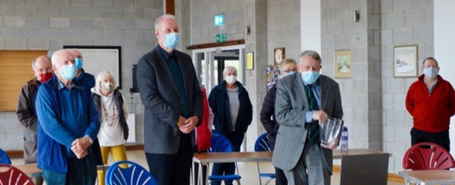
Kington Langley marked the event with a socially distanced gathering at the village hall where we watched the event on a large screen.

The South West secured a bumper crop of awards – so well done everyone involved.
Best behaviour for Zoom: Brian extols John’s work

Diplomas were awarded to

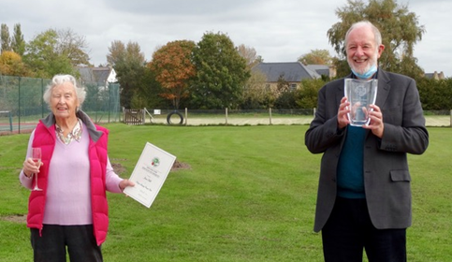
Adam Moliver, Cheltenham
Christopher Hague, Beckford
David Hunt, Nailsea
David & Nancy Temple, Sidmouth
Des Honey, Cornwall
Howard Rosevear, Cornwall
Ian Stratford, Budleigh Salterton
Jane Hull, Kington Langley

John Evans, Glamorgan

Finally, John Grimshaw was presented with a beautiful engraved glass vase: the new Bernard Neal Award for exceptional services to croquet, by Brian Shorney, a past Chair of Council and well-known to many of us in the South West.
Socially-distanced celebrations for Jane and John

Thanks to Kington Langley for their hospitality – the fizz and nibbles to celebrate the two, local award-winners was much appreciated.

Now it’s your turn?

Every croquet club is well-served by many volunteers who frequently go above and beyond in their contribution to the life of the club. If your club wants to recognise someone in particular, you can read the criteria at https://www.croquet.org.uk/?p=games/clubs/caClubGuide#cadiplomas

But do contact Paul Francis if you’re thinking of applying for one of these. They are handled by the Development Committee (of which Paul is a member) and he can help you with the bid and promote your cause at committee level. paulwfrancis@icloud.com

St Agnes and the Apps Heley – more celebrations

St Agnes CC were the proud and worthy winners of this CA Award last year, receiving a cup and a cheque for £250. Their Chair, Ivan Corbett, describes how they used the funding:

We have used this cash to promote the development of croquet for younger players. We have purchased ten short shafted mallets from a local golf centre which flirted with croquet and then decided to concentrate on the golf business and turn their farm into a nine-hole golf course.

The upshot was that we were able to obtain these ten £50 mallets brand new for half price. The only thing wrong with the deal was our impeccably bad timing – this was in February. Hopefully ‘normality’ will return at some stage and these mallets can be used.

It has taken all this time for the matter to be raised at a Zoom meeting and for the committee’s agreement that this was a sensible use of the award. If sounds very inefficient. but I will say in our defence that since we re-opened our lawns (courts!) on May 15th we have booked and played over a thousand sessions of croquet. I think you will agree we have our priorities right. Croquet clubs are in the business of playing croquet!

CA club awards
As a reminder - the CA makes these awards biennially in three categories to clubs that have made exceptional progress in providing a good playing environment over the previous two years:
- The Townsend Award is given every two years to a club with one or two courts that has, in the opinion of the Development Committee, made exceptional progress in providing a good playing environment over the previous two years.
- The Apps Heley Award is given every two years to the club with three or four courts that has made most progress at a national or local level in the last two years.
- The Millennium Club Award is given every two years to the club with five or more courts that has made most progress at national or local level in any of two of the previous three years.

Check out https://www.croquet.org.uk/?p=tournament/honours/awards/ClubAwards ffi. And again, do contact Paul if you’re club is thinking of applying: paulwfrancis@icloud.com

East Dorset retain Murphy Shield – keep the bubbly flowing …

East Dorset CC, has retained the trophy they won in 2019 at their first attempt in the Murphy Shield competition.

This is the second-tier national inter-club GC KO competition organised by the CA for teams of four with a total handicap of at least 12. The match format is one doubles and six singles rubbers, each best of three games. In the 2020 final, played at a hospitable Cheltenham, East Dorset defeated Ashby 5-1 with one rubber unfinished, although the final score was perhaps a little flattering.

With the advent of coronavirus, the original entry of 24 clubs reduced to just 6, including 2 from SWF, willing to continue in the competition. The draw left open the possibility of a repeat of the 2019 final between East Dorset and Camerton & Peasedown, but that was not to be. In the semi-final Ashby exacted revenge for their defeat by Camerton & Peasedown at the same stage last year.

The winning team lines up on a rather dull day. From the left:
Mark Hamann, Hannes Hamann, Michelle Leonard, Tony Green with John Bowcott (competition director) in the centre.

East Dorset had an easy passage to the final with a bye in the quarter-final followed by a walkover in the semi-final when, East Dorset having won the toss for home advantage, their opponents conceded victory as they did not wish to travel.

The winning East Dorset team was Michelle Leonard (3), Hannes Hamann (3), Mark Hamann (3) and Tony Green (4). Mark and Tony had also been members of the 2019 winning team.
East Dorset’s victory was largely based on a clean sweep of the singles involving Mark and Tony.
The team started strongly and by soon after lunch had established a 3-1 lead. At that point however, overall victory remained in the balance for some time as Ashby fought back to take a 1-0 lead in each of the three remaining singles.

The decisive result came when Tony won at hoop 13 of the third game of his rubber in a contest which had been close throughout and could have gone either way. With the match result settled East Dorset rallied in the other two singles, winning one and leaving the other unfinished in the interest of long journeys home.

The challenge now for East Dorset is to become the first club to win the trophy on three occasions, Broadwas being the only other club with two victories.
Keith Southern, East Dorset captain

National Short Croquet
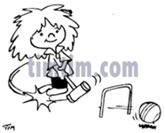
This wasn’t played this year and neither did we hold either our own Spring or Autumn Short Croquet tournaments.
We have therefore decided that Bristol, Sidmouth and Kington Langley (last year’s contenders) be invited to play off for a place in the 2021 national event.
Many thanks to John Grimshaw for continuing to co-ordinate this for us and fingers crossed for some play next year.

Zoom

It’s been great catching up with so many at our monthly Zoom meetings.

Our last session focussed on Marketing – expertly led by Paul Hetherington who now has the lead on this topic with the CA Executive Committee. If you missed it, or want to refresh your memory on any of the points, it’s available here: https://us02web.zoom.us/rec/share/JDhlKbeqyfI82z6MjaXj7IuvoQBGLeFss-um8upQvCXoXNx5EXWx1Oz9Rx8-_nSm.iwqX1GjfWO6xyhpX Passcode: zY+.6m4!

We’re looking forward to our next meeting on 10th November. We’ll be having a bit of a practice on voting, speaking etc ahead of the AGM but we’re also looking for a focus topic. Full details will be in the invitation which will be sent out a week or so before the event.

Correction
Thanks to David Steadman (East Dorset) for pointing out his name was missing from the list of people attending our September Zoom meeting. Apologies David – and on your debut appearance as well!

Playing to the Rules

This is the title of Stephen’s excellent series of sessions reminding us of the rules we all need to be aware of. With attendances of 60+ on the night, and the sessions being available on line afterwards, we’re delighted to be reaching so many GC players.

For those who’ve missed them, here are the links to the sessions we’ve run so far.

Session 1: 14.10.20 - Overview
https://us02web.zoom.us/rec/share/rFeO0zuU0VYEMgNnfBQJZVPV0nj7thkWwlDbkxRRHPcdOwJDL1w_ifuyCRk8sCiH._rGe9mD-0WFNI5Ii Passcode: 62.SHF+D

This session covered: self-refereeing – errors and faults – how and when to call for a ref – anticipating faults – disagreeing with the ref – what is an umpire – how and when to call for an umpire – how to mark a ball

Session 2: 21.10.20 – Wrong ball
https://us02web.zoom.us/rec/share/8iMHrq-X6Tw1kDG-7NZ7AVOlmz-f4sTJduwp1GYeKUUz4QXw7xM9igoYPqaLOXdn._Xju4XaaR05V-KO- Passcode: R4K1+!82

Session 3: 28.10.20 – Offside and Deeming
A different format this time:
Click to Download
zoom_0.mp4
212.9 MB
Who da thought it!

Dowlish Wake have been having a grand old time. They tell us about this amazing climax to a game of GC Doubles – let this be a warning to anyone playing there next year! Dave Green and Keith Bryant tell all.

It was a warm sunny day at Dowlish Wake CC in rural Somerset when Katie Bryant, Dave Green, Malcolm Norton and Keith Bryant took to the court for a GC handicap doubles game.

It was a competitive but uneventful game when yellow ran the 12th hoop to make it 6-6. No one could have imagined what happened next.

Katie played her blue ball down the long slope (yes "slope" is the correct terminology as visiting teams will testify) towards hoop 13, took her final extra stroke and put the ball in front of the hoop well hidden from the red/yellow combo.
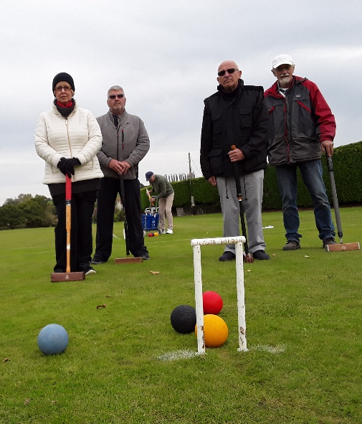
Red played, went through the back of the hoop with just enough momentum to move blue so that Katie could not run the hoop. Her exclamation of "What the ****!!” could be heard for miles around.

Unbelievably this was followed by both black and yellow also going through the back of hoop 13.

There followed an exchange of clearance shots before the red/yellow team prevailed.

The chances of 3 balls being played in turn down the long slope through the back of hoop 13 must be a rarity to say the least unless you know differently!!!!

The motley crew: From left to right Katie Bryant, Dave Green, Malcolm Norton, Keith Bryant

Lawn-friendly Wheelchair

We are grateful to Peter Moore who has donated an adapted wheelchair to the Federation. At the moment it is on loan to Swindon CC. If your club is interested in using this, please contact Paul Francis: paulwfrancis@icloud.com

Shout it loud: Promoting your club

Broadwas give us an excellent case study on how they’ve done this. Chris Croft writes:

I retired some while ago from the crystal and glass engraving business, but I do still have responsibility for publicity and communications here at Broadwas Croquet Club.

To encourage people in the Teme Valley to consider croquet as their game, we undertook a major drive earlier this year to invite anyone who was interested to get in touch so that we could give them some more information with an invitation to visit us on a trial basis.

One of the ways we’ve done this is to identify the editors of all the local Parish Magazines and Newsletters (electronic or text) and send them regular updates of our activities and progress over the year.

The attached article (see Appendix 1) is the third such update and all 10 editors have been good enough to publish everything we’ve sent them to date. All our own members have received copies of the articles I’ve written and they have been published on our website.

This has taken place in the context of their Membership Development Plan (see Appendix 2) which is an inspiration to us all.

Green shoots for Moreton in Marsh

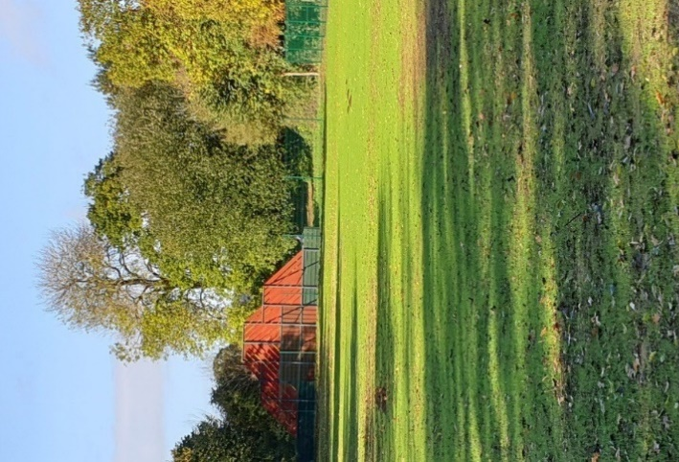
In the last issue we showed you a photo of Moreton in Marsh lawns after 4 days rain – it was a sorry sight – but baby just look at them now …

Film stars in Nailsea
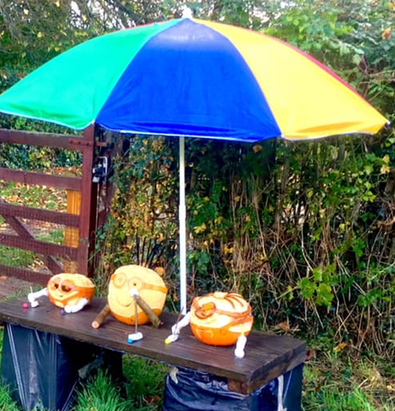
Nailsea CC joined in the local Halloween Pumpkin Trail to help keep the club on the map. They promoted their entries on their own Facebook page and on the Nailsea Community Group page.

Libby, Terry, Pete and Maggie worked hard creating the replicas.

The theme was Films – can you match the models to the films?

Who’s this sheltering from the rain?
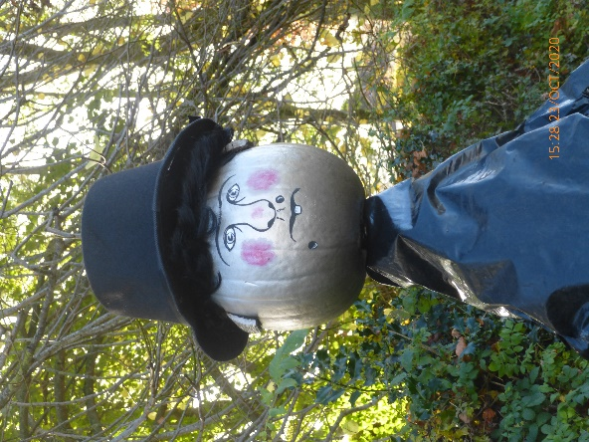
Whoever they are – I love their mallets!

And who’s this watching over them?

Answers at the bottom of the page.

Don’t be strangers

We may be entering into a quiet time of year as far as playing croquet is concerned, but some clubs will be playing through the winter.

And there’s the AGMs, planning and preparation for next year and so on.

Do share your ideas, photos and stories with us – we’d love to see and share them – but do make sure anyone appearing in the photos is happy with this.

Answers: Minions and Nanny McPhee

Appendix 1
Broadwas CC Local Press Release

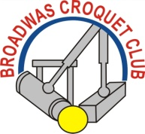 Upbeat at Broadwas

Broadwas Croquet Club is tucked away in the Teme Valley on the border of Worcestershire and Herefordshire. We’re a lively and competitive Club with four full-sized lawns and 55 active members.

This year a dry Spring followed a very wet Winter which made lawn preparation difficult, though not half as difficult as the ensuing Covid 19 pandemic. We could have caved in; put up the shutters and stood back until things settled down, but like other Clubs, that’s not the Broadwas way, so we persevered with getting the lawns ready using our own skills and the expertise of a local contractor.

Having received excellent advice and guidance from the Croquet Association we found ourselves back in business by the third week in May with an exhaustive sanitisation regime but without the use of our pavilion and toilets and with all competitions, both internal and external, cancelled.
We also introduced a new lawn booking system under the eagle eye of our Club Captain & Secretary John Guy, so as to control lawn usage and record when each member was playing. A side benefit of this system is that our members are now spreading their use of the lawns over a greater proportion of each week.

In January we had embarked on an ambitious membership development programme mainly through local newsletters and Parish magazines. This generated plenty of interest but then the pandemic struck. Rather than disappoint prospective joiners we kept all their contact details and promised to re-connect when things improved.

The moment isolation was lifted we honoured our promise, whereupon we welcomed 38 visitors from whom 28 prospective members emerged. They all attended taster sessions and in the end 18 of them actually joined as full Club members. To introduce these new members to the Club and make them feel welcome, we appointed a New Members Secretary, Mary Dryden. Our sincere thanks to Mary for carrying out this important role in such difficult circumstances.

In parallel with all the other events of this year, our President, John Steel and our Chairman, Stuart Smith had been making formal approaches to Sport England for funding to create and kit
out a new fifth lawn. Sport England provided us with a generous grant and we thank them both for the grant itself and for their support throughout what turned out to be a pretty rigorous application process. The new lawn has provided very welcome extra playing space that has helped to accommodate both new and existing members within the playing limits imposed by Covid19 safety requirements.

In all, life in the Broadwas Croquet bubble has been very different, but we’re more than managing. In fact, one of our Club Coaches, Jeff Faulkner, has instigated and run a very well organized and successful internal league Golf Croquet competition for the benefit of new and existing members that has brought out the best competitive instincts in everyone.

So, what next for Broadwas Croquet Club? Well we intend to remain upbeat but watchful for the future. If we can, we aim to play right through the Autumn - elements and pandemic permitting. But, most important, we plan to keep in close touch with each other over the Winter by enjoying our monthly Croquet Club Breakfasts that proved so popular last year – taking all the requisite precautions, of course.

So, don’t be surprised to receive another upbeat report from us here at Broadwas next Spring when hopefully we’ll be looking back on Covid19 and looking forward to a new season of Croquet and to playing the game that offers so much fun and fellowship to us all.

Chris Croft

Appendix 2
Broadwas Croquet Club Membership Development Plan 2020

- Introduction
As a Club we need a steady flow of new, like-minded members to refresh our numbers and to maintain a financially viable Club with acceptable annual membership subscriptions. Otherwise we run the risk of contraction and eventually extinction. Rather than adopt a scattergun approach, we’ve worked on a Membership Development Plan with identified priorities and a modest annual budget.

Outlined below is our Plan. It’s fairly simple and simple to operate. We’ve been using it for the last 12 months and it’s worked pretty well for us.

- Priorities
2.1 Work on satisfying the needs of our existing Membership so that they want to continue to be members (Atmosphere, Enjoyment, Loyalty, Lawn Quality, Subs, Competitions, Social, AC-GC Balance, Communication, Feedback etc)
  - Our best ambassadors are our (happy) members. We all have friends, relatives and neighbours who, if asked, may well like the idea of unlocking the secrets of croquet. They may be just waiting for an invitation, so we try to make sure we all have a handy supply of up-to-date fliers showing our contact details and our website address.
  - We try to alert each other when guests first come to visit us as prospective members so we can extend a warm welcome. There’s always a good supply of information in the pavilion on the game, how it’s played and the costs and benefits of membership.

- Essential Promotional Support
In our case Essential Promotional Support falls into three or four areas, namely:
3.1 Simple-to-access-and-read website saying who we are, how we operate and how to get in touch with us. Images speak 1,000 words! CA can be very helpful here with web prototypes and skeletons which we’ve tailored to fit our Club’s own requirements.
3.2 Good supply of A5 fliers with accurate contact details in prominent places within our catchment area (Our Own Pavilion, Village Hall Noticeboards, Community Shops, Doctors/Dentists/Opticians Reception Areas, local U3As, Golf & Cricket Clubs etc
3.3 Carefully chosen local Shows and Fetes (with flat lawn areas) that would like us to promote croquet at their annual show/fete through croquet demonstrations and hands-on experience for visitors.

- Publicity Opportunities
Lots of publicity opportunities are available but we try to be careful here otherwise they can become too onerous and too costly. Here are three we’ve found to be very cost-effective:
- A simple Newsletter, emailed monthly or quarterly, primarily for Club members, prospective members, our own website, the CA and Cygnet.
- A steady flow of Press Releases and photographs (one per month is pretty demanding) with emailed copies to (a) all our existing members, (b) past and prospective members, (c) sponsors and prospective sponsors, (d) local Parish Council websites, (e) local press/TV & Radio Stations, editors of local Newsletters & Parish Magazines in our catchment area.
- A professionally produced A5 flier, full of colour and action, to double as an invitation to like-minded people interested in playing our game.

- Budget

It would be wrong to expect a few members to fund this initiative from their own pockets. That said we found that only a modest budget is required. Here are the basics: they are all annual costs:

- Website Maintenance & Development £100
- Introductory A5 fliers (500) £100
- Show/Fete Preparation (say, 2 annually) £100
- Quarterly Newsletter Preparation £50

- Conclusion
As a Club we were already doing some of the things contained in this plan. The aim was and still is to bring what we’re doing and what we need to do under one banner, prioritise it ready for action. By doing so we feel we stand a much better chance of safeguarding our Club’s future by augmenting our numbers with new, like-minded members.

Our first step was to get our Management Committee to buy into the Plan and get the budget approved: next to invite a couple of willing members to go ahead and run the Membership Development team: and, importantly, to get members on board by letting them know what’s happening and encourage them to participate.

Well, the proof of the pudding is in the eating, because as the attached End of Season Report shows, we’ve increased our membership by just under 20 new members and, just as important, we’ve retained almost all our current membership

Chris Croft
Broadwas Croquet Club
(October, 2020)

