Well, we’re seeing some hopeful signs and several clubs are playing again, taking great care to do so safely. Let’s hope that this positive trend is echoed across the country.
Contents
P1 League Play
P3 Financial Support
P3 Zoom
P3 Clubs’ News
P5 On-Line Booking System
P5 Coaching
P6 Chastel Tivy
P7 Aqua Power
P8 Marketing Successes
P9 CA Affairs
P11 Quiz Corner
P12 Appendix 1 - Zoom
P14 Appendix 2 – Handicapping

As ever, lots to read this month and, as ever, we’d love to hear your feedback, comments and contributions. Please send them to Linda:
lindawithani@hotmail.com

Now let’s get going:

League Play

Firstly: information from Beatrice McGlen, director of the National Short Croquet Competition who informs us that the state of play for this year is under discussion. Stephen is keeping Weston-super-Mare, who will be representing the SW, up to date with events.

So, will we be able to play any League matches this year? Stephen has been keeping an eagle eye on developments and how we might facilitate this if conditions allow – and if there is sufficient interest / ability to play from SWF members.

These are his tentative suggestions as things stand at the moment and please do contact him if you have any views.

- Purpose
  - The aim of the matches will be to approximate the normal leagues in the South West but the actual details will be wholly dependent on the time available
  - If blocks are used, or some equivalent, then play-offs and finals can be completed in an extended season.
  - It is inevitable that whatever system we use will be a compromise between fairness and expediency

- Pre-requisite conditions
  - Government and CA regulations must allow for car-sharing.
  - Host clubs can offer playing facilities and conditions meeting the regulations.
  - Refreshments will be brought by individual players for their own consumption.
  - Toilets will be available

- Expected additional limitations
  - The Short Croquet league will be postponed until 2021.
  - Instead of Home and Away we will use whatever facilities are available.
  - Matches will be arranged within small regions to minimise travel.
  - Matches will be restricted by time, facilities and players available.
  - There will be no promotions or relegations in the Advanced AC league this year.
  - If some clubs are unable to raise handicap teams, the handicap restrictions may be relaxed.
  - It is not intended to have trophies and plaques awarded for the leagues in 2020

- Plan and schedule
  - The schedule for any resumption is currently very uncertain. If, in late June, it seems feasible that some form of inter-club play may be possible in July, we will canvass all of the clubs to find who wishes to play in which leagues and what facilities, if any, they have to offer.
    - Matches may follow the normal structure or there may be single day inter-club tournaments which will equate to several matches and therefore replace blocks. (These are described below.)
    - Play-offs and finals held in late September or October, assuming that many clubs will extend their playing season if the weather allows.
  - Some clubs will not be able to participate fully for a variety of reasons. Whilst sympathising with their problems, we believe that those clubs that are able to enter inter-club competitive play should be enabled to do so, if possible.
  - It may be necessary to organise events at short notice and we hope that clubs will be accommodating when it comes to fitting in dates.

- Single-day team tournaments.
  - These will be like the Spring and Autumn Short Croquet tournaments, i.e. 1-day events in which several teams play each other and are ranked at the end.
  - A structure has been created to cater for different team sizes and numbers.
  - The number of players that can compete will depend on the number of lawns available, which will require the cooperation of some multi-lawn clubs.
  - The cost of the use of the lawns may need to be shared between the teams, with a subsidy from the SWF.
Financial support

It would be good to hear how you’re getting on with your grant applications – you can see there has been a measure of success for some clubs – it would be helpful to share tips on writing good applications so do send us your ideas.

It would also be good to share your ideas for how you might spend the Covid 19 grants: longer term safety measures, bigger projects, membership fee subsidy? Do drop us a line. paulwfrancis@icloud.com
And we received this update from the CA:
For clubs in England that were ineligible for the Coronavirus Small Business or Leisure & Hospitality grants, a further funding scheme has opened up for which they could be eligible. Please see the latest Press release:
https://www.croquet.org.uk/?p=press/news&Action=NewsDetails&NewsID=7012&pup=y&RFB=y
The moment our hearts went ‘Zoom’
There was a great turnout for our first Zoom meeting – thanks to Paul for arranging everything and making it run smoothly. Apart sadly from Abbey who were unable to activate their sound – let’s hope it’s sorted for next time. And thanks to Paul and Stephen for the account that appears in Appendix 1

Clubs’ News

Winterborne Valley Croquet Club Opens

Great news as an update to the item in the March issue of Cygnet from Tim Dennis. This is an extract from the press release issued by the club:

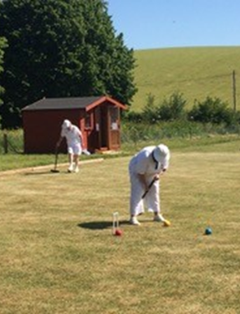
Oldest club member opens play on new lawns in
Winterborne Stickland.

Our oldest member, Tess Burt, was the first person to play on the new lawns, and this was on her birthday! Tess is the holder of a Croquet Association Diploma for services to croquet and has represented England in a women’s team in Australia.

Winterborne Valley Croquet Club is an existing (renamed) club which has relocated to the Winterborne Stickland Sports and Community Club (WSSCC) from its previous site at Kingston Maurward, Dorchester.

The support of WSSCC for the project has been superb. After a great deal of work what was a football pitch is now fit for playing croquet.

The weather in 2020 has been a trial. 6 weeks of continuous rain prevented seeding, followed by (so far) 2 months of almost no rain after grass seeding. Then came the rabbits! A rabbit proof fence has been installed - rabbit damage has limited the opening to one lawn instead of two but the second lawn should be playable also in the reasonably near future.

The project has been accomplished with a generous grant from the local Solar Fund and also the Croquet Association.
The strict application of social distancing requirements and, following advice, other precautions, means that only social play is possible at present. League matches and competitions will follow when the regulations allow.

Chair Tim Dennis said “We are delighted that play can now start on our new lawns. Without a generous grant from the local Solar Fund the project would have proved very difficult to accomplish. Following the latest lockdown changes we can now welcome new members with coaching available. We look forward to encouraging others locally to take part in this skillful, fascinating, and social sport.”

********
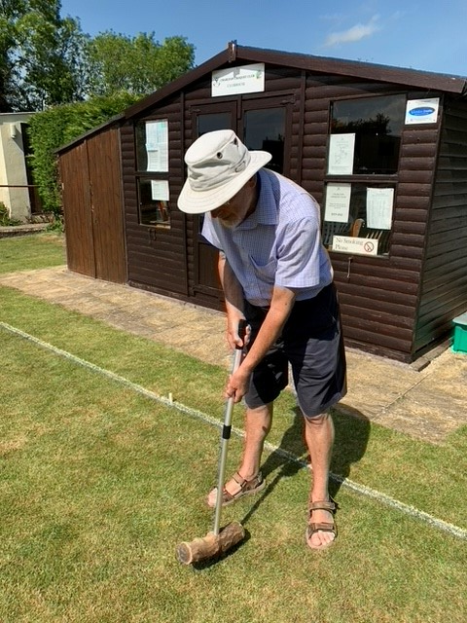
Dorian from Charlton CC wrote to say they opened their lawn to couples only. And someone hasn’t been wasting their time – David Peet made his own mallet from a piece of laburnum wood from his garden for the head, and the handle from a brush he used to wash his caravan with!
Who knows – he may have hit upon the magic solution!
********
We got a sober reminder from Richard Wood at Mumbles CC (not a SWF member – yet! - but in the SW region) that Wales hasn’t left lockdown yet so no play for them

********
And finally, from Gary Brennan at East Dorset: both the AC High Bisquers on 30th June and the GC 'C' Level on 1st July have been cancelled. They were advertised in SWAN and it probably won’t be a surprise to anyone, but do pass the word on.

For Sale: Croquet and Lawn Equipment
Very sadly for a variety of reasons we had to disband Great Bedwyn Croquet Club.
We have a vast amount of second hand equipment for sale including a 24-inch Atco mower which has just been serviced and has not been used since the service.

We have balls, hoops, mallets, lining machine, sprinkler hose, and fertiliser sprinkler and loads of other useful bits and pieces. If you are interested please email me for details and photos.
Yvonne Cunnane
yvonnecunnane@yahoo.com
07900680942

On-Line Lawns booking systems

Several clubs are already using such a system and Covid 19 has encouraged other clubs to think about this.

The CA hosted an excellent webinar run by Campbell Morrison and Simon Hathrell who have designed an on-line lawn booking system. Those of you who weren’t able to attend, or those of you who’d like to refresh your memories, can view the event at https://www.youtube.com/watch?v=iBDAFjmfSLI – at the time of writing this was an un-edited version but this should be sorted in due course.
Coaching

Dave Kibble sent us this – essential reading especially for GC players.
If you are interested in improving your performance, I strongly recommend you read
http://www.croquetworld.com/Game/quantifying-golf.asp and especially note:

"Because more than half of the game (GC) is about taking position, a significant amount of time should be spent practising this simple closed skill. No opponents are needed, and a player determined to improve can endlessly work on controlling their power and
direction.

However, from years of coaching and talking to Golf Croquet players, it is very evident that discipline is needed to prevent a well-intentioned session of position-taking practice evolving into one that involves shooting at long hoops and trying to hit long clearances.

Hitting powerful clearances in the middle is an activity which gives immediate positive feedback, while position taking can feel mundane and irrelevant. However, as the most commonly played shot in the game, it should be a player's most accurate stroke."

The SW Croquet Academy gave us this update: With many clubs now open and allowing play under the CA's latest guidelines, I am sure there will be players eager for some coaching.
However, although Budleigh has opened up its lawns, the club is not yet ready to receive visitors and non-members. And this means that the SWCA can't restart our coaching activities yet. Let’s hope we don’t have to wait too long.

Richard has just finished giving a four x 40 minute Zoom coaching course on "Getting a Break Going without Bisques", aimed at AC 8-14 Handicaps.

There were seven participants. He will be happy to repeat it if there is a demand (one person so far) - please contact him directly if interested. He is not aware of this having been tried before, but the feedback was good. richard.jackson@yahoo.co.uk

Chastel Tivy – re-visited

And while we’re with Bristol there’s an update concerning Chastel Tivy. We re-visit our old friend from last month’s issue of Cygnet. Chris Frew’s article received this response from Patricia Duke-Cox.
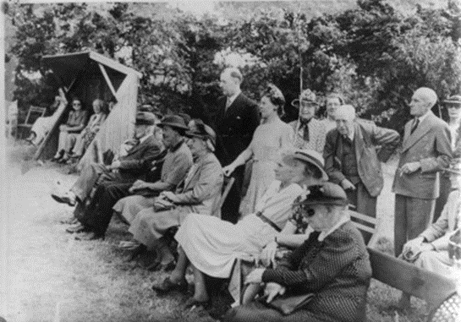
“Delighted to see the article on Bristol and see a picture of Daisy Lintern in whose footsteps I have followed some 50 years on. Daisy was the first lady to be a CA chairman and then a vice-president. It was 50 years between her appointment and mine as Chairman.

Daisy Lintern was Chairman (of the CA) 1958 - 1960, vice-chairman 1973 - 1976 and a benefactor in 1977. My dates are 2008 - 2010, V-c 2018 - and I think benefactor in 2013.”

Unfortunately this photo from Bristol CC website doesn’t feature Daisy, but it shows some then BCC members watching her play – apparently.

Klim was triggered to write:

I was particular interested to read about some examples of Croquet's historical place in their local community, the "Tivy" story being one example. This has prompted me to remind people about Heritage Open Days, which usually takes place around the first two weekends in September and are usually organised via the National Trust.

They usually take the form of guided tours and present an opportunity for recruitment. Cheltenham are to be included for the first time and appear in a classy brochure alongside other illustrious Cheltenham buildings.

Paid for content
Marketing Successes

The CA Marketing Committee (Klim, one of our Reps to CA, is a member of this) has been working hard to promote Croquet during lockdown. The CA shop has seen a surge in the purchase of home croquet sets and now it is one of the few officially sanctioned sports that can be played during Lockdown-Lite!
Clubs should have received a copy of the press release from the CA and were encouraged to follow this up at a local level – this has been really successful and in the South West, Bristol CC received a visit from a Points West crew - well two people: one with a camera and one with a borrowed mallet.

The result was an excellent piece on Points West. You can view this on the CA YouTube channel courtesy of the BBC https://youtu.be/qpi_N4dBASA
Thanks to the BBC for their excellent support with this – they made a specially-edited version for us to use. And, thank you to the Bristol members who gave such a relaxed and friendly view of the game.

Chris Southworth tells us that Worcester Norton CC were featured briefly on BBC local radio: https://www.facebook.com/watch/?v=633121723950874 – this was recorded by Chris from the on-line podcast

And there is a longer (4 min) version that went out one hour earlier in the broadcast. So, croquet got mentioned twice. This is the version that was provided to us by the BBC

Bristol member, Ed Morris, sent us this cutting from the Sunday Times of 24th May:

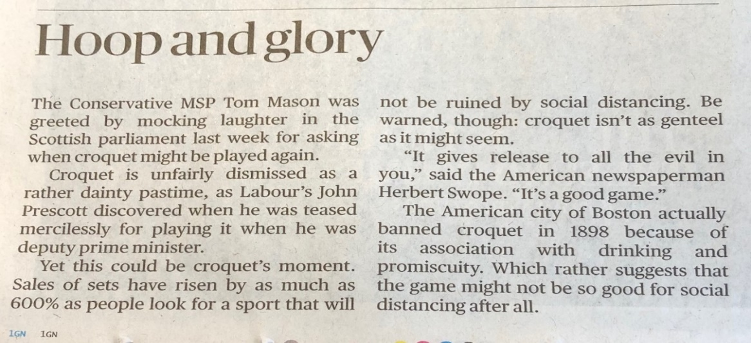

Please do keep those contributions rolling in!

CA Affairs

Council Update

Following each CA Council meeting, Ian Vincent – CA Secretary – sends a summary around to Federations. Minutes appear on the CA website and in the Croquet Gazette.
Some of the key issues in the May meeting were:
- Jonathan Isaacs, the Chairman, gave a broadly positive review of the first eight months of the new Council in terms of high-level policy, strategy, scrutiny and transparency – as well as getting to grips with virtual tools
- But felt it needed to guard against the tendency to procrastinate or micro-manage
- He urged for clear communication between Council and the Executive Board and then on to the Committees noting the particular success of the Marketing & Communication Committee and the Coronavirus Task Force
- The financial outcome for the year was predicted as being not significantly worse than the budgeted deficit but that the outlook for 2021 was less encouraging
- The Executive Board presented a proposal (accepted in principle by Council) to re-structure the Board to have six Directors, three of whose portfolios would cover the CA’s sporting activities, the other three its administrative functions, with a recommendation that the Directors should be appointed following an open recruitment process
- An update on the work of the Marketing & Communications, Efficiency and Technology reviews was presented
- Three new working groups were in the process of formation
  - Membership issues – Klim, one of the SW Reps is on this
  - Competitive play and recruitment
  - Role of Federations – Brian Wilson, SWF Chair is on this
- A review of the CA’s communication led by a PR Lead is to take place and an attempt will be made to recruit volunteers to more specific roles
- The Bernard Neal Award for Exceptional Services to Croquet – its first recipient is to be our own John Grimshaw – truly well-deserved John, congratulations
Something from the CA handicapping committee

We have been asked by the CA handicapping committee to circulate to clubs their paper on this topic. It may be found in Appendix 2. We have our own thoughts about this – if you have any comments please let us know and we can incorporate them into a response to the Committee – or of course you can contact the committee direct yourself.

CA Membership Categories Review

The CA has set up a small working group to review membership categories, both individual and club. Issues raised so far include:
- Should the Affiliate category be time limited?
- Is Premium a good term for that form of membership – a bit elitist?
- Payments made to the CA by members for various services are complex – is there a way of rationalising these?
If you have any views on this, please contact Klim: klimseabright@gmail.com

Safeguarding Policy Review

A review group has been set up by CA Council, comprising John Dawson (Chester & CA Council), Ian Shore (High Wycombe) and Linda Shaw (Bristol & SWF).

It looks as though it will take a few months to get this ready for presentation to Council. We aim to update the CA policy and then to create a set of draft policies and model documents for use at Club and Federation level.

We have started work on the Safeguarding Children documents and will also be looking at Safeguarding Vulnerable Adults.

If you have any views or ideas on either of these please contact Linda: lindawithani@hotmail.com

Keeping up-dated

The CA website is a good place to keep yourself updated about the current state of affairs and they are circulating clubs and federations with changes to this. So, keep checking it out and to download a newer version of their friendly info-graphic of advice. https://www.croquet.org.uk/

You can also follow the CA on Facebook – many of our clubs also have Facebook pages – if you let us know who you are, we can compile a list!

Quiz Corner

Dave Kibble sets us our challenge for this month with some deceptively simple questions
1. How long did the Hundred Years War last?
2. Which country makes Panama hats?
3. From which animal do we get catgut?
4. In which month do Russians celebrate the October Revolution
5. What is a camel's hair brush made of?
6. The Canary Islands are named after which animal?
7. What was King George VI's first name?
8. What colour is a purple finch?
9. Where are Chinese gooseberries from?
Look out for the answers in the next exciting issue of Cygnet.

And last month’s answers?

We had some interesting brain teasers last month – how did you get on with them? If you’ve forgotten to do them you can find that issue of Cygnet on our website: https://www.swfcroquet.org.uk/cygnet-newsletters/ – you might like to try them one more time before reading on!

First of all, Pete Trimer asked: How many circles (milling grooves) do you think there are on a standard (Dawson 2000) croquet ball?
The answer is 91

The explanation goes: There are 23 circles from equator to a pole, so 4 x 23 = 92 (‘non-equator’ lines) +2 (‘equator’ lines) = 94.
But 3 of the lines are interrupted by the Dawson 2000 logo (so aren’t actually circles), so the actual answer is 91. The O of Dawson is nearly round, but I’m not counting that, nor the 0’s of 2000.

Well who knew that? Not many – in fact if you got within 10 points of this then you’ve done better than anyone else so far! Any queries about this will be passed straight to Pete – the editor has no intention at all of getting involved.

Pete also set us some anagrams to work on:

1 | brag formed | Reg Bamford | 9 | alls energy | Sally Green
2 | flourish aborted | Louise Bradforth | 10 | avows android-hero | Dave Harrison-Wood
3 | brain guider | Ian Burridge | 11 | balked vibe | Dave Kibble
4 | shark circle | Chris Clarke | 12 | perky biter | Peter Kirby
5 | jam headset | James Death | 13 | yarn roams | Ray Ransom
6 | mama tune | Aunt Emma | 14 | surly hold | Dolly Rush
7 | jams leaping | James Galpin | 15 | lawn dashi | Linda Shaw
8 | goad archived | David Goacher | 16 | musk rater | Mark Suter
 |  |  | 17 | blown raisin | Brian Wilson
Appendix 1

The moment our hearts went ‘Zoom’

A total of 19 delegates attended this meeting, representing 14 clubs, the SWF committee and the CA reps. Each delegate spoke in turn about their club and its current activities and state of membership. Apologies were received from Budleigh Salterton and Cheltenham.

The memberships were very variable as may be seen from the table below.
One reason for this is that some clubs have their fees to be paid during January and others, like Taunton Dean, by April 1st.

Most of the clubs represented are now playing or will be starting soon. We also know that Lym Valley, which uses local authority land, is unable to restart as is Glamorgan as it is in Wales where different lockdown rules apply.

Those clubs that have started play are operating in much the same way. It was emphasised that CA guidelines should be clearly visible and that sharing of mallets should be avoided e.g. by those without being able to ‘adopt’ a club mallet for the time being.

We were entertained by the story of Plymouth’s robot lawn mower which will be purchased thanks to a loan from the CA but which frustratingly they are unable to purchase at the moment. We look forward to seeing it in action.

Clubs are clearly taking club play cautiously – some running competitions for those who want to - and are interested to know what’s happening with the Leagues – this is covered elsewhere in Cygnet.

SWF Treasurer, Peter Kirby, was asked how SWF finances are being affected and informed us that we will probably make a loss but that there are sufficient reserves to cover this. The exact amount will not be clear until the end of the season when we will know whether or not any League play has been possible. Clubs not taking part in League play will have their entry fee refunded.

Klim reminded people to keep an eye on the CA website for updates and advice – thanks to the Coronavirus Task Force

Dave Kibble informed us that a revamp of the CA website is underway and work continues on the CA member database.

We received positive feedback and suggestions for the future

- I found the discussion on ‘what’s happening at our club’ very helpful
- Encourage others to take part
- Many thanks
- Thanks for setting this up – informative, useful and encouraging – we all seem to have different problems!
- I enjoyed it and found it interesting to hear about the other clubs
- Such a platform is a great, low-cost, easy to commit to, way for clubs to discuss issues
- Excellent meeting
- Better than many fact-to-face meetings I’ve attended!
- We are seeing a much wider representation clubs when this doesn’t involve travel - it’s no longer the same old faces every time
- It would have been helpful to have a stated time limit
- Ideas for the future

  - Hold them regularly
  - Media
  - Stimulating AC
  - Funding and sponsorship
  - Handicapping
  - Refereeing

 | Members 2019 | Members 2020 | Re-opening | Booking system | Comments | *LA / SE Grant
St Agnes | 59 | 46 | yes | Google | Holding in-club comps
Exeter | 55 | 0 | no | no | Council-owned land so in negotiation
Cornwall | 56 | 50 | yes | On-line | Not many playing
East Dorset | 120 | 90 | yes | Manual – one for AC one for GC
Nailsea | 100 | 81 | 20th June | Manual | Club house out of bounds
Swindon | 65 | 65 | After 6th July? | Want to set up on-line | Waived 2021 fees | SE - applied
Plymouth | 47 | 37 | yes | On-line | Beware of putting personal info on open on-line systems
W. Norton | 30 | 29 | yes | Whats App
Bath | 95 | 54 | 1st June | CA system | Only toilet can be used | SE – yes, but less than applied for
T. Dean | 57 | 41 | yes | On-line
C&P |  |  | yes | CA system |  | SE - applied
Bristol | 102 | 102 | Yes | On-line | Club house out of bounds. | LA – yes  SE – unsuccessful
Cheltenham | In absentia | 50% | Yes | On-line |  | LA – yes
Budleigh | In absentia |  | Yes | Telephone

* LA = Local Authority Grant to those claiming business rates relief
SE = Sport England stream for Covid 19 which is now closed to new applications.

Appendix 2
Club Handicapper(s) at your club

The CA Handicap Committee would like to remind all clubs that you should have an appointed Club Handicapper(s) in place.
A recent survey suggested that a minority of clubs still have not made such appointments and so, if that includes your club, we ask that you please remedy this situation at your earliest convenience.

Why are Club Handicapper(s) important?
Your Club Handicapper(s), will act as the primary contact for all handicap matters.
They are backed up by Handicappers at Federation level and nationally at CA Handicapper level.
Our sport functions well from club to club and from one Federation area to the next, only because we strive to maintain a uniformity of handicapping throughout the domain.
Please help the CA to achieve this by appointing a Club Handicapper(s) at your club and by supporting him/her fully.

You might choose to appoint separate Club Handicappers for AC and GC or one individual to cover both codes.
All handicapping information sent out to Club Secretaries by the CA or Federations should be passed to the Club Handicapper. The name and contact details of the Club Handicapper should be recorded on the Federation and CA websites (the latter by notifying the CA Office).

Attributes of a Club Handicapper
Ideally, your Club Handicapper will be someone who plays, manages or referees at events away from your club, because it is important that handicaps within your club, are kept in step with those in the wider croquet community.
If this is not possible, you should appoint an individual who is well respected withing your club and likely to be vigilant and pro-active (in a supportive way).
He/she will be someone who does not tend to take “knee-jerk” decisions, but can stand back and give a considered opinion.
It is important that your members see that handicapping is taken seriously and if you are able to offer your appointed Club Handicapper(s) a place on your committee, so much the better.

Duties of a Club Handicapper(s)
Your Club Handicapper(s) will be responsible for monitoring the handicaps of all club members and to ensure that handicap grades truly reflect the skill level of the individual players.
It is the players’ own responsibility to faithfully record all competitive singles game results on their own handicap cards, and this should be monitored by your Club Handicapper.
The Automatic Handicap System will make adjustments to players’ handicap grades as results are entered on their handicap cards, but the system only works if sufficient games are played in a given period, and it does not cater for certain cases, such as the ‘rapid improver’ or the player who plays few competitive singles games whilst their playing standard gradually improves or declines.
It is a crucial role of the Club Handicapper to step-in and make manual handicap adjustments (within the prescribed limitations of the role) where there is evidence that it is necessary to do so.
- The full duties of the Club Handicapper(s) and limitations of their powers are detailed at https://www.croquet.org.uk/?p=games/association/handicapping/managing

Help at Federation and CA Handicap Committee level
The CA handicap Committee is working through the Federations to assist where we can.
Building on some excellent work undertaken by the South-West Croquet Federation, who organised some Handicapping Workshops in the last two years, we had plans to deliver a similar workshop to the East Midlands Croquet Federation just before the current virus lockdown was announced.
Hopefully we will pick that up when normality returns, and we will look to extend the offering to other Federations if requested.

If you would like to correspond on any of the above, please contact your Federation Handicap Officer, or the CA Handicap Committee.

Frances Colman, Chairman, CA Handicap Committee, frances@luxtersfarm.com

