Welcome to an extra issue of Cygnet – largely a bit of fun to keep us all in touch – but with some useful updates too. Do keep your photos and stories coming in (please confirm you have permission for these to be published in Cygnet) and we’ll do another issue in early May.

**Contents**

Financial impact p1

Club finances p2

Support from the CA p2

League Play p3

Short Croquet p3

Club development p3

Coaching p4

The Mental Approach p4

Clubs’ news round-up p5

Quiz Page p8

Appendix 1: Financial Report p9

Send them to [lindawithani@hotmail.com](mailto:lindawithani@hotmail.com)

There’s a wealth of info all over the place – do keep an eye on the CA website for croquet updates and we have a summary of some of those that have come to our attention.

**The Financial Impact**

SWF

An important consideration for all clubs is how the loss of income is going to affect financial viability. The CA has set up the Club Assistance Fund (mentioned elsewhere here), and in Appendix 1, Peter Kirby gives us a rundown on the Federation’s situation.

“It is clear that where tournament(s) / League(s) are cancelled then a refund to clubs is appropriate. It is proposed that any refunds are rolled-up into one payment due at the end of the season, to reduce the number of financial transactions.

If the whole season is cancelled then it needs to be considered whether Membership Fees should also be refunded, a decision will be made by committee towards the end of the season.”

Basically, Peter reassures us that even in the event of a worst-case scenario (if all fees had to be returned), our reserves would cover our losses.

Sport England has set up a £195m fund to help the sports sector through Coronavirus. This includes a £20m Community Emergency Fund which clubs can now bid into. Grants of between £300 and £10,000 are available and the fund is designed to “help organisations meet their obligations, in particular fixed costs, which are no longer supported with revenue as a result of coronavirus, such as rent, utility costs, insurance, core staff costs, and facility or equipment hire.”

Visit their website for further information: <https://learn.sportenglandclubmatters.com/course/view.php?id=71> or contact our Development Officer, Paul Francis [paulwfrancis@icloud.com](mailto:paulwfrancis@icloud.com)

How are your club’s finances holding up?

Covid 19 is clearly yet another challenge for clubs’ development and sustainability. Paul Francis is wondering what impact it has had so far on your memberships this year.

Clubs have different renewal dates which may well have an impact on this. Paul is keen to hear from you on this so please contact him: [paulwfrancis@icloud.com](mailto:paulwfrancis@icloud.com) with the following information:

* Membership renewal date
* Number of renewals
* Membership at the end of last financial year
* Any other information that may impact on this.

**Support from the CA**

There have been a lot of briefings from the CA just recently. We now receive a copy of each general email that goes to all the clubs from the CA. We really appreciate this as it helps us keep in touch with what’s going on – previously a rather haphazard process.

These are those we’ve received since the last Cygnet. They will have been sent to your club secretaries but just in case you missed any, here’s a summary of the ones we’ve seen.

Clubs Assistance Fund – having established the Emergency Assistance Scheme, the CA is now turning their attention to more general support to clubs. They are reviewing their own membership fees for 2021 and are asking clubs for information about their plans – there is a form to complete which your club secretary will have received. Contact CA office if you need further information: [caoffice@croquet.org.uk](mailto:caoffice@croquet.org.uk)

Lawn Maintenance Survey – on behalf of the CA Task Force, Beatrice McGlen (Executive Board Member) is gathering information about the issues clubs may be facing. If you haven’t received the survey, you can contact Beatrice on: [beatrice@mcglen.co.uk](mailto:beatrice@mcglen.co.uk)

Keeping in touch – Roger Staples, Chair of the Executive Board, circulated ideas on keeping in touch with members e.g. Facebook, Whatsapp, Zoom – all Googleable!

Cancelling tournaments or courses – the CA Office issued guidance to Tournament Secretaries on processes for cancelling these events

These join the previously issued information:

* Emergency Assistance Fund
* Entry Fee Donation Scheme

The CA website home page has a link to all the information they have issued – so check it out for the most recent news. [www.croquet.org.uk](http://www.croquet.org.uk) But do contact Paul Francis, for further info. [paulwfrancis@icloud.com](mailto:paulwfrancis@icloud.com) **League Play**

We are not really any clearer about when we might be able to resume play, though the indications are that it will be later rather than sooner. Stephen Custance-Baker writes:

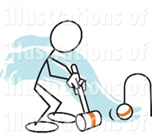

“As far as the leagues are concerned there really isn’t anything significant to offer. In my last report I said that all matches were cancelled until the end of May and that would be reviewed during May.

I think we will probably have plenty of notice before the situation changes sufficiently for competitive inter-club play to resume so I will wait until I can see the future more clearly.

This is still the case except that several clubs have declared their lawns closed until later than that (e.g. end of June) so it is extremely unlikely that any proper leagues will start in June. I haven’t tried to design a possible form of league play appropriate to a 3-month (or less) season.

**Short Croquet Tournaments**

John Grimshaw writes:

“At this stage, the Autumn competition is still on, as long as Budleigh Salterton is in a position to host it. We do not need to make a decision on this until late August, so I will wait and see how things proceed with the pandemic.

**Club Development**

Paul Francis, our Development Officer – offers this selection of snippets and advice.

It’s times like these that reveal the stress points in our systems. Information and ideas abound alongside sources of financial support.

But potential funders will want to see evidence of sound practice that is implemented throughout the year, not just a panic reaction now. So, this may be a good time to review all your processes to ensure your club offers its members and potential members the best possible environment.

Club Matters (<https://www.sportenglandclubmatters.com/>) provides a comprehensive framework for checking out where your club stands. It is very detailed – best approached perhaps one bite at a time. Paul would be delighted to offer support with this so do get in touch with him.

Lawns maintenance continues throughout all this – in fact there are rumours that lawns teams are delighted that their hard work isn’t being disrupted by those pesky people wanting to play croquet!

Paul has sent us this link to advice on what constitutes essential maintenance.

<https://www.bigga.org.uk/news-listing/covid-19-crisis-essential-maintenance-randa.html>

**Coaching**

Richard Jackson gives us some ideas to keep our minds thinking about croquet even if our bodies can’t engage:



While we are unable to play Croquet, there is a wealth of interesting croquet information on the internet. Try typing “golf croquet video” or “association croquet video” into your search engine. You will find everything from simple outlines of the game to advanced tips.

For Golf Croquet, there are You Tube videos ranging from “Introduction to Golf Croquet” to Ian Harrison’s “Golf Croquet Tutorial Module 6” which covers jump shots, tactical situations, and when and what advice you can give.

For Association Croquet, what about Three and Four Ball Break Videos, both as animations and actual play. Several of these are available.

For both codes, there are also a number of top flight games you can watch. It is instructive to watch the smooth mode of action of the players, and the care they take over simple shots to get the exact position required.

The Mental Approach: Imagine Your Success

Dave Kibble gets us thinking …

Itching to get on the lawn and play, but being sensible and staying home instead, presents an opportunity to improve the most neglected aspect of this great sport of ours: your mental approach and strength.

You really can improve your croquet without leaving the house by knowing that your brain cannot tell the difference between something you imagined and something that really happened. Play perfect croquet in your mind and so improve your accuracy, concentration, and confidence when you play for real.

First, get comfortable and be somewhere free of distractions. For some, this means lying down in a darkened room, but you can do it sitting by the pond. Then, with your eyes closed, and without moving, play perfect croquet in your imagination. Whether you play GC or AC is immaterial.

As you would (should!) in reality, follow a full shot execution routine, including visualising the outcome, preparing your grip, lining-up, stalking, taking your stance in a smooth movement, then rhythmically swinging through the ball and watching the mallet contact the ball.

See (and hear) the stroke's result (hoop run, roquet, clearance, rush) and watch the balls in your imagination land exactly where you planned. Then move to be ready to play the next stroke. This helps too with croquet strokes, big and small.

Play immaculately, smell the grass, feel the warmth of the sun (or the splash of the rain). The more real your illusion feels the more powerful the effect will be. This is as useful as a good practice session and much better than a bad one.

There's also something physical worth doing: swinging your mallet. Get the feel of it swinging back and forth and concentrate on the wrist and other joint movements that allow your mallet to swing straight.

Think about how it feels and let it swing by itself, back and forth. Just be careful you aren't too close to the display cabinet with your backswing. Doing this while looking straight into a full-length mirror allows you to easily see any imperfection in your swing’s straightness - much easier than diagnosing a golf swing!

**So, what’s everyone been up to?**

It’s been really great to hear from you about what you’ve been up to – and how we’re keeping ourselves and others going. Do keep those stories and photos coming – we’ll be sending out another Cygnet in a few weeks when there’ll be another roundup.

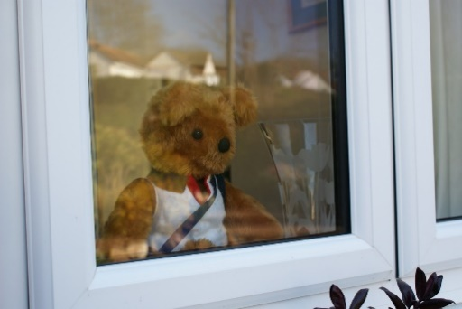

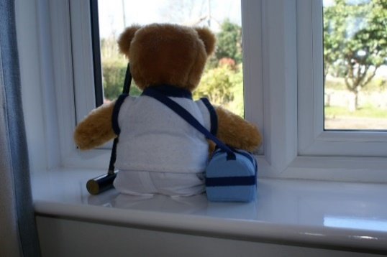Robert Moss starts us off – his wife Sue made this bear which has been keeping a forlorn eye on the outside world, but take another look and we can see why he’s so miserable …

Swindon CC have established a Covid exchange group – here’s a selection of what they’ve been exchanging:   
  
Clive Smith says: “Had this imaginary game of croquet while spending another day in the garage… It had everything … Jump shots, 'in offs', long shots wrong ball... Have to say I played brilliantly ... But still lost...!”

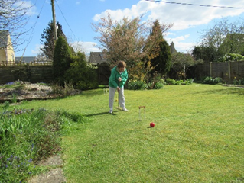Swindon’s Jean Alexander practices at home. Her husband, Crawford, writes:

“I have managed to get 2 proper hoops in. Our lawn is a bit small and the grass is not very good. I need to try and get the lawn mown a bit closer and perhaps put the hoops on the diagonal to get the greatest distance between hoops. At one time when I had 4 hoops in, the local rule was play across the flowerbed was permitted between hoop 2 and hoop 3 but it now has rather large shrubs and small trees!”

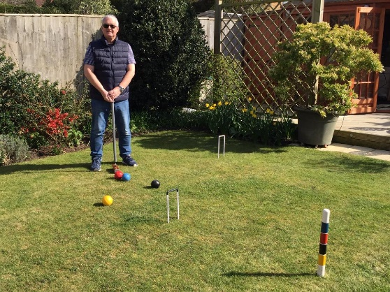Beverly Briggs writes “Lots of garden croquet last week for us in the back garden, unfortunately I lost too often ☹, however I did successfully execute a jump shot😀.”

In the photo, Martin, her husband gets ready to practice and Beverly subsequently writes: “Perfect weather for croquet. Honours even between us today. We have to adjust our shots near the house as there’s a slight gradient which attracts the balls towards the flower bed!”

Dave and Janet Booth managed to get back from New Zealand before the lockdown and tell us:

“We recently returned from a fantastic holiday in New Zealand. Just in time, as they closed their borders 2 days after we left!  
  
While there, we made a small detour from our planned itinerary for a quick visit to a relation of a friend of ours, in a small town called Te Aroha, about 100km south of Auckland. When we got there, we saw there was a croquet club in the town, with fantastic facilities. Unfortunately, nobody was around from the club, but we took some pictures of their lawns and information boards. You can view the pictures here:   
<https://photos.app.goo.gl/JZa5GebuWGKFuPnC6>

The next club we encountered was just outside Wellington, the capital, at the south end of North Island, a little place called Plimmerton. Again, a lovely clubhouse, 4 very nice lawns and shelters for each lawn. Here, there were actually some people playing, so we sat down to watch. When they saw us, they asked if they could help us and we explained that we were visiting from England, were croquet players ourselves and thought we'd just pop in and say 'hello'. So, they stopped their game, invited us to play with them and provided us with mallets. The UK team incurred a (tactical) 7-5 loss to Murray and John.  
  
Finally, we visited a club in a beautiful place called Wakatipu, near Queenstown in the South Island. Once again, nobody was there. Once again, a nice clubhouse, 4 lawns and shelters for each lawn. The sun wasn't shining this time, but it's in a wonderful setting. You can see the cloud-covered mountains in the first picture.  
  
We did see signs to several other clubs, but didn't manage to visit any."

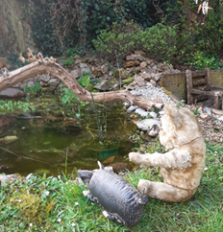  
John Grimshaw (Kington Langley) says: “We are still cutting the grass at KL and I am keeping reasonably fit by walking at least three miles each day, but boredom is a problem. If anyone is interested in puzzles etc, then I recommend the Giant Sudoku in the Western Daily Press each Friday. It takes a long time to do and is fiendishly difficult. One day I will complete one successfully!”

Linda and Dave K have been entertaining Teddy and Piggy (right) and treated their old friends (living in the same household) to a tour of their garden where they’ve been working very hard.

George and Linda Lang (Plymouth) have been busy: Local firm Allett Mowers did some “blogs” for International Women’s Day and Linda, who looks after Plymouth’s lawns was asked to provide an input – check out a really interesting story <https://www.allett.co.uk/international-womens-day-linda-lang-plymouth-croquet-club/>

George adds a rider: “All well here, the grass is beginning to grow with no players to mess it up.”

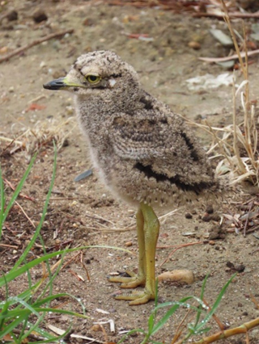Stephen has been further afield, fortunately returning before lock-down:

I am spending some of my time on my book on GC Tactics and some on processing my bird photos from South Africa. These include the attached photo of the Spotted Thick-knee chick, which was actually taken at the Somerset West Croquet Club near Stellenbosch. There is a resident family of Thick-knees who nested nearby and they come onto the lawns in the evening. I swear it’s real (just in case anyone thinks it’s just a woolly toy).

Kathy Wallace (Nailsea) writes: I thought you might like to see the results of an initiative from John Hancock of Nailsea Croquet Club. He contacted the North Somerset Times knowing that they would be short of Sports copy.

They offered him loads of space and here’s what he did with it. He got the entire inside back page. Like the detail or hate it, it’s fabulous PR and there might be more bored people reading local free papers at the moment.

This is the link to the electronic edition of the newspaper. Go right to the back then back one to page 55. Most of you will recognise some faces in the photos.

<http://edition.pagesuite-professional.co.uk/html5/reader/production/default.aspx?pubname=&pubid=111bb1ff-b940-4136-bc60-332bc0bf4c0e>

A couple of funnies:

Richard Jackson spotted this:

While David Enticknap suggests this YouTube link – timeless advice from the M.A.S.H team:

<https://youtu.be/L5CNHDeF2xA>

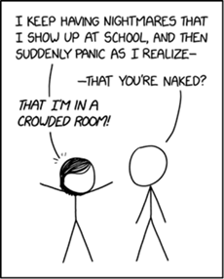

<https://xkcd.com/2285/>

**Quiz Page**

One from Stephen Custance-Baker:

“Precisely how many letters are there in the answer to this question?”

And Brian Wilson sets us these teasers. No prizes and the answers will appear in the next issue of Cygnet.

1. Why is Max Yasgur’s farm in the Catskills famous?
2. What was Che Guevara’s real first name?
3. In which sport are left-handed players banned?
4. Coulrophobia is a fear of what?
5. Denis the Menace features in which comic?
6. The fuppence was a silver coin worth 4 old pence and was discontinued in 1856 - how is it better known?
7. Where is Queen Maud Land?
8. Food given to patients in Battle Creek sanitorium in 1894 is now better known as what?
9. How many times does the digit ‘7’ appear in the numbers from 1 to 100?
10. Which fictional submarine was captained by Troy Tempest?

And for maths buffs: can you find the fallacy in the following?

Let a = b

Multiply both sides by ‘a' to get a2 = ab

Take b2 from both sides to get a2 - b2 = ab - b2

Factorise to get (a + b)(a - b) = b(a - b)

Divide by (a - b) to get (a +b) = b

But a = b

Therefore a + a = a

Or 2a = 1a

Hence 2 = 1 (or does it?)

And if you want to get your own back just send us your teasers (and the answers – I promise not to tell anyone what they are until a later issue of Cygnet.)

Please send your contributions to Linda to arrive by 1st May for the next issue please.

[lindawithani@hotmail.com](mailto:lindawithani@hotmail.com)

**Appendix 1**

**Treasurer’s Report**

Financial Impact of Coronavirus

Please see below potential impacts of coronavirus, assuming in the worst-case scenario, refund of Short Croquet Tournament Fees, League Fees and Membership Fees.

Note that even in this worst-case scenario losses that would be incurred can be covered by reserves.

Tournament & Membership Fees

It is clear that where tournament(s) / League(s) are cancelled then a refund to clubs is appropriate. If the whole season is cancelled then it needs to be considered whether Membership Fees should also be refunded, a decision will be made by committee towards the end of the season.

It is proposed that any refunds are rolled-up into one payment due at the end of the season, to reduce the number of financial transactions.

