This is the 20th issue of Cygnet – a fitting number for the first one for 2020. Some clubs will be receiving this for the first time – welcome to you.
In this issue …

P2 Winterborne Valley update
New SWF Treasurer
National Short Croquet
P3 Coaching Matters
- Coaches’ Refresher
- SWCA
- GC at Camerton
P4 Handicapping Matters
- Club Handicappers
- Handicapping
- Recording handicaps
P5 Development Matters
- Grant applications
- Safeguarding
- Greening
P6 Schools Tournament
From GC to AC
P7 Swindon Success
Competitions
John McCullogh
P8 News from the Reps
P9 League update
Losing
P10 Appendices – full list

This is prompted by changes in how CA members in the SW are represented at CA Council level. We have decided to send Cygnet to all clubs in the SW whether or not they are currently SWF members.

We are doing this on a trial basis at the moment but we hope new readers will be attracted to the activities and ideas in the region and decide to join us next year – thus enjoying all the benefits of membership: playing in the Leagues, access to development support and any workshops we run.

Lots in this issue as usual. We have received some comments about the amount of reading which can be off-putting, but we know some of you appreciate more detail.

We have been making use of appendices to separate the overview from the detail and will continue to do this – but a bit more assiduously.

Hopefully this will make Cygnet an easier read – clubs can print out the pages before the appendices as an easy-read for the club house, but for those who want more, the information is there electronically and, on our website, – where you’ll also find all the back issues.
www.swfcroquet.org.uk

Do let us know how that works for you.
Don’t lose touch

You can contact the committee at any time by email – check our website or send them to lindawithani@hotmail.com in the first instance, but if you want to bring something to our attention to tie in with our committee meetings, these are scheduled this year for 22nd March, 14th July and 11th October.

Winterborne Valley CC – the club previously known as Kingston Maurward
Our friends at Kingston Maurward have found themselves a new home and are re-naming the club to reflect this.
Their new address is
Winterborne Stickland Sports and Community Club
Winterborne Stickland
Blandford Forum
Dorset
DT11 0LZ

We wish you all the best and look forward to visiting you.
Found – a Treasurer

We are really pleased to have co-opted Peter Kirby, a new player at Bristol, as Treasurer. He has a background in finance and is really enthusiastic about the game.

He writes:

I started playing croquet in May 2019 following introduction sessions at Bristol CC, and in my first season I have been playing GC and AC.

Bristol CC have made me very welcome as a newcomer to croquet and helped in my development, so thanks go particularly for their coaching and mentoring (and often for their patience!) to Bob Whiffen, Linda Shaw, Ray Ransom and Richard Jackson.

I want to make a contribution and to do my bit, and position as Treasurer fits well with my background in Finance!

National Short Croquet Inter-Club Competition
Your club will have been contacted by Beatrice McGlen, Tournament Director of the CA’s Short Croquet Competition.

The SW Federation plans to enter a team into this competition if there is an interest from at least one Full Member club in the region.

If there is interest from more than one club, the Committee will arrange for qualifying heats to be played.

Please notify Linda by 1st March if your club is interested as we need to register our interest by 9th March.

To find out more about the competition and how to register your interest with us – see Appendix 1 p10

Coaching Matters
Attention all coaches: Coaches Workshop
The SWF will run a free, one-day Coaches Refresher Workshop on Thursday 26th March at Bristol CC for qualified (i.e. Club-level and Graded AC and GC) Coaches, if there is sufficient interest.

It will be led by a senior coach and focus will be on sharing, not telling but is likely to include: Opportunity for coaches to share experiences and tips to improve our coaching, refresher on resources available, upgrading our qualifications, coaching beginners, practical sessions on court, and coaching Short Croquet.

This is not a qualification course; no upgrades in qualifications will be made on the day and attendees will pay their own travel costs.

Please express interest by the end of February to richard.jackson@yahoo.co.uk and feel free to suggest further topics.

Richard adds:

Also do let us know if you would like to come but are not available on March 26th. Further details will be sent to those interested if there is sufficient interest.

We understand the two-day SWCA Coaches Training Course at Budleigh in April is full, but at the time of writing there were two places left in the development course for existing coaches there.

SWCA courses - Roger Mills writes:

Just to remind you, if you haven’t already looked at the SWCA’s website, that there is a wide range of coaching course available at the SWCA at Budleigh.

There is coaching available for players of all handicaps and in all forms of croquet – GC, AC and Short Croquet as well.

This year members of all SWF clubs can take advantage of a discounted price for most of the courses – so long as you book by February 20th. But you will need to act fairly quickly as some of the courses are almost full.

Clubs arranging their Coaching Programmes for 2020 and who cannot meet their coaching needs from their own members should contact me. I have a list of qualified coaches who may be willing to undertake a limited amount of coaching outside their own club.

See Appendix 2 p12 for more information and contact details.

GC Coaching

If you’re interested in some GC coaching, Camerton & Peasedown are offering a day on Etiquette, Tactics and Consistency – further details see Appendix 3 on p13

Handicapping Matters: Club Handicappers

Remember those handicapping workshops we ran? Well, Robert is following up on some of this – how is your club getting on? He writes:

Following up from the last three handicapping workshops, we need to know whether all clubs now have club handicappers and also that all those who attended one of the workshops feel they have all the knowledge and support they need to do this job as they would wish.

If anyone has concerns, questions, requests or suggestions, please contact Robert on robert.moss444@btinternet.com

It is recommended that each club has two handicappers – they may move on so do keep a look-out for members willing to develop these skills. We are not intending running a workshop this year but if there is the need, we could hold another in 2021.

Handicapping

The SWF committee has appointed Richard Jackson as Federation Handicapping Officer.

His main role is to ensure as far as possible parity of handicapping in the SWF, mainly by analysis of the previous season’s SWF league handicap matches (GC and AC), and also to act as a contact point for handicapping queries.

Questions about the handicaps of individual players will be referred to one of the CA Handicappers of the appropriate code living close to the club concerned.

Recording handicaps

Please note that the SWF League Rules now include the following requirement:
“… every player must have a properly assessed Association/ Golf Croquet handicap, and all players should have a completed handicap card. Each player is responsible for ensuring that his/her handicap is correct on the CA website.”

This raised the following queries from one of our member clubs who were concerned that:
- Not all club members have taken up Standard Membership of the CA as they do not want their details on the CA website
- This being the case, are they still permitted to play in League teams

Being listed on the CA website is not a requirement for playing in the South West Leagues as long as the player has a proper handicap and card.

In Appendix 4 p14 Stephen Custance-Baker clarifies sets out the situation for us and Dave Kibble provides reassurance about the security of our data.
Development Matters: What makes a good CA grant application?

Paul Francis, our Development Officer, gives us invaluable tips in making the most of support from the CA:
In the last two years it has been my pleasure to view many good grant applications to the CA.

There is up to £5000 per club available for projects to assist with lawn improvement, better facilities and infrastructure. On top of this there is the opportunity to bid for interest free loans.

Here are just a few tips to maximize your chances of success.

- A clear description of the proposal.
- Detailed costings and the options that were also considered.
- The club’s plans for other sources of finance
- How it will help the club to grow membership and/or reduce costs
- A business plan
- Consultation with members
- Good club records and up to date documents/policies including Constitution (including ‘winding up’), AGM/EGM minutes, latest accounts and Safeguarding Policy.
- The club’s members’ commitment to CA membership (premium and standard).
- The number of AC players and plans to develop numbers
- The club’s involvement in competitive croquet.

Of course, your club’s involvement in ‘Croquet Matters’ would help with many of the above!
Enjoy putting your applications together – and I’ll enjoy reading them!
Email me for more information. paulwfrancis@icloud.com

Safeguarding

All clubs should have received information from the CA – do check out the link: https://www.croquet.org.uk/?p=clubs/info/safeguarding - ffi

How Green is Your Club?

Are we doing our bit for the environment? Klim Seabright reminds us:

The Chair of the CA Development Committee has reported that the committee had recently made a grant towards the provision of solar panels and that this is the type of application the committee would wish to encourage.

Has your club explored such possibilities as solar panels, wind generation or bore holes?
If so, do tell us more – we’d love to share it in Cygnet.

And don’t forget the basics – switch off the lights, turn off the taps, close the doors!
Schools Tournament

Paul Francis, the SWF Development Officer writes:
We are looking for a club to pilot a Schools Tournament in their area.

Over the last few years New Zealand Croquet has successfully run a National Schools Tournament. As a result, a good number of the competitors are progressing through the New Zealand croquet ranks.

The eventual aim here is to run a tournament across the SWF and then a national programme - but small steps at a time!

Here are the basic ideas for the one-day tournament – it is probably advisable to only invite secondary schools to participate
- GC tournament on half lawns (to maximize numbers).
- The format to be decided by number of entries but the playing time needs to be maximized.
- First 30 minutes devoted to basic coaching and rules.
- Tournament to take place in June/July.

I am very happy to discuss this initiative with any club that is interested and assist with the planning. paulwfrancis@icloud.com
GC AC: Why not give it a try - you might enjoy it!

Robert Moss enthuses us:

Both AC and GC are wonderful games that give many people endless pleasure. Some people prefer one code but an increasing number are playing both - something we wish to encourage and are working on a programme to do just that.

The basics in both games are the same so trying out the other one is not like starting from scratch. Like any sport, it does need a good introduction with clearly understood instructions, a willingness to persevere and the encouragement of a good coach.

We’re inviting expressions of interest from
- clubs who would like to introduce AC but may not have the resources
- clubs or individuals who have found successful ways of doing this that they would like to share
To register your interest, please email me robert.moss444@btinternet.com – check out Appendix 5 on p16 ffi.

Prestigious Award for Swindon CC

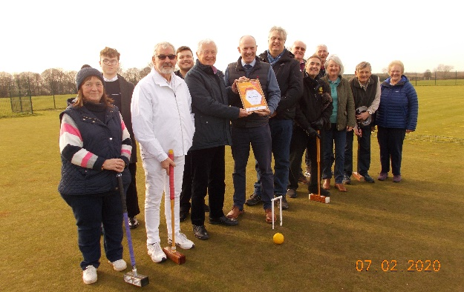
Swindon CC have achieved the Sport England Club Mark – no mean feat. John Airey, Secretary of Swindon CC tells us how they did it:

John Hawkins volunteered to fill the position of Accreditation Manager and take on the challenge of the renewal. With many set-backs he persevered along with Wendy White who volunteered to fill the Welfare Officer’s position, Steve Smith and Tony Tomlin renewing their First Responders certificates.

For John’s account of the process have a look at Appendix 6 p17

The photo: Swindon North MP Justin Tomlinson presents Sport England Clubmark Certificate to Swindon’s Accreditation manager John Hawkins. To the left of John is the Club Chairman John Small in whites. To the right of Justin (tallest) is David Reward Leader of Swindon Borough Council

Competition time

Budleigh has a full programme of events for its 150th (yes – a century and a half!) and Nailsea is running its OBE competition again.
Check out what all this involves in Appendices 7 p 18 for Budleigh and Appendix 8 on p20 for Nailsea

A trip down memory lane
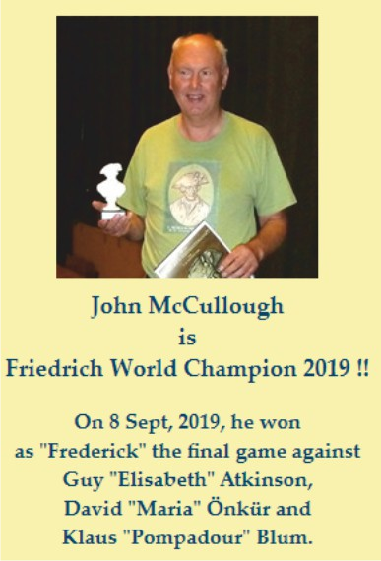
Ray Ransom, Bristol CC has been keeping track on a figure from history - John McCullough - an active member of Bristol CC from the late1970's until he relocated to York in the late 1980's. Ray writes:

John kick-started Bristol CC, tripling Club membership during this period and introducing the Beginners' Coaching Course which we and the CA use to this day. He was also instrumental in the formation of the South West Federation of Croquet Clubs and acted as its secretary from start until he left Bristol.

He and I were part of a board games group playing strategy games (primarily Diplomacy) and in 1987, collaborating with Stephen Mulliner, he published ‘The World of Croquet’.

John's involvement in croquet tailed off but his interest in strategy games has, it seems, continued and in Berlin last September he entered and won a tournament to become the 14th Friedrich World Champion. Friedrich is an historical simulation game named after Friedrich II of Prussia and based on the Seven Years' War which took place in the mid-18th Century
News from the Reps

Some questions answered

Following the Reps’ workshop at the SWF AGM last November, Dave Kibble presented our queries and concerns to the CA.

Initial responses have been received and are summarised in Appendix 9 p21. They cover such matters as branding, promotion and advice for players.

Report from Klim Seabright

The full minutes of the Council Meeting held on 23rd March may be found on the CA website: https://www.croquet.org.uk/?p=press/news&NewsID=5468&pup=y
Klim adds the following points:
- A small group has been set up to consider nominations for Council Medal. The group was formed from those present who hold the Council Medal (Quiller Barrett, Ian Vincent and Dave Kibble) and so the SW has a representative there. This group will consider nominations and make a recommendation to Council.
- The new system of representation means that there is no direct Federation representation to Council – this needs to be pursued in some way.
  - At present the arrangements are variable, with some Constituency Representatives being substantive members of the appropriate Federation Committee and others having a less formal arrangement.
  - The Chair of Council will be writing to all Federation Secretaries asking that the Federation Committees consider making the Representatives members of the Federation Committees. Please note the word “consider”.
  - The South West would also need to think about the issues arising from having three representatives from the region
Handicap Committee
- Very soon now each club should receive a supply of the newly designed handicap cards. We have tried to take into account suggestions from club members (including the South West). Do let me know how you get on with them.
- We are also keen to see an increase in handicappers (all levels) and there will soon be a paper with suggestions about selecting and supporting handicappers.
Marketing
- There are lots of ideas flying about. I will be able to say more after Eugene Chang has completed his analysis of the recent survey – thanks to all who completed this (about an 85% return).

And don’t forget to get your Tournament entries in and have a good season –when it arrives!

Remaining Full CA Council meetings this year are, 28th March and 17 October – so contact your CA reps in good time if you want them to be aware of anything.

League Results

These would normally be included in SWAN, but as you will see in a few weeks, SWAN will be looking different this year. Last year’s League Results are to be found on the SWF website.

But check out Appendix 10 p23 for the B League report and Appendix 11 p24 for the GC Handicap report.

And Stephen tells us what’s in store for us this year:

13 teams from 11 clubs have entered the new Short Croquet League. It probably would have been more but a lot of clubs had already made up their minds about league entries before the league was approved at the AGM. Some have said that would have liked to enter a team but only if there was no handicap restriction so that will need to be reviewed during the season.

This year’s league entries will be the highest ever, with 144 teams from 29 clubs playing 385 matches. There are 8 leagues, involving 26 blocks with 3 to 7 teams in each block. In the smaller blocks (3 or 4) the teams will play each other twice.

The Short Croquet tournaments are also up in numbers, with 6 full divisions of 5 teams at Nailsea and at Budleigh, plus an extra team at Budleigh.

So why did you lose? Klim Seabright gives us his excuses – what are yours?

Sidmouth I was watching the young boy in Station Road (so where’s the Station?) ogling his 99 and blissfully unaware that a large Seagull was about to swoop and spoil his day!

Budleigh Salterton I was wondering how long the queue would be that evening at Budleigh Fish and Chips.

Sidmouth I was daydreaming about the genius who had designed those delightful thatched pavilions.

Blewbury I was too busy bird watching ---probably the best opportunity for bird watching anywhere when sitting out --- Kite, Buzzard, and Wagtails, Martins, Thrush and much, much more

Phyllis Court I was completely absorbed watch pre-Henley rowers practicing ....and watching a Common Tern on the opposite bank of the Thames (Kites overhead too)

Southport I was making a mental note that I must visit the long shrubbery outside the club.... admired the splendid Pavilion....dreaming of a splendid lunch.

Nailsea I was thinking about where I could obtain a piece of their famous glass.

Cheltenham I was busy reminding myself that I must CONCENTRATE!

Appendices

Appendix | Page | Title
1 | 10 - 11 | National Short Croquet Inter-Club Competition
2 | 12 | SWCA Programme
3 | 13 | GC Coaching at Camerton & Peasedown
4 | 14 - 15 | Handicapping Matters
5 | 16 | GC to AC
6 | 17 | How Swindon achieved success
7 | 18 - 19 | Budleigh Tournaments schedule
8 | 20 | Nailsea OBE competition
9 | 21 - 22 | Replies from the CA
10 | 23 | B League Final 2019 - report
11 | 24 | GC Handicap League Final 2019 - report

Appendix1

National Short Croquet Inter-Club Competition

The SW Federation plans to enter a team into this competition if there is an interest from at least one Full Member club in the region.

If there is interest from more than one club, the Committee will arrange for qualifying heats to be played.

Please note in particular:

- Each team must have at least one player with a SC handicap or more
- The competition is open only to CA Full Member clubs
- The players must be individual members of the CA and playing members of the club they are representing.

Please notify Linda by 1st March if your club is interested as we need to register our interest by 9th March.

The following is an extract from Beatrice McGlen’s notice:

Following the review of the National Short Croquet Competition the decision has been taken to modify the format so that preliminary rounds are Federation based. The handicap requirements of the teams have been changed in response to requests from many of the previous participants.

The competition will therefore be run as follows in 2020:

Team Selection and player eligibility
Each Federation may select one club team to represent them in the National Short Croquet Competition. The way that the Federation chooses that club team is left to their discretion. If a club enters more than one team in any preliminary rounds organised by their Federation then the players in any fielded team cannot have played for the other team/s at any stage in the competition in that season. In line with all other CA competitions, the players must be Individual Members of the CA, and playing members of the clubs they are representing. Players cannot represent more than one club in a season in this competition.

Team make-up
Each team of four players must have at least one player with a SC handicap of 6 or more. The maximum handicap for any player is SC 10 and there is no minimum handicap. Details of short croquet handicaps can be found on the CA website at https://www.croquet.org.uk/?p=games/association/handicapping/short (being updated shortly).

National and regional finals
If more than 4 Federations wish to take part then regional finals will take place so that 4 teams go through to the National Short Croquet Final. The regional finals would be held in a single day at a venue to be decided. Where possible these will be arranged at a weekend but may have to be on a weekday, depending upon lawn availability.

The National SC Final will involve 4 teams, so two semi-finals, a third/fourth play-off and a final will take place at a predetermined venue. In 2020 this will be Bowdon Croquet Club on 12/13 Sept 2020.

Format of finals
The final (including regional finals) will consist of 3 rounds of singles and 1 round of doubles and singles, so there will be a total of 14 games of singles and 1 game of doubles in each match. Time limits will be 75 minutes for each game. The doubles will be played in the first round. Singles games will be double-banked but doubles games will be single-banked. All games will be played full bisque.

Entry procedure
The entry fee will be the same as the Secretary’s Shield (£30 per Federation). Entry will be via the CA’s on-line entry system. The closing date for entries is 9th March 2020. If more than four Federations enter an announcement will be made on 16th March 2020 regarding regional finals. Federation Secretaries should inform the tournament director no later than 7th August 2020 which club has been selected to represent them.

Beatrice McGlen
Tournament Director Short Croquet Competition
20 Nov 2019

Appendix 2
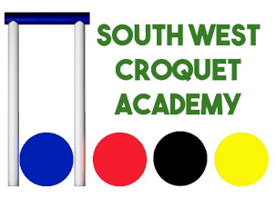 | The South West Croquet Academy coaching programme – the special offer to members of SWF clubs closes on Feb 20th

Just to remind you, if you haven’t already looked at the SWCA’s website, that there is a wide range of coaching course available at the SWCA at Budleigh.

There is coaching available for players of all handicaps and in all forms of croquet – GC, AC and Short Croquet as well.

This year members of all SWF clubs can take advantage of a discounted price for most of the courses – so long as you book by February 20th. But you will need to act fairly quickly as some of the courses are almost full.

For GC players, there is just one place left on Cliff Jones’ new intermediate/advanced GC course, but there are a few places still available on Stephen Custance-Baker’s ever popular course for GC high handicappers.

For AC players, the Bronze Badge course is proving very popular, but there are some places remaining. However, there is just one place left on Jonathan Powe’s Masterclass. There is also a one-day course for anyone wanting to develop their triple peel skills or win their Gold Badge.

Cliff Jones’ course that focuses on the practical applications of sports psychology has proved very popular, and there are just three spaces available now.
If you were hoping to qualify as a GC Referee this year, I’m afraid Tim King’s course is now fully booked.

And if you wanted to qualify as a Club-Level Coach, that course is also fully booked – BUT – we are ready to run a second course if there is interest – please let us know!

The course for coaches to upgrade their coaching qualification to a Grade 1 or Grade 2 level is still open, but there are just two places available now.

A one-day course is there for anyone wanting develop their Short Croquet skills.
Players can also take advantage of the high quality 1-to-1 coaching offered by the SWCA.

Take a look at the SWCA’s website where you will find full details of all the coaching opportunities, and don’t forget to book by February 20th to take advantage of the discounted prices.
www.southwestcroquetacademy.co.uk

If you need more information, give Roger Mills a call on 01395 512250.
Appendix 3
Etiquette, tactics and consistency

Tuesday April 21st 2020 10.00am – 5.00pm

at Camerton and Peasedown Croquet Club

For players with a GC handicap of 4 - 12

This is a course for all standards from those just starting to play in the SW Federation Leagues and those who are experienced and improving but would like some advice and encouragement to improve further.

Content:
- Etiquette on lawn for matches
- Exercises to improve accuracy and consistency of shot making - taking hoops, making placements and hit outs both straight and angled
- Practice in choice of shots – in defence and in attack – taking account of ability of opponent and their range of shot
- Planning the end position of both balls
- Effective use of extra turns.
  - What if anything can the lower handicapped player do to minimise their effectiveness?
  - Making sure the higher handicapped player always plans their use as 2 shots not as a get out of jail card!
- Jump shots – extending your range, improving your consistency and confidence
- Queries about the new laws can also be discussed if desired

Cost £10pp BYO lunch. Drinks and biscuits provided.

Book your place with payment by cheque (payable to Camerton and Peasedown Croquet Club) or cash, please to:

Ros Key-Pugh
8 The Linleys
Bath
BA1 2XE

Any questions or suggestions for any other points you would like me to include in the course please ring me on 01225 427525 or email roskeypugh@yahoo.co.uk and I will be happy to help.

Assistant Coaches: Mo Boys, Brian Wilson and Patrick Knight

Maximum places: 16

Appendix 4

Recording handicaps

The SWF League Rules now include the requirement:

“… every player must have a properly assessed Association/ Golf Croquet handicap, and all players should have a completed handicap card. Each player is responsible for ensuring that his/her handicap is correct on the CA website.”

This raised the following queries from one of our member clubs who were concerned that:

- Not all club members have taken up Standard Membership of the CA as they do not want their details on the CA website
- This being the case, are they still permitted to play in League teams

Being listed on the CA website is not a requirement for playing in the South West Leagues as long as the player has a proper handicap and card.

Stephen Custance-Baker writes:

Clearly, the bit about the CA website cannot apply to any club member who is not mentioned on it.

In the case of these members it is incumbent on the club handicapper to ensure that their card and handicap are both up to date and up to the individual player to bring their card to every match.

This places an additional responsibility on the club handicapper or secretary and I would recommend these members to allow at least the minimum entry on the website, i.e. Name, Club, Handicap(s).

Some reassurance:

Dave Kibble (who manages the CA database as well as being one of our Reps to CA Council) was included in the correspondence and remarked:

I hope that Club members can be reassured that their information is safe in the CA database, and generally much safer than the way most clubs deal with it - e.g. emailing a membership list.

I’d also like to make it clear it that it is not necessary to be a CA member to be recorded in the database for club and SWF purposes.

The requirement for players' handicaps to be properly recorded and available to others online is a SWF policy which I fully welcome and will help to make as easy as possible to accomplish.
With regard to concern about the security of information on the data base, I am not aware of a serious sport, other than croquet, where the national governing body has no record of serious players (e.g. Bridge, Tennis, Badminton, Football).

Clubs can choose to record all their members on the database and enjoy the secure membership management features, without any of them needing to be a CA member -although that remains a (free-to-them) option.

And finally, those who have no access to the internet can have their handicap maintained by their club secretary as most already do with their membership list.

Appendix 5

GC – AC

Robert Moss enthuses us:

Both AC and GC are wonderful games that give many people endless pleasure. Some people prefer one code but an increasing number are playing both - something we wish to encourage.

We hear that some clubs and some individuals who currently play GC would like to find out more about AC and give it a try but do not know how to go about it. Despite what you may hear, AC is not particularly complicated and games do not have to take three hours. Shorter versions are available.

Like any sport, it does need a good introduction with clearly understood instructions and a willingness to persevere. Personally, I love AC because I like the challenge of creating and running a break (similar to snooker), and I enjoy trying (but rarely succeed) to get my shots inch perfect in order to make hoop running easy (does that bit sound familiar?).

The basics in both games are the same so trying out the other one is not like starting from scratch. It does, however, require an understanding of the additional types of shot and the encouragement of a good coach.

The Federation wants to encourage more people to play more croquet and so we are working on a programme to help clubs develop AC, whether that be for beginners or for existing GC players who would like to extend their croquet enjoyment by dipping their toes into AC.

Currently, we have some clubs who find it easy to introduce AC, some clubs who play both codes with equal success, but others are saying that they do not know how to go about it or that they do not have an AC coach. We want to provide a solution for those needs by putting together a package of help and support. We are particularly keen to support small and new clubs who may not have other clubs nearby.

For starters, please can we invite expressions of interest, both from clubs who would like to introduce AC but may not have the resources to do so, and also from clubs or individuals who have found successful ways of supporting their members and who would be prepared to share their experience and expertise. Your responses will influence the type of package we develop - course, workshop, visits, printed materials, etc. We will then tailor a suitable programme which we hope to get underway this season.

To register your interest, please email me robert.moss444@btinternet.com or Linda lindawithani@hotmail.com

Appendix 6

Achieving the Sport England Clubmark - how Swindon did it
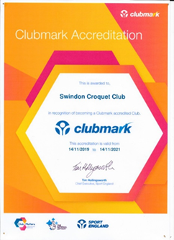
John Hawkins was the Accreditation Manager throughout this process and writes:

“Clubmark is the universally acknowledged cross sport accreditation scheme awarded by Sport England and stands for higher standards of welfare, equity, coaching and management in community sports clubs making sure the infrastructure is safer, stronger and more successful.

An accredited Club is recognised as a safe, rewarding and fulfilling place for participants of all ages providing the right environment which ensures the welfare of members and encourages everyone to enjoy sport and stay involved throughout their lives.

This is based on four key areas of development, each of which has to be supported by specific evidence collected by the Club, covering the Playing Programme, Duty of Care and Welfare, Knowing our Club and Community and Club Management.

Our assessor was Helen Weeks who is a Club Development Officer with Swim England and as Helen Slatter she represented Britain in three Olympic Games in 1988, 1992 and 1996.

After providing satisfactory answers to 63 online questions, with either a written text answer or a copy of an appropriate Club document, she made a site visit to Swindon in November last year and the Club was awarded the status of Clubmark by Sport England.

The certificate is displayed on the noticeboard in the Club Room and may I thank all those who provided me with assistance during this process.”

But the club hasn’t just been looking inwards – they were awarded a certificate of thanks from the Wiltshire Air Ambulance for the donations that Swindon Croquet Club have raised during their annual Charity Tournaments over four years.

Two amazing achievements for Swindon.

Appendix 7

Celebrate at Budleigh

Budleigh Salterton has a huge range of tournaments in its 150th anniversary year. You are all welcome to join us, play croquet, groan/ exult at your performance, have fun.

*** STOP PRESS***
Join us for our start of season extravaganza!

Saturday April 4th - charity one ball doubles for Macmillan Cancer Support. This is for anyone who can hold a mallet, no specialist skills required - ideal for beginners. You’ll be partnered by the Manager into a fairly level pair but who cares about winning! - there’s 150th Anniversary Ale at lunch, Devon Cream Tea and great company. Wear green and a smile. All welcome.

Sunday April 5th - for anyone who happens to have an established AC handicap of 18+ (say a year of play) you can join us for our High Bisquers tournament. Stay the weekend?
GOLF CROQUET
Aug 22nd | B Level local championship and qualifier for the National Final. Level play, results go into the international rankings. Make your mark on the world stage! | Handicaps 3+, typically 3 - 8.
Aug 23rd | C Level local championship and qualifier for the National Final. Level play. For the first time this year results will go into the international rankings! | Handicaps 7+
ASSOCIATION CROQUET
April 5th | High Bisquers’ Tournament - for those with a year’s experience or more, a chance to compete against players from Budleigh and other local clubs. Perfect first tournament. (Fee £5 BSCC/ £8 other) | Handicap 18+
April 25th/ 26th | B Level Championship. Our friendly fun B Level - which has produced quite a few first triples! | Handicaps 1 - 8
May 4th - 9th | May Week. One of our biggest club tournaments with AC available for experienced players at all standards. | Handicap 20 maximum
May 30th/ 31st | AC Class Weekend. Advanced/ Level play within classes of similar players. Players on handicaps 12 & below should stay on for … | Handicap 20 maximum
June 1st | 14-point Advanced. Now the AC variant of choice for many experts, fast moving and offering fascinating strategic choices - use your advanced rules wiles in a 6 hoop turn. We look forward to introducing this format to many of you! | Handicap 12 maximum

ASSOCIATION CROQUET (continued)
June 22nd - 27th | Croquet Association Veterans’ Championship. The national championship for players over 65 years of age (with a special and delightfully friendly division for the over 75s). Travels around the country, this year it’s in Budleigh. | Handicap 20 maximum
July 13th - 18th | Croquet Association Seniors’ Championship. The national championship for players over 50 years of age. Travels around the country like the Veterans’, this year it’s also in Budleigh - a wonderful chance for local players to compete in Championship events on the cheap! | Handicap 20 maximum
Aug 5^{th -} 8th | August Tournament. Long seen as the Championship of the South West. 4 days of class singles and handicap doubles. | Handicap 20 maximum
Sep 19th/20th | AC Class Weekend. Advanced/ Level play within classes of similar players. | Handicap 20 maximum
SHORT CROQUET
Sep 29th/ 30th | Individual Tournament. We run the country’s largest individual tournament for this code. Quicker games, perfect for the cooler Autumn days. Entry fee £25. This one fills quickly! | All handicaps, some AC experience needed
ONE-BALL
April 4th | Charity Doubles for Macmillan. This is our spectacular start-of-season event and we would like to see every club member playing and as many visitors as possible. Just turn up and donate (£5 minimum suggested, £500 if you want! - we can’t charge an entry fee because of Gift Aid regulations). 100% goes to the charity. We’ll sort you a partner to even up the standards and you can play as many or as few games as you wish. Wear green, have fun, help a cause that affects many of us! | Absolutely anyone welcome. These events are held at many croquet clubs and last year we had the highest number of participants nationwide. We’d like to beat our own record!

How to enter: Nearly all the events listed above are official Croquet Association (CA) fixtures. The CA website is now live to let you book them online. Tournaments do fill up so it’s worthwhile entering reasonably promptly. If you have any problem with booking online please speak to an official of your club. Entry fees for these tournaments are on the booking site.

Online booking is not available for the Macmillan Charity One-Ball on April 4th, Hibiscus on April 5th or the Short Croquet Individual Tournament on September 29th/30th. To enter any of these please contact me directly: Peter Moore, email toursec@budleighcroquet.org. If you want to phone me it’s 01395 268657; please leave a message because I’m often not around, I will get back to you.

Appendix 8

Are you an OBE?

If you are in your 80th year or more then Nailsea and District CC invites you to come along to enjoy a day of FUN croquet – based on AC rules but with a difference.

Tuesday 19th May 2020
10.30 start
Entry fee: £10
Soup and roll lunch: £10 – or bring your own
Dress code: 1930’s – if you fancy it!

This 10-shot, level-play game – the rules of which will be given to each entrant – ensures there is no long period of sitting out while you watch your
opponent go round.

If you’d like to enter, or find out more, then contact Terry Young:
terandlib@yahoo.co.uk
01275 707 475

Appendix 9

The CA replies

This is a summary of the points raised with the CA by Dave Kibble following the workshop at our AGM last year, and the responses received.

- CA website and branding looks old-fashioned
  - Eugene Chang, Chair of the Marketing Committee replied that the Marketing Committee is continuing to assess the best options and are actively recruiting for the vacant Webmaster position, which would help move things on

- Consider a more modern logo
  - Other work is taking a priority but members wishing to help with this should contact Eugene

- What is happening to raise the profile of croquet with the public?
  - Encouraging clubs to take part in National Croquet Week (used to be National Croquet Day?
  - Live streaming WCF GC World Championship and the Under 21s
  - Lobbying BBC to get croquet added to the Get Inspired sites
  - Secured listing on other similar websites e.g. The Girl Can
  - Lobbying to get croquet added to approved list of sports for GCSE PE – this would mean it would be added to Duke of Edinburgh award scheme
  - Presence at BBC Countryfile events
  - Working with organisers of social croquet events to attract more people
  - Looking at simpler formats for AC
  - Looking at health benefits and social prescribing potential

- What is the relationship with national sports bodies?
  - We are in contact with the Sports and Recreational Alliance, subscribe
to their daily newsletter and attend conferences run for
administrators of other amateur sports in the UK.
  - Encourage adoption by clubs of Club Matters framework for development

- Is the CA in discussion with the National Trust about clubs being thrown off their properties?
  - The Marketing Committee is not but Eugene will raise this with Development Committee

- What plans are there to publish guidance and sharing good practices for recruitment and retention, and club development?
  - Existing materials on these topics exist on the CA website already,
and we are in a process of updating these materials

- Promotion materials should avoid looking elitist (e.g. players
wearing whites)
  - There are multiple views on this topic … Players wearing white suggests a level of professionalism and that it is a serious competitive sport (which is a message we want to promote as well). Tennis players wear white but this is not an indication that it is elitist, whereas polo players don't wear white but are probably much more elitist.
Dave also posed a series of questions and comments to Ian Vincent and Stephen Mulliner, respectively Chairs of AC and GC Rules Committees but the only response has been an acknowledgement from Ian.

The questions were:

- Can the Laws/Rules be published more accessibly, for example using an app?
- What about short training videos to help digest the rules for regular players, not just referees?

When Rules/Laws change or proposals are being discussed, the CA should push this through the organisation in a timely fashion so that CA-Members (federations, clubs and individual players) are properly informed and have opportunity to comment. The Nottingham list is not an official communications channel.

Appendix 10

2019 SWF B League Final: Sidmouth v Bristol at Taunton Deane

Saturday September 28th 2019: Report by Stephen Custance-Baker

7:0 to Sidmouth

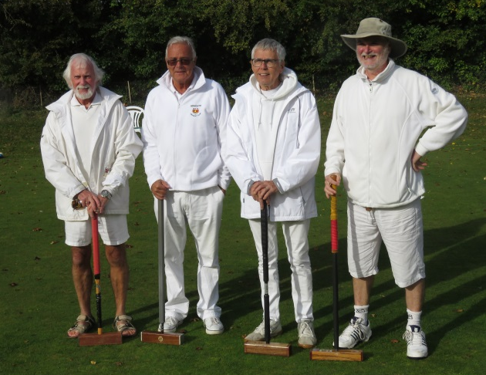
The day started promptly with both teams turning up early, having allowed for heavy traffic. We had a showery start but the day was mostly dry with some periods of bright sunshine.

The lawns were green and rather slow after some heavy rain in the previous week. It was agreed that the games would be 14-point on full-size lawns with a time limit of 2¾ hrs.

The Sidmouth line-up: Rob Bayliss, Duncan Hasell, Ed Dolphin, Richard Croft

The first result came after 1½ hrs when Rob Bayliss of Sidmouth beat Mike Chan 14-5. Duncan Hasell then beat David Woodward 14-8 to give Sidmouth a 2-0 lead, which Ed Dolphin and Richard Croft extended to 3-0 at lunch by winning the doubles 12–7 against Pat Whiffen and Mick Brown.

Bristol now needed to win all of the afternoon’s singles to snatch a victory but it was not to be. Sidmouth‘s preparation under Pamela Bowra’s leadership was just too good and Duncan won against Mike to secure a 4-0 lead. Richard added a 14-1 win against Bristol’s Isobel Sara who was playing off her new 14 handicap.

That still wasn’t enough and Sidmouth went on to win the remaining two singles and secure an excellent 7-0 result.
Before the match started, I emphasized the benefit of calling for a referee before a problem rather than after and the players cooperated by calling me on a number of times.
Left: The Bristol team: Mike Chan, Pat Whiffen, Mick Brown, Isobel Sara, David Woodward

Right: Mike Chan (Bristol) and Pamela Bowra (Sidmouth non-playing captain) with the trophy

Appendix 11

Golf Croquet Handicap League Final

Report by Robert Moss.

Weston-super-Mare:11.5
St Agnes: 8.5

Being a spectator at a final is always enjoyable but watching St Agnes and Weston battling for the trophy was a particularly inspiring experience. These two teams were well matched and both were making their debut at a GC Handicap League final.

At the end of round 1, no-one would have predicted which team would come out on top with the results at that stage being 2-2. Although three of these games finished within the time, Stef and Gerry’s game went to the bell with a 4-5 result. The accuracy of their shots, tactical skill, intelligent use of extra shots and efficient clearances made good viewing.

At lunchtime they were still neck and neck but by the end of round 4, Weston were 1 game ahead, and with just the final round of 4 games to play, no-one was predicting which team would win. However, Weston strengthened their lead to finish the match on a score of 11.5 games and St Agnes with 8.5 games.

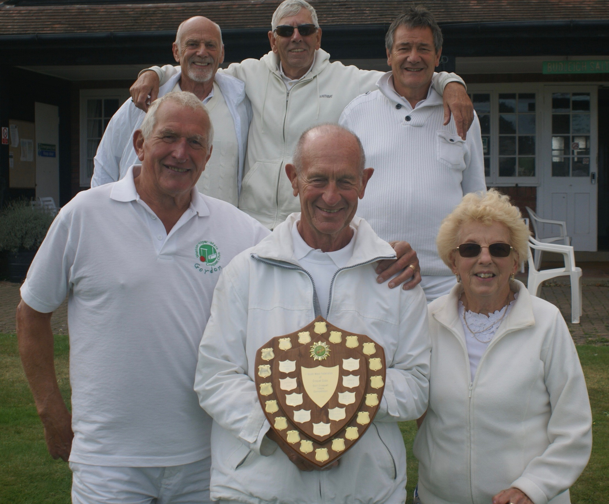
I would advise all players to make more use of the referee. There were several really risky shots which should have been watched by the referee, and it may be worth reminding players that they can ask a referee to explain points of law at any time if they are not sure what is legal. It is always better to err on the side of caution. However, there was one impressive example of good practice with several players always announcing that they “may take an extra turn” before playing their stroke.

The camaraderie of the teams and spirit of the match made for a truly enjoyable day.

The Weston team: Front Row: Gordon Taylor (6), Brian Robinson (3) (Team Captain), Jane Binning (9).
Back Row: Gary Serle (11), Lance Binning (0), Gerry Williams (3).
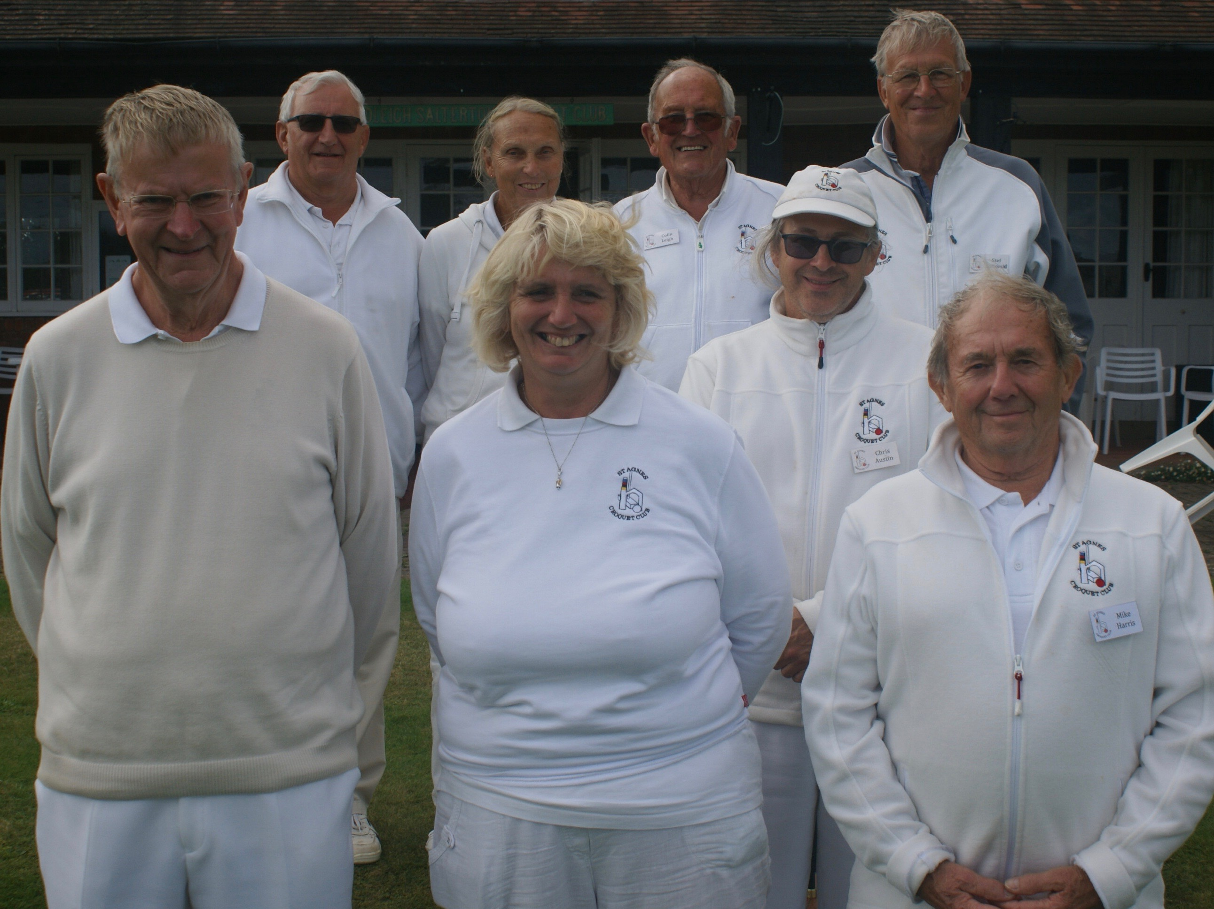

St Agnes Team: Front Row: Donald Moore (5), Caroline Halliday (6). Chris Austin (6), Colin Leigh (11).
Back Row: Mike Row (Non-playing Team Captain), Anne Kilaruth (9), Colin Leigh (11), Stef Nahorski (8).

