Welcome to the last Cygnet for 2019.
In this issue …

P2 Short Croquet League
P2 Committee changes
P3 Help wanted
P4 Development grants
P4 CA membership
P4 Recording your handicap
P5 Croquet Matters workshop
P5 Meet your reps workshop
P6 SWCA 2020
P7 CA Reps’ reports
P8 Celebration South West

Appendices
P11 Reps’ workshop
P13 SWCA 2020 programme
P14 Klim Seabright
P16 Dave Kibble
P18 CA Database
P20 National Short Croquet

It’s been an eventful year and hopefully it’s been a good one for you. This is a bumper issue – lots of holiday reading:

- More about the work of the committee and how you can help
- Introducing the SWF Short Croquet League
- Write up of the two AGM workshops
- Reports from the SW Reps to CA Council
- News and celebrations

AGM postscript

We had a great turnout at our AGM – it was lovely to see so many clubs being represented, especially those we don’t see so often. So do put the date for next year’s in your diaries: Sunday 15th November 2020.

We eventually worked through an enormous agenda including some complicated Constitutional and League Rules changes.

We will be considering ways of streamlining these discussions in the future and are grateful to everyone for bearing with us through that and for some really helpful suggestions about how we might improve this for the future.

Look out for more information about this in the new year and if you’d like to help further with this, please see the piece on p3 – we’re looking for people like you!

The new League Rules are now available on our website from the tab on the home page: https://www.swfcroquet.org.uk/ . Club captains should check and familiarise themselves with the rules and the changes in good time for next season.

The Minutes and Constitution will be on the website before too long – and a timely congratulations to Alison Maugham who manages our website, and her husband David – proud parents to Benjamin Ian.

Introducing our own Federation Short Croquet League.

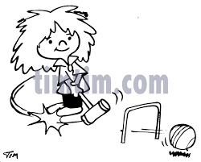
This is an increasingly popular version of the game and at the AGM it was overwhelmingly agreed to introduce this.

The League will run in addition to the Spring and Autumn tournaments - clubs have been sent entry details and the rules are on the SWF website.

The rules will be reviewed at the end of the season so do let us have your feedback about how effective they are and suggestions for improving them.

Committee changes

We said ‘goodbye and many thanks’ to Marcus and Maureen at the AGM and hope we won’t lose touch completely. We are however, delighted to have recruited new blood to support the committee’s work.

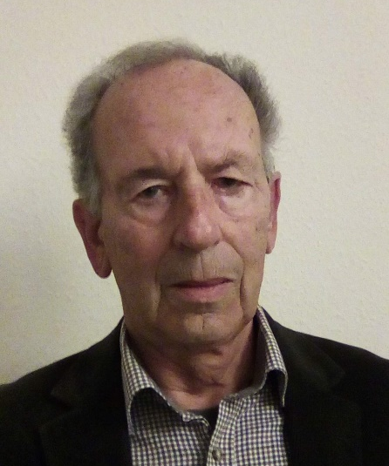
David Enticknap (Bristol CC) introduces himself as a newly co-opted member of the committee:

In 2008 I attended a taster session at Bristol CC and enjoyed it. I later undertook a beginners’ course. I caught the croquet bug.
Since then I have captained the club's GC(HC) team, the B-Level team and have been on the committee for a couple of years.
Enjoying playing the game and benefiting from the organisation of others, I now want to give something back. Having been co-opted on to the SWF committee I now have my opportunity.
Tony Mayer (Swindon CC) has also been co-opted:

I took up croquet in 2011 and quickly became ‘hooked’, first with GC and later with AC. Over the years I have been able to gradually reduce my handicap in both versions of the game, although not as quickly as I would have liked!
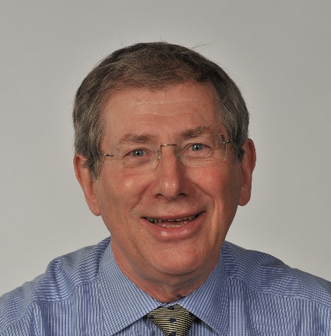
An active member of my club (Swindon) I captained its Open Handicap GC team. Through the SWF leagues and from playing in tournaments I have been able to visit many clubs other than my own.

I am interested in developing more links between clubs through competitions across the large SWF region and, generally, in club development. When I expressed interest to SWF after reading the Cygnet, I found myself quickly co-opted to the Committee!
And Rhona Foster (Cornwall CC) is our new SWAN editor:
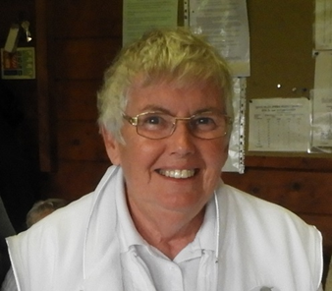
I started playing croquet in 2012 as a member of Cornwall Croquet Club. An invitation to join the committee followed shortly afterwards and after working my way through the ranks am now in my third year as Chairman of the club.

When I read the piece in September's Cygnet about the development of Cygnet and future of SWAN. I wrote to Linda supporting the committee's plans. Linda was quick to reply and somehow or other I ended up being 'volunteered' as editor of the (new) SWAN, so look forward to being part of this new initiative.

Can you help?

But we need even more. We are looking for …
Website co-ordinator – we are finding it difficult to keep details on our website up-to-date and no one currently on the committee has the time to review and monitor it regularly.

We’d like to co-opt someone to take on this area of responsibility – an understanding of what our members need from the website and good written communication skills are integral to this role. Alison Maugham maintains the site for us but can only do what we ask her to.

Constitution and rules reviewers -

As many of you who will appreciate, keeping on top of constitutions and rules can be an uphill task and there is not really enough committee time to do this justice at the moment.
We are therefore considering assembling some sort of review / editorial group to support us in this. This does not have to be a committee role (we think a lot of the work could be undertaken via email discussion) but a keen eye for detail and understanding how rules are understood are important skills.

One or two people have already expressed an interest in this – would you like to join them?

If you are interested in these positions, please email lindawithani@hotmail.com by 10th January – and also let us know if you would be able to attend our next committee meeting from 10.30 – 1.00 on Sunday 25th January at Nailsea CC.

Committee meetings have been arranged for the following dates in 2020 – please bear these in mind when you think of anything you’d like us to consider.

25th January 22nd March 19th July 11th Oct

Development Grants

Hot off the press – two local clubs have been awarded grants from the CA – Camerton & Peasedown have been awarded £5,000 plus an interest-free loan of another £5,000, while Kingston Maurward have received £3,125 grant.

Congratulations to you both – we look forward to hearing about the impact of these for you.

The next development group meeting will be in February and Paul will be writing about grants in the next issue of Cygnet – so do look out for this and of course, if you have any queries in the interim, do get in touch with Paul: paulwfrancis@icloud.com or 07411044109

Benefits of CA membership
Dave Kibble gives us a timely reminder:

I thought I would make sure everyone knows that the offer of CA Standard membership at no cost is still available to all club members, indeed the club (through your subscription) pays for it.

Benefits include being able to enter tournaments and to receive the Gazette magazine for your first year (thereafter you will have the option to subscribe directly for it).

If you register on the database, there's no obvious reason not to take advantage of this offer.

Recording your handicap

CA members are now required to keep an up-to-date record of their handicap on the CA website. This applies to both Standard and Premium members.

This sparked some discussion at the AGM, particularly in relation to the visibility of this information when a member has requested their data not be shared.

Dave Kibble clarifies the situation for us and provides some useful insights into the CA database and how clubs might use this in Appendix 5 on p18.

AGM workshop: Croquet Matters

A short workshop followed on from the SWF AGM. Dave Gunn (The National Development Officer for the CA) kindly agreed to run the session.
Club representatives were introduced to the Club Matters - Club Improvement Plan which comprises four areas for clubs to consider in developing a strategic plan. The four areas are:

Marketing
People
Management
Financial.

Dave introduced the marketing and people toolkits. The workshop was interactive and club representatives were encouraged to carry out a series of self-assessment exercises based on questions relating to their club’s current effectiveness. Here are a few examples:

From the People unit
Does your club understand what your members want and need from your club? Do you know what is important to them?

From the Marketing unit
Does your club have a clear plan for its marketing activities?

The workshop was very well received by the group and many wish to follow up with a half-day workshop where all their committee can be involved.

Paul Francis will in touch with these clubs to organize the events but all clubs in the SWF are invited to request a workshop.

Please contact Paul for further information paulwfrancis@icloud.com or 07411044109

AGM Workshop: Meet your Reps to CA Council

Peter Nelson and Dave Kibble led and supported discussion about developing communication and understanding between the CA and its members, reflecting on the potential role of the Reps in this.

More details of the discussion may be found in Appendix 1 p11, but we looked at:

- Complexity of individual, club and federation memberships
- New CA structure
- What the CA does
- What we’d like to see the CA do –
  - communication – resources – modern thinking
  - How this could happen
We are delighted that these issues have been raised with the CA and look forward to progress reports. Thank you, Reps!
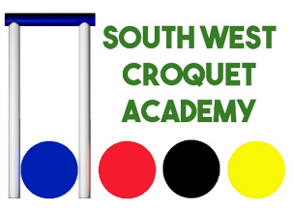 | The South West Croquet Academy announces its 2020 coaching programme – and there is a special offer for members of SWF clubs!

After a successful 2019, when its wide range of coaching opportunities proved very popular with players in the South West, the SWCA has now announced its programme for next season.

As always, there is coaching available for all players of all handicaps, and in all forms of croquet – GC, AC and Short Croquet as well. This year, though, members of all SWF clubs can take advantage of a discounted price for most of the courses – so long as you book by January 31st.

A copy of the SWCA’s programme brochure is included with this issue of the Cygnet – see Appendix 2 p13 - and full details of the courses can be found on the SWCA’s website: www.southwestcroquetacademy.co.uk

To mention a few highlights.

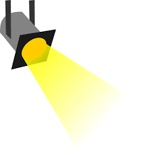
- There are two courses from Cliff Jones: a new intermediate/advanced GC course and a course that focuses on the practical applications of sports psychology to croquet
- Stephen Custance-Baker continues his ever-popular course for GC high handicappers
- For AC players, the Academy is promoting the CA’s Merit Award Scheme and running courses to help players achieve their Bronze, Silver or Gold badge under the Scheme
- Low handicappers have the chance of a one-day AC Masterclass with Jonathan Powe
- In addition, there is 1-to-1 coaching available with Cliff Jones and Roger Mills.
- If you are thinking of becoming a GC Referee or a Coach, then don’t miss out on Tim King’s massively successful course to qualify as a GC Referee, and Roger Mills’ Club Coach and Graded Coach courses

Check out the SWCA’s website, and don’t forget to
book by January 31st to take advantage of the discounted prices.

https://www.southwestcroquetacademy.co.uk/

If you need more information, give Roger Mills a call on 01395 512250.

CA Reps’ Report

The South West Constituency Reps to CA Council (Peter Nelson, Dave Kibble, Klim Seabright) are now in post and, with the rest of Council, getting to grips with the challenges ahead.

We are inviting them to keep SWF members updated via each edition of Cygnet and are pleased to have received the following update.

“The new CA Council has embarked on the development of an improved strategy to promote the sport and to see more people enjoying croquet in more places.
The strategy will be wide-ranging and hopefully will result in a more effective organisation and one that is seen by clubs and players alike as being more relevant. We will keep you posted on important developments by means of these pages.

In addition, recognising the large number of clubs in the South West and to improve communication, one of us will be designated as the principal contact for each club.
These allocations will be posted on the Federation website.

Thanks to those who participated in the workshop after the AGM. We gained useful feedback – some of it delivered with passion!”

In Appendices 3 and 4 you will find a more detailed update from Klim (p14) and a personal perspective on the new structure from Dave (p16). They make interesting reading so please spare a few minutes to read and digest.

If you have any questions for the reps please contact them direct – we’d be more than happy to publish the discussion in Cygnet. Their contact details are:

Peter Nelson peter@nelson01.eclipse.uk
Dave Kibble DaveKibble@gmail.com
Klim Seabright klimseabright@gmail.com

Not everything that is faced can be changed
but nothing can be changed until it is faced.

James Baldwin

Celebrating the South West

In the last issue of Cygnet, we carried stories about local successes – this time we have more local successes that have been recognised at a national level:

CA AGM

Three local members were honoured at the CA’s AGM in November –

Dave Kibble (Bristol CC) left receives the Council Medal from CA President, Quiller Barrett

John Wallace (Nailsea CC) left in the photo on the right! receives the CA Diploma from Quiller Barrett

Daniel Gott (Bath CC) below was awarded the Apps Memorial Bowl (best male AC). He tells us:
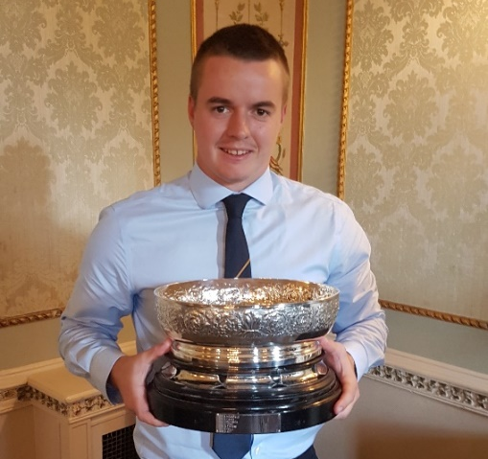

I played my first ever croquet tournament at Cheltenham over Easter where I was instantly hooked to the competitive side of croquet, and quickly after signed up to a number of tournaments over the summer including a couple of regional championships and the Opens.

Having nothing to lose but everything to gain, I played a fearless brand of attacking croquet, picking up some unexpected wins as well as some valuable lessons from top players in the country.

Croquet is special in that after every game, your opponent will give you tips and advice and help you improve, and it is that phenomenon that I have to thank for the progress I made in 2018

SW Clubs in Murphy Shield Final

Keith Southern (Swanage and East Dorset CCs) tells us about this:

The Murphy Shield, a national KO competition organised by the CA, involves inter-club matches for teams of four with middle-range GC handicaps satisfying the criteria:
- The total handicap of the team must be at least 12.
- A team may include one player with a handicap of 2, others must have higher handicaps.
The match format is one doubles and six singles rubbers, each best of three games.
The competition was introduced in 2010 and was won for the first two years by Broadwas. Since then it has not been won by a SW Federation team.

That was set to change in 2019 as two teams from the region contested the final. East Dorset, in their first year of entering the competition, reached the final by beating Sussex County, Merton and Guildford & Godalming while Camerton & Peasedown had beaten Leighton Linslade, Croquet Durham and Ashby.

The final was played on the excellent lawns at Budleigh Salterton. East Dorset were represented by Keith Southern (2), Sandra Allan (3), Mark Hamann (3) and Tony Green (4). The Camerton & Peasedown team was Brian Wilson (3), Ros Key-Pugh (3), Mo Boys (3) and Patrick Knight (4). With virtually nothing between the aggregate ranking scores of the two teams a close match was anticipated and that was indeed the case with East Dorset eventually winning 4-3 in a dramatic finish. But they made hard work of it, winning the first game of the three in only one of the seven rubbers.

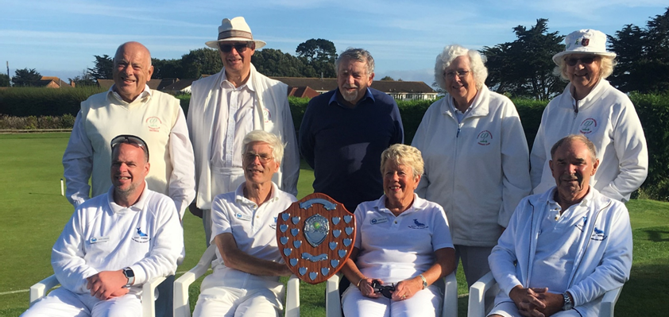

The smiling finalists are (left to right): front Mark Hamann, Keith Southern, Sandra Allan, Tony Green; rear Patrick Knight, Brian Wilson, Ros Key-Pugh, Mo Boys with Brian Shorney in the middle.

In the morning East Dorset won both singles but lost the doubles, thereby establishing a 2-1 lead at the lunch break. In the afternoon the bottom two singles were shared making the score 3-2 so attention turned to the top two singles both of which went deep into third games.

After a long tussle at hoop 12 Ros prevailed over Sandra so the destiny of the trophy hinged on the top singles which had reached hoop 13. Keith played Blue into a 2-yard running position and then put Black between Brian's Red and the hoop. With Yellow Brian played an excellent 25-yard clearance on Blue, Keith missed the angled hoop attempt with Blue, and then with Red Brian cleared Black - through the hoop!

Representing the CA, Brian Shorney presented the Shield to the victors and complimented both teams on the high quality of the play that he had witnessed throughout the day.

Coaching

Stephen Custance-Baker has been promoted from Grade 2 to Grade 3 Golf Croquet coach – this is truly well deserved – many have benefited from his excellent coaching and advice.

Up and coming

It’s great to recognise developing talent – this may be new players or it may be longer-standing players who are suddenly making huge strides. Whoever you are and whatever your achievements we’d love to hear from you.

Here’s one example from Bristol CC with thanks to Pat Thompson and Ray Ransom.

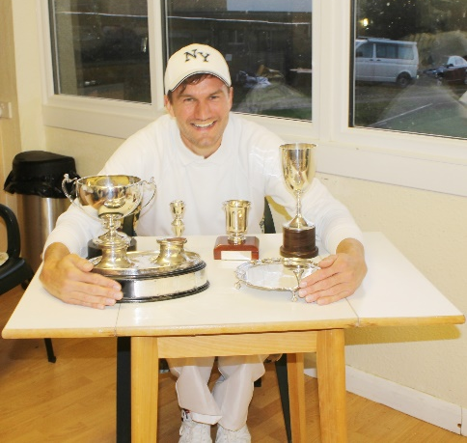
Dom Aarvold joined Bristol only last year and his play has developed in leaps and bounds. This year alone he played in five Club competitions finals, winning them all.

He then received a sixth club trophy for being the most improved player in the club.

Further afield he represented the club in the All England GC Handicap and reached the final, played at Camerton & Peasedown CC. There he came top having faced 13 other competitors on an all play all basis and losing only one game

He played at Budleigh where he won his block, and was runner up in the Daniels Cup at Cheltenham where he was beaten by another up-and-coming Bristol player – Peter Kirby.

From starting handicaps of 20 (AC) and 10 (GC) he ends this season at 6 and 3 respectively.

GC Federations Shield

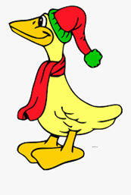
Congratulations and good luck to Weston super Mare who will be representing the South West Federation in this prestigious event in 2020.

At the time of writing we know that their rivals include High Wycombe, Maldon, and Phyllis Court.

AC Secretary’s Shield

We also wish good luck to Nailsea and District who won our Federation League and will therefore represent the South West Federation in the Secretary’s Shield.

Appendix 1

Meet the Reps AGM workshop

Peter Nelson and Dave Kibble led and supported discussion about developing communication and understanding between the CA and its members, reflecting on the potential role of the Reps in this.

There is a complicated membership matrix:

- Clubs are separately: members of the CA and members of the Federation
  - Some clubs are CA members but not Federation members
  - Some clubs are Federation members but not Full CA members
  - The SWF has decided that their Full members must be CA members (but not necessarily Full CA members)
- Individuals are not members of the Federation but can be CA members
  - This can be through membership of their club – Standard Member
  - Or by paying their own subscription
- A few clubs require their playing members be CA members
All clubs pay the CA for their playing members whether or not the individual takes up CA membership

The restructuring of the CA was outlined with a slimmed-down CA Council focusing on setting the overall strategy.

What the CA does

- Maintains the Rules, Laws, handicapping system and Regulations used in tournaments / competitions organised by clubs, Federation or CA
  - The Federation maintains the League Rules used for its inter-club matches
- Trains and qualifies referees and coaches and appoints CA-handicappers, with guidance for all published on the website.
- Collects money from a per-capita levy on most clubs, from individual direct-paying members, and from a levy on all tournaments published in the CA programme.
- Distributes – with the Federations - a proportion of its income back to clubs in development grants and loans.
- Produces the Gazette, a bi-monthly glossy magazine aimed at all
croquet players,
  - The SW Federation produces an annual pamphlet (SWAN) and periodic e-newsletter (Cygnet)
- In the past, the CA organised coaching courses, but these are now mainly delivered by the Academies, with the Federation picking up on some coach and referee training
What was not clear is how the Council will communicate with players, clubs and Federations – or even their own committees – to ensure strategic aims are embedded in the day to day activities of all these agencies. It was generally agreed that the Federations and clubs could develop a better understanding of each other.
What we’d like to see from the CA:

- Effective promotion of the game at national level –
  - Government
  - Sports Council
  - National Trust – clubs are being excluded – this is a missed opportunity
  - Media – update the image – refute the stereotypes
  - Less elitism in the Gazette and promotional material – too many ‘whites’
- High quality accessible resources / frameworks / guidelines

  - Rules – easy to digest, videos
  - Coaching
  - Refereeing
  - Recruitment and retention
  - Club development support
    - Develop a Club Marque as a quality improvement framework
    - Guidance and sharing good practice

- Modern thinking:
  - Developing apps to access e.g. rules
  - Team colours rather than whites – promote awareness of the real rule!
  - Indoor croquet
  - Quality standards for clubs
- Recognise and respect the needs and aspirations of grass-roots players
How would this happen?

- Effective and appropriate two-way communication
  - the Notts list is not an official communication channel
  - recent changes in Laws were not communicated well and there was no mechanism for promoting them through Federations and clubs
- Review CA website to improve its ‘friendliness and accessibility’ factor
  - This has started
- Understanding and clarifying the role of the Federations
  - Should they be an integral part of the CA structure?
  - Should they be independent of this?
How will the Reps take this forward?

- Note that only individuals vote for the reps, but they have a responsibility to represent clubs and Federations as well
- How they will communicate with us? Cygnet is a resource available to them
- How will they liaise with each other to execute their responsibilities?

We are delighted that these issues have been raised with the CA and look forward to progress reports.

Thank you, Reps!

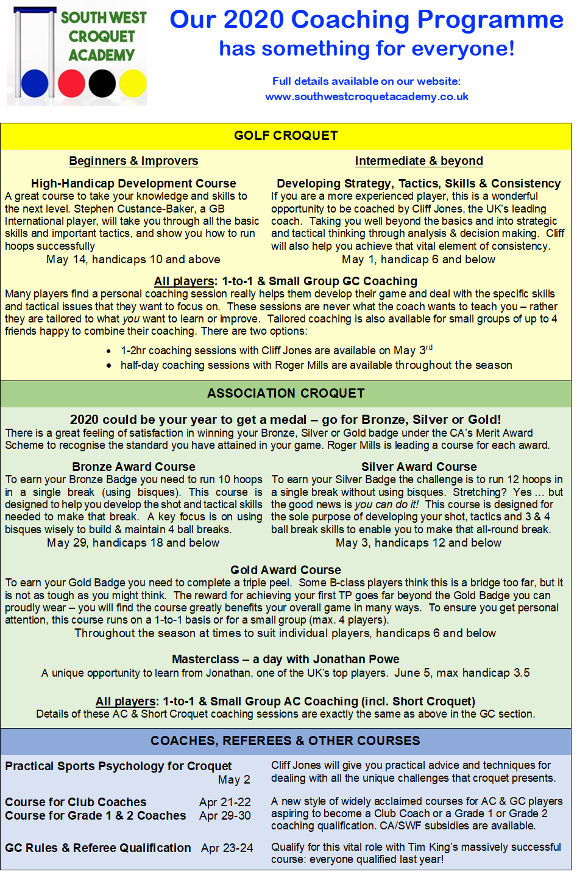
Appendix 3

CA Update: Klim Seabright

Council is now much smaller, as the CA website sets out: https://www.croquet.org.uk/?p=ca/gov

The Council has overall responsibility for the affairs of the Association, with a focus on high-level policy, strategic initiatives, scrutiny and transparency. It has:

12 Voting members elected … by Individual Members of the Association to represent a Member Federation and the Member Clubs and Individual Members served by it, except that several Federations may be grouped to form a single constituency.

There is provision for several Federations to be grouped together to form a single constituency, should that be necessary. Council also includes the CA Officers as non-voting members. This reinforces the undertaking to work with and through Federations.

Editorial note: Not all clubs are members of the Federation and not all Individual members are members of a club. Therefore, working only through the Federations does not guarantee that all voting CA members will be reached. If you or anyone you know falls into this group, then you might like to let the Reps know.

Council has chosen Marketing and Efficiency as the first two priorities and Council Members are working on the detail, which the Chairman (Jonathan Isaacs) has asked to be finalised by the end of the year.

Council has asked Dave Kibble and Peter Nelson to be members of a working party to make policy recommendations to address the shortage of referees in both codes at all levels, noting specifically the requirement for AC Championship Referees for the World Championship we are hosting in 2022.

Council has decided that all other committees will remain in force for the time being.

The Management Committee has been replaced with an Executive Board (see Gazette issue 382 p9). The Executive Board will, in consultation with Council, implement the policies determined by Council.

I am a member of the Marketing Committee. You are probably aware that we have sent a questionnaire to all club Secretaries. I would urge Club Secretaries to send in replies as soon as possible to Eugene Chang (etychang@gmail.com).

Editorial note: N.B. This is not the same as the return requested by the CA though they appear to be seeking similar information at times.

The Marketing Committee meets on the 14th December and it would be great to have as full a response as possible. There are lots of other ideas being passed around the committee but we would like our plans to reflect the findings of the questionnaire, as much as possible.

This is my first full year serving on the Handicap Committee. This can get quite technical. Suggestions come in on how the current system might be “tweaked.” We have taken the view that the combination of the Automatic Handicap System (AHS) and a more pro-active approach to Handicapping would the best way to cope with most such suggestions.

We will shortly be launching a drive to recruit more Handicappers of all types. We are also working on a paper which is intended to give “tips and hints” about how Handicappers can be supported.

Do think about anyone in your club who might make a good Handicapper. Is there a Club Handicapper who should now become a CA Handicapper? If so, do send a short paragraph about them to Frances Coleman – frances@luxtersfarm.com

It was with great pride that I sat hearing high praise for the Handicap Seminars held in the South West. Brian Fisk will be working with Robert Moss to produce a final summary which can then be disseminated to other Federations.

Similar compliments were paid to the work which Richard Jackson has undertaken during the last three years. His meticulous analysis of league results in order that a view can be taken about how a club’s handicaps are accurate was much admired. Richard has agreed to contribute his methodology and approach across the whole of the CA domain.

Klim Seabright

Appendix 4

A Personal Perspective on the New CA Structure: Dave Kibble
As you will see elsewhere, the CA has restructured to have a much-reduced Council whose voting members are elected directly by Individual CA members. The Council is now responsible only for strategy and policy.
The CA restructure focussed on reducing the size of the Council and removing its ability to revise plans made by its committees. It seems it did not attend enough to making sure the organisation is more fit for purpose. Further restructuring is needed to reconnect the CA with the croquet-playing community, and perhaps that creates the opportunity to strengthen the Federations.
The working machinery of the CA remains largely unchanged with aspect-focussed committees (such as Tournaments, Handicapping, Development, etc.) and an Executive, (technically) elected by Council.
I say "technically" because, as before, there was only one proposal on the table - that's something I'm very keen to change, particularly now that the Executive wields so much power, especially over the purse strings. We should dig much deeper into the CA membership for talent beyond the personal contacts of the few CA officers.
Federations get no resources from the CA to support their work and can find it difficult to get CA Office support for initiatives they want to carry out.
I feel that the Federations have been disempowered by the CA restructure. There is now no direct relationship between the Council or Executive and the Federation - a big mistake that must be rectified.

Previously, each Federation had a representative on Council, filled by a Federation committee member - providing a direct decision-making link between the local and national governing bodies. Of course, I and my two colleagues will represent to Council views and issues communicated to us by the Federation committee, but we have no
direct influence on the Executive Committee (where decisions are now taken) and are not privy to the dealings of the Federation committee.

Editorial note: The minutes of Federation Committee meetings appear on the website shortly after the event and the dates of 2020 meetings are set out on p1 of this Cygnet.
We undertake to circulate these to the Reps individually. We have already asked the Reps to suggest ways of communicating with the Federation but have received no suggestions and we will be considering this further at our next meeting.
In the SW, we are blessed with three Reps, but some Federations are joined with others and share a single Rep. (In case you are wondering, the representation is based on a constituency of equal number of Individual CA members.)
This representation gives its own problems for accountability and re-election: if the three reps divide the large territory to serve their local patch, they are by definition not serving the rest of the constituency. This is a foreseeable problem that surely was discussed in the organisation re-design, but nothing has made it through to resolve the issue. We've agreed to focus mainly on our smaller region.
I would rather see a structure where the CA and Federations are one organisation, with the centralised functions doing only what is best done centrally and the Federations controlling more of the resources in their area, including grants and loans to clubs.
Each Federation still has a representative on the highly-functional CA Development Committee, which determines where goes the very significant amount of money the CA gives out in grants and loans for the development of croquet, but one might wonder why other than Federation representatives and the CA Treasurer are needed on that
committee.

It, of course, needs a large amount of admin support, usually delivered by its Chair (now appointed by the Executive Committee).
There has been a drop-off in grant applications over the last few years. I know the SWF's Development Officers have been very responsive so wonder if clubs are fully aware of the funding opportunities. I believe that the Federation committee has plans to be much more in contact with clubs.

I will from time to time through Cygnet outline how the CA operates for the benefit of clubs and players.
I have attended many SWF AGMs over the years and I see good governance and communication in action:

- clubs, representing their members, argue for improvements to the way croquet is managed in their area
- the League Secretary is in constant communication with club team organisers
- the Development Officers are on call to help clubs plan and finance their developments
There's more to do, and the CA reps would do well to work through and with the Federation to avoid miscommunication and left hands not knowing about right hands.

Dave Kibble

Appendix 5

CA Database

It is good to see the SWF taking a lead by asking in the league rules for players to maintain their handicaps on the CA website.
This allows other players to complete their handicap cards after competitive play by looking-up their opponents, and for league and team managers to quickly check that teams meet the rules.
It's now very easy to log-in and update your handicap as it changes, or your club secretary can do it for you if you don't have access to the Internet. One change and it's done - and everyone is informed.
In response to comments at the AGM, the display has been changed so it now shows a missing handicap with a dash, rather than not showing it at all.
Your club secretary can easily add you to the database.
You don't have to be a CA member to be allowed onto the database, but you do have to give consent to share your details with the CA. That is a technicality, which arises because the CA runs the database and there is only one copy of your details (and handicap) if you are a member of more than one club or are a CA member. If you are on the database and not a CA member, the CA cannot (and will not) contact you
unless you enter a tournament, and then only for matters relating to that tournament.
The CA system is very secure and requires a log-in with a password before seeing personal information. That information is held in an encrypted database and is accessible only to someone with the right password. When you view personal details, the link is encrypted and cannot be intercepted.
Many people think that an online database is inherently insecure without realising that regular emails are visible to anyone with a bit of IT knowledge.

If you email a spreadsheet or word document containing personal details,
it is open to anyone on the Internet to see the content.
Not so with the CA database.

Anyone logged into the website with a password can see your name, handicaps and club memberships. They cannot see your contact details to send you an email or phone you up unless you have explicitly authorised it.

You can decide (and change online) to hide your contact details from fellow club members, or fellow CA members. Club administrators have full access in order to manage your club membership. CA database administrators also have access so they can help club administrators.
Regardless of your settings, search engines, such as Google, will not find you or your details on the website - because they cannot log-in. Try it for yourself - don't log-in and see what you can find.
If you are a club officer, such as a contact for inter-club play, but have indicated that you don't want to share your contact details, that raises a warning and you'll eventually get an email from the CA office suggesting that you fix the situation.
How clubs can use the database

The CA database is freely available for member clubs to use to manage their membership if they want to. However, the EC regulations on data sharing prevent club members who are not CA members accessing the information - they must agree to share their details with the CA, even though they are not members and the CA will not use their details.

All the features you'd expect for managing members are in place (after all, the CA uses it), including the ability for a membership secretary to download a spreadsheet to achieve anything not yet thought of.
It's quite in order within the EC Regulations for a club to decide to use the database and to tell its members that they are using it to record all relevant member details and that it is necessary to run the club's membership to do so.

That gives people who really don't want to be recorded on the database the opportunity to cancel their club membership - but I hope I've shown there's no reason anyone would think that necessary. Feel free to contact me if you want to get started.

Dave Kibble
DaveKibble@gmail.com

Appendix 6
National Short Croquet Inter-Club Competition

N.B. This is not run by the SWF so please address all queries and comments to Beatrice McGlen whose details appear at the end of the article.

Following the review of the National Short Croquet Competition the decision has been taken to modify the format so that preliminary rounds are Federation based. The handicap requirements of the teams have been changed in response to requests from many of the previous participants. The competition will therefore be run as follows in 2020:

Team Selection and player eligibility
Each Federation may select one club team to represent them in the National Short Croquet Competition. The way that the Federation chooses that club team is left to their discretion. If a club enters more than one team in any preliminary rounds organised by their Federation then the players in any fielded team cannot have played for the other team/s at any stage in the competition in that season. In line with all other CA competitions, the players must be Individual Members of the CA, and playing members of the clubs they are representing. Players cannot represent more than one club in a season in this competition.

Team make-up
Each team of four players must have at least one player with a SC handicap of 6 or more. The maximum handicap for any player is SC 10 and there is no minimum handicap. Details of short croquet handicaps can be found on the CA website at https://www.croquet.org.uk/?p=games/association/handicapping/short (being updated shortly).

National and regional finals
If more than 4 Federations wish to take part then regional finals will take place so that 4 teams go through to the National Short Croquet Final. The regional finals would be held in a single day at a venue to be decided. Where possible these will be arranged at a weekend but may have to be on a weekday, depending upon lawn availability.

The National SC Final will involve 4 teams, so two semi-finals, a third/fourth play-off and a final will take place at a predetermined venue. In 2020 this will be Bowdon Croquet Club on 12/13 Sept 2020.

Format of finals
The final (including regional finals) will consist of 3 rounds of singles and 1 round of doubles and singles, so there will be a total of 14 games of singles and 1 game of doubles in each match. Time limits will be 75 minutes for each game. The doubles will be played in the first round. Singles games will be double-banked but doubles games will be single-banked. All games will be played full bisque.

Order of play
The order of play will be as follows, where 1-4 represent team 1 in handicap order (lowest to highest) and A-D represents team 2:
Round 1: 1&4 versus A&D (doubles); 2 v B; 3 v C (singles)
Round 2: 1 v A; 2 v C; 3 v B; 4 v D (all singles)
Round 3: 1 v B; 2 v A; 3 v D; 4 v C (all singles)
Round 4: 1 v C; 2 v D; 3 v A; 4 v B (all singles)

Timetable for National Final
Since travelling distances could potentially be large, the National SC Final will be held over two days, starting at 12.00 on day 1 and finishing at 16.30 on day 2, which gives an opportunity for a social gathering on the intervening evening.

Day one (semi-finals)
12.00 – 13.15 (1 game of doubles and 2 of singles)
Lunch
14.00 – 15.15 (4 games of singles)
15.25 – 16.40 (4 games of singles)
Tea
17.00 – 18.15 (4 games of singles)
Social gathering at local pub/café

Day two (Finals and 3rd/4th playoff)
9.30 – 10.45 (1 game of doubles and 2 of singles)
10.55 – 12.10 (4 games of singles)
Lunch
12.55 – 14.40 (4 games of singles)
14.50 – 16.05 (4 games of singles)
Tea and presentation

Entry procedure
The entry fee will be the same as the Secretary’s Shield (£30 per Federation). Entry will be via the CA’s on-line entry system. The closing date for entries is 9th March 2020. If more than four Federations enter an announcement will be made on 16th March 2020 regarding regional finals. Federation Secretaries should inform the tournament director no later than 7th August 2020 which club has been selected to represent them.

Beatrice McGlen
Tournament Director Short Croquet Competition
20 Nov 2019

