South West Federation Committee Meeting Agenda
Date | 17th July 2019
Time | 10.00 – 1.00
Venue | Cheddon Fitzpaine Memorial Hall
Present | Brian Wilson, Linda Shaw, Neil Morrison, Stephen Custance-Baker, Paul Francis, Robert Moss, Richard Jackson, Maureen Smith
Apologies | Klim Seabright, Marcus Evans
- Minutes of last meeting
  - Agreed and signed as a correct record
- Matters arising
  - None
- Treasurer’s report
  - Report and balance sheet previously circulated – see Appendix 1
  - Noted that Robert has now been paid
  - Noted Budleigh have not yet submitted an invoice
  - More bursaries have been claimed this year than last year which is a good sign that people are attending relevant training sessions
  - Noted we are unlikely to need to consider raising fees next year as funds are in a healthy condition
  - Noted that Development Officers can claim expenses – claim should be made to Neil who will re-claim from CA
- Elections to Council
  - Three nominations for Council have been received with 2 – 3 more anticipated
  - Confirmed that in the event of an election, all candidates will be invited to answer the questions previously agreed.
    - These will be circulated in Cygnet along with a photo Action: Linda
- Development Officer report
  - Report as circulated – see Appendix 2
  - Brian informed us that a new club is being formed at Westbury consisting of a group of C&P players
    - Members of C&P are supporting them
  - Paul suggested developing a register to support links between clubs to enhance their development needs
    - This was agreed to being a useful move and could be supported in various ways e.g. articles in Cygnet, resources pack etc Action: Paul
  - Neil reported that Swindon are working on plans to develop 3 more lawns – they will have lots of skills to share with other clubs wanting to develop their facilities and membership
- League Secretary Report
  - Stephen reported that of 331 matches, 216 have been played so far
  - 61% of these have been home wins – clear advantage seems to be emerging – especially when the conditions of the lawns is not ideal
- Dispute resolution
  - Stephen had circulated a detailed report on several disputes that have arisen during league matches and reported a further instance when a was made to play off the wrong handicap because of incorrect information about league rules given by the home team captain.
    - In the AC Intermediate match the game was discounted giving a drawn result
    - In the GC High Handicap match, a drawn game was converted to a win but the match result was unchanged.
  - He also reported that it there appeared to be two instances of ineligible players participating (Advanced Div 3 and GC Level Play). This was subsequently confirmed
    - it was agreed as a general rule that any wins by an ineligible player are converted to losses. This reversed one of the match results.
  - There was extensive discussion about the issues raised and appropriate responses from the SWF committee as the League Secretary’s decision had not been unanimously agreed by the affected players / clubs
  - With regard to the reported incidents the following points were made:
    - The High Handicap league was introduced as a non-threatening introduction to competitive play – teams and captains need to be reminded of this point
    - Agreed that the drawn game converted to a win – no other changes as all captains should be aware and the other game not affected
    - Make the affected games void – must always play off the right handicap – so overall result is a draw
    - Ineligible player: the affected games will be awarded as a win to the opposing side
  - With regard to further action the following points were made:
    - Aggressive / threatening behaviour is not acceptable
    - The situations arise at least in part because captains are not aware of current League rules or indeed GC rules / AC laws
    - We need to remember to be clear about the difference between CA rules / laws and SWF rules for League games
      - All captains should be aware of this and encouraged to have an up to date copy of the League rules with them when they go to matches
    - While it is primarily a CA responsibility to ensure rules / laws are clear and comprehensively available, feedback from the SWF on relevant issues would be helpful
      - An article to be included in Cygnet reminding people about the importance of this Action: Linda / Stephen
      - SWF to ensure the information on our website is accurate and up to date. Action: Linda
      - Clubs will be reminded of the need to ensure team captains are familiar with the current rules Action: Stephen / Linda
      - We discussed having a simplified outline of the rules but will consider this further at a subsequent committee meeting Action: Linda
    - Confirmed that constitutionally the committee has responsibility for helping resolve such issues
    - Confirmation of consequences of not adhering to the rules to be confirmed at AGM Action: Linda
- Extra strokes article
  - Discussion re draft article submitted by Stephen
  - Amended article to be produced Action: Stephen
- CA Rep Report
  - Reports from Klim and Brian previously circulated - See appendix 3 - were noted
- Handicaps
  - Richard talked to his previously circulated report – see Appendix 4
  - He noted the analysis indicated more nuanced reasons for certain results and that generally club handicappers appeared to be doing their job well
    - This was encouraging and justified the workshop series
  - It was agreed this is a useful analysis and should continue Action: Richard
    - This was amended at committee meeting on 4th Oct to read: It was agreed this is a useful analysis and should continue. Richard would make small changes to the report to make it suitable for transmission to the CA Handicap committee and when these had been approved by committee members, the report should be forwarded to the CA Handicap Committee.
  - Discussed an alternative handicapping system to manage fast improvers more effectively
    - This would involve changing the index by 25 points rather than 10 once someone wins more than 7 consecutive games
    - This raises some interesting issues including ‘statistically, what is the perfect handicap?’ but it was agreed these are beyond the scope of this committee but could usefully be presented to the CA handicapping committee
    - Richard plans to do this either on a personal level or with SWF support
    - He will circulate a draft paper for comment Action: Richard
  - Brian noted that many players are not aware of the trigger points especially when their handicap has recently passed one trigger point then falls below it again but does not reach the next one!
    - Again this is really an issue for CA handicapping committee to ensure process is clear, but a reminder to be included in Cygnet / advice to captains Action: Robert / Linda
- CA Medal nomination
  - Unanimously agreed to support the nomination as requested Action: Linda
- SWAN
  - Agreed that SWAN should be developed as a handbook along the lines suggested – see Appendix 5 Action: Maureen / Linda
- Cygnet
  - Draft being prepared for circulation early/mid August Action: Linda
- Lawns workshop
  - Agreed that we facilitate the running of the seminar proposed by Dennis & SISIS to the following extent Action: Linda
    - Ask for host club
    - Circulate flyer
- AOB
    - Paul kindly agreed to be SWF rep at League Final on 28th Sept
    - Tour operator request – Bath already in contact so no input necessary from us
    - Agreed to plan for 4 shorter committee meetings next year rather than 3 longer ones Action: Linda
- Date of next meeting
  - 4th Oct at venue to be arranged – Nailsea to be confirmed as venue Action: Linda
  - 17th November AGM

Agreed as a correct record of the meeting

Signed

Role

Date
Appendix 1
Treasurer’s report

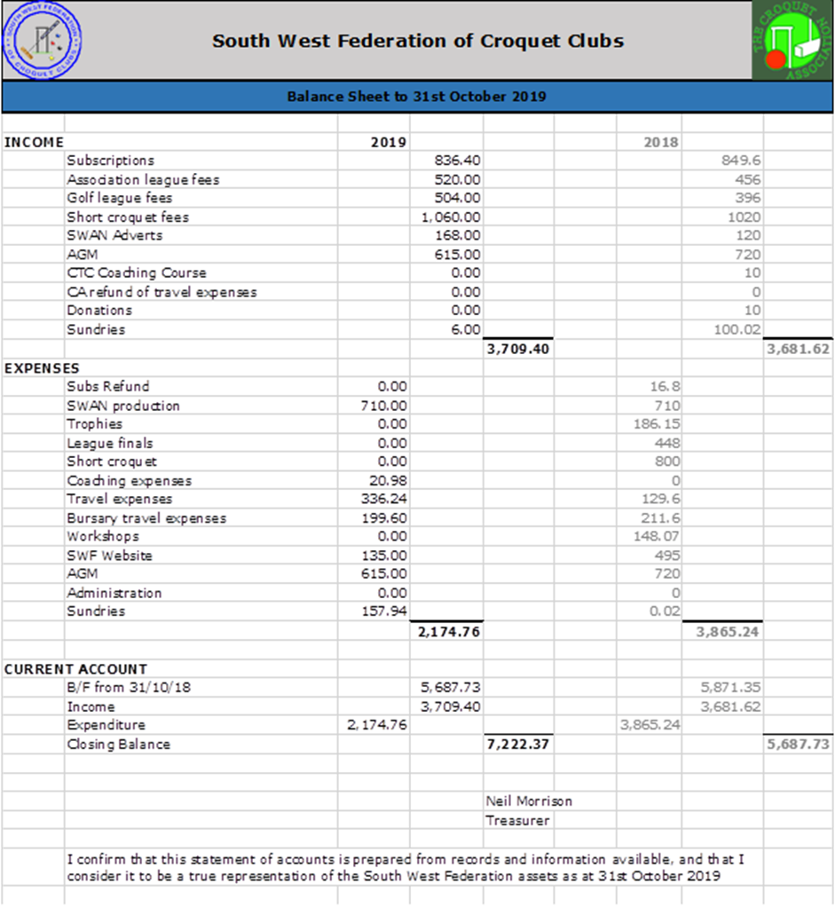
The balance sheet for the accounts up to the 14th July 2019 is shown on the next page. If committee members need further information on any entry, please email me.

Income shows a small increase since the last committee meeting with all League fees now paid and expenditure has increased by just under £1,000 for the Swan production of £710 and travel and Bursary payments of approximately £250.

The only other expenses outstanding is the invoices from Robert Moss and Budleigh of approx. £25.00 for the Handicapping Workshop.
Lawn fees for the League Finals and Short Croquet Tournaments will fall due later in the year amounting to approximately £1,300.

The final balance at the end of the year is therefore expected to be approximately £5,700 which is the same as at the end of last year.

Club Membership Returns
The number of full member clubs and affiliated clubs has not changed from the last committee meeting.
Appendix 2
Development Officer report

The spring and early summer period has been noted as a time of finding new homes for existing and new clubs.

Kingston Maurward have been served notice by their landlords (Kingston Maurward College). The club has to leave by the end of this season. Clearly a permanent solution is impossible to achieve in this time frame. At present, the club has made several approaches to local sports clubs and private landowners. To date, no detailed negotiations have taken place but a private landowner with an existing croquet lawn is a potential short-term solution.

There is far more positive news from the north of the SWF. The new Moreton in Marsh club has formed a committee with a constitution. The committee includes two experienced GC players. The committee has found a flat site with room for three lawns. The land is owned by the Town Council and a lease is close to being agreed and signed. We are in discussion with regards to financing the new lawns build and contractors. I have promised the club the loan of a set of equipment in order for them to attract members through a series of open days to be run at their new home on a temporary lawn.
I am visiting them this Friday (hopefully with the loan equipment) to look at the site and a general discussion about their plans and the time scale.

Although I haven’t been involved in developments at Westbury (Wiltshire), I believe things are moving along well in the formation of a club there.

Similarly, there is very good news with regard to Dyffryn who have a new home at Glamorgan Lawn Tennis Club. I believe that this relocation to the Vale of Glamorgan is likely to lead to a change in club name.

Paul Francis

Appendix 3
Report from Council Rep

COUNCIL: There is little to report, since there are few meetings at this time of year. Most of what I would have to say is covered in an item about the "new" council which will.no doubt, be a substantive item on the SW Agenda.

I think we need to find the appropriate way to remind all CA members to use their vote.

I think it is healthy to try to encourage an election, as long as this does not become too artificial i.e. any "over twisting" of arms just for the sake of it.

No doubt Linda will be able to report on nominations so far received.

MARKETING: I continue to try to persuade more organizations to take an advert in the Gazette and/or sponsor events. I am in communication with Institute of Advanced Motorists (they have a mature assessment scheme), a retirement property scheme and the Co-operative Funeral Service (they sponsor Bowls). I also have some ideas about other approaches.

It is quite frustrating. All the above have initially responded positively but I have not yet persuaded them to sign the cheque.

My next round of effort will be on companies with which croquet spend significant sums of money e.g. Insurance, equipment, clothing etc

HANDICAP: I am reasonably new on this committee. There is some debate about a policy on the recording of handicaps for short croquet. There is lots of input going on at present. According to my information the North Federation have had a system for some years and they report that it has worked satisfactorily and so I tend to feel that it might be sensible for all in the CA domain to adopt it. Having said that statistics etc is not an area of particular strength so will wait and see.

Klim 30.6.19

This was received from Brian following Council meeting after the SGM.

Meeting
There was time spent on reviewing the minutes of previous meetings etc - this must change with the New Council or we will get nowhere

SW Fed letter
I read our letter to the CA - the SE Fed does hold personal details on all their club members - but I raised all the points we had highlighted.
Our paper did not stimulate a detailed discussion
Thanks for sending IV’s email response to all Federations
So, I would advise that we wait for the Election communication from the CA, however we have made it clear what we can and cannot do

CA Accounts
The CA’s reserves have decreased by £52,000, due mainly to the costs of the National Development Officer and membership changes (database)
The CA was worried about the continuing ‘losses’ and hence was looking for savings
I have always said that, whilst the costs of the NCD were agreed there was no ‘hard’ targets e.g.; to increase club membership by 10% over 2 years
However, it has become clear to me that many developments do not have a robust (if any) financial evaluation of the impacts of the decision)
This was evidenced by the discussion on Croquet Gazette; as whilst the CA had said ‘Becoming a member means getting your own copy of the Gazette so you can see more of what is happening outside your club’ (John Dawson CG Sept 2017), there was no financial assessment of this decision i.e the costs of posting hard copies to all Standard Members.
So, whilst not looking at ‘what did we do wrong’ the CA Executive are looking for savings

Premium members and Fixtures book
They will not receive paper copies unless they reorder one at a cost of £5. This would save £3,000
I asked, assuming there might some negative reaction, was this worth the saving of £3,000, bearing in mind the £165,000 in the Bank?

Croquet Gazette
It was agreed, with one vote against (myself) that the CG would cease to be a hard copy posted to all Standard Members after 2019
The proposal did not include an idea of the possible savings!
I asked for this figure and walked into quite a negative response from Peter Death (CA Treasurer) ‘just look at the accounts!’
As I would have expected an indication of the proposed savings (there was one for Premium members) I asked again for such a figure and eventually the Chair of the Publishing Committee came up with ‘circa £10,000, but do not hold me to it’
So it is clear to me that there was no idea about the costs of posting out CG when the decision to change the membership and levy more costs onto clubs
I did point out that the CA has some £165,000 in the bank, so there is no need to make such decisions at this time
I also pointed out that Standard members had been told by the CA they would have copy of CG and these had been sent out by post. To change this now, after only 2 years and whilst many club members are considering taking up the offer off CA membership, would be seen in a very negative manner.
It was said that Standard members could still access their electronic copy, but, as I mentioned, many Standard members do not like to access or read items on their computer and you would be disadvantaging this without a computer or who live in low IT speed areas
I noted that Standard Members now comprise 71% of the CA’s voting potential and we should not be seen to be disregarding their needs
I also noted the marketing and communicating advantages of the CG, but to no avail
I was somewhat amazed that, at the last Council, there was a strong support to keep CG - see minutes of meeting of Council 26/1/19 - this seemed to have ‘dried up’
Yet another ‘reason to take up your CA membership’ knocked on the head

Club Subscriptions
This year is the final £1p.a. increase for larger clubs - so now, increases will/should be based on inflation
I advised that clubs/members should be told of this
Should we not tell clubs ourselves or see what the CA does?

Risk Assessment
The Executive have carried out a Financial Risk Assessment and this pointed out that Reserves should not go below £100,000
This seemed to me to be a good idea, but i am still not sure if £80,000 would suffice

Grace Period for club subs
The Executive have agreed (no need for Council approval) that whilst CA levy become due on 1st January, that there will be a 4-month grace period for payment of club subscriptions provided that membership numbers have been supplied at that date.
I questioned why, as the CA wishes to improve its finances, that such a long period is given.
I was told that many small clubs do not have the finds in place to pay the levy on 1st January and must wait until their own subs become due circa March
I noted that, as clubs are aware of the need to pay the CA levy on 1st January and that the membership figure given to the CA on the 1st January reflects membership in the previous year, that clubs have already collected the CA levy and hence should have ring fenced this money.
I asked why other clubs, once they hear on this, consider not to pay their CA levy on 1st January but wait until the grace period has ended - i.e. to keep their money in their bank for as long as possible? There was no response - I wondered if the CA Executive had even thought of this!
Again, even though the CA is highlighting the losses in previous years, the Executive have agreed to this move
Note for SW Federation: - it was hinted that the CA could ask Federations to encourage those clubs who are late in paying, to send in their money to the CA
As there was no adverse comment, I just noted it down.
If we receive such a request from the CA then I would advise that we notify the CA that that is not within our remit to chase up debtors for the CA as, after all, the relationship is between the CA and the Club
However we could write to all clubs to advise them of the 1st January due date and the need to pay up by the 4 month period so that their Standard members can take part in CA competitions

CA Membership (22 March 2019 c.f. 2018)
Premium membership has increased from 1,253 to 1,264 and increase of 11. But 35 Standard members have upgraded their membership to Premium. This means that there has been a ‘loss’ of 24 Premium Members
Standard Members now stand at 3,631
Toal membership (incl overseas and supporters) stands at £5,126
Standard Members reflect 71% of the total membership

Appendix 4
Results analysis

Report on SWF Handicap Matches 2018. Possible anomalies.

I have checked through the results of the SWF handicap matches for both AC and GC, and identified clubs that have won or lost significantly more games than would be expected if the handicaps were perfect and no other factors were involved. The threshold chosen is that the result good or bad could not be expected to have occurred by chance more than about 1 in 1000. Since we have about 40 teams involved each year, this would correspond to such an event taking place about once in 25 years.

In fact, other factors will always be involved such as home advantage and team morale, but there is always the possibility that a club's handicaps have drifted away from national norms. It is also likely that improving players (playing better than their "equilibrium handicap") are being selected for their club teams. The SWF Committee have asked me to check with the club handicappers of clubs falling above or below the above thresholds for their comments on their teams' performance in 2018, especially with regard to improving players and whether or not manual adjustments have been made to their handicaps.

The results of my conversations are as follows:

High Success Rate:
AC
Club A: 52 wins, 16 losses. Win/loss ratio 3.25:1
The club handicapper identified two rapidly improving players, one of whose handicaps reduced automatically, one had his handicap reduced manually. Given the relatively small number of games played by this club, two rapidly improving players will have a very significant effect on the results. One of the players concerned has had a manual change made to his handicap this season as well, a change that could only be made by a CA handicapper.

Club B: 97 wins, 59 losses.
Two improving players identified, no manual changes made.

GC
Club C: 195 wins, 134 losses
From their Handicap Committee Chairman: "I verified that all GC cards had been manually checked by our two GC handicappers, who are both experienced and one in particular is completely up to speed with our current approaches having attended the handicapping workshop this spring.
I understand from them that a small numbering of manual adjustments were made following a run of good results. Two primarily AC players also had their GC handicaps cut to correspond to improved AC performance.
I looked at a small random sample of cards, about 10, and saw no evidence in them of any need to interfere with the AHS; nor, looking at the match results for last season, does there seem any clear evidence that things are adrift."

Club D 132 wins, 88 losses.
They queried my figures, on first impressions the win/loss ratio is only 1.5 but the number of games played increases the significance dramatically. One improving player, manual handicap reduction made the day before I contacted them, likely to be unpopular with player concerned. My call may have strengthened the handicapper's position!

Low success rate, both GC
Club E 76.5 wins 122.5 losses.
Lawns not available early in the season, most matches played away.

Club F 42 wins, 76 losses.
Handicapper stressed that he started beginners on a round the hoops basis rather than an arbitrary high handicap. However, players had to win games to get their handicaps reduced. This is a club which has lost its ground, which must cause much disruption.

I conclude there is little ground for action by the SWF this year. The four clubs with high success rates all had improving or rapidly improving players and three of them had made manual adjustments to at least one of their players. I am satisfied that Club A has carried out current CA procedures correctly, but their win/loss ratio of 3.25 is very high. If Club B showed a similar result next year, it might be worth a more careful enquiry. The low success rate clubs both had problems which could have contributed. All the clubs contacted had functioning club handicappers or committees.

For the benefit of the new SWF committee members, last year we identified a high success club which was a small club that had just started playing league AC croquet. Our enquiry about their success rate coincided with an internal realization that their handicaps might be too high, and a visit from a CA Handicapper was arranged.

I suggest we continue with this analysis programme in future years. It is not too time consuming to make the enquiries and shows that the SWF takes handicapping seriously.

On the question of the management of the handicaps of rapidly improving players, I have a personal view that the current arrangements could be improved by increasing the points won or lost in a game by rapidly improving players from the current 10 to say 25, which would result in a more rapid approach to an equilibrium handicap. This would of course be a matter for the CA handicapping committee, and I am at present preparing a proposal for this committee for their consideration.

Richard Jackson July 2019.

Appendix 5
SWAN format

Following the issue of this year’s SWAN and receiving comments from some players I wonder if we could usefully think about enhancing its role – so far, our discussions have focussed on reducing its costs.

Instead we could produce it as a landmark publication each year, enhancing awareness of the Federation’s role and what we can provide to member clubs.

Consider:

SWAN titles itself the ‘newsletter’ of the SWF
We now have Cygnet as an Enewsletter which means we produce much more timely items – in fact several items in this year’s SWAN first appeared in Cygnet

The committee could consider ‘owning’ the document more rather than leaving Maureen to produce this with not much input from the rest of us

We did not review it as a committee this time and some items have a very personal feel rather than present the views of the committee as a whole. I think this is a missed opportunity

What about viewing SWAN as the Year Book or Handbook of the SWF celebrating the game and achievements in the SW containing e.g.:
o League results for the previous year
o League fixtures for the current year
o League contacts
o Finals reports
o Club and personal CA awards / top rankings
o Set out the function of the SWF
o Set out bursaries and other support and how to access these
o Reports from each of the officers (basically what is presented at the AGM so not a lot of extra work) – including agreed priorities for the coming year or so

I suggest we consider excluding too much sad / negative news though we probably don’t want to gloss over difficulties clubs may be having – it should be positive

This way we could be producing a publication that is valued throughout the year for more than the League info.

Linda Shaw

