Cygnet
November 2019

The e-Newsletter for the South West Federation of Croquet Clubs
Contents

P1 Seeking a Web Co-ordinator
P2 Bye-Bye “Bandits”
P2 Short Croquet
SWF tournaments
CA competition
Laws changes
P3 Chastleton CC
P4 Lawns Care seminar – update
P4 Local successes
P5 Bristol High Handicappers
P6 Camerton GC Doubles
P7 Treasurer’s Tankard
P7 All England GC Final
P9 App 1 Handicaps
P10 App 2 Short Croquet National
P 13 App 3 Short Croquet Laws

This is the last edition of Cygnet before this year’s AGM – it’s been a busy year and it already looks as though next year will be just as full – so do keep reading these newsletters and do keep sending us your articles for inclusion.

The AGM agenda and papers have already been sent to your club contacts and are on our website www.swfcroquet.org.uk – so you can let your club committee know if you have any thoughts on the League Rules and Constitutional changes that are being proposed.

This edition is chock-a-block with local success stories so do read on for inspiration and encouragement – let’s hope we’ll be telling your story next year.

Website Co-ordinator

We’re planning a significant re-vamp of our website for next year. Alison Maugham is giving us sterling service as our Webmaster but we are very aware we are not on top of the site and would like to recruit someone to the position of Co-ordinator or Content Editor as a committee member. This would need to be a co-opted position for this year.

You don't need any technical knowledge of computers for this role – what we need is someone to review the current website contents, pull together requests from other committee members for the pages that relate to their responsibilities. They would then liaise with the Webmaster to make this happen.

If you or anyone you know has an eye for detail and presentation, good communication skills and a dose of common sense please let us know – we need you!

Please send queries, suggestions and feedback about Cygnet or any aspect of the SW croquet scene to: lindawithani@hotmail.com
Remember- we send Cygnet to our club contacts and ask them to pass them on to individual club members – ideally putting a hard copy on the club noticeboard. But Cygnet is also available shortly after publication on-line on our website: www.swfcroquet.org.uk
Bye-Bye “Bandits”?
Managing the Handicaps of Rapidly Improving Croquet Players (AC and GC)

The SWF Committee has been giving some thought to the issue and Richard Jackson has put our thoughts together with the intention of presenting this paper to the CA Handicap Committee.

Before we do, we’d really appreciate your thoughts – please send them to Richard:
richard.jackson@yahoo.co.uk

The full paper may be found in Appendix 1 p9 but here is a summary of the main points:
- The current Automatic Handicap System (AHS) works well for most but not for rapidly improving players
- To mitigate this, the suggestion is that rapidly improving players should have a larger number of points awarded for a win or loss – 25 or even 50
- If this were to happen
  - How would a rapidly improving player be identified?
  - What should the level of increase of points be?
  - When does the player revert to the usual 10 points per game?
- These are all explored further in Appendix 1
- This proposal would increase fairness and reduce tensions, with only a modest complication of the AHS system
We should encourage, not discourage rapidly improving players, and avoid the use of the term “bandit”. The difficulty lies entirely with our management of their handicaps, not with the players themselves!
Short Croquet

SC in the SW
By now, your club will have received the entry form for next year’s League matches and the two Short Croquet Tournaments
- Nailsea on 17/18/19 April
- Budleigh on 2/3/4 October

Short Croquet Competition organised by the CA
We received the following notice from Beatrice McGlen, Chair of the CA AC Tournaments committee.

Following the consultation in August/September the AC Tournament Committee has written the attached review document with a proposal for a new format for the National Short Croquet Competition. We would be pleased if you could discuss this within your Federation and respond with your feedback by Friday 8th November.
Thank you.

The full text of the consultation may be found in Appendix 2 on p10 so please reply direct to Beatrice. If you could copy us in to your comments, that would be great.

SC Laws

Thanks to Paul Pristavec’s (Dyffryn CC) eagle-eyed perusal of the Notts List, we were made aware that the CA was considering changes to these. We were concerned that some of these would be detrimental to the game and that this wasn’t being discussed widely with those who play the game at that stage.
Stephen Custance-Baker, as many of you will be aware, undertook a survey at the Budleigh SC tournament and wrote to Graeme Roberts, (Chair of the World Croquet Federation and Association Croquet Laws Committee) – the full text may be found in Appendix 3 on p13 together with the reply from the Laws Committee.
News from Chastleton

Sue Mackay has been on her travels and tells us about a local detour with rather sad news for croquet over here:
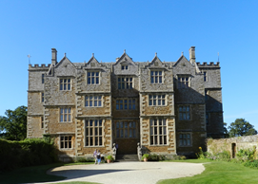
Returning from a recent trip to Norfolk, we decided to cut across country and avoid busy roads and motorways. We thus found ourselves, mid-afternoon, passing Chastleton House in Gloucestershire, a National Trust property where Walter Whitmore Jones codified the rules of croquet in 1866.

Imposing: Chastleton House

We used our National Trust for Scotland cards to gain entry, having resigned from the National Trust after they kicked Dyffryn Croquet Club out of Dyffryn Gardens. Today we discovered that the croquet club at Chastleton has been forced to disband due to issues with the Trust, who would not allow them to continue to play when the house was not open, as they had been doing for a good number of years.

A rare chance to get onto the court

Four ladies, ex club members, now play GC on Friday afternoons as house volunteers, but there is no club left to back them up. It seems a trifle short-sighted, as the leaflet handed out at the gate says “Between April and September head down to the croquet lawns. Have a game at the place where the rules were first drawn up.” The public can knock about on the adjacent lawn, but it seems that except for an hour or two on a Friday there will be no-one to demonstrate how to play.

The Jacobean house is well worth a visit, and tea and cake is served by local charities in the parish church next door – it was strange to be sitting drinking tea amongst the gravestones in the sunshine!

A footnote in passing thanks to John Hancock of Nailsea CC: Jeremy Clarkson dropped in to the local pub while a friend of his was there. It is not recounted what JC’s views on the closure might be – we can only imagine …

Lawns Care Seminar

Hosted by Budleigh CC this was the first seminar of its kind in this region and we’ve received the following feedback from Alison Pickering of Dennis SISIS, the company that delivered it.

The day proved to be very successful with superb facilities and support from the club. The feedback from the 23 delegates on the day was very positive and many asking when we would be holding another one.
The summary from the feedback forms on the day are as follows:
- Very informative presentation from Alan Lewis, which was very easy to understand, with a good balance of practical and scientific content
- Very useful discussion on scarification and verticutting
- A well-paced presentation which was delivered in an entertaining way, but blowing away a lot of misconceptions
- They enjoyed the outdoor demonstration which put the theory from the morning into practice, showing them how to improve their lawns
- The venue was described as excellent, very accessible with a lovely lunch
The only really negative comment we had about the day, was that there was a lot of information to take in and a handout would be useful. This is something we are aware of and working on at the moment.

Local successes

Many thanks to everyone who has sent in accounts and photos of local success stories during this season. It’s great to see all this and marvellous to be inundated with articles – so many in fact that some of these have been held over until the next edition of Cygnet. So please don’t be offended if you don’t see yours here – it will be – and there’ll be room for more over the winter so it’s not too late to send in yours.

Double fun at Bristol

Bob Whiffen tells us all about a new initiative for high handicap AC and GC players at Bristol CC – with thanks to Mike Chan for the photos …

Bristol Croquet Club organised a high handicap event on 5th and 6th of September which was the first of its type for the club.

Thursday was an AC day for those with handicaps between 16 and 24 which attracted twelve players from a variety of clubs including Cornwall (the first to arrive and last to leave!), East Dorset, Sidmouth, Llandaff, Nailsea, and Bristol.

Friday was a GC day for those with handicaps between 8 and 16 which brought together the five players from Llandaff and Nailsea that had played the day before as well as players from Abbey, Camerton & Peasedown, and Bristol.

The weather on the Thursday was kind to us, but the forecast for the Friday did not look good. However, the threat of rain never materialised, the atmosphere was friendly and relaxed, and the feed-back suggested that everybody enjoyed the tournament. A surprise treat of buttered scones on the GC day went down particularly well.
The GC contingent looking very happy – they must have eaten the buttered scones

The winner on AC day was Mike Rice (East Dorset) H/C 22, and the runner-up was Sandra Morgan (Nailsea) H/C 18.
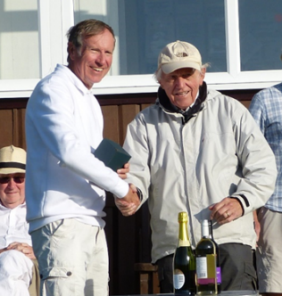
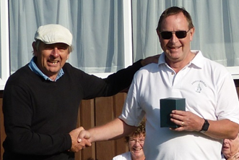
Left – Chris Spray (Abbey) receives his GC award from Manager, Bob Whiffen

Right – Mike Rice (East Dorset) accepts the AC award from club Chair, Ray Ransom

On the GC day many games, including the final, were decided on the golden hoop, and the winner was Chris Spray (Abbey) H/C 10, and runner-up was Campbell Smart (Llandaff) H/C 9.

The tournament itself ran smoothly and if we run it next year, several players are already looking forward to returning.

GC extravaganza at Camerton and Peasedown

Ros Key-Pugh tells us all about the 2019 GC Open Doubles competition:

A full complement of 16 pairs from 6 different clubs booked to come and play in our Annual Doubles tournament. Unfortunately, Roger Pocklington was ill the night before and could not play at the last moment so his partner Marion Button from CPCC gallantly agreed to play for both of them! Then Andrew and Anne Larpent did not appear so one block was reduced to 3 pairs.

The morning consists of mixed ability pairs in 4 blocks of 4 then in the afternoon those finishing first in their block are formed into a new Block, all coming second into another etc and all within each new block play each to determine a final rank order for all 16 pairs.

Karen Cromey and John Knowler just beat Colin Britt and Ros Key-Pugh into second place in Block A, and Brian and Graham McCausland beat Brian Robinson and Sue Norfolk into second place in Block B.

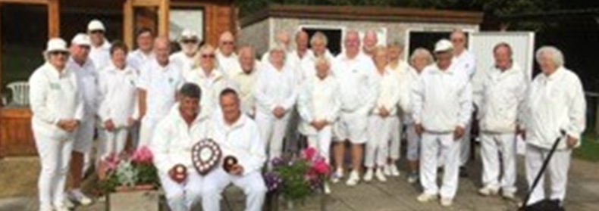

A smiling Karen and Jon display their trophies

However, the games played in Block C resulted in 3 pairs each having 2 wins. Net hoops for all their games had to be calculated and then as two were still tied who beat whom was used to separate them resulting in Patrick Knight and Fran Ralli making it through to the top afternoon block just beating Dave Kibble and Linda Shaw.

In the afternoon the blocks were reconfigured and all but the top group showed a clear order from just the number of wins. However, the top group was very hard fought. The closest game which lasted well after all other groups had finished was between Brian and Graham McCausland and Karen Cromey and John Knowler – a Nailsea nailbiter.

After some excellent hit outs in front of both hoops 11 and 12 by both sides which lasted over 20 minutes Karen and John finally won 7-5 giving them 2 wins in total. However the other ‘pair ‘with 2 wins was Marion Button and she had beaten Karen and John. Gallantly she chose to leave before the presentations and Karen and John were presented with the Doubles Shield. Marion will receive a special trophy of her own at our Club Tournament Presentations later in October.

Look out for this tournament next year. Why not come and join in?
Treasurers Tankard

Nailsea & District Croquet Club played host to the prestigious Treasurer’s Tankard tournament. Entry was by selection and the eight players came from all over the country to try to win the beautiful glass tankard and included Ian Vincent, Secretary of the CA, and James Hawkins, the author of Complete Croquet.

The last time this was held in Nailsea was 2003 when Nailsea player Marcus Evans won!
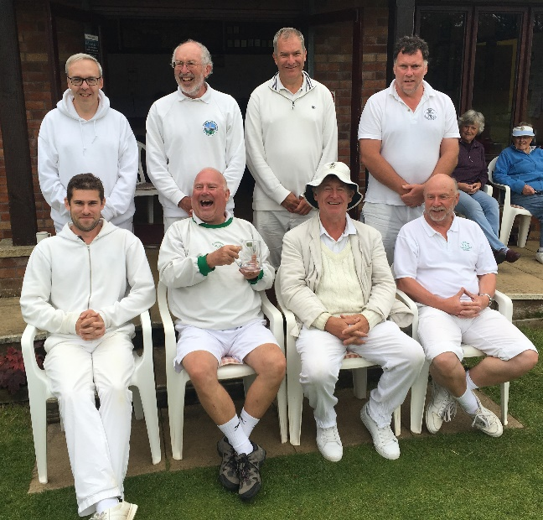
The club members worked hard to provide good lawn conditions and high-quality catering – Nailsea hoops are generally regarded as amongst the best in the croquet world because they are rigid and precisely set.

The players loved the challenge of these hoops and thoroughly enjoyed their stay in Nailsea, visiting local pubs in the evening, taking part in a quiz and playing darts.

A cheerful TT crew – Phil Cordingly holds the trophy!

On the lawns, the format was a double “round robin” where the entrants all played each other twice. The contest was expertly managed by Phil Cordingley from Hampstead Heath. In spite of the time spent on organisation, Phil still managed to stay relaxed and to win the competition by gaining 11 victories out of the possible 14. It was a popular win with the players and also with spectators, some of whom had travelled from afar to watch the high-level croquet.

Runners-up with 9 wins each were Robert Wilkinson from Bristol CC and Jonathan Lamb who spends much of his time living in Uruguay.

Kathy Wallace NDCC

All England GC Final: Youth Triumphs

Ros Key-Pugh not only managed and referred this event but also found the time to set pen to paper again for us to report on a local triumph for this national competition…

14 players from all over the country won through to these Finals:

- There was a wide range of handicap: +12 down to -4! Would the high handicapped players’ greater number of extra shots be enough to win or would the extra skill of the lower handicapped players prevail?
- There was a wide range of experience: for some this was their first National Final, for others it was just another major tournament to try to win.
- There was a wide range of age: from 13-year-old Jack Good to one or two in their seventh decade!
Played over two days everyone plays everyone else – 7 games on the first day and 6 on the second day. Unfortunately, one player fell ill after two games on the Saturday and had to retire and return home so her games had to be withdrawn from the tournament results determining the eventual winner, and each round in the remainder of the tournament gave one player a bye.

It is indicative that the handicap system works – half of all the games played were scored at 7-5 or 7-6 and no-one had less than 3 wins to their name at the end of play.

Simon Carter and James Galpin were the lowest handicapped players at -4. Simon had some good wins but succumbed to some of the middle order players in close games. James from Nailsea was very determined and won 8 of his games with some excellent hit outs and tactical play. The surprise to me was Jack Good (+5) from Bowdon who at age 13 showed great skill and understanding of the game and won 8 of his games also – a man to look out for in the future!

James and Jack could only be separated by net hoops scored – James had +19 and Jack + 17 giving James 2nd place and Jack 3rd. However, it soon became clear that Dominic Aarvold with a handicap of +4 from Bristol was playing superbly. He had to work hard but was so persistent and accurate in his take outs and long hoop shots that he succeeded in completing the weekend with 11 wins –only losing in his last match to young Jack – and achieved a well-earned 1st place.

What a delight and promising sign for the future that the top three places were taken by players all under 35 and two of them from our South West region.

My thanks to all my team from Camerton and Peasedown who provided us all with excellent refreshments throughout the weekend, and to those who came early each day to reset the hoops and lay up the lawns.

Tournaments like these are totally dependent on the goodwill and enthusiasm of such members.

That’s about it for now folks – but keep reading for the appendices

Appendix 1
Handicaps for fast improvers

The current Automatic Handicap System AHS works well for established players whose handicaps are changing slowly if at all with time, but does not work well for rapidly improving players who are improving more rapidly than can be accommodated by a change in handicap of one step for every net five games won. The current way of managing this is to allow Club or CA Handicappers to make arbitrary changes to players’ handicaps, often awarding them 150 or even more points to try to align their handicaps to their ability. This can cause difficulties; the change may or not be welcome, and requires the handicapper to follow closely the progress of the improving player, which he/she may or may not be able do effectively.

My suggestion is that for rapidly improving players, they should have a larger number of points awarded for a win or loss in a handicap game, say 25 or even 50 rather than the current 10, so that their handicaps would move more quickly. This would reduce but not eliminate the need for manual intervention.

If this is agreed, three questions need to be considered. How do we identify the rapidly improving player, what is the level of increase of points won or lost for a single game, and when does the player revert to the normal 10 points per game? This is a matter for the Handicap Committee and for general debate.

The possibilities for identifying rapidly improving players could be:

- A player who wins 7 consecutive games or 9 out of 10 (about 1 % chance if their handicap is correct)
- A player who has had a manual change of handicap (this would encourage less draconian interventions by handicappers since the player would be put on an accelerated points won/lost program)
- All beginners. Many move fairly rapidly – this would allow quicker movement and less intervention
- All of the above: would get handicaps towards equilibrium more rapidly, but might be seen as too radical or disruptive

Number of points won/lost per game. I would suggest 25 but 50 is a possibility. A matter for debate if the principle is agreed.

When to revert to the normal 10 points. My suggestion would be when the player loses 5 out of his last 10 games. Players who are winning 70 % of their games may still be 4 steps from their equilibrium handicap.

Resentment is caused when players in their first or second season win handicap competitions easily, often with bisques standing at the end of games, and the All-England Cup for AC, which should be a premier event for all AC players in the domain has been abandoned by almost all established AC players. Many rapidly improving players want to bring their handicaps down and are frustrated by the relatively small number of competitive games they can play in a season; more points for a win would enable their handicaps to come down more rapidly.

This proposal would increase fairness and reduce tensions, with only a modest complication of the AHS system.

Richard Jackson

Appendix 2
Review of National Short Croquet Competition: written by the CA AC Tournament Committee

This competition was introduced two years ago to promote short croquet both as an attractive variation of croquet in its own right and as a stepping stone for beginners and GC players in to Association Croquet.

The format of the competition was similar to that of the other National inter-club competitions. The specific rules for the SC competition were that teams had to have a combined handicap of SC25 with a maximum of SC10 and a minimum of SC3, with a restriction that only one player could be between SC3 and SC5.

This competition has not been very successful. 11 teams entered this year but only 5 matches were actually played, with all the others being walk-overs. The reasons given for not playing matches were mainly because a team could not be raised, but the causes for this were complaints about the handicap restrictions, unwillingness to travel, and insufficient time between rounds to arrange games (even when the previous round had been a walkover!).

This is clearly not a very satisfactory situation for a National Competition and a review of the competition has therefore been instigated. The options under consideration are continuing in the current format, abandoning the competition, or coming up with another format that may be more popular.

These options are discussed below:

Continue with the current format
The 11 clubs that entered this year were, with the exception of Nottingham, all from the SW, Yorkshire and NW Federations where short croquet is a popular form of the game. The two clubs from the SW had long distances to travel to their fixtures and they did not play any of them. It is probably unlikely they would enter this competition again under the current format. If no clubs south of Nottingham enter then it really ceases to be a National Competition, so continuing with the current format does not look an attractive option

Abandon the SC competition
The original aim of introducing this competition is probably still a good one, so giving up on it after just two years is rather defeatist.

Find another format
The popularity of short croquet in the three federations that hold leagues of their own suggests that this could be replicated elsewhere so a consultation was started at the end of August with all the Federations. Each one was asked if any of their clubs played short croquet and if so how many, and if they already had a league or tournament within the Federation. They were also asked if they would be interested in a Federation based competition. Replies were received from all 9 Federations, some of whom had surveyed all their clubs. A summary is shown in the table below:

Federation | Number of clubs playing SC |  | Interested |  |  | Comments
Croquet North | 1 |  | Not sure |  |  | Distance a problem
Yorkshire | 6 |  | Yes
North West | 6 |  | Yes |  |  | No minimum handicap, max 10
East Midlands | 2 |  | Possibly |  |  | Used to be played a lot but GC has taken over.
West Midlands | 1 |  | Yes |  |  | Distance an issue even within Fed.
East Anglia | 2 |  | Yes |  |  | SC withered as GC expanded. Lack of SC coaching. Regional one-day tournaments could
 |  |  |  |  | be a possibility
South East & London |  | 1 |  | Not sure | All clubs were asked, many just play GC. Some were interested to find out about SC
Southern |  | 0 |  | Yes | All clubs were asked, some interested. Fed considering setting up a league
South West |  | At least 18 |  | Yes | 2 SC tournaments, with ~30 teams, held each year. Winter league at some clubs. No minimum  handicap

Some of the comments revealed that there is confusion between Short Croquet and 14-point games on full lawns, or games with time limits, so there is clearly a need for a clear explanation to appear in the Gazette, at the very least. Many of the responses indicated that short croquet has been played in the past but GC has replaced that and, whereas some clubs said they had no intention of changing that, others suggested that the reintroduction of SC has some merit.

The AC Tournament Committee would therefore like to submit the following proposal to the Federations for their consideration:

The Federations each put forward one team to the National Final. It is suggested that each Federation chooses whatever method suits it to find this ‘champion’ team, so, for example, one or more tournaments could be held or there could be a league which could run in summer or winter, or even indoors. Whatever method is chosen the winning team would need to be decided by a specified date so that there was time to arrange travelling and accommodation for the final.

A National Final would be arranged by the CA at a predetermined venue (which is currently planned in September but could be shifted), the format of which would depend upon the number of Federations participating. For example, if 4 take part then the semi-finals and final could take place on a single day or over two days. If 8 take part then we could have two blocks of 4 with a final between the winners of each block or a simple knockout with a random draw, with appropriate X,Y,Z format to generate full placings. This would be a two-day event.

Alternatively there could be a north and south regional final with the top one or two going through to the National Final. Whatever the number of teams, we would like to make this National Final an ‘event’ so that participants and their accompanying partners have an enjoyable time.

Regarding handicaps it is suggested that since the CA database now records short croquet handicaps separately, players should use their SC handicap. Each team would consist of 4 players with no minimum handicap limit. Having no minimum may entice better players to participate since the mandatory peels rule for A class players brings an interesting challenge to them.
The maximum handicap any player can have is SC10 and it is proposed that there should be a requirement that each team has at least one player with a SC handicap of 8 or more, so that high handicap players are encouraged to participate. If a club enters more than one team then the players in any fielded team cannot have played for the other team/s at any stage in the competition in that season. In line with all other CA competitions, the players must be Individual Members of the CA, and playing members of the clubs they are representing.

Decision making
Feedback from the Federations on this proposal is encouraged, with a cut-off date of November 8th. In particular we would like your views on:

- Do you think the proposed format is an improvement on the current format?
- Would your Federation be interested in sending a representative team in 2020 and /or subsequent years?
- At what time of year would you like a National Final to be held, bearing in mind that the cut-off date would have to be about 4 weeks in advance of the Final?
- Would you prefer a one-day National Final or a two day event? Would a weekend or weekday be best?
- If more than 4 Federations enter what would be your preferred format for the final – 8 teams playing over two days or two regional semi-finals with 2 or 4 teams going to the National Final?
- Does the proposed handicap requirement of no minimum handicap, maximum of SC10 and at least one player with a handicap of SC8 or more suit you or do you have a different suggestion?
- Would you prefer the matches to be a mixture of doubles and singles, or all singles, or all doubles, or, as it currently stands, the teams can agree prior to the match starting?

A decision, based on the responses will then be made at the AC Tournament Committee meeting on November 9th so that the details can be circulated and appear in the Fixtures Calendar for 2020.

Please send your comments to Beatrice: beatrice@mcglen.co.uk
And if you’d like to copy us in, to Linda: lindawithani@hotmail.com

John Grimshaw has advised Beatrice of a factual error in her report and she has acknowledged and apologised for this.
Beatrice, there is a factual error in your summary of 2019 competition. Kington Langley, from the SW Federation, did undertake their match. After receiving a walkover from Chester in the previous round, we played Bury in the semi-final at Kenilworth.
Appendix 3
Short Croquet Laws

Stephen Custance-Baker wrote the following letter to the Association Croquet Laws Committee:

As one who enjoys Short Croquet as an excellent and challenging game in its own right I do not want to see its rules changed in order to reduce the differences between Short Croquet and other forms of AC. I therefore took a petition with me to the recent individual and team tournaments at Budleigh Salterton to see whether others agreed with me.

The heading on the petition reads:
“We, the undersigned, are all players of Short Croquet and do not wish the wiring lift rule to be changed from the version in The Laws of Association Croquet - 6th Edition.”

Well over 100 players signed this petition and I hope you will take this into account when the new laws are being reconsidered after the consultation process.

I would be happy to send you the original petition or copies of the completed sheets if you wish.

Breaking News:

Graeme Roberts – Chair of the Committee - has now confirmed the SC Wiring Lift Law will not be changed. He writes:

The ACLC has considered the views expressed on the short croquet laws and in response has agreed the following changes to the short croquet Laws published in the 7th Edition consultation draft.
1. The SC Law modifying the standard wiring lift Law will be reinstated in its 6th edition form.

This is a rare success for a protest campaign.

