Cygnet
September 2019

The e-Newsletter for the South West Federation of Croquet Clubs
Contents

p1 CA Council Election results
p2 SWF AGM
p3 SWAN
p4 Somerset success
p5 Tree fellers in Bristol
p6 Scammers
p7 Appendix – voting analysis
It hardly seems a moment since the last issue of Cygnet was winging its way through the ether but already there’s loads to catch up on.

It may be nearing the end of the playing season but we’re all gearing up for the winter planning and preparations – read on for information about the new SW Reps to CA Council, our own AGM and lots of other news.

Council election results

It’s congratulations to Dave Kibble, Peter Nelson and Klim Seabright for winning the ballot for the South West’s three places on the CA Council.

They are all well-known and experienced in the South West and the croquet world and we are looking forward to working with them to develop broader relationships between this region and the CA, and to enhance croquet here.

You can read Ian Vincent’s (General Secretary of the CA) analysis of the results of the ballot for the SW in Appendix 1 on page 6.

Please send queries, suggestions and feedback about Cygnet or any aspect of the SW croquet scene to: lindawithani@hotmail.com

Remember- we send Cygnet to our club contacts and ask them to pass them on to individual club members – ideally putting a hard copy on the club noticeboard. But Cygnet is also available shortly after publication on-line on our website: www.swfcroquet.org.uk

SWF AGM update

Have you noted these key dates?

30th September Deadline for proposals to AGM
4th October Next SWF committee meeting
17th November AGM

Proposals for consideration

A Resolution for inclusion in the Agenda of the Annual General Meeting may be proposed either by the Committee or by a Member club (duly signed by its Secretary or delegate)
Proposals to the AGM will not be tabled if they were considered in the previous AGM.

Please include the following information:
• Name of Club
• Proposal
• Rationale
• Name and contact details of club secretary

Committee

The closing date for nominations to the SWF Committee has passed and the following have been received and will be presented at the AGM for election.

Brian Wilson: Chair | Linda Shaw: Secretary
Stephen Custance-Baker: League Secretary | Paul Francis: Development Officer
Richard Jackson: Regional Coaching Officer | Robert Moss: General member

As you can see, we’re a tad diminished –

- Neil Morrison will not be standing as Treasurer but has kindly agreed to continue with the Treasurer’s tasks for the interim period.
- Maureen Smith is standing down as SWAN editor after many years of sterling service and Marcus Evans will not be standing.
- Klim Seabright is now one of the SW reps to CA Council and has not stood for any other role on the SWF committee.
We are clearly in need of new blood. There must be (at least) 50 ways of helping …

We have for some time been reflecting on the best way of structuring the Committee and roles and are thinking along the lines of taking on more shared responsibility for supporting and developing clubs.

We would like to involve non-committee members in this process – helping to make a flatter, more involved and informed network. So please, please, please – do let us know if you can help.
- You could be our next Treasurer
- You could be our next SWAN editor
- You could make yourself available for co-option to the committee
  - This is a great opportunity to test the water – you’ll have far more skills and talent for this than you think
- You could share your skills in all sorts of areas with other clubs and players

If you’d like to discuss this with any of us then please get in touch
lindawithani@hotmail.com

SWAN

With Cygnet providing more regular updates to SWF members, we’ve been having a think about the future of SWAN.

It is always keenly anticipated, well used, and a jolly handy size – but we’re thinking about making it a SWF handbook containing more information about the committee, our policies, bursary schemes and main objectives for the year.

If you have any suggestions about what you’d like to see in SWAN just drop us a line: lindawithani@hotmail.com

Inter-Counties Victory for Somerset

Great news: Somerset won the GC Inter-counties Championship at Southwick. This is the first time that Somerset have won – and the first time the trophy has come to the West since Dorset won it about 9 years ago. Stephen Custance-Baker tells all:

Our team was:

Jim Gregory |  | Non-playing captain - Nailsea
James Galpin | -3 | Nailsea
Stephen Custance-Baker | -2 | Taunton Deane
David Goacher | -2 | Bristol
Colin Britt | -1 | Camerton & Peasedown
Ryan Cabble | -1 | Nailsea

And here’s a sight never seen before, the GC Inter-counties score board with Somerset at the top and no-one was more surprised than ourselves at this outcome.
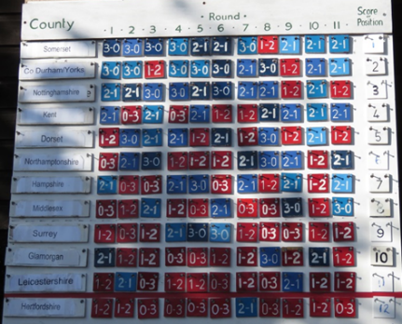
The competition was held at the East Sussex club at Southwick on 11 immaculate courts. Each county plays the other 11 over two days with each match consisting of a doubles and two singles.

Everything started well as we won our first fifteen games. After that it was steady progress but with most matches being 2-1.

We went down 1-2 against Nottinghamshire who were favourites with a team of four -4s, but managed to beat Co. Durham & Yorks.

In both matches the star performer was James Galpin who beat Will Gee (-4) and then John-Paul Moberly (-5). We still expected to finish 2nd but at the very end Co. Durham & Yorkshire beat Nottinghamshire and we finished as the only county with a single loss.

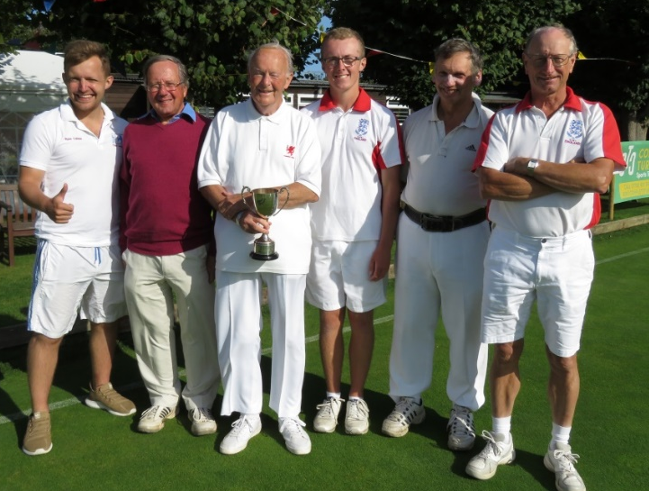

Beaming winners: Ryan, Colin, Jim, James, David and Stephen

Goodbye Monterey Cyprus

Some sad news (but stunning photos on this and the following page thanks to Ray Ransom and Sally Green of Bristol CC).

Ray tells the story:

It's always sad when you have to destroy a tree that has been alive for decades, but it just had to be done. It had already lost a large limb which, fortunately, did not result in personal injury nor damage to lawn 1.

The tree surgeons we had inspect the tree, unanimously agreed that it was only a matter of time before more limbs collapsed. The council agreed, in fact insisted, that the tree should be felled and the work should be done before the school re-opened.
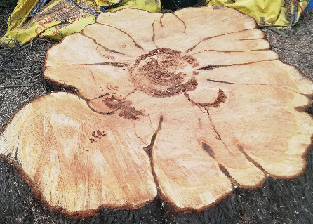
You will see from the photo, and even better by inspecting the actual stump left, that there are clear signs of rotting at the centre. Many of the branches showed similar signs.

However, there are benefits arising from the removal of the tree. A tree of this size soaks up an enormous amount of water and as a result, the grass on the drive side of lawn 1 has suffered as is clearly visible. Also, it will in time provide a bit more parking space.

The downsides are the loss of shade for spectators and it opens up an unwanted view of the school. Any ideas for overcoming these disadvantages, which do not involve the club in high upfront or maintenance expense would be welcomed by the Committee.
One of the problems that we had was that our lease from the council meant that we had to pay all costs relating to the removal of the tree, which in the end cost us around £3000. Possibly clubs in a similar situation to Bristol should have a close look at their lease.

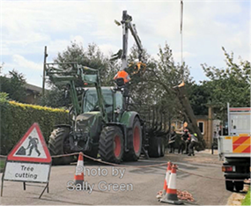  Road closed: equipment in place |  | 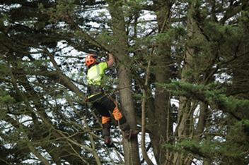  The first ascent
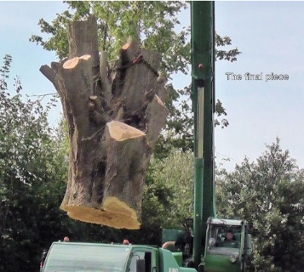  Off to a better place | 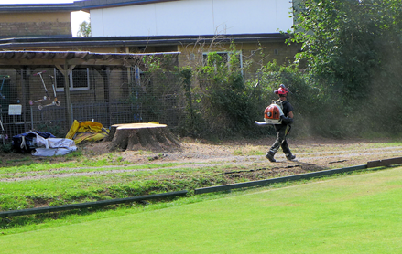  Job done

What’s happening in your neck of the woods? – please let us know about your interesting stories and we’ll publish them here.

Beware the scammers

Your club should have received the following advice from the CA but it’s worth reproducing here for individual members as well as clubs – do take care.
Two of the CA's Member Clubs have reported that they were the subject of an attempted fraud, in which an e-mail, purporting to come from the club's Chairman, was sent to their Treasurer asking them to make a payment to a bank account.

The attempts, though very plausible, were spotted, but it was suggested that other clubs and individuals should be warned.

Reports of such attacks are common, affecting both commercial and voluntary organisations as well as individuals. The advice to prevent them is always to check, by phone or text message, but not e-mail, that a request to make a payment to a previously unknown account is genuine.

Recently, it was announced that online banking systems would be enhanced to report mismatches of account names, which it is hoped will reduce the opportunity for such frauds. However, that won't happen until next year, so be on your guard.

Mark Suter, CA Manager, added:

You need to be especially suspicious when someone puts the bank details in the body of the email. Legitimate requests for payment are normally sent in an attached Pro Forma.
Also look at the email address of the sender, these criminals clone names to make them look authentic... e.g. email from; 'Mark Suter [CA Manager]' but the actual email address is caoffice@dfvgra231.com.

Do check carefully.

Appendix 1

Council Elections: Analysis for the South West

Candidate | Votes
Dave Kibble | 96
Peter Nelson | 92
Klim Seabright | 67
Linda Shaw | 42
Brian Wilson | 62

Ian Vincent writes:

“There were 359 valid votes cast (262 online and 97 postal) from an electorate of 1369, a turnout of 26%. There were also 8 invalid papers. The quota for election by single transferable vote was therefore 89.01. The number of first preference votes cast for each candidate were as follows:

Dave Kibble and Peter Nelson were deemed elected at the first stage as their first preference votes exceeded the quota. Linda Shaw was eliminated in the 2nd stage and her votes redistributed.
No further candidate reached the new threshold.

In the third stage, Dave Kibble’s surplus votes were distributed and Klim Seabright reached the final threshold. Dave Kibble, Peter Nelson and Klim Seabright are elected to serve for terms of 3, 4 and 2 years respectively.”

Information about the results in other regions may be found on the CA website https://www.croquet.org.uk/?p=press/news&NewsID=6858&pup=y

-----------------------------------------------------------------------------------
Voting turnout

Brexit referendum 72.2%
UK General Elections 55%
SW Croquet constituency 26%

Let’s do better next time!

Our local turnout was 26% which is 60% higher than in the other constituencies where voting took place.

Thanks to everyone who made the time to vote.

One vacancy will occur in two years’ time – please do follow events and have an input into these – maybe you’ll be one of those standing.

