

**Cygnet**

**Issue 13: February 2019**



**Offspring of SWAN**

**The e-Newsletter for the South West Federation of Croquet Clubs**

**Contents**

**GC Rules Changes**

p2 Are you ready for these?

**Handicapping**

p3 Workshops

p3 Completing handicap cards

**New League Results forms**

p3 How to complete them

**Committee**

p5 Adam leaves us

p6 Co-opting new members

**Club development**

p7 Croquet Matters

p7 Promoting croquet

**Personal development**

p8 Supportive google group

**Camerton & Peasedown**:

p8 courses

**Obituary**

p9 Stephen Read

**CA Governance**

p 9 What’s happening?

**Appendices**

p12 GC rules Update session

p 13 New GC rules: summary

p 15 Handicapping Workshop

p 17 Handicap cards

Please send your queries, suggestions and feedback to us: [lindawithani@hotmail.com](mailto:lindawithani@hotmail.com)

We send Cygnet to our club contacts and ask them to pass them on to individual club members – ideally also putting a hard copy on the club noticeboard.

A lot of effort goes into making Cygnet interesting, relevant and readable and its aim is to keep clubs and their members informed and to feel part of the local croquet scene.

So please do circulate this as widely as possible.

We welcome items and photos for inclusion, and suggestions for ways of improving this newsletter – don’t be shy but do be polite!

Many thanks

Cygnet is also available shortly after publication on-line on our website: [www.swfcroquet.org.uk](http://www.swfcroquet.org.uk)

The next SWF Committee meeting will be 23rd March so please let us know if you have anything you would like us to discuss or be aware of.



An information-packed issue so get yourself a cup of coffee and settle down for the big read!

**GC Rules Changes**

This remains one of the key issues for the forthcoming season and the rules become live on 1st March and must be implemented in all games this season.

The CA wrote a two-page article in the Gazette (January 2019)) and we understand the new Rules are now available from the CA.

Information about the new rules is available locally:

The SW Croquet Academy is running a GC New Rules and Refresher day on March 28th – full details on their website: [www.southwestcroquetacademy.co.uk](http://www.southwestcroquetacademy.co.uk)

Taunton still has a few (very few) places left on Stephen’s New GC Rules pods on Sunday 10th March and Monday 11th March. First come, first served – contact Stephen: [webmaster@tauntoncroquet.org](mailto:webmaster@tauntoncroquet.org)

Other clubs are running smaller events as promoted in the last edition of Cygnet. If yours is one of them and you have space for people from other clubs, then do let us know if you would like us to help you promote it.

In the previous edition of Cygnet, we asked for an estimate of continuing demand for another course – we didn’t receive any replies but have provisionally arranged a further briefing session:

|  |
| --- |
| **New GC Rules Update Session**  **Saturday 6th April 10.00 – 1.30**  **Nailsea Croquet Club**  Kevin Ham and Jay Dyer will present this session which will cover:  The wrong ball rule  Changes to the offside rule  Handicapping  If there is sufficient demand a second session will be run in the afternoon.  Please apply for places using the format in Appendix 1 |

In the meantime, Ray Ransom at Bristol CC and our own Stephen Custance-Baker have written a summary of the changes which may be found in Appendix 2

Referees

It could well be that the new rules are the source of some confusion during this year’s league games and clearly it is not always possible for a genned-up referee to be present.

Could captains therefore please do their best to ensure that their teams are as well briefed as possible and err on the side of caution when undertaking strokes that may be affected by the new rules.

Please ensure a copy of the new rules is available at all matches and refer to this if necessary.

Decisions made on the day are valid but do contact a referee subsequently if you’re not sure you actually got it right. You can find out who is a GC referee vi the CA data base

|  |
| --- |
| **Handicapping workshops**  A reminder that we are running another Handicapping Workshop in Budleigh Salterton Croquet Club on:  [Image result for Workshop Clip Art](https://www.bing.com/images/search?view=detailV2&ccid=tcixv%2bDz&id=ACBBCD4CA5D27DE01CC61635E3EC16B066691437&thid=OIP.tcixv-DzKHiFmw4Ch2_X8AEsDL&q=Workshop+Clip+Art&simid=607995349016120676&selectedIndex=1)  **Sunday 24th March 2019**  **Arrival: 9.30**  **Start: 10.00**  **Departure: 15.30**  The session is filling up nicely but there’s plenty of space and a warm welcome for more.  We urge, not only existing and potential club handicappers to attend but also League Captains and are particularly keen to welcome clubs who haven’t been able to send anyone to our previous workshops.  We are all working to ensure fairness throughout the croquet world but this will rely on every club taking an active role in bringing it about.  See Appendix: 3 for further info and how to book. |

**Completing our handicap cards**

And while we’re on the subject, we received an A4 document setting out how this should be done in a variety of circumstances. Chris Donovan undertook this on behalf of Sidmouth CC – many of you should find this helpful in clarifying this “vexed” topic.

The document may be found in Appendix 4

Chris may be contacted on [chris@navonod.plus.com](mailto:chris@navonod.plus.com) if you’d appreciate further support with this.

**Completing League Results Forms**

And on a related topic: new results forms have been designed and are available for download from the SWF website at [www.swfcroquet.org.uk/results-form.](http://www.swfcroquet.org.uk/results-form) There is a separate form for each of the leagues but they are all very similar. If a form is completed by hand then please make it as neat as possible as they will be scanned before being transferred to a spreadsheet.

The forms can be downloaded in pdf format and printed out or, for those of you who use MS Office software, they can be saved as MS Word or MS Excel files and completed electronically. In either case they should be returned as email attachments to [results@swfcroquet.org.uk](mailto:results@swfcroquet.org.uk).

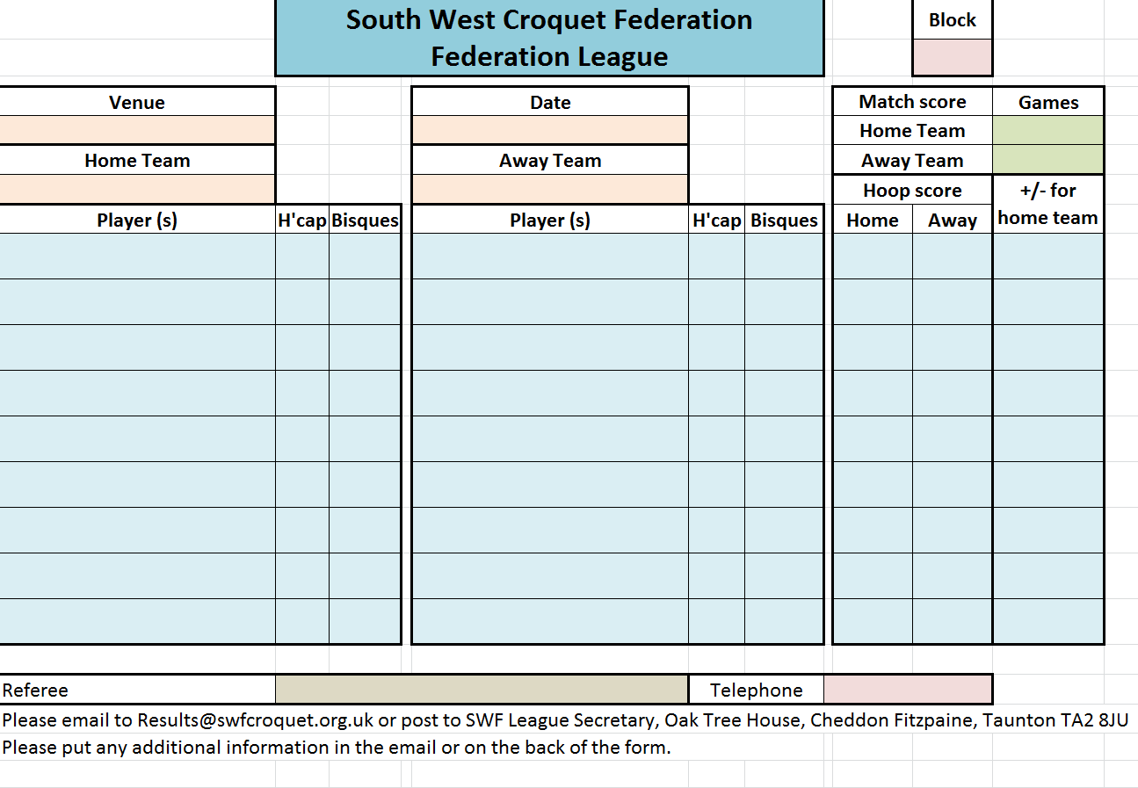The AC forms for Federation, Intermediate and B-League are the same in layout and look like this.

* The light-coloured boxes need to be completed
* The ‘Block’ is the group within the league, such as NW, SE, Central etc.
* The ‘Match Score’ is the number of games won by each team, e.g. Home Team 5, Away Team 2.
* When filling in the players’ names and handicaps you can put doubles partners in two boxes or in a single box. The columns for ‘Bisques’ are there to help the match organiser on the day.
* ‘Hoop Score’ is the actual number of hoops scored by each side, e.g. 26 17.
* “+/- for home team” is the hoop difference preceded by ‘+’ for a home win or ‘-‘ for an away win. For example, if the home player won 23-8 then this cell would read +15 but if they lost 0-26 then it would read -26. (Do not put ‘T’ after an unfinished game as the hoop score gives this information.)
* Please put the details of a match referee, if present, in case of any queries arising.

The form for the Advanced League is very similar except:

* ‘Division’ instead of ‘Block’. i.e. Div 1 or Div 3 N
* There is no column for Bisques, but there is a column for ‘Peels’, e.g. tp, oqp, sxp as relevant

The GC forms are in portrait orientation but are broadly similar to the AC forms. The Handicap and High Handicap forms look like this. The columns for Extra Strokes are there to help the match organiser on the day. The rest of the form should be filled in as described above.

The form for the Level Play league is the same but without the columns for Extra Strokes.

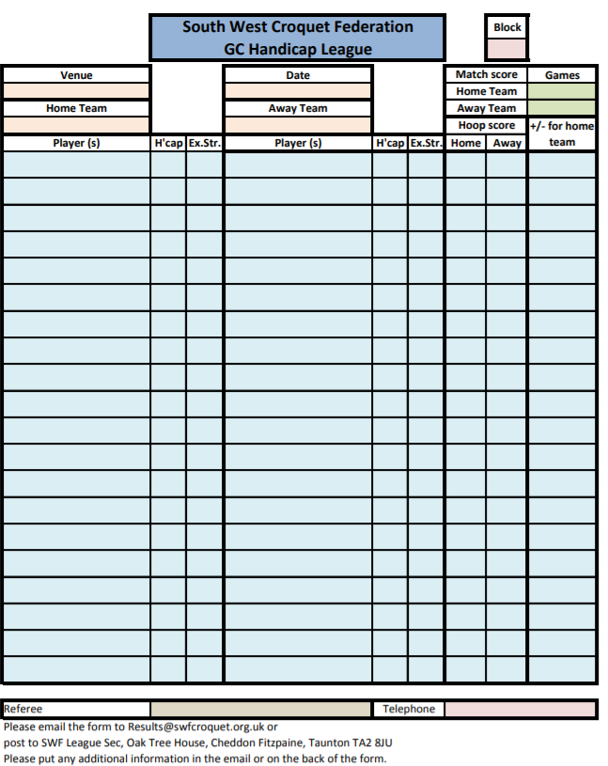

**Thank you, Adam**

After many years’ service to the SWF – not to mention his own clubs – Adam Wimshurst stood down from the committee at our last meeting.

His input will be sorely missed – he has supported the start-up and development of many clubs and was Chair at Budleigh Salterton for some time.

He’s been playing croquet since childhood – by the headlights of a mini according to his brother – and we look forward to playing him on the lawns and catching up with him over a cup of coffee.

Many thanks Adam.

**Would you like to join the SWF Committee?**

We’re looking for two or three people to join us – could you be one of them?

At the AGM we failed to elect anyone to replace Ros Key-Pugh as GC Adviser and since then Adam Wimshurst has resigned – he was our Development Officer for the South of the region.

We’d therefore like to co-opt people to join the committee immediately and test the water – if you like it, you could stand for election at the AGM in November.

We have two more committee meetings planned for this year – 23rd March at Nailsea CC and 12th October at a venue to be arranged – and between times we are in regular email contact about various issues.

The meetings start at 10.00 and finish around 3.00 – this includes lunch and a chance to chat and catch up.

|  |
| --- |
| If you’d like more information then please contact any committee member but in particular:  For general information  Brian Wilson, Chair: [brian@europaassociates.co.uk](mailto:brian@europaassociates.co.uk) 07970 922867  Linda Shaw, Secretary: [lindawithani@hotmail.com](mailto:lindawithani@hotmail.com) 07785786147  For information about development support  Paul Francis, Development Officer: [paulwfrancis@icloud.com](mailto:paulwfrancis@icloud.com) 07411 044109 |

At the moment we face bigger developments within the CA – development of the Croquet Matters framework and the proposed Governance changes – and we are reflecting on how this might affect our own structure.

So, we’re looking for people with enthusiasm, patience, persistence and a good sense of humour who are good team workers and enjoy working as part of a committee.

Women and younger players are not well represented on the committee and we’d particularly welcome some interest from you if you fall into these groups – or any other you feel has too low a profile!

**Your club matters – do you know Croquet Matters?**

****How often has your club sat down together to discuss ‘what we do well’ and ‘how could we improve?’

‘Croquet Matters’ is a logical and easy tool kit to help you to evaluate these questions and plan for the future.

Developed by SportEngland the CA’s Development Officer (Dave Gunn), has been offering introductory sessions for clubs. He has received very good feedback and, our very own Cornwall Club has participated. They are now planning to use Croquet Matters to develop a long-term club plan for improvement.

The session lasts for about two to three hours, depending on how much discussion is generated. There are four areas to consider:

Marketing – People – Management - Finance

The session will be introduced and led by the SWF Development Officers, on the day the club is asked to score itself on one of four levels. It is this activity which sets up the discussion and leads to ideas/plans on how the club can move up to the next level.

If you are interested in running a session for your club and/or need further information, please contact Paul Francis (SWF Development Officer) on 07411044109 or email [paulwfrancis@icloud.com](mailto:paulwfrancis@icloud.com)

<http://www.sportenglandclubmatters.com/club-planning/planning/club-development-plan/>

**Promoting croquet**

It’s that time of year when we’re beginning to think our Open Days and encouraging more people to give Croquet a go.

A cursory search on the internet reveals an overwhelming number of suggestions and everyone will have their own take on this. Here are a few more to add to the mix:

‘While You Wait’

Klim Seabright is a member of the CA marketing committee and suggests:

In the USA, clubs are placing copies of their magazine in doctors’ and dentists’ waiting rooms – and other places people are hanging around – and sticks a club contact label on the front of each one.

Do let Klim know if this meets with any success: [klimseabright@gmail.com](mailto:klimseabright@gmail.com)

Marketing

Brian Wilson, erstwhile Chair of the CA Marketing Committee, which have been circulated to club contacts – please ask your club’s committee if you’d like to know more.

**For women croquet players especially**

Alison Maugham, the CA’s International Performance Director, has created a Google Group to encourage more women into competitive play. Do read on for more information and to sign up. Be aware there is a time out on this link so do contact Alison direct if you need a fresh link: [alison@alisonswebsites.co.uk](mailto:alison@alisonswebsites.co.uk) or 07766 720 830

*We have recently created a Google Group to encourage more competitive croquet amongst our women players.  The group is to be used as a communication tool to share knowledge and provide guidance towards entering competitive and hopefully advanced croquet tournaments.*

*Please note this group is not exclusively for women to join, all croquet players are welcome.*

*We already have over 50 women players from the UK and rest of the world, where we can hear about and learn from some experiences from other countries.*

*I am a strong believer that playing competitive croquet isn’t just about the croquet, it’s also about planning, knowing what tournaments exist and having courage to take the next steps towards a higher level of play.*

*Regardless of your current standard of play, whether you only play handicap games on the club roll up days, fill in for the local League match or only play Advanced Tournaments or Championship events, we would love to hear from you.*

**Additional Coaching**

Camerton and Peasedown CC have asked us to pass on details of an addition to their programme for the year – highlighted in red:

|  |  |  |  |  |  |
| --- | --- | --- | --- | --- | --- |
| **Events at Camerton & Peasedown Club 2019**  **www.camertonpeasedowncroquet.co.uk** | | | | | |
| 3 April | Wednesday | AC One Ball Tournament | All Hs | 9.30 – 5.00 | Min £10 in aid of the Alzheimer's Society |
| 30 April | Tuesday | CA “B” Level Series (GC) | H 3-8 | 9.30 – 5.00 | Apply on CA Website –details in Fixture Book. |
| 8 May  **7 May** | Wednesday  **Tuesday** | GC Improver’s Course  **Additional GC Improvers Course** | H 7-14  **H7-14** | 9.30 – 4.30  **9.30 – 4.30** | £10pp  Coaching notes provided. **FULL**  **£10pp.** |
| 11 June | Tuesday | CA “C” Level Series (GC) | H 7+ | 9.30 – 5.00 | Apply on CA Website – details in Fixture Book |
| 3 September | Thursday | GC Open Doubles Tournament | All Hs | 9.30 – 5.00 | £20 per pair  BYO lunch |
| 29 September | Sunday | “64” Challenge Progressive Doubles | All Hs | 9.30 – 5.00 | £15 pp including Lunch |
| Members from all SW Fed clubs are welcome to enter any of these events: first come:first served  For non CA events please send entries with your name, handicap and cheque to  Ros Key-Pugh 8 The Linleys, Bath BA1 2XE Tel: 01225 427525  Email: [roskeypugh@yahoo.co.uk](mailto:roskeypugh@yahoo.co.uk) | | | | | |

**Stephen Read**

We were saddened to hear from Cornwall CC that Stephen Read has passed away. I certainly remember him as a charming man (especially on one occasion when I beat him thanks to an enormously lucky fluke hoop run in the last turn of our game) and Des Honey’s tribute to him will surely bring back some fond memories for many:

****Stephen Read joined the Fowey Croquet Club in 2003 and then the Cornwall Club a year later. With his wife Margaret, he developed a great enthusiasm for the game playing competitive and social croquet regularly at both clubs.

Stephen was immediately involved with the upkeep of the clubs, making himself indispensable by working tirelessly, maintaining all the equipment as well as applying his extensive horticultural skills to the lawns.

He somehow managed to find time to play both croquet codes and achieved a very good level in each. Stephen represented the clubs in various Federation Leagues over the years as well as entering several CA Tournaments. He enjoyed inspiring new players; he just loved and lived for croquet. In 2015 his contributions to the game was recognised by being awarded a CA Diploma.

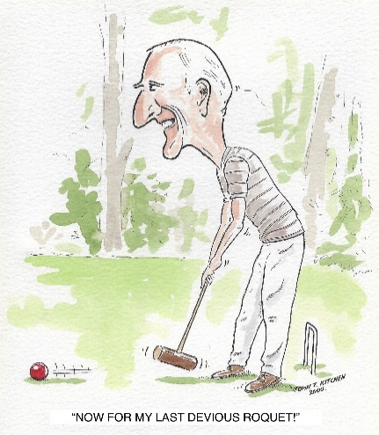Stephen played croquet with a great tenacity and determination, his strong will to win often being disguised by his wry smile and wicked sense of humour. The same determination that kept him playing in the last few years, despite failing health.

We wish a fond farewell to a good friend and stalwart member of the croquet community. Stephen’s input into maintenance of the lawns and machinery is already being missed. We could always rely on Stephen’s tireless pursuit of solutions to the problems that arose in the day-to-day running of the club. On a personal level we will miss his companionship and the challenges and enjoyment he gave as an opponent on the lawns.

**CA Governance Changes – what’s going on?**

In the previous edition of Cygnet, we highlighted some of the planned changes and this article aims to update you and set out the local implications.

**What is the current situation?**

* At a CA Council meeting held on 26/1/19, it was agreed that CA Council be reduced from 30+ to 12 elected members
* Currently too much time is spent on minutiae and not enough time being spent on forward planning
* This is poor governance – more time needed to spend on reviewing the achievements of the CA Executive

**What are the proposals?**

* Council to be 12 elected people, plus Chair, Secretary and Treasurer from the Executive Committee, but these 3 people do not have a vote
* These 12 places will be elected by 7 ‘Constituencies’ based on the CA Membership of current Federations
* The South West and South East each have 3 places, Anglia 2 and others 1 each
* Each member serves a 3-year term and can only serve for 3 consecutive terms

**What is the role of this new Council?**

* Policy making
* Strategic vision and initiatives
* Scrutinising and review the Executive Board’s performance
* Good governance

**Nominations and voting**

* Any CA member whose primary club is in the South West Federation Area can be proposed and seconded to stand
* Elections will be managed by an Electoral Commission including: - CA President, Secretary, Treasurer or nominees
* Voting will be by a single transferable vote
* Electronic voting is possible

**What’s the next move?**

* There will be a SGM of the CA on 30th March where the proposals to adopt Constitutional changes will be presented. If passed, then a lot will happen.
* Voting: - Either in person, electronically or by post
* First vote: - changes to the CA Constitution
* Second Vote: - on the proposals to change the CA Council
* Then, if passed at the SGM: - Elections to the new Council will take place before 1st October 2019

**What to watch out for?**

* Information from the CA and read your Croquet Gazette
* Your Federation will keep your club up to date

**What to do now?**

* Consider this proposal
* Talk it over in your club and with others
* Look out for the voting instructions from the CA and the Federation

If these proposals are agreed …

**Nominations will be invited from**

* Any CA member whose primary club is in the South West Federation Area can be proposed and seconded to stand
* Each nominee must have a proposer and seconder (who must be a CA member within the South West Federation)
* Each nominee must provide a short personal statement (more guidance later)

**Role of your Federation**

* To publicise the elections
* Encourage CA members to seek nomination
* Send the nomination papers and personal statements to the CA and publish them on Federation Website.
* Ensure sufficient nominations to cover allocation
* Ensure that more club members take up their CA membership
* Encourage CA members to vote

**What is the role of the CA?**

* Elections will be managed by the CA who will create an Electoral Commission and Returning Officer including the CA President, Secretary, Treasurer or nominees
* The CA will collate all the nominations and personal statements from all Constituencies/Federations and send them to all CA members in the South West (and to all other Constituencies/Federations)
* The CA will manage the voting process and count all votes (sent in by post or electronically)
* Voting will be by a single transferable vote
* Electronic voting is possible

**What should Clubs do?**

* Publicise and discuss these elections
* Encourage CA members to seek nomination
* Ensure that more club members take up their CA membership (remember only CA Standard and Premium members can take part in this election)
* Encourage CA members to vote

**What should I do?**

* Watch out for updates from the CA (The Croquet Gazette) and your Federation
* Consider who you think should serve on this new Council – and talk it over with them and their supporters
* Look out for the voting instructions from the CA and the Federation
* Read all the personal statements and consider who should have your vote (remember it is a single transferable vote)

**CA Governance Changes – your vote counts: make sure you have your say**

Take up your ‘Free’ CA Standard membership (you’ve already paid it in the CA levy) – your club will have further information about this

If you want to be able to influence these you must be a member of the CA – you may be a Premium Member or you may be a Standard Member – that is, you will have given your club permission to share your details with the CA. This doesn’t cost you anything as long as you are a fully paid up playing member of your club, and your club is a member of the CA.

The CA website provides full information on types of membership, benefits of membership and costs and we would encourage all Clubs and their members to join.

**Appendix 1: GC Rules Update Session**

**Saturday 6th April at Nailsea Croquet Club**

**10.00 – 1.30**

Places will be limited to 2 per club in the first instance.

Please feel free to nominate more than this as further places may be available if level of demand permits.

If there is sufficient demand, a second session will be run from 2.00 – 5.30 on the same day.

In the event of over-subscription, your club will be asked to prioritise who should attend from amongst its members.

The event will be free to attend but a charge of £2 per person per session will be made for teas/coffees/biscuits. This will be payable on the day.

Please email [lindawithani@hotmail.com](mailto:lindawithani@hotmail.com) to book a place at this session stating the following information:

|  |  |
| --- | --- |
| Your name |  |
| Your club |  |
| Your email address |  |
| Would you be able to attend an afternoon session if necessary |  |

**Appendix 2: New GC Rules**

Many thanks to Ray Ransom of Bristol CC and Stephen Custance-Baker for their collaboration on this summary of changes most likely to impact our games.

# When a ball leaves the Court

A ball leaves the court as soon as any part of it would touch a straight edge raised vertically from the inner edge of the boundary marking or when it is directed to be played from a penalty area.

The penalty area is a semi-circular area on the court with a radius of one yard from what, in the 4th Edition, was described as a Penalty Spot. (It's good to see that the croquet world is sticking to the Imperial standard of measurement). If a ball is to be played into the game from where it left the court, it is to be placed so that it is on the court and one point on its circumference would touch a straight edge raised vertically from the boundary.

# Non-Striking Faults

Non-Striking Faults have been removed from the new GC Rules. However, the striker**\*** can commit a fault if they touch any ball other than the ball they intended to strike with the mallet or any ball with any part of their body, clothes or personal property during the Striking Period.

The Striking Period starts when the striker takes up their stance with the apparent intent to play a stroke and ends when they quit their stance under control. As before, if you fail to make contact with the striker's ball, no stroke has been played and you are entitled to try again. Again, if you touch the ball whilst casting, your stroke has been played.

# Deemed Strokes

The striker may now declare their stroke to have been played without actually touching the striker's ball.

# Outside Agencies

Scoring clips, including those belonging to another game, are no longer outside agencies whilst attached to a hoop or to a player, and as a result a ball which strikes a clip whilst making a hoop has made the point. A falling clip, or one lying on the court surface, is an outside agency.

# Playing a Wrong Ball

A good deal of effort has gone into simplifying the wrong ball rule. Now, no penalty is imposed in this situation, ***unless the wrong side plays,*** so if you believe that a wrong ball is about to be played in your game, **you must forestall play and make sure that the correct ball is played**.

For the most common situations where a wrong ball has been played, there are 2 possible remedies;

* **Replace and Replay –** all balls moved as a result of the stroke are replaced, no points are scored, and the striker for the last stroke replays the turn with the striker's ball
* **Ball Swap** – all balls moved are left where they stopped, except that the position of the ball played and its partner are swapped. The stroke is valid and any point scored is counted for the owner of the ball that scored the point. The non-offending side then plays the ball next in sequence after the partner ball of the ball played in the last stroke**\*\***
* **Penalty Area Continuation -** if one side plays an opponent’s ball and the opponents then play, no points are scored and a Penalty Area Continuation is used

The most likely situations to occur are:

* **Striker played partner ball or striker’s partner played own ball-** the non-offending side chooses whether to apply Replace and Replay or Ball Swap.
* **Striker or striker’s partner played opponent ball -** Replace and Replay only.
* **Striker’s partner played striker’s ball** - Replace and Replay only.

# Handicap Play

There are some changes to the rules covering handicap play. What were termed 'Extra Turns' are now described as 'Extra Strokes'. The side playing an extra stroke may not score a point for their side but may score a point for the opposition.

The calculation of Extra Strokes in handicap doubles has changed. Instead of comparing the higher handicappers from each side and then the lower handicappers, in the new rules you start by comparing the higher handicapper on one side with the lower handicapper on the other side.

The higher handicapper is awarded half the difference between their handicaps, rounded up. This is repeated for the other two players. In general, this will mean that there are more extra strokes in the game but the lower handicapper on a side will never get extra strokes unless their partner also gets some.If both players on the same side benefit from the rounding up then only one gets the additional stroke.

The extra strokes allocated to players in games for different lengths are set out in Appendix 2 of the Laws Book.

Extra strokes may now be used after a wrong ball, provided the Replace and Replay option is taken by the opponent.

**\*** The striker is defined as the owner of the striker's ball, that is the ball that follows next in sequence after the ball played in the last stroke.

**\*\*** Let's assume that the blue ball has just been played. The next ball in sequence is the red ball (the striker's ball). If the striker (owner of the red ball) plays the yellow ball, or the striker's partner plays their (yellow) ball, then a wrong ball has been played. If the opponents decide on a ball swap then after the exchange, the next ball to be played is the black ball.

**Appendix 3: Budleigh Handicapping workshop Sunday 24th March 2019**

**If you would like to come to Budleigh please read this carefully then send me details of your delegates** – [lindawithani@hotmail.com](mailto:lindawithani@hotmail.com)

* Their name
* Their club
* Their email address
* Clubs are requested to nominate 2 delegates only initially – one for AC and one for GC
  + A third delegate may be nominated who will be invited if there is sufficient space
* All are welcome to attend but we would particularly like to see existing Club Handicappers, Potential Club Handicappers and League Captains.
* Priority will be given to clubs who have not been able to send anyone to previous workshops but everyone is welcome to apply
  + Attendance will be confirmed nearer the time for the ‘previously experienced’ clubs.
* Please bring your own packed lunch
* Tea, coffee and a tea time cake will be available at a reasonable charge

**Draft schedule**

9.30 Registration, coffee

10.00 - 1.00 Why does every club need a handicapper?

How does the handicapping system work?

Practical tasks for assessing handicaps

1.00 – 1.30 Lunch

1.30 – 3.30 Points common to both games

Various technicalities

Managing the system: AHA, non-automatic changes

How do you know you’re getting it right? – strategies for success

What next? – on going support

15.25 Evaluation and exit register (for issuing attendance certificates)

15.30 Tea and depart

**Further information**

These workshops are designed to develop the understanding and application of good handicapping principles in both AC and GC and we hope that every club in the SW will participate in these.

This will help develop consistency across the region and as stated at the AGM, in 2019 we will be introducing the expectation that clubs will have a Club Handicapper for the relevant code in order to be able to enter League teams

*Continued overleaf*

**Aims of the workshops:**

* Achieve 100% of clubs with at least one Club Handicapper for both AC and GCE
* Ensure all Club Handicappers are trained and supported by a dedicated CA Handicapper
* Ensure consistency across the SWF and all federations
* By the end of the day, everyone should feel confident that, with further support, they can become a Club Handicapper and that they will have easy access to the support network and that every club will have the name of a more experienced handicapper who can give regular and on-going advice and practical help

**Expenses**

* There are no fees to attend these workshops.
* A contribution to travel expenses may be claimed from the SWF Bursary Scheme
  + A claim form will be available on the day
* Please note that only one claim from each club for each workshop may be made.

